unit 65
Case study 1
The ‘alabado’ as a resource for healing: Bojayá massacre, Colombia
Context:
The United Self-Defense Forces of Colombia (AUC) was an extreme right-wing counterinsurgency group whose main objective was to combat Colombian guerrilla groups, mainly the Revolutionary Armed Forces of Colombia (FARC-EP). This guerrilla group, the largest in the country, was based on leftist ideology and the principles of Marxism-Leninism and Bolivarianism. For more than 10 years, these two insurgent organizations fought each other in several territories of the country. One of these places was in the middle of the Atrato region where the town of Bojaya is located. On 2 May 2002, during one of their battles in this town, mortar round crashed through the roof of the town church and killed 119 people who were sheltering there to escape fighting between left-wing guerrillas and right-wing paramilitary units. Another 100 were wounded and approximately 5,700 people were displaced to Quibdó, the capital of the department of Choco in the middle Atrato region.
The population living in the Atrato region is mainly Afro descendant, whose rich heritage includes not only music, dances, songs, but also social practices and festive events, knowledge related to nature and traditional medicine, among others. One of the social and ritual practices of high relevance in this community was related to the mortuary ritual. When someone died, the entire village community gathered to accompany the grief of the relatives of the deceased. During this event, the ‘rezanderos’ (people who lead the prayers) and the ‘cantadoras’ (singers who sing according to the prayer) play a fundamental role. They accompany the deceased with their prayers and songs throughout the night of the wake. Their work, which is often accompanied with ‘vinche’ or ‘arguardiente’ (alcoholic beverage), is perfectly synchronized to perform their task at the right time during the wake. At dawn, the deceased is paraded through the village stopping at significant places for him/her while continuing to sing and pray before burial. This mortuary system integrates African influences and Catholic traditions of colonial origin, which in a broad sense are oriented to process and accompany the transition from life to death of the deceased.
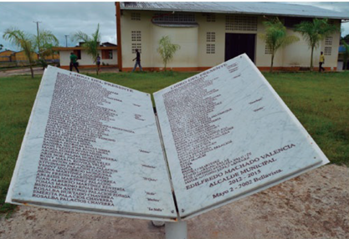
Impact on intangible cultural heritage
The massacre undoubtedly altered the intangible cultural heritage of the community, including mortuary practices. As the fighting continued after the massacre, the dead could not be buried according to traditional rituals but were disposed of in a mass grave on the outskirts of the town. Thus, the communities of Bojayá could not close the grieving of their loved ones because they could not provide them with the symbolic act that allowed them to move from life to death. However, after the massacre, one woman began to compose ‘alabados’, funeral songs, and later many other women became attuned to this proposal and began to compose lyrics and sing songs together to heal the wounds left by the untimely absence of their loved ones. As a result, the women of this community gather year after year to remember their dead through their songs, which not only invigorate the memory of the massacre, but have also become a political stage to question the absence of the State and the responsibility of the armed actors in the massacre.
Figure 1"Libro del presente [Book of the present]" Tribute to victims of the 2002 massacre. Photo: ©Quiceno Toro, Natalia. (2016). Vivir Sabroso. Luchas y movimientos afroatrateños
And a tenth anniversary  and this is history in the making,  Tell those in the press  Don't erase the memory  And that was left for history  and will never be forgotten  Gentlemen armed groups  don't come back here anymore  And this was a very hard blow,  that frightened everyone  They formed that fight  and the peasants suffered  Children are the future  and many children died  Gentlemen armed groups  do not cause us more terror  With this we say goodbye,  we no longer sing to you  Let the violence end  in the river of Bojayá  May the violence end  and may we live in peace.  Excerpt from ‘Alabado’, Commemoration of the Bojayá massacre, May 2, 2013. | 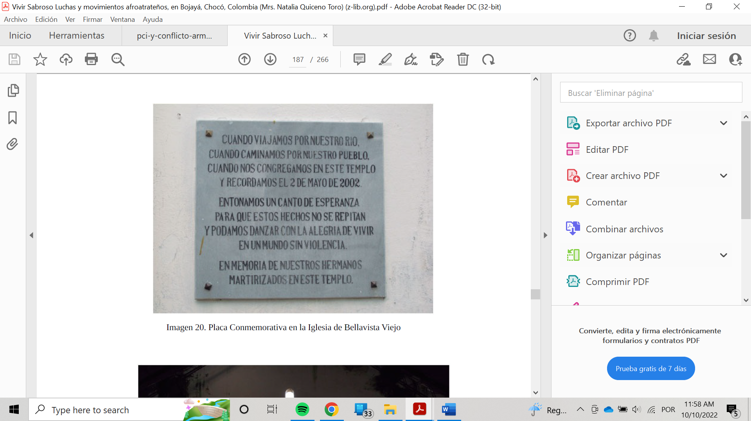When we travel along our river,  when we walk through our town,  when we congregate in this temple  and remember May 2, 2002.  We sing a song of hope  so that these events will not be repeated  and we can dance with the joy of living  in a world without violence.  In memory of our brothers  martyred in this temple.  Memorial plaque at Iglesia bella Vista: Photo: © Quiceno Toro, Natalia. (2016). Vivir Sabroso. Luchas y movimientos afroatrateños.
References:
Quiceno Toro, Natalia. (2016). Vivir Sabroso. Luchas y movimientos afroatrateños [Vivir Sabroso. Afro-Atrateño Struggles and Movements], en Bojayá. Chocó, Colombia. Bogotá: Editorial Universidad del Rosario. DOI: http://dx.doi.org/10.12804/th9789587387506
CRESPIAL (2020), Patrimonio Cultural Inmaterial y Conflicto Armado: Reflexiones sobre Patrimonio Cultural Inmaterial en Latinoamericano [Intangible Cultural Heritage and Armed Conflict: Reflections on Intangible Cultural Heritage in Latin America]. See https://crespial.org/wp-content/uploads/2020/09/pci-y-conflicto-armado.pdf (Available in Spanish online)

