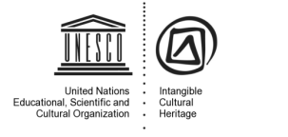
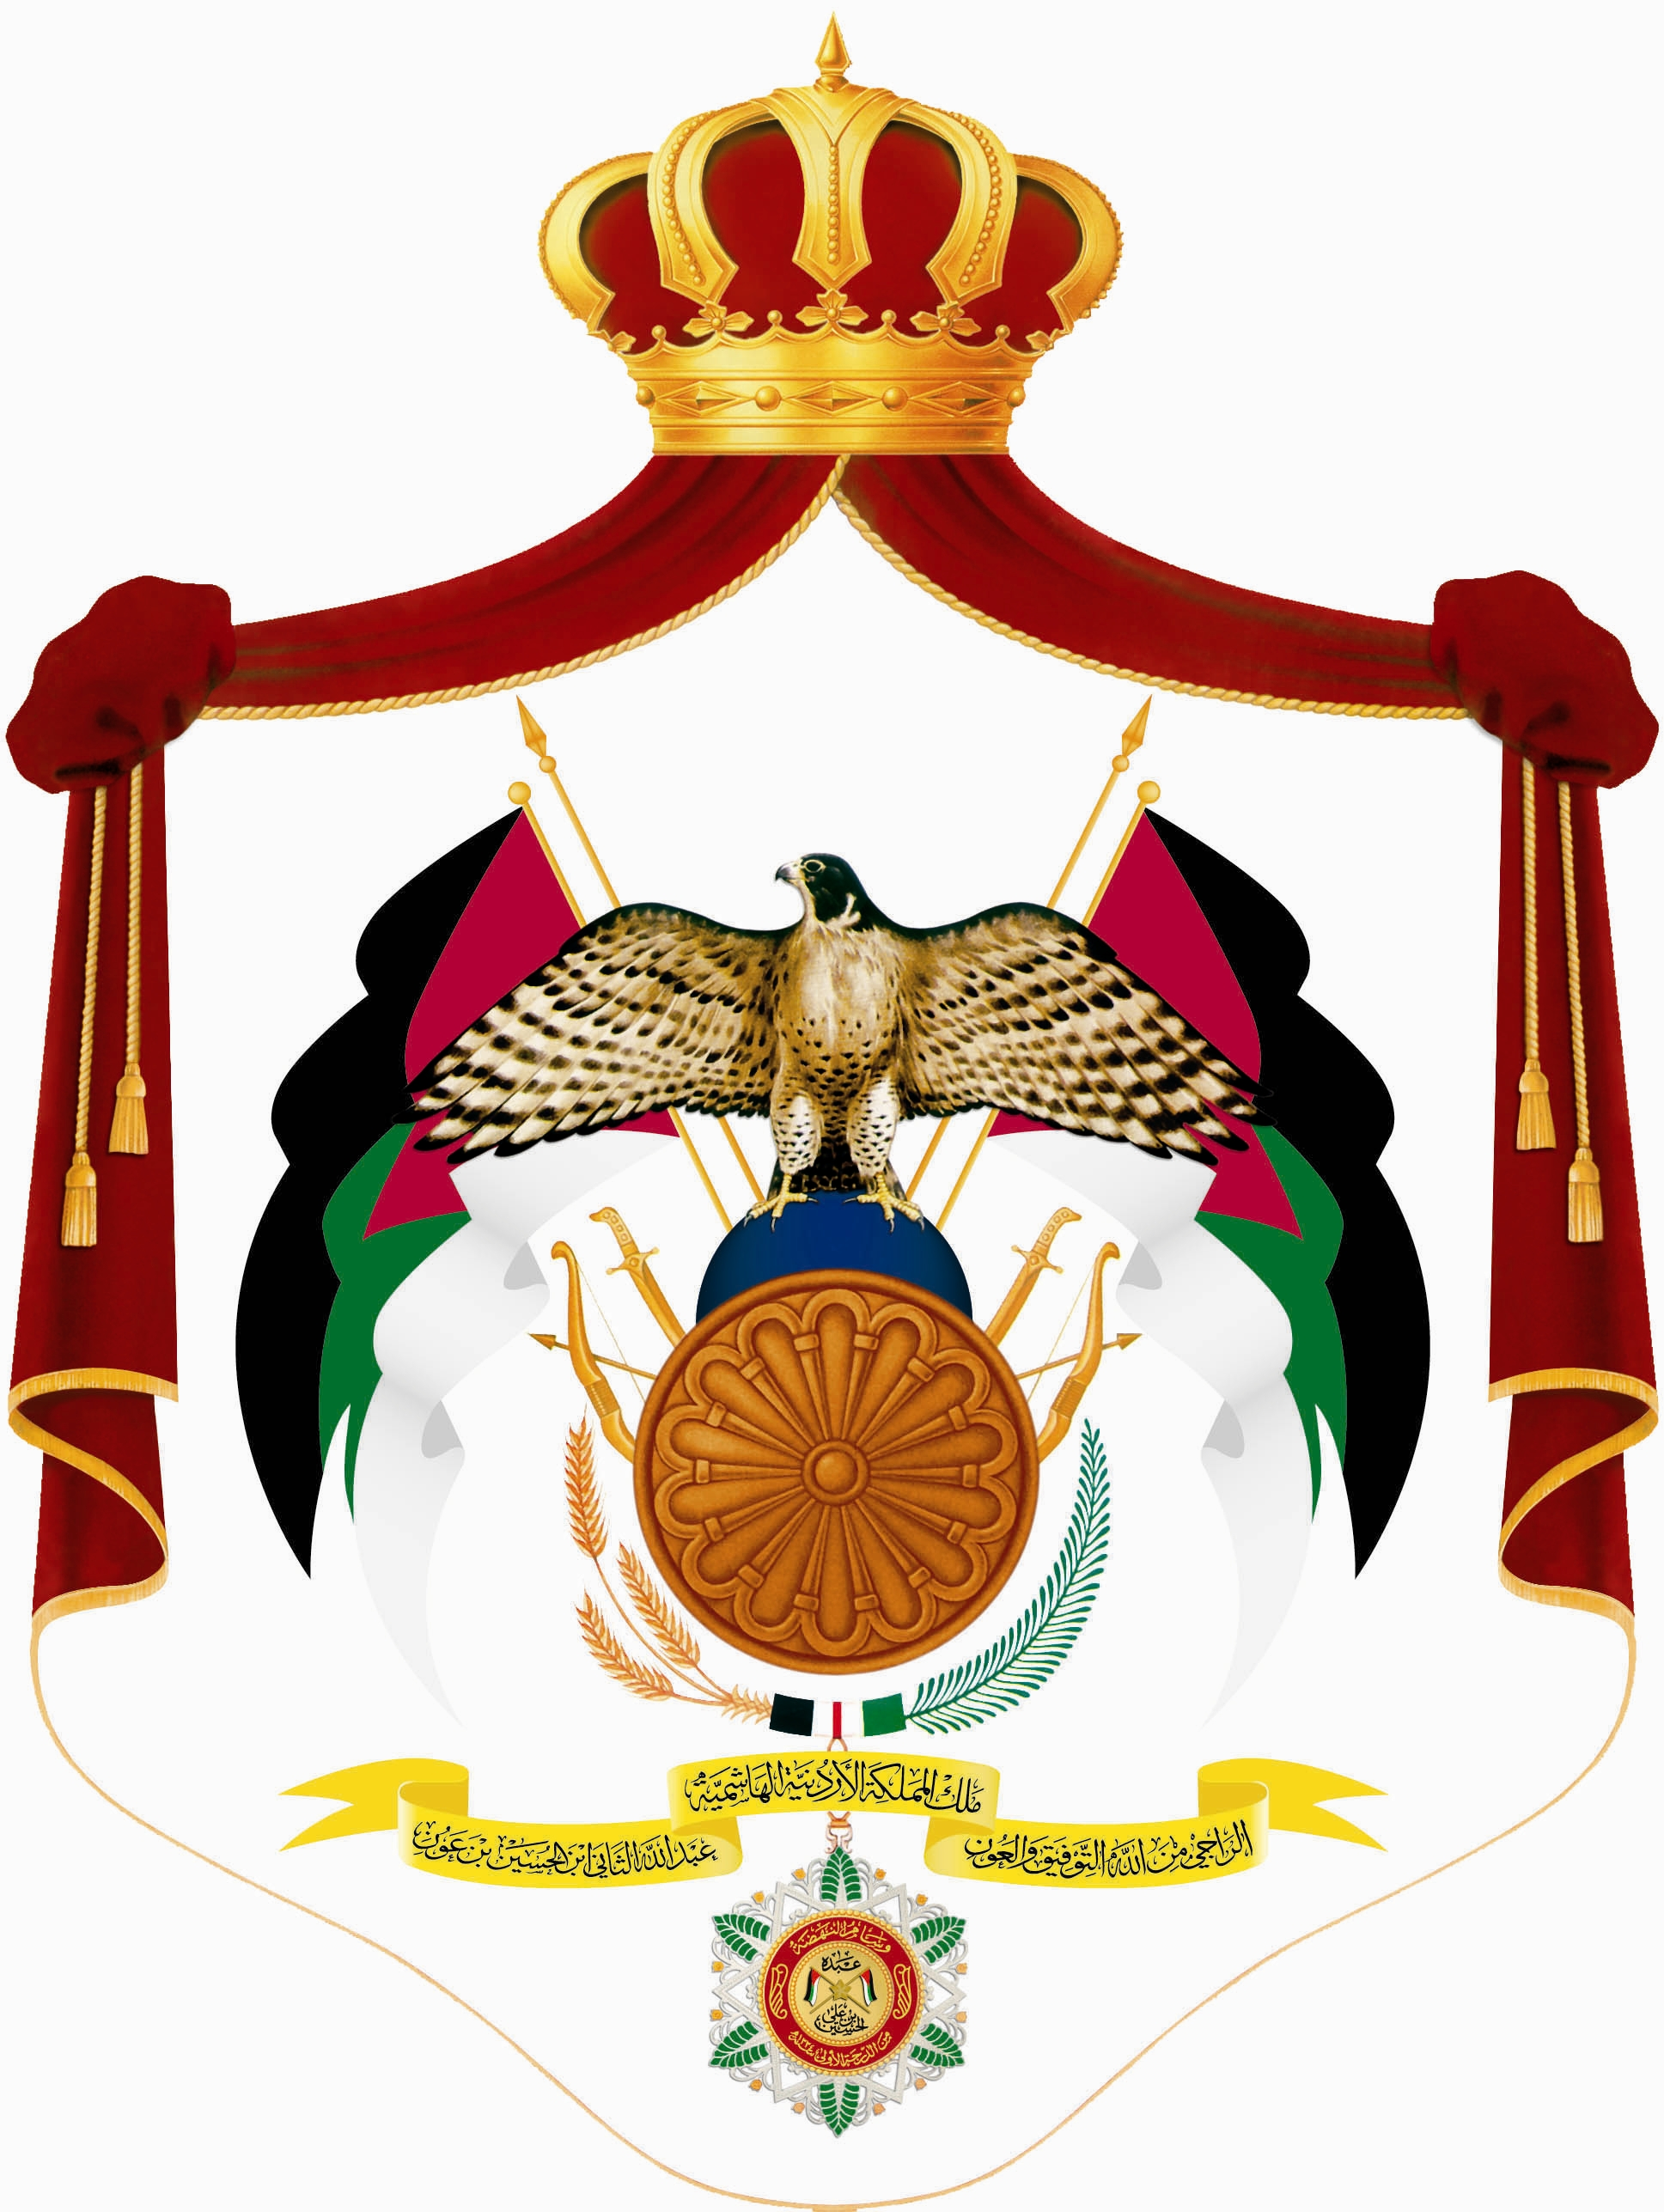

A Training Workshop on
“How to prepare nominations for the Urgent Safeguarding List and the Representative List of UNESCO’s Convention for the Safeguarding of the Intangible Cultural Heritage”
7-11/10/2012
Amman-Jordan
In the context of Phase III of "Mediterranean Living Heritage" (MedLiHer) project which is co-funded by the European Union (EU) and UNESCO, a workshop on the methodology and procedures of nominating intangible cultural heritage elements to the Representative and Urgent Safeguarding Lists will be held in Amman between 7 and 11 October 2012. The MedLiHer project, which commenced in 2010 and is part of the larger Euromed Heritage 4 programme , aims at enhancing institutional capacities in Egypt, Jordan and Lebanon for safeguarding the intangible cultural heritage in the three countries and build knowledge and skills for their effective participation in the international mechanisms established by the UNESCO Convention for the Safeguarding of the Intangible Cultural Heritage (2003) and to elaborate specific safeguarding measures with the participation of communities and concerned groups. The MedLiHer project is financially supported by the European Union through Euromed Heritage 4, a regional programme aiming at creating new opportunities for Mediterranean people’s awareness and appropriation of their extraordinary common cultural heritage.

The Amman workshop follows the Madaba one, and is intended to reinforce the capacities of participants to contribute to a specific aspect of the implementation of UNESCO’s Convention for the Safeguarding of the Intangible Cultural Heritage (ICH), i.e. the preparation of nomination files for inscription on the Lists of the Convention, the requirements of the nominations process, evaluating sample nominations, discussing descriptions of the elements from the Madaba Inventory, and the participation of communities in the process of identifying and documenting as well as the safeguarding measures identified. It will develop key parts of a nomination file as well, i.e. a summary for the element and a community participation strategy for the nomination.
The targeted group in the present training workshop consists of members from the Jordan National Commission for Education ,Culture and Science and the Ministry of Culture, especially the people who are directly involved in the administration and the preparation of the documents and deliverables of the project. Some of them are connected to the local communities of Madaba.

Two accredited UNESCO facilitators, Prof. Dr. Hani Hayajneh (Jordan) and Prof. Dr. Mustafa Gad (Egypt), will run the workshop. They will use the UNESCO capacity-building workshop materials in training activities, and deal with some nominations predefined by the UNESCO as case studies.

To find our more:
Name and mail address of contact person
MedLiHer : http://www.unesco.org/culture/ich/index.php?lg=en&pg=00226
Euromed Heritage 4 : www.euromedheritage.net

