CONVENTION FOR THE SAFEGUARDING OF THE
INTANGIBLE CULTURAL HERITAGE
INTERGOVERNMENTAL COMMITTEE FOR THE
SAFEGUARDING OF THE INTANGIBLE CULTURAL HERITAGE
Meeting of the Bureau
UNESCO Headquarters, Room VIII
1 October 2024
10 a.m. – 1 p.m.
Item 6 of the provisional agenda:
Use of the emblem of the 2003 Convention
Summary
In response to the increasing requests from stakeholders wishing to use the emblem of the 2003 Convention for their safeguarding activities and special events to safeguard and promote their intangible cultural heritage, the present document proposes ways to facilitate access to its use.
Decision required: paragraph 8

Introduction
- The emblem of the 2003 Convention was adopted in 2010 (Resolution 3.GA 5) to support the activities of the Committee and of States Parties in promoting the objectives of the Convention (Decision 1.EXT.COM 8, Decision 2.COM 13 and Resolution 2.GA 9bis). As stipulated in Chapter IV.2 of the Operational Directives, the emblem of the Convention shall be accompanied by UNESCO’s emblem and may not be used in isolation, it being understood that each of them is governed by a separate set of rules and that any use thereof must have been previously authorized in accordance with the respective set of rules. The provisions of the Operational Directives apply only to the use of the emblem of the Convention, while the most recent version of the Directives concerning the Use of the Name, Acronym, Logo and Internet Domain Names of UNESCO is found in the annex to Resolution 86 of the 34th session of the General Conference (34C/Resolution 86).
- With reference to the abovementioned provisions, notably paragraph 133 of the Operational Directives, the use of the Convention emblem has been authorized most notably in connection with the following three arrangements:
a. The patronage of the Convention may be granted to an event or ad hoc activity. These activities can include performances, congresses, meetings, conferences or other national and international events, as well as efforts that embodies the intangible cultural heritage, except for those produced mainly for profit.
b. A contractual arrangement can be concluded between UNESCO and outside organizations in the framework of partnerships, co-publication and co-production agreements.
c. Specific promotional activities undertaken by the stakeholders of the Convention have also been recognized.
- At the same time, paragraph 139 of the Operational Directives provides that ‘Communities, groups or, if applicable, individuals concerned are encouraged to use the emblem of the Convention with regard to their activities and special events to safeguard and promote their intangible cultural heritage elements inscribed on the List of Intangible Cultural Heritage in Need of Urgent Safeguarding or the Representative List of the Intangible Cultural Heritage of Humanity, under the conditions specified in the present Operational Directives’. Following the inscriptions of elements on the Lists, stakeholders of the Convention naturally seek to promote their living heritage practices using the emblem of the Convention, for instance on signs used in associated physical places and spaces. Such permanent uses of the emblem do not qualify as specific events and ad hoc activities that are time-bound, nor can they be regulated by contractual agreements.
- As was pointed out when the issue was previously brought to the attention of the Committee (document ITH/12/7.COM/13.d and Decision 7.COM 13.d), the Secretariat is therefore compelled to decline many worthwhile requests in order to abide by the rules governing the use of the emblem of the Convention and of UNESCO’s logo. The situation creates frustrations as the communities, groups and individuals are not fully cognizant of the specific conditions for use of the emblem of the Convention. Moreover, in many cases communities use the emblem of the Convention with the UNESCO logo to promote the inscribed elements without seeking the prior authorization from UNESCO to do so. Considering the importance of the issue for the future development of the Convention, the Bureau of the Committee has requested that the Secretariat seek possible ways to facilitate access to the emblem of the Convention for communities, groups and individuals wishing to safeguard and promote their living heritage elements inscribed on the Lists of the Convention.
Experiences from recent global activities
- Recent experiences gained in the framework of communication campaigns to promote specific activities for two global events may provide useful inspirations for the case at hand:
  - Twentieth anniversary: In line with the encouragements given by the ninth session of the General Assembly in July 2022 (Resolution 9.GA 13), stakeholders of the Convention undertook series of events around the world to celebrate the anniversary of the Convention. These celebrations were showcased on the dedicated webpage of the Convention. A twentieth-anniversary logo, incorporating the text ‘in support of the 20th anniversary of the 2003 Convention’ (see below), was made available (upon request, using a designated form) and adapted in the requested languages to support these initiatives. The direct administration by the Secretariat of the Convention allowed a speedy process of requests. A total of 180 activities were featured on the webpage.
  - International Day of Intangible Cultural Heritage: The 42nd session of the General Conference in November 2023 proclaimed 17 October as the International Day of the Intangible Cultural Heritage (42 C/Resolution 34). In line with the resolution of the tenth session of the General Assembly of the 2003 Convention (Resolution 10.GA 10), a web-based campaign was initiated in September 2024 to mark the first edition of this International Day and to recognize events organized by stakeholders of the Convention in September, October and November 2024. Upon requests using the dedicated form, stakeholders of the Convention will receive the ‘in support of the International Day of Intangible Cultural Heritage’ logo (see below).
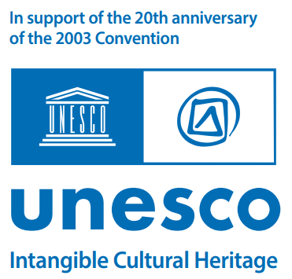 | 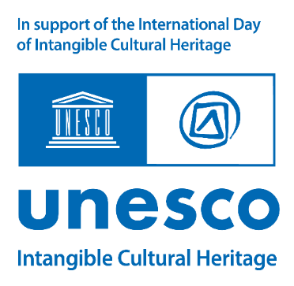
- These ‘in support of’ logos for the above-mentioned initiatives were made available with reference to the Graphical Standards and Logo Toolkit (issued in 2021 to complement 34C/Resolution 86), which indicates that ‘when an external entity or brand wishes to undertake its own activity to support a UNESCO initiative, it can use the UNESCO logo block after having obtained permission from the Secretariat. However, it must add a phrase as defined by the Secretariat, such as ‘in support of UNESCO’. The ‘in support of’ logo, as the name suggests, allows the entities authorized to use it to express their support to the 2003 Convention’s programmes and activities. It does not suggest UNESCO’s endorsement on activities covered by the logo. Furthermore, it should not be used for obtaining commercial or financial gains.
Ways forward
- Based on the abovementioned experiences, the Bureau may wish to encourage the Secretariat to further explore the conditions for the permanent use of the emblem of the Convention by communities, groups and, if applicable, individuals wishing to undertake programmes and activities to safeguard and promote their cultural heritage, particularly those inscribed on the Urgent Safeguarding List or the Representative List and in the sense of paragraphs 133 and 139 of the Operational Directives of the Convention. Such an initiative would provide an opportunity to benefit from lessons learnt from other UNESCO conventions and programmes in the field of culture and beyond.
- The Bureau of the Intergovernmental Committee may wish to adopt the following decision:
DRAFT DECISION 19.COM 3.BUR 6
The Bureau,
- Having examined document LHE/24/19.COM 3.BUR/6,
- Recalling 34C/Resolution 86 and the Graphical Standards and Logo Toolkit (2021) as well as sub-chapter IV (especially paragraphs 133 and 139) of the Operational Directives,
- Further recalling Resolutions 2.GA 9.bis, 9.GA 13 and 10.GA 10, and Decisions 1.EXT.COM 8, 2.COM 13 and 7.COM 13.d,
- Taking note of regular requests from communities, groups and individuals wishing to use of the emblem of the Convention to safeguard and promote their intangible cultural heritage, particularly regarding elements inscribed on the Urgent Safeguarding List or the Representative List,
- Considers that the experiences gained through the communication campaigns undertaken in the framework of the Convention’s twentieth anniversary in 2023 and the first International Day of Intangible Cultural Heritage provide valuable examples of ‘in support of’ logos that include the emblem of the Convention;
- Encourages the Secretariat to further explore ways to enhance the accessibility of the emblem of the Convention and requests that progress on the matter be reported to a future meeting of the Bureau.

