CONVENTION FOR THE SAFEGUARDING OF THE
INTANGIBLE CULTURAL HERITAGE
Expert meeting on economic dimensions of
intangible cultural heritage safeguarding
27 – 28 September 2023 (Part I)
UNESCO Headquarters, Paris
20 October 2023 (Part II)
Online
Survey methodology and overview of results

Introduction
This survey was conducted in late 2022 in the course of developing a Guidance Note for communities, and States Parties requested by the Committee of the UNESCO 2003 Convention for the Safeguarding of the Intangible Cultural Heritage, concerning ‘the safeguarding measures and good practices that address the risk of decontextualization and over-commercialization of elements’ of intangible cultural heritage. The aim of the survey was to collect opinions, experiences and examples relating to economic aspects of intangible cultural heritage safeguarding. This information was used to supplement and inform desk research and case study development for the Guidance Note.

About the survey and its respondents
The survey was designed by Harriet Deacon (the author of this report) with the assistance of the Peer Review Panel, a geographically balanced group of experts from different disciplines and backgrounds. It had a total of 21 questions, organized in four sections. The first section concerned the respondent themselves (background, gender, region, country), the second and third sections on positive and negative effects of economic factors on intangible cultural heritage safeguarding and sustainable development, and the final section about mitigations of possible negative effects.
The survey was sent by the Secretariat to the following email addresses:
- States Parties: 233 email addresses
- Focal points of elements inscribed on the Lists and programmes selected for the Register of the Convention: 611 email addresses
- Accredited NGOs: 433 email addresses
- UNESCO Category 2 Centres: 47 email addresses
Just over 150 responses (n=151) were collected between 27 September and 17 November 2022. Excluding around 150 addresses that were not operational (predominantly among the focal points of inscribed elements) from the 1,324 email addresses to which the survey was sent, this represents about a 13% response rate. This level of response is considered acceptable, although not high, in the analysis of survey instruments. One of the reasons for low response rate might be the length or complexity of the survey, since the average time of completion was 69 minutes. However, this may be because the respondents left the survey tab open while they were performing other tasks. The estimate from the survey tool was 9 minutes, and the estimate from the research team was 20 minutes.
In Question 1, respondents to the survey identified themselves, allowing for multiple designations (Figure 1). About one fifth of the respondents (31 out of 151, or 21%) described themselves as bearers of intangible cultural heritage; slightly fewer described themselves as focal points of inscribed elements or as researchers. About a quarter (40 out of 151, or 26%) described themselves as representatives of NGOs and two fifths (63 out of 151, or 42%) said they were government officials or employees.

Figure 1: Identification of respondents in survey
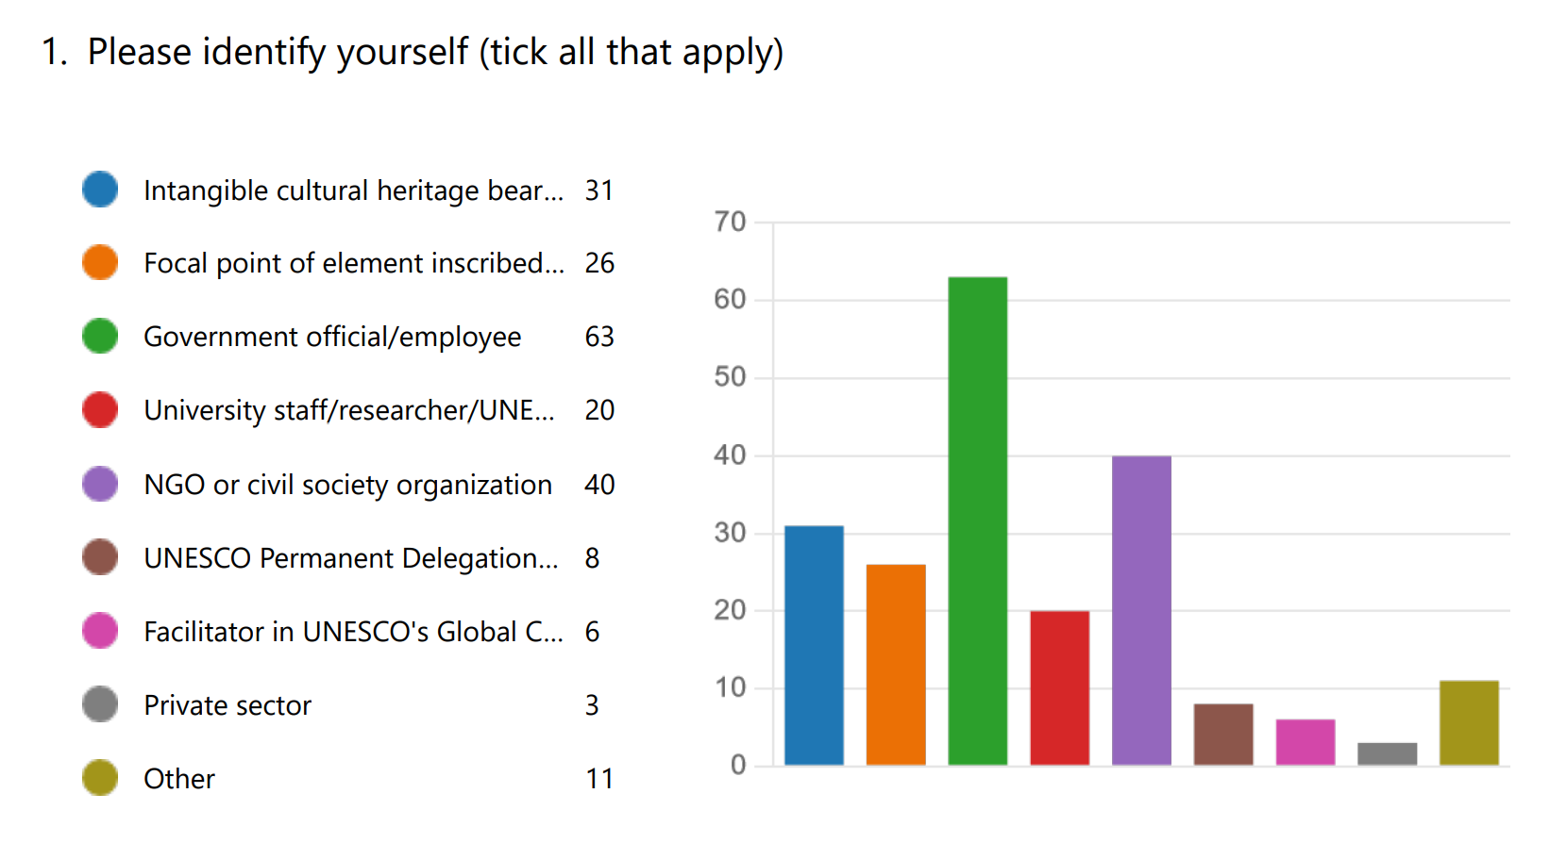
Slightly more of the respondents were women (83 out of 151, or 55%) than men (62 out of 151, or 41%). Two respondents said either they were non-binary or preferred not to give their gender.
There were some regional imbalances among respondents. About half the number of responses were received from Africa and the Arab States than other regions. This may partly be because Africa and the Arab States remain somewhat under-represented both among accredited NGOs and inscribed elements or selected safeguarding programmes, and thus the survey was probably sent to fewer addresses in these regions. China was the country most strongly represented among survey respondents, with 13% of all responses.

Figure 2: Regional focus of the work of respondents
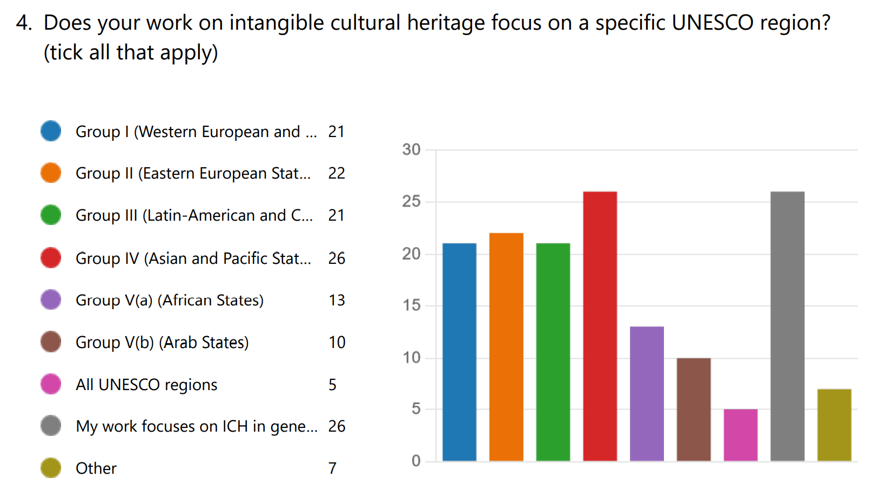

Analysis of survey responses

Positive and negative effects of economic activities: general comments
In general, respondents felt that economic activities contributed positively to intangible cultural heritage safeguarding and sustainable development, but were somewhat more optimistic about its contribution to sustainable development (average rating 3.86) than to safeguarding (average rating 3.74). Respondents said that the frequency with which negative effects impacted safeguarding and sustainable development was in general lower, with an average rating of 2.61 and 2.56 respectively.

Figure 3: Responses to Questions 6 (on left) and 7 (on right), about frequency with which economic activities contributed positively to intangible cultural heritage safeguarding and sustainable development respectively.
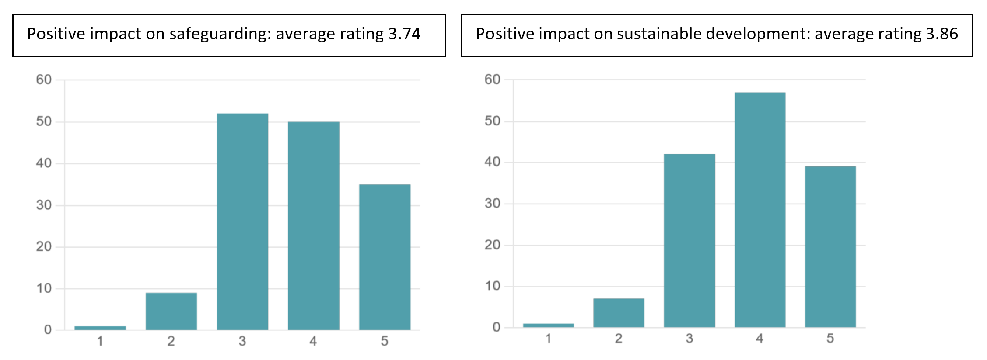

Figure 4: Responses to Questions 12 (on left) and 13 (on right), about frequency with which economic activities contributed negatively to intangible cultural heritage safeguarding and sustainable development respectively.

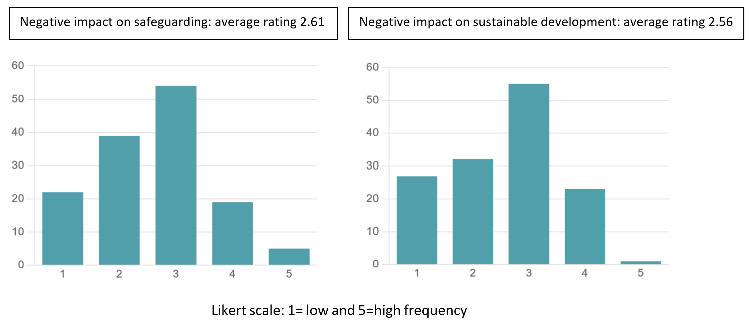
Thus, survey respondents considered negative effects of economic activities on both safeguarding and sustainable development to be less frequent on the whole than positive effects. However, they felt that safeguarding is somewhat more likely than sustainable development to be affected negatively by economic activities.
In the framework of activities under the Convention, as the review of Committee decisions has shown, concerns about avoiding negative effects of economic activities (such as over-commercialization and decontextualization) have to date been much more widely discussed (mainly in regard to inscriptions) than efforts to harness positive effects of economic activities for safeguarding and sustainable development. Where positive effects of economic activities are identified, this is often mainly in regard to sustainable economic development of local communities. There has been less discussion about the possible positive effects of economic activities on the meaning and value, and practice and transmission, of the intangible cultural heritage itself.
The survey responses suggest that more attention should be paid to identifying and supporting possible positive effects of economic activities on intangible cultural heritage safeguarding and sustainable development, not just because communities, groups and individuals can benefit economically, but because safeguarding itself can benefit from economic engagement in a number of different ways.

Identification of specific cases of positive and negative effects
The survey asked respondents to give specific examples in which economic activities had had positive or negative effects when linked to intangible cultural heritage, and then asked respondents to categorize these effects, and the stakeholders involved, in that particular case. These examples are of course not representative, but they may be considered illustrative, and can cast more light on specific avenues through which benefits can be gained from economic activity relating to intangible cultural heritage.
The main specific positive effect identified by the chosen examples was enhanced value and meaning to the communities concerned (108 out of 140 responses, or 77%). Other positive effects that were specifically mentioned most frequently clustered in two groups: positive effects on practice and transmission (such as increased practice of the element, improved transmission, heritage-sensitive innovation, maintenance or enhancement of repertoire), and sustainable economic development effects for communities (e.g. income generation for communities, improved community living standards, decent work). Higher social cohesion was mentioned by about half (76 out of 140, or 54%) of respondents. Respondents noted relatively few examples of positive environmental benefits, or reduced conflict, from economic activities. However, one fifth of respondents chose ‘all of the above’ positive effects, indicating general benefit from economic activities (these tallies were not included in the statistics discussed above).
For example, in Armenia, the program "Arar; safeguarding, dissemination, and popularisation of national culture in the marzes of the Republic of Armenia" involved public-private cooperation and a singer to support local bearers teaching a wide range of ICH skills (including traditional song and dance, fine arts, rug making, carpet weaving, lace-making and embroidery, pottery, art processing of stone, wood, and metal, and khachkar-making) by setting up free courses for local people. As a result of the program, participants have learned heritage skills (contributing to safeguarding) and established local businesses (contributing to the sustainable economic development of the community). Similar programmes were reported in countries such as Türkiye (see case study on One Master, Thousand Masters), and Palestine.
Earning money from ICH practice can raise practitioner status in society, and increase the popularity of the practice with new groups of practitioners, including young people. The martial dance known as raibeshe, lathikhela, or binoti in Bangladesh, using the bamboo staff as a weapon of both defence and offense, has been traditionally practised by men and boys, and not by women and girls. The Cholo Lathi Kheli project actively supported the teaching of the martial art to young girls and has now enabled them to make substantial earnings through commercial performances all over the country. Some girls have relocated to the city and conduct workshops for various groups there. The success of public performances has raised the status of women performers. In Brazil, better online marketing raised the status of musician instrument makers. In Syria, the income generated by shadow play puppeteers encouraged new practitioners to learn the craft.
The survey also asked respondents to give examples of negative effects of economic activity on intangible cultural heritage safeguarding. In the survey responses, most respondents referred to misrepresentation, decontextualization, over-commercialization, loss of value and meaning to communities, and misappropriation (see Table 1 below).
Other examples showed that third party commercial activity may also have direct negative influences on ICH elements themselves. Misrepresentation may directly affect ICH practised within the community, for example, leading to loss of meaning or reputation. Lack of community involvement or consent for market engagement around their ICH was often associated with negative outcomes for safeguarding and sustainable development. In Mexico, the traditional Feast of January in Chiapa de Corzo is linked to a trade fair managed by the private sector and by the local authority, without community participation. This has had a negative impact on the development of the ritual cycle around the festivity. The central figure of the feast, the Parachicos, has been represented differently for tourists, and a researcher has attempted to register intellectual property rights associated with the steps of the ritual dance. Loss of community control over the use of their ICH in the market may also arise when regulations require specific training or production specifications to be followed. This has affected traditional cheese-making in Europe and elsewhere. In Switzerland, standardization of training courses for watchmakers has led to the exclusion of certain traditional mechanical skills and techniques (e.g. engine-turning, which is a manual decorative finishing technique for watchmaking parts).
Misappropriation (and inequitable benefit arising from that) is clearly a problem in some cases. One respondent suggested that third party actions such as misappropriation may create new ‘hybrid’ forms of ICH, distinct from those practised by the community. Where adequately differentiated, factory-made or tourist versions and more traditional ICH-related products and services can co-exist without directly harming an element, for example in regard to the Voladores performances specifically tailored for tourists. However, mitigations need to be in place to ensure that the ritual aspects of the ceremony are not lost. Third party actions are not the only ones to affect ICH. Community members may of course also engage in activities that have negative effects on their ICH, and there may be disagreements within a community about the economic strategies to be adopted in regard to their ICH.
From a safeguarding perspective, it is important to understand the way the economic context affects practice and transmission. As one survey respondent (from Germany) noted, not taking economic aspects of ICH practices such as traditional craftsmanship into account in safeguarding work is itself a form of decontextualization, in which museums or training agencies can take over the role of practice and transmission from the expert bearers, freezing traditions and trivializing their skills.
Gentrification can price local people out of the market. In Togo, in areas where traditional festivals take place, housing prices and food prices have increased. Ready availability and cheaper pricing of factory-made products can also undermine the market for handmade products. Increased demand for ICH-related practice may stimulate non-community members to offer products or services, perhaps leading to professionalization. Market demand may encourage changes in products and services linked to ICH. In Latvia, the repertoire of Suiti performances has been simplified to accommodate tourists. Increased production could lead to loss of meaning and value if methods or materials are modernized, but also to associated environmental degradation if natural source materials are not changed, as in the case of forests in Albania and woodcarving traditions. There may be an opportunity cost of focusing on certain elements or aspects of ICH practice and transmission that are commercially attractive, and neglecting others that are not. For example, one respondent in Hungary mentioned ‘Reduced use of traditional forms and motifs in a pottery tradition, to favour those that are in line with public taste, in order to sell the product’. In Sri Lanka, reduced local demand for Rukada Natya (Traditional String Puppet drama) discouraged investment and other economic activities to promote it. Under-remuneration for ICH-related practice may discourage younger people from taking it up, as in the case of Jamdani weaving in Bangladesh.
The main positive and negative effects associated with the examples could be summarized as follows:

Table 1: Positive and negative effects of economic activity associated with ICH mentioned in the survey examples

Impact category | Kind of impact | Positive (number of mentions) | Negative (number of mentions)
Impacts on ICH meaning, practice and transmission | Effects on context of practice | n/a/ (not asked) | 200  - 68 decontextualization  - 62 over-commercialization  - 43 theatrification / staging  - 27 professionalization
 | Effects on ICH practice and transmission | 307  - 93 increased practice  - 81 improved transmission  - 71 heritage-sensitive innovation  - 62 improved repertoire | 185  - 54 inappropriate new materials  - 40 reduced repertoire  - 37 shortage of materials / loss of spaces  - 35 decreased transmission  - 19 freezing
 | Effects on ICH meaning and value | 108  - 108 enhanced meaning and value | 135  - 60 loss of value and meaning  - 75 misrepresentation
Impacts on communities and their environment | Economic impacts on communities and practitioners | 253  - 99 income generation  - 82 better living standards  - 72 decent work | 150  - 51 inequitable benefit  - 47 insufficient remuneration  - 28 degraded working conditions  - 24 lower living standards
 | Socio-cultural impacts on communities | 111  - 76 increased social cohesion  - 35 reduced conflict | 72  - 44 increased conflict  - 28 reduced social cohesion
 | Environmental impacts | 39  - 39 reduced environmental degradation | 36  - 36 negative environmental impacts
All of the above impacts |  | 28 responses | 8 responses

Stakeholders
In the examples of positive effects linked to economic activity, communities, groups and individuals concerned were the most frequently mentioned stakeholders, in almost all cases (132 out of 144). As the Convention confirms in its texts, communities concerned are not ordinary stakeholders, but bearers and practitioners who identify with, and are responsible for defining, practising and transmitting their ICH. They have the primary role in safeguarding their ICH, third party use should be subject to their consent, and they deserve to benefit (even economically) from its use, according to the Ethical Principles. Some communities position themselves even more strongly as rightsholders over their ICH from an ethical and/or human or indigenous rights perspective, although conventional intellectual property rights do not generally cover ICH. This approach seems to be supported by the 2022 Mondiacult Declaration in which Ministers of Culture of the Member States of UNESCO committed to ‘implementing legal and public policy frameworks that uphold the rights of peoples and communities to their cultural identity and heritage, including the expressions of the cultures of indigenous peoples’. However, this wording (following UNDRIP), while supporting existing rights, does not necessarily imply conferring new rights on indigenous peoples or other communities in regard to their ICH. This is consistent with the Convention, which does not confer any additional intellectual property rights on communities in regard to their ICH (in line with article 3(b)).
The second most common stakeholders mentioned in the survey (regarding both positive and negative effects) were private sector actors, and then civil society or NGO actors, followed by state agencies and researchers. It is difficult to draw inferences from the priority given to private sector actors in these examples, of course. However, given the low frequency with which private sector actors are generally discussed in regard to positive effects of economic activity in, for example, nomination files or indeed the Periodic Reports analyzed to date from Groups I-III, this suggests a need for further research on how private sector engagement can benefit communities and intangible heritage safeguarding.

Figure 5: Description of stakeholders involved in example of positive (on left) and negative (on right) effects of economic activity relating to intangible cultural heritage (Question 10, n=144; Question 16, n=129)
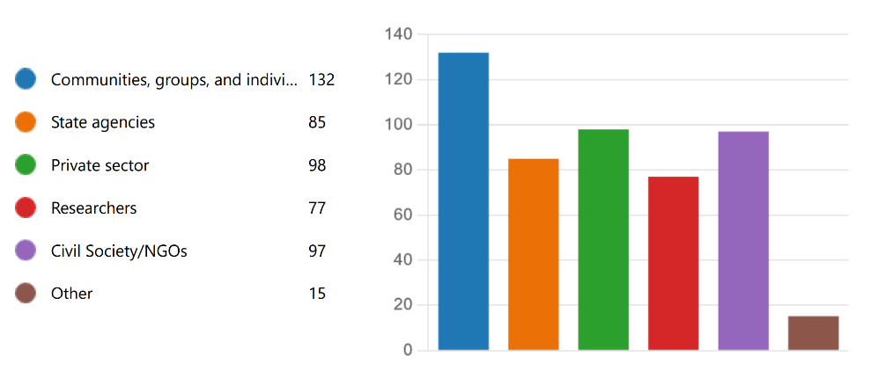
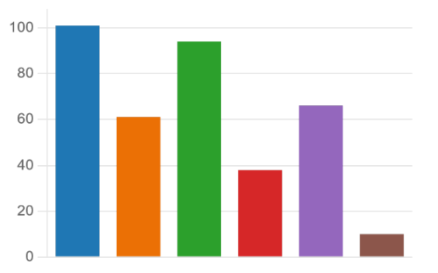

Mitigations in regard to economic activities
Survey respondents were optimistic about the possibility to develop effective mitigations when economic activities have negative effects on ICH safeguarding and sustainable development.

Figure 6: Possibility to develop effective mitigations when economic activities have negative effects on ICH safeguarding and sustainable development (Question 21; 3.93 average rating; 1= never and 5 = always)
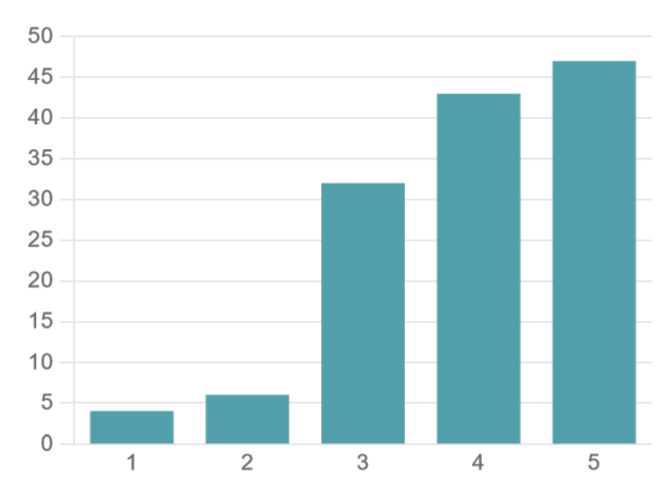
Kinds of mitigations mentioned in the survey included community projects and financial, educational, practical and other kinds of support to communities from governments, NGOs, experts and institutions such as museums or public private partnerships to identify and mitigate challenges and provide general safeguarding or business assistance.
The activities mentioned included:
- Community-led planning, organization and support for safeguarding actions
- Documentation of the ICH and reflection on its economic context
- Awareness-raising about the value of ICH among practitioners and consumers
- Capacity building on business skills (intellectual property rights, marketing, etc.) and on safeguarding measures
- Subsidies, grants and prizes for practitioners and their students, both for the acquisition of ICH-related skills and for related business establishment and management
- Provision of better access to markets, online and in person, including support for market spaces and platforms
- Organization of events promoting traditional skills and workshops, including festivals and other promotional events
- Certification or intellectual property protection for products or services
- Tourism promotion and other forms of regional development programming that incorporates ICH
- Media, legal or other measures to expose and address misappropriation or misrepresentation
Some of these mitigations are primarily promotional: safeguarding in the context of economic use of ICH, for example, ensuring that its context, meaning and value is maintained and communicated to consumers or visitors. Other mitigations are protective: ensuring that practitioners and communities benefit equitably from this economic exploitation, and are protected from third party misuse of their heritage. Both kinds of mitigations are important, but the balance and focus of actions depends of course on community needs and the context.
What kinds of mitigations were most effective? Survey respondents were particularly convinced about the effectiveness of community-led initiatives, and a focus on social meaning and value.

Figure 7: Factors increasing the effectiveness of initiatives that helped to maximize benefits and/or minimize negative impacts of economic activities for intangible cultural heritage safeguarding and sustainable development (Question 20, n=120)
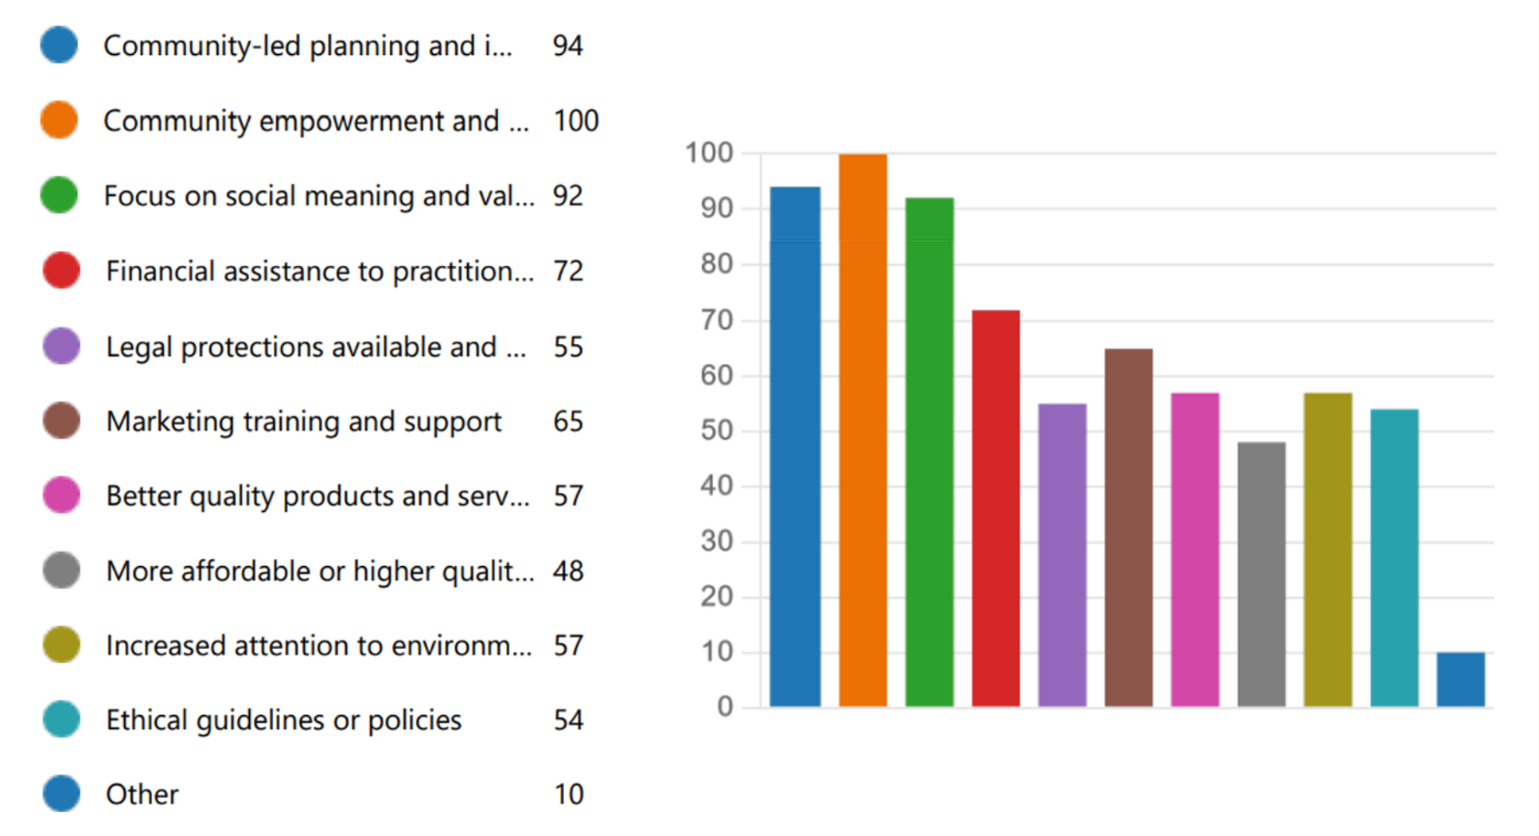
What examples of mitigations were mentioned?
- Initiatives such as Journées européennes des métiers d'art (JEMA) or European Artistic Crafts Days (EACD) in Germany and the "Days of Potters" in Rezekne city, Latvia, provide opportunities for craftspeople to demonstrate their work at the workshops, offering products for sale and encouraging young and old to appreciate the opportunities of craft work as a career, as well as raising awareness of the value of the heritage from the perspective of the practitioner.
- In Czechia, the Crystal Valley project provides a platform for storytelling about the craft as well as linking glass makers with visitors, and potential customers.
- In India, Art for Life and the HIPAMS project provided support to artists in rural villages to develop businesses based on traditional skills, organize effectively as communities, take control of their own marketing, communicate heritage meaning and value, and to understand and better protect their rights as artists.
- In Palestine, the Anata Cultural Center inaugurated an open training project about Palestinian mosaics and traditional handicraft. The two-day project took place in Dar al-Nadwa headquarters in Bethlehem and aimed to improve vocational training and support for self-employment in these areas. The session included the exhibition of training products and the works of traditional industries.
- In Spain, the EnTre2 plan for safeguarding folk embroidery of the Sierra de Francia in Salamanca, designed by the NGO Red Arrayán de Cultura, Patrimonio y Medio Ambiente and the town hall of Mogarraz, combines promoting practice and transmission of the art, encouraging appropriate innovations and integrating the heritage into local tourism.
- In China, the national intangible cultural heritage project Jun porcelain firing technology, based on traditional handicraft production, actively uses online and offline platforms to promote, promote and sell Jun porcelain products, drive the development of Jun porcelain industry, cultivate a large number of Jun porcelain inheritors, and play a positive role in promoting the inheritance and development of Jun porcelain.
- In 2022 in Ghana, the National Folklore Board worked with a non-profit called Dandelion Ghana to organize a seven day food heritage festival, Asanka Intercultural Food Festival. Activities at the festival included daily workshops and a Camp Independence meeting for artists. The Ministry of Tourism, Arts and Culture awards grants to folklore industry players. The
National Folklore Board started a capacity building programme for bearers/practitioners at regional level, raised awareness in the media about use of folklore in the economic sphere and initiated legislation (the Goods and Services Act) to regulate the users of Folklore expressions.
- In Brazil, the Fruit House Project in Santa Izabel developed products for local markets from food produced in the traditional farms of indigenous communities in Alto Rio Negro. The purpose was not only to generate income for community members, but also to value the traditional ways of food production maintained for centuries by indigenous communities right in the midst of the Amazon rainforest. The project generated income from the sustainable production and processing of traditional food, assisted in the valorization and dissemination of local agricultural biodiversity and the importance of the traditional agricultural system of indigenous groups in the region for the conservation of local biodiversity. The initiative strengthens and develops the local economy and positively impacts the perception of the surrounding society about indigenous groups, helping to overcome prejudices and to improve bearers’ self-esteem.
- The Sámi Parliament in Finland adopted Principles for Responsible and Ethically Sustainable Sámi Tourism in 2018. The primary purpose of these ethical guidelines is to terminate tourism exploiting Sámi culture and to eliminate incorrect information about the Sámi distributed through tourism. The second priority is to safeguard the cultural practices and traditions of Sámi people outside the travel industry. The Sámi community also have a number of other initiatives for promoting and protecting Sámi culture in the economic sphere (see Case Studies).
- In Mexico, the Impacto NGO has helped to create ethical guidelines for a healthy collaboration with artisans; empowering artisans to form collectives that, on the one hand, improve the quality of their products to allow them to reach new markets and benefit from marketing tools; while at the same time, fostering spaces to transmit ICH knowledge, skills and techniques to new generations.
- IPHAN (a government agency) in Brazil provided assistance to the Wajãpi indigenous communities from Amapá to address misappropriation of their body art graphics for use on home wallpaper by a decoration company. Reparations by the company included stopping production, destroying stocks of the wallpaper and contributions towards a community project.
- In Colombia in 2016, the Ministry of Culture and the Raizal community of San Andrés Island developed a safeguarding process of traditional Raizal cuisine, based on community led documentation activities. This helped to reduce the impact of over-commercialization of the traditional knowledge for tourism.
- In Nigeria, mitigations against negative effects of increased tourism at the Osun Oshogbo festival include a buffer zone to protect the forests and the animals who inhabit them. Forest guards manage access to the buffer zone. The Osun Priestesses are formed into a guild which also helps control access to the river during the festival.

This document was prepared by the consultant Harriet Deacon, in collaboration with the UNESCO Living Heritage Entity and with inputs from the Peer Review Panel on economic aspects of intangible cultural heritage safeguarding. It is presented as a preliminary draft for the purpose of discussion and review. The content does not necessarily reflect the institutional views of UNESCO and is subject to revisions based on peer feedback.
Decision 14.COM 10 para. 14.
Full set of options available in the Annex 2, Survey Text.
Full set of options available in the Annex 2, Survey Text.
The desk review and analysis of Committee decisions were used to create the categories for these questions.
See https://english.pnn.ps/news/32527
See https://www.theindependentbd.com/magazine/details/125036/Lathi-Khela-With-A-Message
See http://crespial.org/iphan-lanca-campanha-fomento-ao-patrimonio-cultural-imaterial/
See https://textilefocus.com/the-glorious-fabric-of-bengal-jamdani/
For example, The Norwegian National Human Rights Institution and the Sámi Parliament in Norway, Webinar 5 May 2022, ‘Human Rights Protection against Interference in Traditional Sami Areas’. See https://www.nhri.no/en/kalender/human-rights-protection-against-interference-in-traditional-sami-areas-iccpr-article-27-in-a-sami-context/
Mondiacult Declaration, accessed at https://www.unesco.org/sites/default/files/medias/fichiers/2022/10/6.MONDIACULT_EN_DRAFT%20FINAL%20DECLARATION_FINAL 1.pdf.
See Analysis of Periodic Reports from Latin America and the Caribbean and from Europe at 17.COM.
See also https://rezekne.lv/2022/04/14/latgales-podnieku-dienas/
See https://www.samediggi.fi/ethical-guidelines-for-sami-tourism/?lang=en
See http://patrimonio.mincultura.gov.co/SiteAssets/Paginas/Publicaciones-biblioteca-cocinas/Libro%20San%20Andre%CC%81s%20bajas.pdf.

