CONVENTION FOR THE SAFEGUARDING OF THE
INTANGIBLE CULTURAL HERITAGE
INTERGOVERNMENTAL COMMITTEE FOR THE
SAFEGUARDING OF THE INTANGIBLE CULTURAL HERITAGE
Eighteenth session
Kasane, Republic of Botswana
4 to 9 December 2023
General information

The information presented in this document is provided by the host country, unless otherwise stated.
Table of Contents
1. EIGHTEENTH SESSION 3
2. HOST COUNTRY CONTACTS 3
3. VENUE AND SESSIONS 4
3.1. Venue 4
3.2. Registration 4
3.3. Sessions 4
3.4. Opening ceremony 4
3.5. Side events 5
3.6. Interpretation 5
3.7. Documentation 5
3.8. Security badges 5
3.9. Internet and computer area 5
3.10. Meals 5
4. ACCOMMODATION 5
5. VISA AND TRAVEL INFORMATION 6
5.1. Visa 6
5.2. Flights, getting to Kasane and airport transfers 6
5.3. Local travel 7
6. MEDIA 7
6.1. Media Centre 7
6.2. Press conference 7
6.3. Image rights 7
7. PRACTICAL INFORMATION 7
7.1. Climate 7
7.2. Banking services and value added tax (VAT) 7
7.3. Electricity supply 7
7.4. Time zone 7
7.5. Medical information 8
7.5.1. Insurance and medical services 8
7.5.2. Vaccines and health-related measures 8
7.5.3. Doctor on call 8
7.5.4. Water 8
7.5.5. Important contact numbers 8
7.6. Security 9
7.7. Tourism 9
ANNEX A: Registration form 10
ANNEX B: List of countries and territories which do not require a visa for entry into Botswana 11
- EIGHTEENTH SESSION
Hosted by the Republic of Botswana, the eighteenth session of the Intergovernmental Committee for the Safeguarding of the Intangible Cultural Heritage will be held at the Cresta Mowana Resort, Kasane, from 4 December to 9 December 2023.
All relevant information is also available at the following address: https://ich.unesco.org/en/18com.
The Intergovernmental Committee for the Safeguarding of the Intangible Cultural Heritage is composed of twenty-four representatives of the States Parties to the Convention for the Safeguarding of the Intangible Cultural Heritage, elected by the General Assembly of the States Parties to the Convention.
The current composition of the Committee is:
- Electoral Group I (North America and Western Europe): Germany, Sweden, Switzerland.
- Electoral Group II (Eastern Europe): Czechia, Slovakia, Uzbekistan.
- Electoral Group III (Latin America and the Caribbean): Brazil, Panama, Paraguay, Peru.
- Electoral Group IV (Asia and the Pacific): Bangladesh, India, Malaysia, Republic of Korea, Viet Nam.
- Electoral Group V(a) (Africa): Angola, Botswana, Burkina Faso, Côte d’Ivoire, Ethiopia, Rwanda.
- Electoral Group V(b) (Arab States): Mauritania, Morocco, Saudi Arabia.
The elected members of the Bureau of the eighteenth session of the Committee are:
Chairperson:
H.E. Mr Mustaq Moorad
Ambassador Extraordinary and Plenipotentiary to France, Permanent Delegate of the Republic of Botswana to UNESCO, Botswana
Vice-Chairpersons:
Switzerland, Slovakia, Peru, Bangladesh, Morocco
Rapporteur:
Ms Eva Kuminkova, Czechia
- HOST COUNTRY CONTACTS

General information (except visa inquiries)
- Kindly direct your general inquiries to the following contact address:
Email: Infor.18.com@gmail.com

Ms Obenne H. Mbaakanyi
Director, Cultural and Creative Sector Development
National Arts Council of Botswana
Tel: +267 72892448
Email: Coordinator.18com@gmail.com
For visa issues
- Mr Oteng Arthur Ketshabile
First Secretary
Permanent Delegation of Botswana to UNESCO
Tel: +33 141 31 31 00
Email: botfra@gov.bw

- Ms Thatayaone Sethembeni
Department of immigration of Botswana
Tel: +267 71233439 / +267 72691853
Email: tsethembeni@gov.bw
- VENUE AND SESSIONS
  - Venue
The session will take place at the Cresta Mowana Resort, Kasane.
Address: Plot 2239 President Avenue, Kasane, Republic of Botswana
Phone: +267 625 0300
Email: resmowana@cresta.co.bw
Website: https://www.crestahotels.com/hotels/botswana/cresta-mowana-safari
  - Registration
The main participants are the twenty-four members of the Committee. All participants, delegates, observers, and those wishing to attend the session are invited to register as early as possible, to give the organizers time to process all information and prepare logistics before the opening of the session.
Please register online on the dedicated webpage: https://ich.unesco.org/en/registration-01317. Information to be provided as part of the registration process is included in Annex A. Upon validation of your registration, participants will be invited to send the following information to the host country contact address (Infor.18.com@gmail.com) in order for the host country to facilitate their arrival and stay in Kasane:
- Family name:
- Given/first name:
- Title and function:
- Flight details (arrival and departure dates with the flight number):
- Name of hotel booked:
  - Sessions
The Committee will meet every day from 9:30 to 12:30 p.m. and from 2:30 to 5:30 p.m. from Monday 4 to Saturday 9 December 2023. The provisional agenda and the timetable are available on the dedicated webpage of the Convention.
  - Opening ceremony
Registered participants, delegates and observers are invited on Sunday, 3 December 2023 to the opening ceremony, organized by the Ministry of Youth, Gender, Sport and Culture, which will take place at the Kazungula Bridge from 7:00 p.m. to 9:00 p.m. A free shuttle service will be provided between the venue and recommended hotels (see Section 4 for the list of recommended hotels).
- Shuttle bus timetable (Kasane time):
- Leaving the recommended hotels at 6:00 p.m.
- Leaving the venue at the end of the event.
Participants must obtain their 18.COM badge to access the venue of the opening ceremony (see section 3.8).
It will be a moment to share Botswana’s cultural expressions, as well as an occasion to experience Botswana’s hospitality. The opening ceremony will include performances featuring some of Botswana’s elements inscribed on the Lists of the 2003 Convention.
  - Side events
All side events are to be approved by UNESCO. The host country will provide space at Cresta Mowana Resort for these side events which will not take place at the same time as the plenary sessions.
Each space provided will have minimum technical and logistical equipment installed (audio-visual equipment, chairs, and tables). The organizers must make the necessary arrangements to provide any additional services it requires.
Requests with specific requirements must be sent to the Secretariat of the 2003 Convention by sending the side events request form, no later than 20 November 2023, to ichmeetings@unesco.org. The calendar of events of the meeting, including side events, is available from the dedicated webpage: https://ich.unesco.org/en/calendar-of-events-01328.
  - Interpretation
Simultaneous interpretation will be provided in the following languages for the plenary sessions: English, French and Spanish.
  - Documentation
For environmental reasons and in order to limit costs, hard copies of documents will only be provided on request. All documents of the session will be published on the dedicated webpage of the Convention. Participants are invited to bring their laptops to consult them.
  - Security badges
Badges will be issued to all delegates and observers at the registration desk. Participants must wear their badges at all times. Only people with badges can access the site. Please note that luggage (travel bags) is not allowed inside the venue.

A 18.COM badge is required to attend all events held as part of the eighteenth session of the Committee, including the opening ceremony on Sunday, 3 December 2023.
Participants are encouraged to collect their badge at the entrance of the Cresta Mowana Resort as soon as possible upon their arrival. Registration will be open between 8:00 a.m. and 6:00 p.m. from 1 December to 9 December 2023.
Badges are personal and non-transferable. Proof of identity will be requested when collecting your badge. In order to facilitate the process, please complete first your online registration as soon as possible through the above-mentioned link.
  - Internet and computer area
Free Wi-Fi will be provided at the venue. Connection information (login and password) will be provided onsite.
An area outside the plenary room will be provided for delegates during the session, with computers, internet access and printers.
Technical staff will be present to assist them.
  - Meals
A food court will be set up at the venue, where a reasonably priced lunch will be available. Refreshments will be available throughout the day. Catering is at the expense of the participants.
A restaurant will be put at the disposal of Committee members and the catering costs will be covered by the host country for the Heads of Delegations of States Members of the Committee.
- ACCOMMODATION
Participants are responsible for booking their own accommodation and for all expenses incurred during their stay in Botswana. Participants are encouraged to book their accommodation as soon as possible by contacting one of the following travel agents identified by the host country:
- No.1 Lady Travel Agency
Phone: +267 71 265 521
Email: Jchika1961@gmail.com
- Double Tracks Africa
Phone: +267 73 223 925
Email: travel@doubletracksafrica.com
- Iswiza Tours and Safaris
Phone: +267 71 368 350
Email: iswizatours@btcmail.co.bw
The list of designated hotels is available through the following link:
https://ich.unesco.org/doc/src/60848-EN.pdf.
Information regarding transportation between the designated hotels and the venue is provided in Section 5.3 of this document.
- VISA AND TRAVEL INFORMATION
  - Visa
Participants are invited to contact the relevant embassies, consulates, or travel agents for visa requirements before their departure. Visas can be obtained at entry points for both tourist and business purposes after receiving an acceptance letter from the following website: http://evisa.gov.bw/#/.
The list of countries whose nationals are exempt from visa requirements for entry into Botswana is provided in Annex B.
Members of the press must apply for a short-stay visa by contacting the host country through the following address: media.18.com@gmail.com.
  - Getting to Kasane and airport transfers
Kasane can be accessed through the following international airports:
- Kasane International Airport (Botswana, 8 km from 18.COM venue)
- Livingstone Airport (Zambia, 80 km from 18.COM venue)
- Victoria Falls Airport (Zimbabwe, 100 km from 18.COM venue)
Participants experiencing issues to book their flights to Kasane – in particular for the leg between Johannesburg and Kasane – are invited to contact the Permanent Delegation of the Republic of Botswana to UNESCO (dl.botswana@unesco-delegations.org) and the Host Country Team (ombaakanyi@nacb.co.bw).
A shuttle service will be provided from the airports to the hotel (on 2 – 5 December 2023) and from the hotel to the airports (on 8 –12 December 2023) only for participants staying at the recommended hotels. For any inquiries regarding airport transfers, please contact Mr Bopelo Gaothusi at the following phone number: +267 75490900.
- Airport transfers – Committee members (Heads of Delegations)
The host country will provide a free car service with driver for the Heads of Delegation of Committee members upon arrival in Kasane, Botswana until departure. Please indicate your arrival and departure times by e-mail to: Protocol.18.com@gmail.com.
- Airport transfers – Committee members (other members of the Delegation)
A free shuttle service will be provided between all three abovementioned airports and recommended hotels. The schedule of shuttle buses will be aligned to the arrival times of flights at these airports.
- Airport transfers – Other participants
A free shuttle service will be provided between all three abovementioned airports and recommended hotels. The schedule of shuttle buses will be aligned to the arrival times of flights at these airports.
  - Local travel
A free shuttle service will be provided between the venue and recommended hotels (see Section 4 for the list of recommended hotels):
- Shuttle availability dates: 03/12/2023 to 09/12/2023
- Shuttle bus timetable (Kasane time):
- Early shuttles at 7:30 a.m. and 8:00 a.m.
- Every twenty minutes from 8:30 a.m. to 10:00 a.m.
- Every hour from 10:00 a.m. and 5:00 p.m.
- Every twenty minutes from 5:00 p.m. to 7:00 p.m.
- Every hour from 7:00 p.m. and 9:00 p.m.
An information desk will be available in each of the recommended hotels to direct you to your shuttle or for any further information.
  - Media Centre
A media centre will be provided for the coverage of the eighteenth session of the Committee. Media will also have access to Internet and a fax machine.
  - Press conference
A press conference is planned to be organized on 4 December 2023. Only registered media will have access to this event. For any enquiries, please contact Mr Thomas Mallard, UNESCO (t.mallard@unesco.org).
  - Image rights
Participants will be recorded and photographed during the event. Through their participation and registration, participants authorize the use of their image for communication and broadcast purposes of the event.
- PRACTICAL INFORMATION
  - Climate
December to March is the summer season in Kasane with high temperatures averaging 30 to 35 degrees Celsius and lows around 18 degrees Celsius. Rainfall can be expected during this season.
  - Banking services and value added tax (VAT)
The official currency is Pula (meaning ‘rain’ in Setswana language); one Pula (1 BWP) is divided into 100 thebe. 100 BWP = 7.3 USD approximately. Foreign exchange services are available at the airports, commercial banks, bureaux de change and authorized hotels. US dollar, Euro, British Pound, and South African Rand are the most easily convertible currencies.
Banking hours are usually from 8:30 a.m. to 3:30 p.m. from Monday to Friday and 08:30 a.m. to 10:45 a.m. on Saturday. Your passport is required when making currency exchanges.
Major credit cards such as MasterCard and Visa, are accepted throughout the country, that is, in most hotels, restaurants, retail outlets and safari companies. However, shops in remote areas, service stations and cultural sites and community arts and craft outlets usually only accept cash.
  - Electricity supply
Electric current is 220/240 volts, 50 Hz. Type A, C and I power sockets can be used in Botswana; other types of power sockets will require an adapter.
  - Time zone
Botswana time zone is Central Africa Time (CAT), UTC/GMT+2.
  - Medical information
    - Insurance and medical services
It is essential for visitors to Botswana to have a comprehensive medical insurance policy, to provide coverage for the treatment of serious illness/accidents, and if required, medical evacuation. Personal effects insurance is also advisable. Participants are encouraged to check that their insurance policy will be accepted by service providers in Botswana.
In Botswana, hospitals require medical coverage, or cash payment in advance where medical coverage is not available. Paramedical services will be available at the 18.COM venue, while hotel receptions will also be able to direct you to the nearest medical facility or practitioner.
    - Vaccines and health-related measures
Participants travelling to Botswana from areas infected with yellow fever must have a valid Yellow Fever Vaccination Certificate. Otherwise, no other vaccinations are required. All participants are encouraged to check their personal health requirements prior to travel including concerning the need for booster vaccinations (tetanus, polio, diphtheria, hepatitis A). Furthermore, participants are advised to take the necessary precautions against HIV and AIDS and other sexually transmitted diseases.
Malaria, including cerebral malaria, is common in Northern Botswana, in the Okavango and Chobe areas, particularly during and immediately following the rainy season, from November to April. As the strains of malaria and the drugs used to combat them frequently change, and as certain strains can become drug resistant, it is best to seek medical advice before your departure and take any prescribed medication. Pregnant or very young children are not advised to travel to malarial areas. Other precautions are: to wear long sleeves, socks, closed shoes, generally keep the body covered, to sleep with a mosquito net, to use mosquito coils and repellents.
Due to the heat, preventive measures are highly recommended, these include wearing of wide-brimmed sun hats and sunglasses, liberally applying sunscreen every three or four hours, regularly taking rehydration mixtures, drinking plenty of water, avoiding prolonged exposure to the sun, as well as excessive amounts of alcohol, which causes dehydration.
    - Doctor on call
For health-related inquiries upon your arrival in Kasane, please contact:
Dr Kedisang Kanjane Boikanyo
(+267) 71752676
(+267) 6251249
    - Water
Botswana is a safe country in terms of health; however, it is advisable to be cautious about what you drink. Tap water throughout the country is usually safe to drink. Bottled mineral water is readily available in most shops, supermarkets, at camps and lodges. All those travelling by road are advised to carry sufficient water at all times.
    - Important contact numbers
Medical Rescue: 911
Ambulance Services: 997
Fire Services: 998
Police Services: 999
NB: All toll-free numbers can only be dialled from a local service provider’s SIM card.
  - Security
Botswana remains a relatively safe place to visit or live. However, participants are always advised to take normal precautions as they would take anywhere else:
- Always lock hotel rooms and car doors;
- Don’t leave valuables in cars or hotel rooms;
- Take care with your bags in shopping centres and other crowded places, and after coming out of banks or ATM kiosks;
- Avoid walking alone at night.
  - Tourism
For any relevant information on places to visit in Botswana, please consult: https://online.flipbuilder.com/lcha/mzas/mobile/index.html and for further information https://www.botswanatourism.co.bw/.

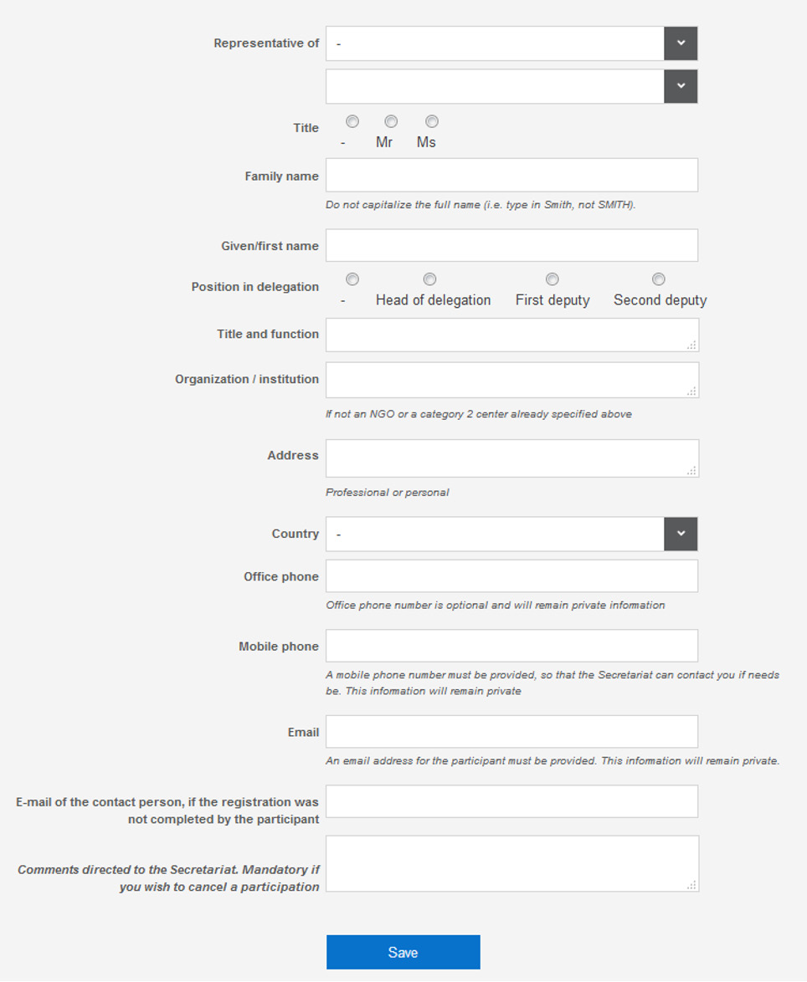
ANNEX A: Registration form

ANNEX B: List of countries and territories which do not require a visa for entry into Botswana

- Angola  - Antigua and Barbuda  - Argentina  - Australia  - Austria  - Bahamas  - Bahrain  - Barbados  - Belgium  - Belize  - Brazil  - Brunei Darussalam  - Bulgaria  - Canada  - Cuba  - Chile  - Costa Rica  - Croatia  - Cyprus  - Czechia  - Denmark  - Dominica  - Dominican Republic  - Estonia  - Eswatini  - Finland  - France  - Gambia  - Germany  - Greece  - Grenada  - Guyana  - Holy See  - Hong Kong (China)  - Hungary  - Iceland  - Ireland  - Israel  - Italy  - Jamaica  - Japan  - Kenya  - Kiribati  - Kuwait  - Latvia  - Lesotho  - Liechtenstein  - Lithuania  - Luxembourg  - Malawi  - Malaysia  - Maldives | - Malta  - Mauritius  - Mexico  - Monaco  - Mozambique  - Namibia  - Nauru  - Netherlands  - New Zealand  - Norway  - Oman  - Papua New Guinea  - Paraguay  - Peru  - Poland  - Portugal  - Qatar  - Republic of Korea  - Romania  - Russian Federation  - Saint Kitts and Nevis  - Saint Lucia  - Saint Vincent and the Grenadines  - Samoa  - San Marino  - Saudi Arabia  - Seychelles  - Sierra Leone  - Singapore  - Slovakia  - Slovenia  - Solomon Islands  - South Africa  - South Sudan  - Spain  - Sweden  - Switzerland  - Tonga  - Trinidad and Tobago  - Türkiye  - Tuvalu  - Uganda  - United Arab Emirates  - United Kingdom  - United Republic of Tanzania  - United States of America  - Uruguay  - Vanuatu  - Venezuela  - Zambia  - Zimbabwe

