CONVENTION FOR THE SAFEGUARDING OF THE
INTANGIBLE CULTURAL HERITAGE
INTERGOVERNMENTAL COMMITTEE FOR THE
SAFEGUARDING OF THE INTANGIBLE CULTURAL HERITAGE
Eighteenth session
Kasane, Republic of Botswana
4 to 9 December 2023
Item 14 of the provisional agenda:
Draft plan for the use of the resources of the
Intangible Cultural Heritage Fund in 2024 and 2025
Summary
Part I of this document examines the use of the Intangible Cultural Heritage Fund during the 2022–2023 period. Part II presents a draft plan for the use of the resources of the Intangible Cultural Heritage Fund for the period 1 January 2024 to 31 December 2025 and the first semester of 2026, to be submitted to the General Assembly for its approval.
Decision required: paragraph 31

Background
- Article 7(c) of the Convention requests that the Committee ‘prepare and submit to the General Assembly for approval a draft plan for the use of the resources of the [Intangible Cultural Heritage] Fund [Special Account]’ (hereafter ‘the Fund’). Article 25.4 of the Convention further provides that the use of the resources of the Fund by the Committee ‘shall be decided on the basis of guidelines laid down by the General Assembly’. These guidelines were adopted by the General Assembly of the States Parties at its second session in 2008 and can be found in Chapter II.1 of the Operational Directives for the implementation of the Convention. The draft plan proposed as annexed to this document was prepared in conformity with these guidelines on the basis of the 2022–2023 plan (document LHE/22/9.GA/10).
- The General Assembly of the States Parties to the Convention meets in ordinary session in even years, about six months after the start of UNESCO’s financial period. At its tenth session in mid-2024, the General Assembly will therefore be requested to approve a draft plan for the use of the resources of the Fund that covers twenty-four months, from 1 January 2024 to 31 December 2025, and, on a provisional basis, the first six months of the following financial period, i.e. from 1 January 2026 to 30 June 2026, preceding the eleventh session of the General Assembly. The provisional budget for the first semester of 2024 that was adopted by the ninth session of the General Assembly (Resolution 9.GA 10) will in turn be superseded by the present plan once it has been adopted by the tenth session of the General Assembly.
- The total amount of funds available for the next financial period cannot be known until early 2024, after the closure of the 2023 accounts. The budget presented in the draft plan (Annex) is thus expressed in percentages of the total amount that will be available. The document to be submitted to the General Assembly will specify the amounts allocated for each purpose. As was the case in the current plan, the Committee may wish to propose provisionally allocating to the first semester of 2026, one fourth of the amount established for the two-year period from 1 January 2024 to 31 December 2025. It is therefore proposed that the Committee submit to the General Assembly an expenditure plan based on the total amount of unrestricted and unencumbered funds available as of 31 December 2023, which is estimated to be approximately US$7 million.
- The present document first provides an overview of the status of the Fund and of current trends (Part A). In the second part (Part B), the document presents the proposed draft plan for the use of the resources of the Fund for the period 2024–2025.
- STATUS AND TRENDS
- Based on the financial report included in document LHE/23/18.COM/INF.14 for the period 1 January 2022 to 30 June 2023 and following the analysis of trends outlined in document LHE/21/16.COM/13, this section describes the evolution of income and expenditures of the Fund until 30 June 2023.
- Compared to the same period in the preceding biennium, the total income during the reporting period remained relatively unchanged, increasing slightly by 2%. While an increase has been observed for the interest credited to the Fund (from US$184,853 to US$471,598), voluntary assessed contributions (from US$430,019 to US$541,684) and to a lesser extent for compulsory assessed contributions (from US$3,800,602 to US$3,956,410), voluntary supplementary contributions decreased, representing a total amount of US$330,249 (against US$757,268 in the previous biennium for the same period).
- The expenditure rate of the latest plan approved by the General Assembly is on the increase, reaching 60.4% as at 30 June 2023, with another six months still remaining in the current biennium. According to the latest forecast, the expenditure rate at the end of the biennium should reach 82%, which would represent the highest expenditure rate of the Fund since 2010 (48% on average between 2012 and 2021) and will surpass, in nominal terms, the level of expenditure reached prior to the COVID-19 pandemic (US$5.4 million spent during the entire 2018 – 2019 biennium against US$5.3 million spent in the first eighteen months of the present biennium).
- The graph below (Figure 1) shows that the expenditure indeed exceeded, for the first time in an eighteen-month period, the amount of US$ 5.2 million in the period from 1 January 2022 to 30 June 2023, while the compulsory contributions assessed for 2022 – 2023, the largest source of income of the Fund (75% of the total income during the reporting period), represent US$3.96 million. The increase in expenditure shows the improvement in the capacity of States Parties to request International Assistance (see document LHE/23/18.COM/10) and of the Secretariat to respond to the growing needs of the States Parties (see documents LHE/23/18.COM/INF.14 and LHE/23/18.COM/5). As a result, the overall approved budget is expected to decrease for the 42 C/5 biennium (2024–2025) from US$8.73 million (Resolution 9.GA 10) to US$7 million. While it is not critical at this juncture, it is worth noting that should the level of expenditure be maintained at such a high level (i.e. above the level of compulsory assessed contributions received each biennium), the approved budget is expected to decrease in future biennia.
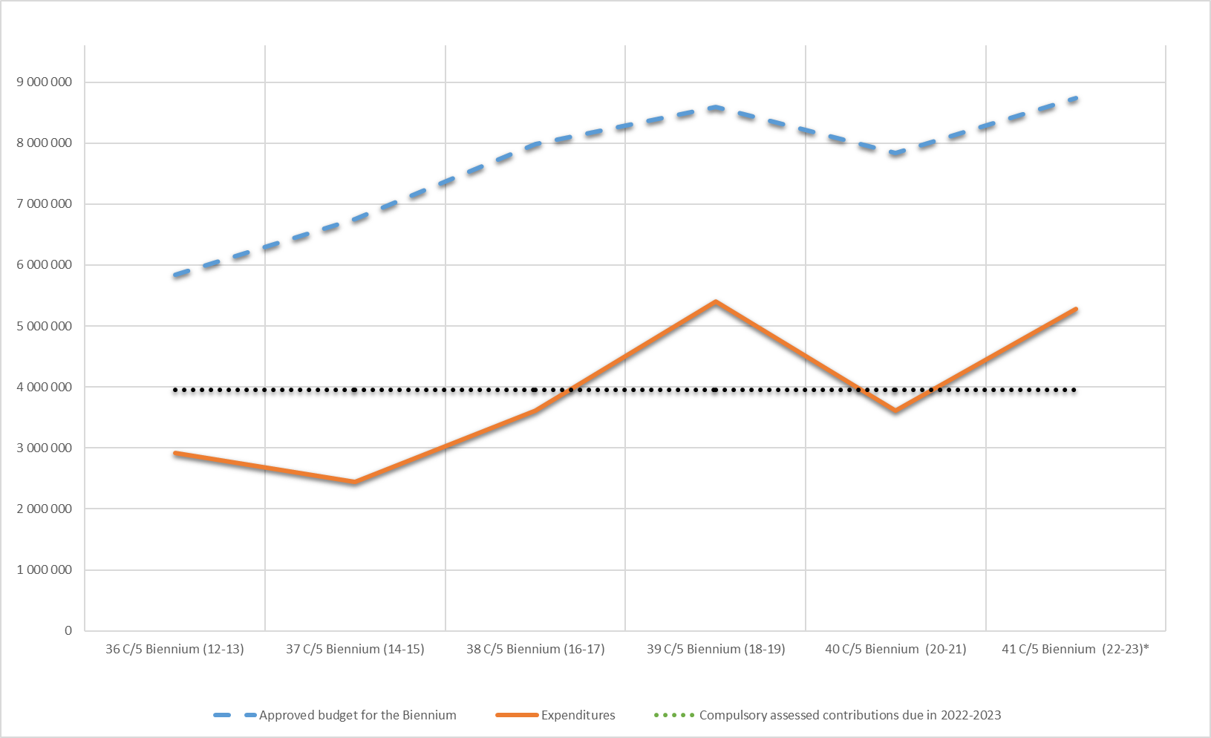
Figure 1: Evolution of expenditures of the Fund
- It should be recalled that the payment of contributions is an obligation incumbent on all States Parties that have ratified the Convention, in accordance with Article 26 of the Convention. As States Parties exercise rights and enjoy benefits conferred on them under the Convention, they are also expected to fulfil their corresponding commitments in return. As already indicated in several statutory documents (most recently document LHE/22/9.GA/10), the lack of cash availability caused by late payments of assessed contributions might delay and thus jeopardize the implementation of activities foreseen in the budget.
- With regards to the compulsory assessed contributions by States Parties to be paid in accordance with Article 26.1 of the Convention, in average, over the past eleven years (2012 – 2022) the level of unpaid contributions at year-end represents 19% of the annual amount assessed. At the end of the reporting period covered by this document, the unpaid contributions represented US$1.52 million (against US$1.40 million on 30 June 2021), US$ 256,418 of which correspond to unpaid contributions of previous years. As at 30 June 2023, 105 States Parties (60% of States Parties bound by Article 26.1) have not yet fully paid their contributions for 2022–2023. Amongst them, 35 States Parties (20% of States Parties bound by Article 26.1) have also not paid their contribution for 2021 and preceding years (see Statement of Assessed contributions as at 30 June 2023).
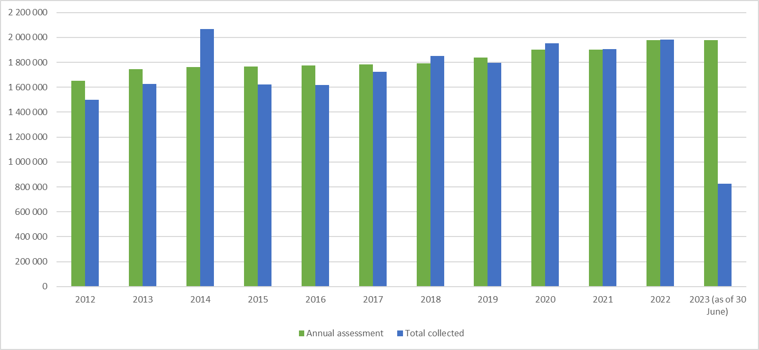
Figure 2: Evolution of compulsory assessed contributions
- The payment of voluntary assessed contributions by States Parties in accordance with Article 26.2 of the Convention, for the 18 months of the biennium 2022–2023 represents 92% of the amount assessed, which is higher than the previous biennia (83% on average over 2012 – 2021), with six months remaining until the end of the biennium.
- During the reporting period, States Parties have been making a significantly higher use of the International Assistance mechanisms. Figure 3 (below) shows an increase in the use of funds dedicated to International Assistance mechanisms, corresponding to budget lines 1, 1.1 and 2. Expenditure rates under these three budget lines reached 56% with another six months remaining in the current biennium (against 44% for the entire 2020–2021 biennium). This is mainly due to: a) the increase in the number of International Assistance requests approved by the Committee and its Bureau (twenty-five requests approved during the reporting period against twelve for the period from 1 January 2020 to 30 June 2021); b) the upstream work of the Secretariat notably by providing technical support to States Parties during the elaboration process (all requests examined by the Bureau since January 2022 have been approved); c) the increased use of technical assistance by States Parties to develop and revise their requests (nine States Parties received the support of experts during the reporting period against three for the period from 1 January 2020 to 30 June 2021); and d) the initiation of actions to promote the objective of the International Assistance mechanisms such as a toolkit in English and French and a series of online information sessions to raise the awareness of stakeholders (see document LHE/23/18.COM/INF.14). A detailed report on the progress of implementation of the International Assistance mechanisms can be found in document LHE/23/18.COM/10.
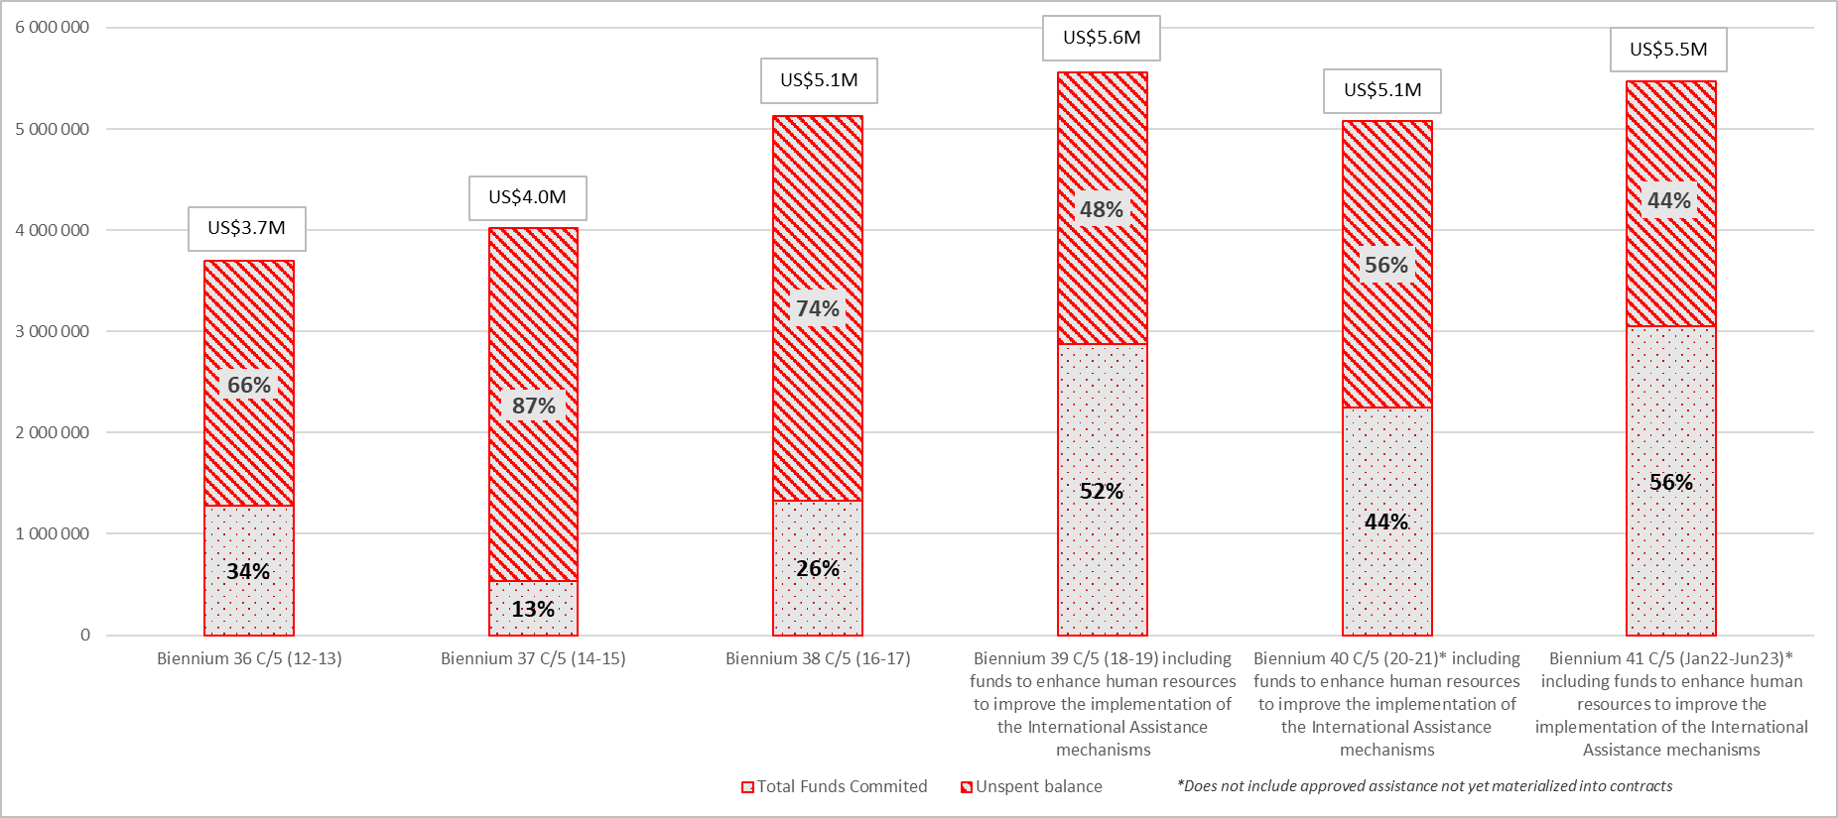
Figure 3: Expenditure rate for International and Preparatory Assistance
- PROPOSED DRAFT PLAN FOR THE USE OF THE RESOURCES OF THE INTANGIBLE CULTURAL HERITAGE FUND FOR THE PERIOD 2024–2025
- The draft plan proposed below is based on an estimated total budget of approximately US$7 million corresponding to the amount forecasted as available as of 31 December 2023. In comparison, the budget available for the current biennium (2022–2023) approved by the ninth session of the General Assembly amounted to US$8.73 million (Resolution 9.GA 10).
- The proposal for the allocation of funds for the 42 C/5 (2024–2025) follows the structure based on budget lines, which has been used for the past equivalent exercises. These budget lines can be divided into three categories, namely expenditures related to: a) International Assistance; b) ‘other functions of the Committee’ in the sense of Article 7 of the Convention; and c) participation in the meetings of the governing bodies and advisory services to the Committee. However, a few adjustments are proposed between the different budget lines as described in the paragraphs below.
International Assistance
- In line with the priorities set by the Guidelines for the use of the resources of the Fund in Chapter II.1 of the Operational Directives, it is proposed that the majority of the resources (65.1%) be allocated to providing International Assistance to States Parties to supplement their national efforts to safeguard intangible cultural heritage (budget lines 1, 1.1 and 2).
- Funds allocated to budget line 1 (50%) are foreseen for the support to States, through the International Assistance mechanisms, in the safeguarding of heritage inscribed on the List of Intangible Cultural Heritage in Need of Urgent Safeguarding, the preparation of inventories and other safeguarding programmes and projects. It is proposed to maintain the allocation of budget line 1 at the same level to enable States Parties to strengthen their safeguarding efforts, with a particular focus on the Africa region and SIDS. These substantial resources will be used to grant funds to as many safeguarding projects as possible, approved by the Committee and the Bureau, on condition that they meet the criteria for International Assistance.
- Following the findings from the 2021 evaluation by the Internal Oversight Service (IOS) of UNESCO’s action in the framework of the 2003 Convention for the Safeguarding of the Intangible Cultural Heritage (see Recommendations 5 and 6 in document LHE/21/16.COM/INF.10 Rev.), the Committee authorized, on an experimental basis, the use of funds under budget line 1 in an amount not exceeding 10% of the approved budget of each approved International Assistance project, to finance the provision of expertise, as described in Article 21 of the Convention, for monitoring and evaluating ongoing and recently completed International Assistance projects (Decision 16.COM 13 and Resolution 9.GA 10). Following the preparatory steps undertaken since the 9.GA (see document LHE/23/18.COM/10), the pilot monitoring and evaluation activities are foreseen to be implemented from 2024. To this end, it is proposed that the Committee renew its authorization to the Secretariat, on an experimental basis, to use funds under budget line 1 in an amount not exceeding 10% of the budget of each approved International Assistance project selected, to finance the provision of expertise, as described in Article 21 of the Convention, for monitoring and evaluating ongoing and recently completed International Assistance projects.
- At its seventh session in June 2018, the General Assembly approved the creation of three extra-budgetary fixed-term posts (one P3, one P2 and one G5) to form a dedicated team to operationalize the implementation of the International Assistance mechanisms (Resolution 7.GA 8). The ‘Safeguarding Implementation and Monitoring (SIM) Team’ was established in February 2020. Some 12.3% of the resources of the Fund are proposed to be allocated to cover the costs of these three posts (budget line 1.1), against 10% in the present biennium in order to maintain this budget line at the same nominal amount.
- Furthermore, it is proposed that 2.8% of the funds be budgeted for granting preparatory assistance (budget line 2). The slight increase compared with the present biennium (2.6%) is proposed in light of the potential additional costs that may result from the extension of the preparatory assistance mechanism to States Parties with no national elements inscribed on the Representative List and who wish to benefit from International Assistance in the preparation of a nomination file (see Decision 17.COM 7 and document LHE/23/18.COM/10). Should the Committee and the General Assembly at its tenth session in 2024 endorse this extension, the proposed increased allocation would allow the provision of such assistance for an initial number of requests that the Secretariat may receive during the 2024 – 2025 biennium, after the tenth session of the General Assembly. In addition to the current preparatory assistance for nomination files and the abovementioned proposed possibility, this budget line also covers the costs incurred for the provision of technical assistance to States Parties for preparing International Assistance requests.
Other functions of the Committee
- Budget line 3 (‘other functions of the Committee’) will be maintained at 20% to strengthen the work initiated during the current biennium. Such functions are listed under Article 7 of the Convention, and the Secretariat makes use of these funds to assist the Committee in performing these functions, as required by Article 10 of the Convention. In other words, these funds will primarily be used for upstream and cross-cutting actions aiming to promote the objectives of the Convention and encourage and monitor its implementation (Article 7[a]), as well as provide guidance on measures for the safeguarding of intangible cultural heritage (Article 7[b]). It is important to note that if the allocation in percentage remains unchanged, the nominal amount of budget line 3 will decrease due to the general reduction in the amount available for 2024–2025.
- In accordance with this Decision 14.COM 7, the proposed Plan presented to the Committee includes a percentage breakdown under budget line 3 in terms of Expected Results (ERs) in line with the Outputs approved in the C/5, with a view to presenting it for approval by the following session of the General Assembly. The Plan proposes to divide budget line 3 into two ERs – instead of four ERs in the present biennium – to better align the activities to be carried out by the Secretariat with the two performance indicators defined in the approved 41 C/5 and draft 42 C/5 (Major Programme IV Culture, Outcome 5, Output 5.CLT4 ‘Member States’ and communities’ capacities strengthened to identify, safeguard and promote living heritage’). The budget allocation repartition between the two proposed ERs is based on the repartition approved for the present biennium, the allocation of the new ER 1 (52%) representing a combination of current ERs 2 and 3 (respectively 33% and 19%), while the allocation of the new ER 2 (48%) is equivalent to the combination of ERs 1 and 4 (respectively 25% and 23%) in the present biennium:
Expected Result | 2022-  2023 | Expected Result | 2024-  2025
ER 1: Sound governance of the 2003 Convention facilitated by enhanced monitoring and knowledge management services | 25% | ER 1: Implementation of the Convention encouraged through a strengthened capacity-building programme and the integration of intangible cultural heritage into development plans, policies and programmes | 52%
ER 2: Implementation of the Convention in Member States encouraged through a strengthened capacity-building programme | 33%
ER 3: Integration of intangible cultural heritage into development plans, policies and programmes supported | 19% | ER 2: Sound governance of the Convention facilitated by enhanced monitoring, knowledge management services and awareness-raising associated with international cooperation mechanisms | 48%
ER 4: Objectives of the Convention promoted through awareness-raising and outreach | 23%

- In line with previous decisions of the Committee (most recently Decision 16.COM 13), it is proposed that the Committee authorizes the Secretariat to make transfers between Expected Results within budget line 3. In accordance with 41 C/Resolution 76 (paragraph 5(b)) adopted by the General Conference at its 41st session in November 2021, authorizing the Director-General to make transfers between appropriation lines of UNESCO’s regular programme up to an amount of 5% of the initial appropriation under the 41 C/5, the draft decision proposes correspondingly that such transfers may be made up to a cumulative amount equivalent to 5% of the initial total allocation to be proposed to the next session of the General Assembly. The Secretariat would inform and Committee in writing, at the session following such action, of the details and reasons for these transfers, should they occur.
Expected Result 1: Implementation of the Convention encouraged through a strengthened capacity-building programme and the integration of intangible cultural heritage into development plans, policies and programmes
- The Secretariat will continue providing upstream guidance and support, drawing from the results of the reflection undertaken on the occasion of the Convention’s twentieth anniversary, notably the Seoul Vision for the Future of Safeguarding Living Heritage for Sustainable Development and Peace (2023), and in line with the 2022 MONDIACULT Declaration on cultural policies and sustainable development. It will further (a) strengthen the global capacity-building programme to respond to the evolving needs of countries in safeguarding living heritage and (b) continue the thematic initiatives on living heritage and sustainable development, in particular in priority areas identified by the Committee. To ensure maximum reach of the capacity-building programme efforts will be made to continue developing training content and tools adapted to hybrid modalities, broadening the outreach of the programme to new audiences, and bolstering networking and knowledge exchange through the utilization of the learning management platform. It will notably strengthen the thematic expertise of the facilitators network to be equipped to respond to demand for capacity building in thematic areas. The Secretariat will furthermore work on living heritage safeguarding in the digital environment to build more knowledge and expertise in this area and continue capacity-building support to States and communities (Recommendations 8 and 9 of the 2021 IOS Evaluation).
- Responding to Recommendation 3 of the 2021 IOS Evaluation to tackle priority thematic initiatives of the Convention and address current challenges for sustainable development and peace, the Secretariat intends to continue its work on ‘Economic dimensions of intangible cultural heritage safeguarding’ based on the Category VI expert meeting held in September and October 2023, ‘Safeguarding intangible cultural heritage and climate change’ and ‘Safeguarding intangible cultural heritage in urban contexts’ (see document LHE/23/18.COM/12). Furthermore, efforts will be put towards pursuing the work on ‘Living heritage in emergencies’ and ‘Safeguarding intangible cultural heritage in formal and non-formal education’. Actions in the coming biennium will involve expert meetings, development of guidance materials and provision of training, while strengthening synergies with other cultural conventions, programme sectors as well as relevant international organizations, frameworks and mechanisms.
Expected Result 2: Sound governance of the Convention facilitated by enhanced monitoring, knowledge management services and awareness-raising associated with international cooperation mechanisms
- Sustaining good governance remains a priority to ensure the effective implementation of the Convention. To continue providing adequate support to the Convention’s governing bodies and States, actions will be taken to strengthen the international cooperation mechanisms of the Convention, notably periodic reporting, International Assistance and the listing mechanisms, in line with Recommendations 2, 5 and 6 of the 2021 IOS Evaluation. As part of the UNESCO Culture Sector’s initiative to produce a quadrennial Global report on cultural policies and recognizing the key role of data to guide the efforts of authorities and communities in safeguarding living heritage as well as to highlight evidence on the role of living heritage in achieving sustainable development, the analysis of information collected through the periodic reporting mechanisms, including during the reflection year, will be carried out and presented to the related sessions of the governing bodies. Furthermore, building on the increased operationalization of the International Assistance mechanisms as demonstrated by the high expenditure rate during the present biennium, the Secretariat will continue its efforts to promote International Assistance including the potential expansion of preparatory assistance (see document LHE/23/18.COM/10), so as to encourage the submission of requests and contribute to increasing geographical representation on the Lists of the Convention. In addition, the Secretariat will carry out upstream actions to continue raising awareness about the Lists and Register of the Convention, notably to better understand the impact of inscriptions on elements and their associated communities. In view of strengthening the implementation of Article 18 of the Convention following the reflection on its broader implementation, support could be provided for the implementation of the possible coming decisions of the governing bodies, including to kickstart the initial operations of an online platform for sharing good safeguarding experiences after its set-up (see paragraph 29).
- Pursuant to actions initiated during the 2022–2023 biennium, the Secretariat will continue enhancing its knowledge management services, which are crucial in light of the geographical (181 States Parties as of 30 June 2023) and thematic expansions of the Convention, notably with thematic initiatives, the reformed periodic reporting mechanism and the reflections launched by the Committee on the listing mechanisms and Article 18 of the Convention. Specific efforts will be pursued in the coming biennium to streamline data production and management, as well as facilitate the access to information through user-friendly and open formats, as prescribed by the 2021 IOS Evaluation (Recommendations 10 and 11). The Convention’s knowledge management will be improved to implement the outcomes of the recent reflections and reforms resulting in a rapidly increasing mass of information coming from a broader range of States and communities and raising the interest of a wider scope of stakeholders. Furthermore, based on the successful experience of the platform launched for the twentieth anniversary of the Convention, the Convention’s website will remain a key repository of information for States representatives and experts, and will continue its revamp to provide thematic approaches, offer transversal navigations – including through the regular update of ‘Dive into intangible cultural heritage!’ – and highlight content such as data-visualization, high-quality photos and audio-visual materials depicting living heritage in action.
Participation of experts in the meetings of the governing bodies
- The participation of experts in intangible cultural heritage representing developing States Parties in statutory meetings is covered either by budget line 4 when they are members of the Committee or by budget line 5 when they are not. The participation of experts representing accredited NGOs from developing countries in the sessions of the Committee is covered by budget line 6. It is proposed that 2.5%, 2.7% and 2.7%, respectively, be dedicated to the above-mentioned lines. It represents a slight decrease of each line, which would however still allow the Fund to respond to all requests from Committee members and most, if not all, requests submitted by States Parties not members of the Committee and accredited non-governmental organizations.
Advisory services to the Committee
- Budget line 7 is proposed to be slightly decreased from 7.7% to 7% to cover the cost of the advisory services provided at the request of the Committee from January 2024 to December 2025, in particular those associated with the work of the Evaluation Body. Under this proposal, it is expected that this line will continue being able to cover the costs of the advisory services provided by the Evaluation Body in 2024 and 2025, even taking into account the increasing number of files for the two corresponding cycles following the decision of the Committee to treat requests for the transfer of elements from one List to another, the inclusion in the Register of Good Safeguarding Practices of the successful safeguarding experience resulting from a transfer from the Urgent Safeguarding List to the Representative List, requests for inscriptions on an extended or reduced basis, as well as the follow-up of inscribed elements, outside of the annual ceiling (Decision 17.COM 15).
- Furthermore, this budget line is foreseen to cover the costs associated with the initial set-up of an online platform for sharing good safeguarding experiences, including IT developments, content preparation and the initial testing of the system, to fully implement Article 18 of the Convention, should the Committee (under Item 11 of the present session, see document LHE/23/18.COM/11) and the General Assembly approve the recommendations of the Open-ended intergovernmental working group in the framework of the reflection on a broader implementation of Article 18 of the Convention (Recommendations 8 to 13 in document LHE/23/18.COM WG ART18/4 Rev.),
- At its ninth session, the General Assembly recommended that the Secretariat be authorized to make transfers between budget lines 4, 5, 6 and 7, for up to 30% of their initial total allocation (Resolution 9.GA 10). After the reporting period and prior to the present session of the Committee, two budget transfers were simultaneously carried out in October 2023, respectively from budget line 4 to budget line 5 (US$20,000) and from budget line 4 to budget line 6 (US$60,000). These transfers are meant to allow the Fund to respond positively to as many requests as possible to cover the participation costs of experts representing developing States Parties non-members of the Committee (budget line 5) and accredited NGOs from developing countries (budget line 6) at the present session of the Committee. To be able to respond to as many requests for financial assistance as possible across the different categories of participants in the coming biennium, it is proposed that the Committee recommend once more to the General Assembly to renew its authorization of the Secretariat to make transfers between budget lines 4, 5, 6 and 7, up to an equivalent of 30% of their initial total. Should such a transfer be necessary, the Secretariat would be requested to inform the Committee and the General Assembly in writing, at the session following such action, of the details of and reasons for these transfers.
- The Committee may wish to adopt the following decision:
DRAFT DECISION 18.COM 14
The Committee,
- Having examined documents LHE/23/18.COM/14, LHE/23/18.COM/INF.14 and their respective annexes,
- Recalling Article 7(c) of the Convention, Resolution 9.GA 10 and Decision 16.COM 13,
- Further recalling the UNESCO General Conference’s Appropriation resolution for 2022–2023 (41 C/Resolution 76),
- Takes note of the statement of accounts of the Fund for 2022–2023 as of 30 June 2023, recalls that the payment of compulsory and assessed voluntary contributions is, per Article 26 of the Convention, an obligation incumbent on all States Parties which have ratified the Convention, and calls upon all States Parties which have not yet paid the totality of their assessed contributions for 2022–2023 or previous years, including voluntary assessed contributions, to ensure that their contributions are paid at the earliest opportunity;
- Further takes note of the transfers carried out during the second semester of 2023, between budget lines 4, 5 and 6 to allow the participation of experts from developing States to attend its present session;
- Also takes note that the draft plan for the use of the resources of the Fund takes into account the potential additional costs that may result from the revision of the Operational Directives that will be examined by the tenth session of the General Assembly in 2024;
- Decides to base the draft plan for the use of the resources of the Fund for the periods 1 January 2024 to 31 December 2025 and 1 January 2026 to 30 June 2026 on the total unrestricted operating reserves available as of 31 December 2023;
- Submits for approval to the tenth session of the General Assembly the draft plan for the use of the resources of the Fund, as included in the Annex of document LHE/23/18.COM/14, and proposes to the General Assembly that one fourth of the amount established for the two-year period from 1 January 2024 to 31 December 2025 be provisionally allocated to the first semester of 2026;
- Authorizes the Secretariat to use on an experimental basis an amount not exceeding 10% of the approved budget of each International Assistance project identified, in addition to the amount granted by the Committee or its Bureau for each project, to monitor and assess the impact of projects supported by the Fund, and requests the Secretariat to report on the use of funds for this purpose at its twentieth session;
- Further authorizes the Secretariat, when utilizing the funds allocated under budget line 3 of the Plan, to make transfers between activities included within the specific proposals for budget line 3 up to a cumulative amount equivalent to 5% of the initial total allocation proposed to the General Assembly for this purpose, and further requests that, in such cases, the Secretariat inform the Committee in writing, at the session following such action, of the details of and reasons for these transfers;
- Recommends that the General Assembly authorize the Secretariat to make transfers between budget lines 4, 5, 6 and 7, up to an equivalent of 30% of their initial total allocation, and also requests that the Secretariat inform the Committee and the General Assembly in writing, at the session following such action, of the details of and reasons for these transfers.

ANNEX
Draft plan for the use of the resources of the Fund
For the period 1 January 2024 to 31 December 2025, as well as for the period 1 January to 30 June 2026, the resources of the Intangible Cultural Heritage Fund may be used for the following purposes: |  | % of the total amount proposed | 2022-2023  Plan
1. | International Assistance, comprising the safeguarding of the heritage inscribed on the List of Intangible Cultural Heritage in Need of Urgent Safeguarding, the preparation of inventories and support for other safeguarding programmes, projects and activities, including the monitoring and evaluation of requests approved; | 50.0% | 50.0%
1.1 | Enhancing human resources to improve the implementation of the International Assistance mechanisms through three extra-budgetary fixed-term posts (one P3, one P2 and one G5); | 12.3% | 10.0%
2. | Preparatory assistance for International Assistance requests, nominations and proposals to the Lists and Register of the Convention; | 2.8% | 2.6%
3. | Other functions of the Committee, as described in Article 7 of the Convention, aimed at promoting the objectives of the Convention and encouraging and monitoring its implementation, in particular by strengthening capacities to effectively safeguard intangible cultural heritage, raising awareness of the importance of such heritage, providing guidance on good safeguarding practices and updating and publishing the Lists and the Register of Good Safeguarding Practices: | 20.0% | 20.0%
 | ER 1: Implementation of the Convention encouraged through a strengthened capacity-building programme and the integration of intangible cultural heritage into development plans, policies and programmes; | 10.4% | 10.4%
 |  | (52% of line 3) | (52% of line 3)
 | ER 2: Sound governance of the Convention facilitated by enhanced monitoring, knowledge management services and awareness-raising associated with international cooperation mechanisms | 9.6% | 9.6%
 |  | (48% of line 3) | (48% of line 3)
4. | Participation in the sessions of the Committee, its Bureau and subsidiary bodies of experts in intangible cultural heritage representing developing States that are Members of the Committee; | 2.5% | 3.1%
5. | Participation in the sessions of the Committee and its consultative bodies of experts in intangible cultural heritage representing developing States that are Parties to the Convention but not Members of the Committee; | 2.7% | 3.3%
6. | Participation in the sessions of the Committee, its Bureau and consultative bodies of public or private bodies, private persons, notably members of communities and groups, that have been invited by the Committee to advise it on specific matters, as well as experts in intangible cultural heritage representing accredited NGOs from developing countries; | 2.7% | 3.3%
7. | The costs of advisory services to be provided at the request of the Committee. | 7% | 7.7%
 | TOTAL | 100% | 100%
Funds that have not been committed at the end of the period of this Plan are carried over to the next financial period and shall be allocated in accordance with the Plan approved by the General Assembly at that time.

This estimate is based on the Fund balance as of 30 June 2023 (excluding the Reserve Fund of US$1,000,000) and does not take into account assessed contributions due for the 42 C/5.
The latest Statement of compulsory contributions is available on the following webpage: https://ich.unesco.org/doc/src/61535-EN.pdf
‘Preparatory assistance’ refers to the assistance that States Parties can request for developing nominations to the List of Intangible Cultural Heritage in Need of Urgent Safeguarding or proposals for the Register of Good Safeguarding Practices, for the transfer of elements between the Lists and Register of the Convention and for the inscription of elements on an extended or reduced basis (paragraph 21 of the Operational Directives). ‘Technical assistance’ refers to the provision of experts, as described in Article 21 of the Convention, to States Parties wishing to develop requests for International Assistance (Decision 8.COM 7.c).
The proposed Expected Result 1 is aligned with Performance Indicator 1 ‘Number of Member States with new or revised policies, strategies and programmes to safeguard living heritage, including within sustainable development plans and frameworks, in line with the 2003 Convention for the Safeguarding of the Intangible Cultural Heritage’ in the approved 41 C/5 and draft 42 C/5 for Output 5.CLT4. It merges ERs 2 (‘Implementation of the Convention in Member States encouraged through a strengthened capacity-building programme’) and 3 (‘Integration of intangible cultural heritage into development plans, policies and programmes supported’) in the Plan for 2022 – 2023.
The proposed Expected Result 2 is aligned with Performance Indicator 2 ‘Number of Member States sustainably safeguarding living heritage through enhanced international cooperation and assistance mechanisms of the 2003 Convention for the Safeguarding of the Intangible Cultural Heritage’ in the approved 41 C/5 and draft 42 C/5 for Output 5.CLT4. It merges ERs 1 (‘Sound governance of the 2003 Convention facilitated by enhanced monitoring and knowledge management services’) and 4 (‘Objectives of the Convention promoted through awareness-raising and outreach’) in the Plan for 2022 – 2023.
This also corresponds to the proposal made in the Draft Appropriation Resolution for 2024-2025 (paragraph 3, p. 19) to be presented to the forty-second session of UNESCO’s General Conference in November 2023.

