CONVENTION FOR THE SAFEGUARDING OF THE
INTANGIBLE CULTURAL HERITAGE
INTERGOVERNMENTAL COMMITTEE FOR THE
SAFEGUARDING OF THE INTANGIBLE CULTURAL HERITAGE
Seventeenth session
Rabat, Kingdom of Morocco
28 November to 3 December 2022
Item 8 of the provisional agenda:
Follow-up on elements inscribed on the Lists of the Convention
Summary
The present document provides a summary of the correspondence received from July 2021 to October 2022 from third parties concerning two inscribed elements, in response to the request by the sixteenth session of the Committee (Decision 16.COM 11).
Decisions required: paragraphs 18 and 24
Introduction
- Taking note of the increasing number of cases brought to the attention of the Secretariat regarding elements inscribed on the Lists of the Convention, the Committee at its thirteenth session in 2018 recognized the need to reflect on the follow up of inscribed elements and on ways for communities, groups and, where applicable, individuals and other stakeholders to participate in the monitoring of inscribed elements (Decision 13.COM 9). Since that session, the Committee has been taking note of information received from third parties concerning already-inscribed elements as well as nominations submitted for possible inscription on the Lists of the Convention.
- Furthermore, the global reflection on the listing mechanisms under the 2003 Convention, which took place between 2018 and 2022, addressed the establishment of a follow-up mechanism for inscribed elements. This led to the revision of the Operational Directives of the Convention at the ninth session of the General Assembly in July 2022 (Resolution 9.GA 9). The listing mechanisms of the Convention now include a set of procedures for transferring elements between the Lists, inscribing elements on an extended or reduced basis, and removing elements from the Lists.
- The first part of the present document (Section A) focuses on the case of the inscribed element ‘Processional giants and dragons in Belgium and France’. This follows the recommendation of the Bureau of the seventeenth session of the Committee to bring this request to remove the element or a specific part thereof, due to alleged racism and discrimination, to the attention of the Committee. The second part of the document (Section B) provides an overview of correspondences received between July 2021 and October 2022 concerning already-inscribed elements as well as nominations submitted for possible inscription on the Lists of the Convention.
- Case of the ‘Processional giants and dragons in Belgium and France’: the ‘Sauvage’ character of the Ducasse of the town of Ath, Belgium
The inscribed element in question
- The element ‘Processional giants and dragons in Belgium and France’ was originally proclaimed a Masterpiece of the Oral and Intangible Heritage of Humanity in 2005 and then incorporated on the Representative List of the Intangible Cultural Heritage of Humanity (the ‘Representative List’) as a multinational inscription (Belgium and France) in 2008 (Decision 3.COM 1). The nomination (file no. 00153) focuses on the traditional processions of large effigies of giants, animals or dragons which make up an ensemble of festive and popular manifestations. While similar traditions can be found in different parts of Western Europe, nine towns are covered by the file: five in Belgium (Ath, Brussels, Dendermonde, Mechelen and Mons) and four in France (Cassel, Douai, Pézenas and Tarascon). The performances often combine secular processions and religious ceremonies. They vary from town to town, but always follow specific rituals in which the giants and dragons relate to the history, legend or life of the town. They act out historical scenes and dance in the streets to the accompaniment of fanfares and people in costumes. The crowd follows the procession, and many participants help with the preparations at different stages of the festival.
- In the town of Ath, the festivity (known as ‘the Ducasse of Ath’) takes places each year on the fourth weekend of August, as close as possible to the birth date of Saint Julien, the patron of the town's parish. While the focus of the Ducasse of Ath is on the giants, animals and dragons, the procession also includes a character known as the ‘Sauvage’. According to the official website of the Ducasse of Ath, the character was introduced into the festival during the nineteenth century, and represents a figure brought onto a ship in chains. The figure has a black painted face and other attributes to the costume and proceeds through the crowd acting out the character. The character is not mentioned in any part of the nomination file.
Issues raised by the public and concerned parties
- In 2019 and 2021, the Secretariat received several letters from non-governmental organizations (NGOs) and individuals concerning the practice of the ‘Sauvage’. In both years, the letters were transmitted to the national authorities of Belgium. The fourteenth session of the Committee in 2019 (Decision 14.COM 14) and the sixteenth session of the Committee in 2021 (Decision 16.COM 11) also took note of the case. No festivities were held during 2020 and 2021 due to the COVID-19 pandemic, meaning that the 2022 edition was the first time the Ducasse of Ath had taken place since the initial correspondences received after the 2019 edition.
- The 2022 edition of the Ducasse of Ath took place from 26 to 28 August 2022. In August 2022, before the 2022 edition, the Secretariat again started to receive a series of communications regarding the character of the ‘Sauvage’, including several letters from individuals and two NGOs (Annex I). A number of email messages were also addressed to the Permanent Delegations of States Parties to the Convention which were members of the Committee at the time of the inscription of the element, with the Secretariat in copy.
- These letters state that the ‘Sauvage’ is ‘a character dressed in black with a whole series of degrading signs attributed to black people by our racist societies throughout history: big nose, big red lips, ‘African’ dress, nose ring, chains around the neck, wrists and ankles etc., plus agitated behaviour designed to frighten especially children’. All the communications received expressed serious concerns about this as a racist and discriminatory manifestation, stating that the character of the ‘Sauvage’ and the use of the ‘blackface’ by white citizens perpetuate negative and degrading stereotypes about black people and are a remnant of slavery. Out of twenty-nine communications received at the time at which this document was issued, twenty-five specifically request that the Ducasse of Ath be removed from the Representative List.
Procedures applied (I): Reception of the removal request
- This case is the first application of the new provisions related to removal requests which were established through the revisions of the Operational Directives by the ninth session of the General Assembly in July 2022. It is defined that ‘[a]n element shall be removed from the List of Intangible Cultural Heritage in Need of Urgent Safeguarding or the Representative List of the Intangible Cultural Heritage of Humanity by the Committee when it determines that it no longer satisfies the required criteria, paying particular attention to criteria U.1/R.1 and U.4/R.4’ (paragraph 40.1).
- Upon receipt of the removal requests, the Secretariat followed the administrative procedure specified in paragraph 40.2 of the Operational Directives. The correspondence received from the NGOs and individuals concerned was transmitted to the State Party of Belgium before the 2022 edition of the Ducasse of Ath on 16 August 2022 and once again on 28 September 2022. In addition, the Secretariat gathered information, in accordance with paragraph 40.2 (e)(i), notably through informal meetings with the authorities of Belgium as well as by studying audiovisual and written press materials (including, for example a television debate specifically dedicated to the issue, broadcast by Notélé on 16 June 2022) as well as the official website of the Ducasse of Ath.
Reaction from the State Party concerned
- In response to the first batch of communications, the State Party of Belgium responded with a letter on 14 September 2022 (Annex II), firmly condemning racism. The reply provided information on a set of initiatives undertaken by the authorities to deal with the concerns raised, which could be summarized as follows:
- In 2019, the municipal authorities of the town of Ath initiated a participatory consultation process, gathering the town's administration, representatives of bearers and practitioners of the Ducasse of Ath as well as the UNIA (Belgium's independent public institution that combats discrimination and promotes equal opportunities). The consultation took the form of a roundtable planned in June 2021 (the meeting was originally planned in November 2020 but was then postponed due to the COVID-19 pandemic), an online forum and survey (March 2022), as well as a meeting between the town mayor, communities of the Ducasse of Ath and the regional authorities (13 April 2022). Furthermore, selected groups of primary-school students were invited to participate in awareness-raising activities about the Ducasse of Ath for three days in June 2022.
- The preliminary result of the above-mentioned consultation is that the communities' opinions are divided, as reflected in the press release issued by the official website of the Ducasse of Ath on 24 August 2022, before the 2022 edition. In general, the communities concerned by the festivity are said to be strongly attached to the ‘Sauvage’ character and consider that it carries no intention of racism. At the same time, about 40 per cent of the community responses demonstrated that they understand that the practice of the ‘Sauvage’ could offend some people and that they are not opposed to seeing an evolution in how the character of the ‘Sauvage’ is enacted.
- As announced in the above-mentioned press release, and following the consultations mentioned above, the town of Ath decided to maintain the character of the ‘Sauvage’ for the 2022 edition of the festivity. Nevertheless, in response to the reflection undertaken, certain attributes of the character were removed during the procession; in a deliberate and public act, on 28 August 2022 the ‘Sauvage’ rid himself of his chain and nose-ring. The town authorities also stated in the press that reflections would continue at the community level, accompanied by authorities of Belgium, on the issue of whether the character would remain or be modified in the next edition of the festival.
- At the same time, the Belgian authorities stated that the legal framework applicable to the French community of Belgium concerning the safeguarding of intangible cultural heritage is scheduled to undergo a major reform, for adoption by Parliament in 2023. This reform is said to take into account various elements related to the requirements of mutual respect among communities.
Procedure applied (II): the role of the Bureau of the Committee
- The case at hand falls under the category of removal requests submitted by entities other than the State Party (paragraph 40.2 (e) of the Operational Directives). As such, the removal requests were presented to the fifth meeting of the Bureau of the seventeenth session of the Committee (UNESCO Headquarters, 4 October 2022), together with the information gathered by the Secretariat and the response given by the State Party of Belgium (document LHE/22/17.COM 5.BUR/5). The role of the Bureau is to recommend whether or not to include the case on the agenda of the next Committee session.
- Having acknowledged the procedure followed to administer the removal requests, the Bureau considered that the case warrants the attention of the Committee, given the seriousness of the issues raised. The recommendation of the Bureau was to bring the removal requests concerning the Ducasse of Ath to the attention of the seventeenth session of the Committee (Decision 17.COM 5.BUR 5).
Next steps
- At this juncture, the Committee has the option to either keep the element on the List or place it under ‘enhanced follow-up’ status so that additional information can be gathered to reach a decision at a subsequent Committee session, as provided in paragraphs 40.2 (e) (ii) of the Operational Directives. In case the Committee decides to place the element under ‘enhanced follow-up’ status, the Evaluation Body will be requested to undertake an evaluation with reference to paragraph 40.3 (a) of the Operational Directives.
- The allegations of racism and discrimination raised in relation to the character of the ‘Sauvage’ are a serious matter which must be addressed as they touch upon UNESCO's founding principles of dignity, equality and mutual respect amongst peoples. These principles are also reflected in the very definition of intangible cultural heritage for the purposes of the Convention, as stipulated in its Article 2.
- At the same time, the consultation and reflection process undertaken by the community, as well as the symbolic changes to the 2022 edition of the Ducasse of Ath, seem to indicate – even if they address only parts of the depiction of the characer concerned – that the community is open to seeing a change in the character of the ‘Sauvage’ to address the concerns raised. Such a change would be in line with the dynamic and evolving nature of intangible cultural heritage, as defined of Article 2 of the Convention. It also appears to be reinforced by plans by the authorities to review and reform policies and legal frameworks concerning the safeguarding of intangible cultural heritage.
Procedural considerations: ‘Enhanced follow-up’
- Following on from the above, it seems appropriate that the Committee may wish to make use of the newly adopted provisions for an ‘enhanced follow-up’ with reference to paragraph 40.2 (e) (ii) in order to obtain additional information. This would allow it to engage with the communities concerned and encourage them to resolve the serious issues raised, in order to ultimately decide whether or not the Ducasse of Ath should be maintained on the Representative List. If the Committee decides to initiate an ‘enhanced follow-up’, the following aspects need to be considered:
(i) Taking into account the issues raised by the third parties and response given by the State Party of Belgium and with reference to paragraph 40.3 (a) which calls upon the Committee to pay particular attention to Article 2 of the Convention, the aspects of the inscribed element to be monitored may be summarized as:
  - Whether the communities concerned have taken specific and appropriate actions to adapt the practice of the Ducasse of Ath in response to the issues raised through the removal requests.
  - Whether the ‘Sauvage’ character, as originally depicted and subsequently changed, represents a form of racism and discrimination, and that the element as a whole is compatible with UNESCO's founding principles of dignity, equality and mutual respect among peoples, as reflected in the preamble of the Organization's Constitution, as well as the requirements of mutual respect among communities, groups and individuals, as stipulated under Article 2 of the Convention.
(ii) The issues raised exclusively concern the town of Ath, and no other towns in Belgium or France covered by the nomination. The removal requests from the third parties refer to the Ducasse of Ath and do not require the whole element to be removed. The possibility of removing only a part of the element may therefore arise in future discussion of the Committee, since the Operational Directives are silent on such an option. For the case at hand, this would mean removing the practices and traditions around the Ducasse of Ath from the inscribed element ‘Processional giants and dragons in Belgium and France’, while the processions connected with other towns in Belgium and France would continue to be part of the element inscribed on the Representative List. This matter, however, will have to be addressed only after the ‘enhanced follow-up’ procedure required under the Operational Directives has been completed since multiple factors may change the review of the case over time. It is submitted that the feasibility of this option be considered if need be at the next session of the Committee.
(iii) The proposed timeline for the ‘enhanced follow-up’ includes the following steps:
Date | Steps | Relevant provision of the Operational Directives
November/December 2022 | Seventeenth session of the Committee  - The Committee places the Ducasse of Ath under an ‘enhanced follow-up’ status | 40.2 (e) (ii)
First half of 2023 | 2023 edition of the Ducasse of Ath  - Two members of the Evaluation Body, accompanied by a member of the Secretariat, undertake a mission, if needed, to the town of Ath in order to engage in dialogue with the authorities and communities concerned and to do so before the 2023 edition of the Ducasse of Ath  - The Evaluation Body and the Secretariat monitor the 2023 edition of the Ducasse of Ath remotely  - Draft mission report submitted to the Secretariat | 40.3 (a)
September 2023 | Third meeting of the 2023 Evaluation Body  - The Evaluation Body discusses and finalizes the mission report  - The Evaluation Body submits its recommendation to the Secretariat, to be forwarded to the Committee | 40.3 (a)
November/December 2023 | Eighteenth session of the Committee  - The Committee decides on the next step(s), namely to:  - continue to place the element under an ‘enhanced follow-up’ status for a period to be determined, if the issues persist  - remove the element [or a part thereof] from the Representative List  - keep the element on the Representative List. | 40.3 (b)
(iv) The financial resources needed to support the ‘enhanced follow-up’ process, such as the on-site mission by the Evaluation Body, have been foreseen as part of the plan for the use of the resources of the Intangible Cultural Heritage Fund (line 7) for the period 2022-2023 and the first semester of 2024 (Resolution 9.GA 10). The plan, as approved by the ninth session of the General Assembly, was designed in such a way as to anticipate the outcomes of the global reflection on the listing mechanisms of the 2003 Convention (document LHE/22/9.GA 10).
- The Committee may wish to adopt the following decision:
DRAFT DECISION 17.COM 8.a
- Having examined document LHE/22/17.COM 8 and its annexes,
- Recalling Decisions 3.COM 1, 13.COM 9, 14.COM 14 and 16.COM 11, as well as Resolution 9.GA 9 and paragraphs 40.1 to 40.3 of the Operational Directives,
- Further recalling that ‘Processional giants and dragons in Belgium and France’ (Belgium and France) was incorporated the Representative List of the Intangible Cultural Heritage of Humanity in 2008, in accordance with Article 30 of the Convention;
- Recalls that intangible cultural heritage, for the purposes of the Convention and according to its Article 2, is ‘[…] constantly recreated by communities and groups in response to their environment, their interaction with nature and their history, […]. For the purposes of this Convention, consideration will be given solely to such intangible cultural heritage as is compatible with existing international human rights instruments, as well as with the requirements of mutual respect among communities, groups and individuals […]’;
- Takes note that in 2022 the Secretariat registered a series of communications from third parties condemning the ‘Sauvage’ character of the procession that takes place in the town of Ath (Belgium) as a form of racism and discrimination, and requesting that the Ducasse of Ath be removed from the Representative List of the Intangible Cultural Heritage of Humanity;
- Further takes note of the information provided by the State Party of Belgium in response to the removal requests, which described the reflection process initiated at the community level in order to address the concerns raised as well as the readiness of many community members to see an evolution in how the character of the ‘Sauvage’ is enacted;
- Also takes note of the recommendations of the Bureau, having examined the removal request, information gathered by the Secretariat and the response given by the State Party concerned, to bring the removal requests concerning the Ducasse of Ath to the attention of the Committee;
- Considers the allegations of racism and discrimination to be an extremely serious matter since they touch upon UNESCO's founding principles of dignity, equality and mutual respect among peoples, as reflected in the preamble of the Organization's Constitution, as well as the requirement of mutual respect among communities, groups and individuals, as stipulated under Article 2 of the Convention;
- Urges the State Party of Belgium to continue working with the communities concerned to stress the evolving nature of intangible cultural heritage as per the Convention to ensure that the aspects of the Ducasse of Ath that are in contradiction with the founding principles of UNESCO as well as the requirement of mutual respect under Article 2 of the Convention will not be maintained in the future;
- Decides to place the element ‘Processional giants and dragons in Belgium and France’ under an ‘enhanced follow-up’ status, with reference to paragraph 40.3 (e) (ii) of the Operational Directives, in order to monitor aspects of the element according to the timeline specified and taking into account other considerations as described in document LHE/22/17.COM 8 (paragraph 17), in accordance with paragraph 40.2 (e) of the Operational Directives;
- Requests that: (a) the Evaluation Body and the Secretariat engage in dialogue, before the 2023 edition of the Ducasse of Ath, with the authorities and communities concerned, if needed through a mission to the town of Ath; (b) the Evaluation Body remotely monitor the 2023 edition of the Ducasse of Ath; and (c) the Evaluation Body submit its recommendations for examination by the eighteenth session of the Committee.
- Other cases of inscribed elements
- During the reporting period, three cases (other than the case of ‘Processional giants and dragons in Belgium and France’ – see Section A) concerning inscribed elements were the subject of correspondence; all of these cases pertained to elements inscribed on the Representative List.
- These communications were administered using the ‘Guidelines for the treatment of correspondence from the public or other concerned parties with regard to nominations’, adopted by the seventh session of the Committee in 2012 (Decision 7.COM 15). Following the practice initiated at the thirteenth session of the Committee, the Secretariat has been requested to bring information received from third parties concerning already inscribed elements and nominations under consideration to the attention of the Committee, and to do so in the form of a summary to be included in a working document (Decisions 13.COM 9, 14.COM 14 and 16.COM 11).
- The first of the three cases regarding inscribed elements, as summarized in the table below, was reported to the sixteenth session of the Committee (document LHE/21/16.COM 11 Rev.). Since then, a response has been received from the State Party concerned in response to the letter received in May 2021.
Element  (List, inscription year) | State(s) Party(ies) | Nature of the issues | Original correspondence and stakeholders | Action
Suiti cultural space (Urgent Safeguarding List, 2009) | Latvia | Concerns regarding the impact of municipal reforms and a request for an evaluation of the safeguarding process of the element. | Letter from an individual member of the communities (representative of the community-based governing entity); May 2021. | - Correspondence transmitted to the Permanent Delegation of Latvia in November 2021;  - Response received from the State Party in July 2022.

- The second and third cases both concern correspondence received in the second half of 2022 from individuals: such communications either expressed a personal preoccupation about an element that involves alcohol having been inscribed on the Representative List or challenged the technical descriptions of an inscribed element. While the Secretariat is currently collecting further information on these two cases in order to determine whether these communications merit specific attention by the Committee, at the same time these cases also raise questions as to whether or not to treat correspondence from an individual expressing a personal opinion on a specific issue, without any institutional affiliations.
- In the meantime, the Committee may wish to request that the Secretariat continue to bring information received from third parties concerning the status of inscribed elements to its attention. This may again take the form of a summary to be included in a working document regarding the follow-up of inscribed elements.
- The Committee may wish to adopt the following decision:
DRAFT DECISION 17.COM 8.b
The Committee,
- Having examined document LHE/22/17.COM/8,
- Recalling Decisions 7.COM 15, 13.COM 9, 14.COM 14 and 16.COM 11,
- Takes note of the correspondence concerning inscribed elements brought to the attention of the Secretariat during the reporting period, as set out in the above-mentioned document;
- Requests that the Secretariat continue to bring information received from third parties concerning already-inscribed elements and nominations under consideration to the attention of the Committee, and that in the form of a summary to be included in a working document.

ANNEX I
Correspondence received by the Secretariat concerning the element ‘Processional giants and dragons in Belgium and France’ from August 2022 to September 2022
No. | Sending entity/individual | Type of correspondence | Date
Correspondence from institutions
1* | Bruxelles Panthères (Nordine S.) | Email to UNESCO | 2022-08-09
2* | Bruxelles Panthères (Mouhad R. & Nordine S.) | Email to UNESCO | 2022-09-10
3* | Bakushinta (Anne M. G. D. B.) | Email to UNESCO | 2022-08-16
4* | Jeunes Organisés et Combatifs Mons (Vic M.) | Email to UNESCO | 2022-08-17
5* | Jeunes Organisés et Combatifs Bruxelles (Sihame H.) | Email to UNESCO | 2022-08-26
Correspondence from individuals in support to Bruxelles Panthères
6* | Martin V. E. | Email to UNESCO | 2022-08-13
7* | Habiba B. | Email to UNESCO | 2022-08-16
8* | Anima E. | Email to UNESCO | 2022-08-16
9* | Lieven Miguel K. | Email to UNESCO | 2022-08-16
10* | Shashitu R. T. | Email to UNESCO | 2022-08-16
11* | Lotus L. | Email to UNESCO | 2022-08-16
12* | Marthe N. | Email to UNESCO | 2022-08-16
13* | Milady R. | Email to UNESCO | 2022-08-17
14* | Christelle B. K. | Email to UNESCO | 2022-08-17
15* | Jessica van Z. B. | Email to UNESCO | 2022-08-23
16* | Anna V. | Email to UNESCO | 2022-08-24
17* | Daniel V. | Email to UNESCO | 2022-08-25
18* | Timour S. | Email to UNESCO | 2022-08-25
19* | Luk V. | Email to UNESCO | 2022-08-26
20* | Juan C. B. | Email to UNESCO | 2022-08-26
21* | Khadija K. | Email to UNESCO | 2022-06-26
22* | Selma B. | Email to UNESCO | 2022-08-26
23* | Azhar R. | Email to UNESCO | 2022-08-26
24* | Latifa L. | Email to UNESCO | 2022-08-27
25* | Jennifer B. M. | Email to UNESCO | 2022-08-29
Correspondence from individuals
26/27 | Julien L. | Email to UNESCO | 2022-08-03  2022-08-25
28 | Karst van Z. | Email to UNESCO | 2022-08-17
29 | Ahmad N. | Email to UNESCO | 2022-09-10
* This correspondence request the removal of the Ducasse of Ath from the Representative List.

ANNEX II
Response from the State of Belgium to the correspondence received on the element ‘Processional giants and dragons in Belgium and France’ (14 September 2022)
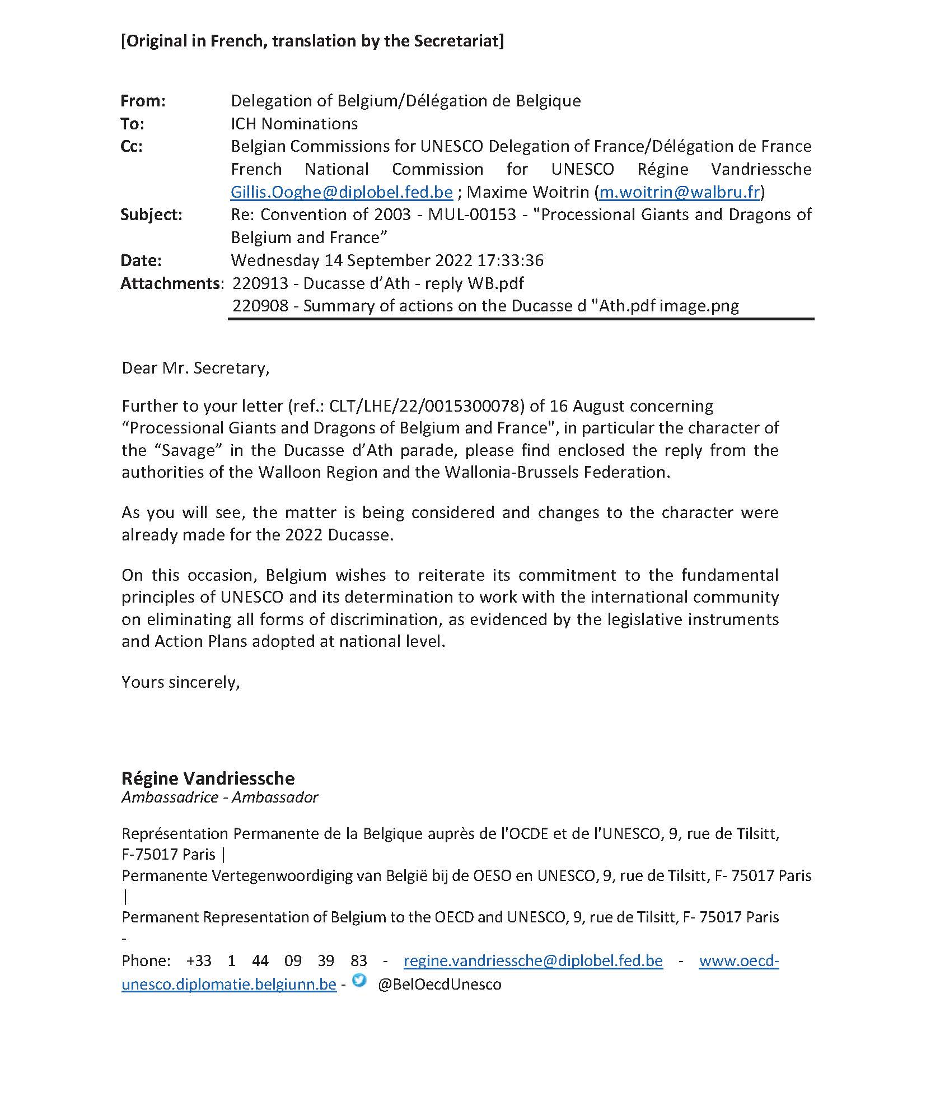

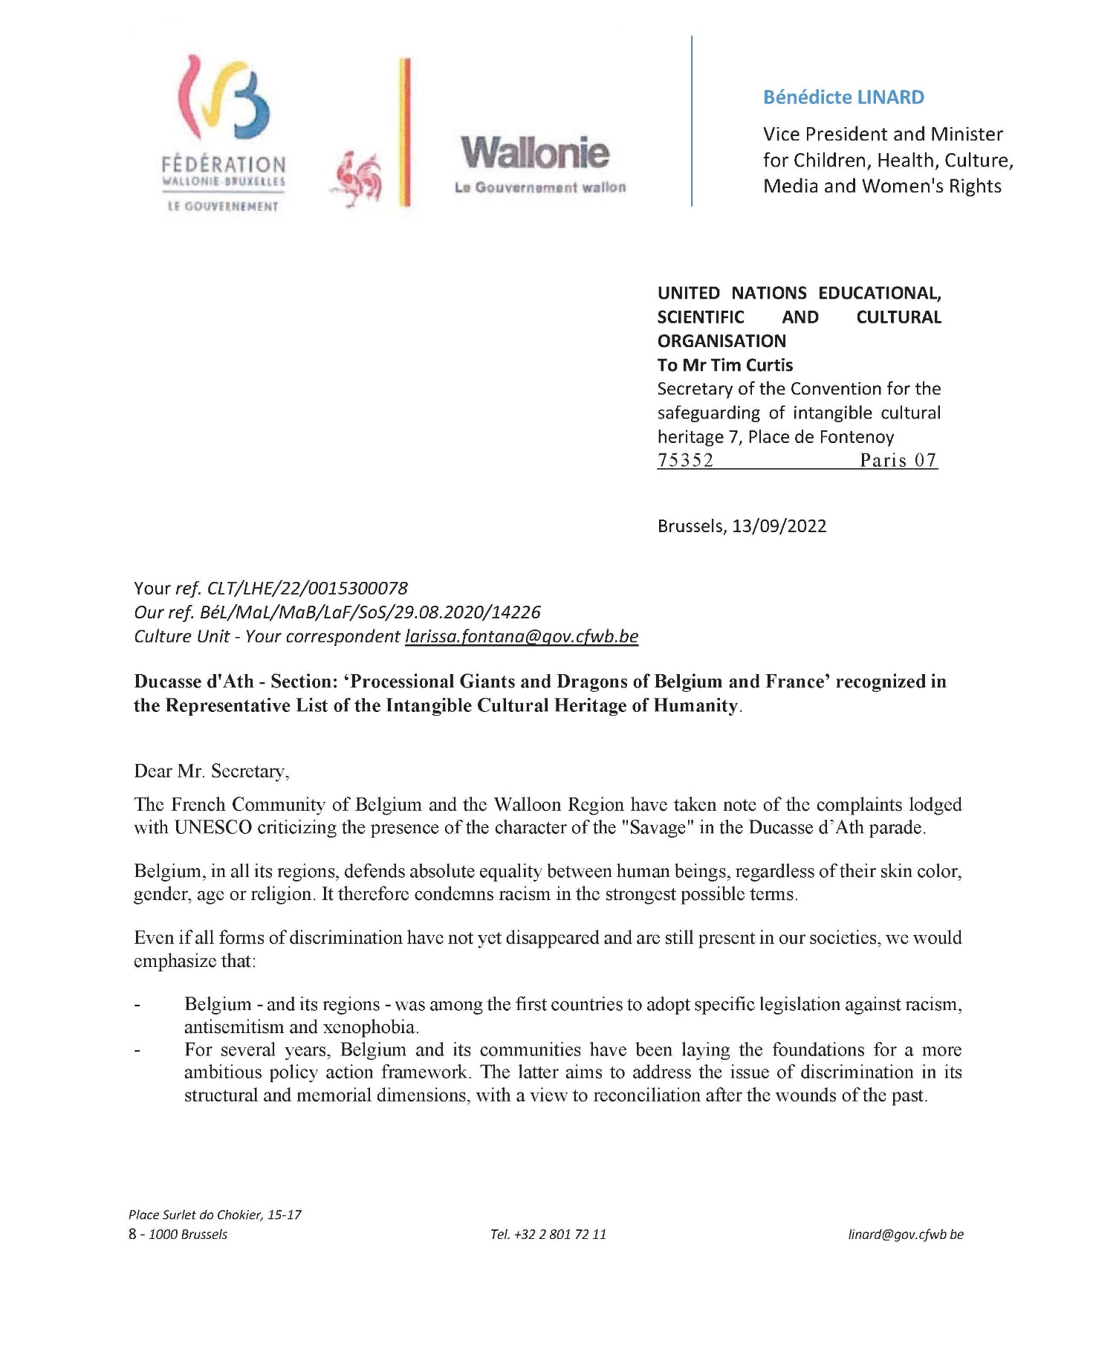

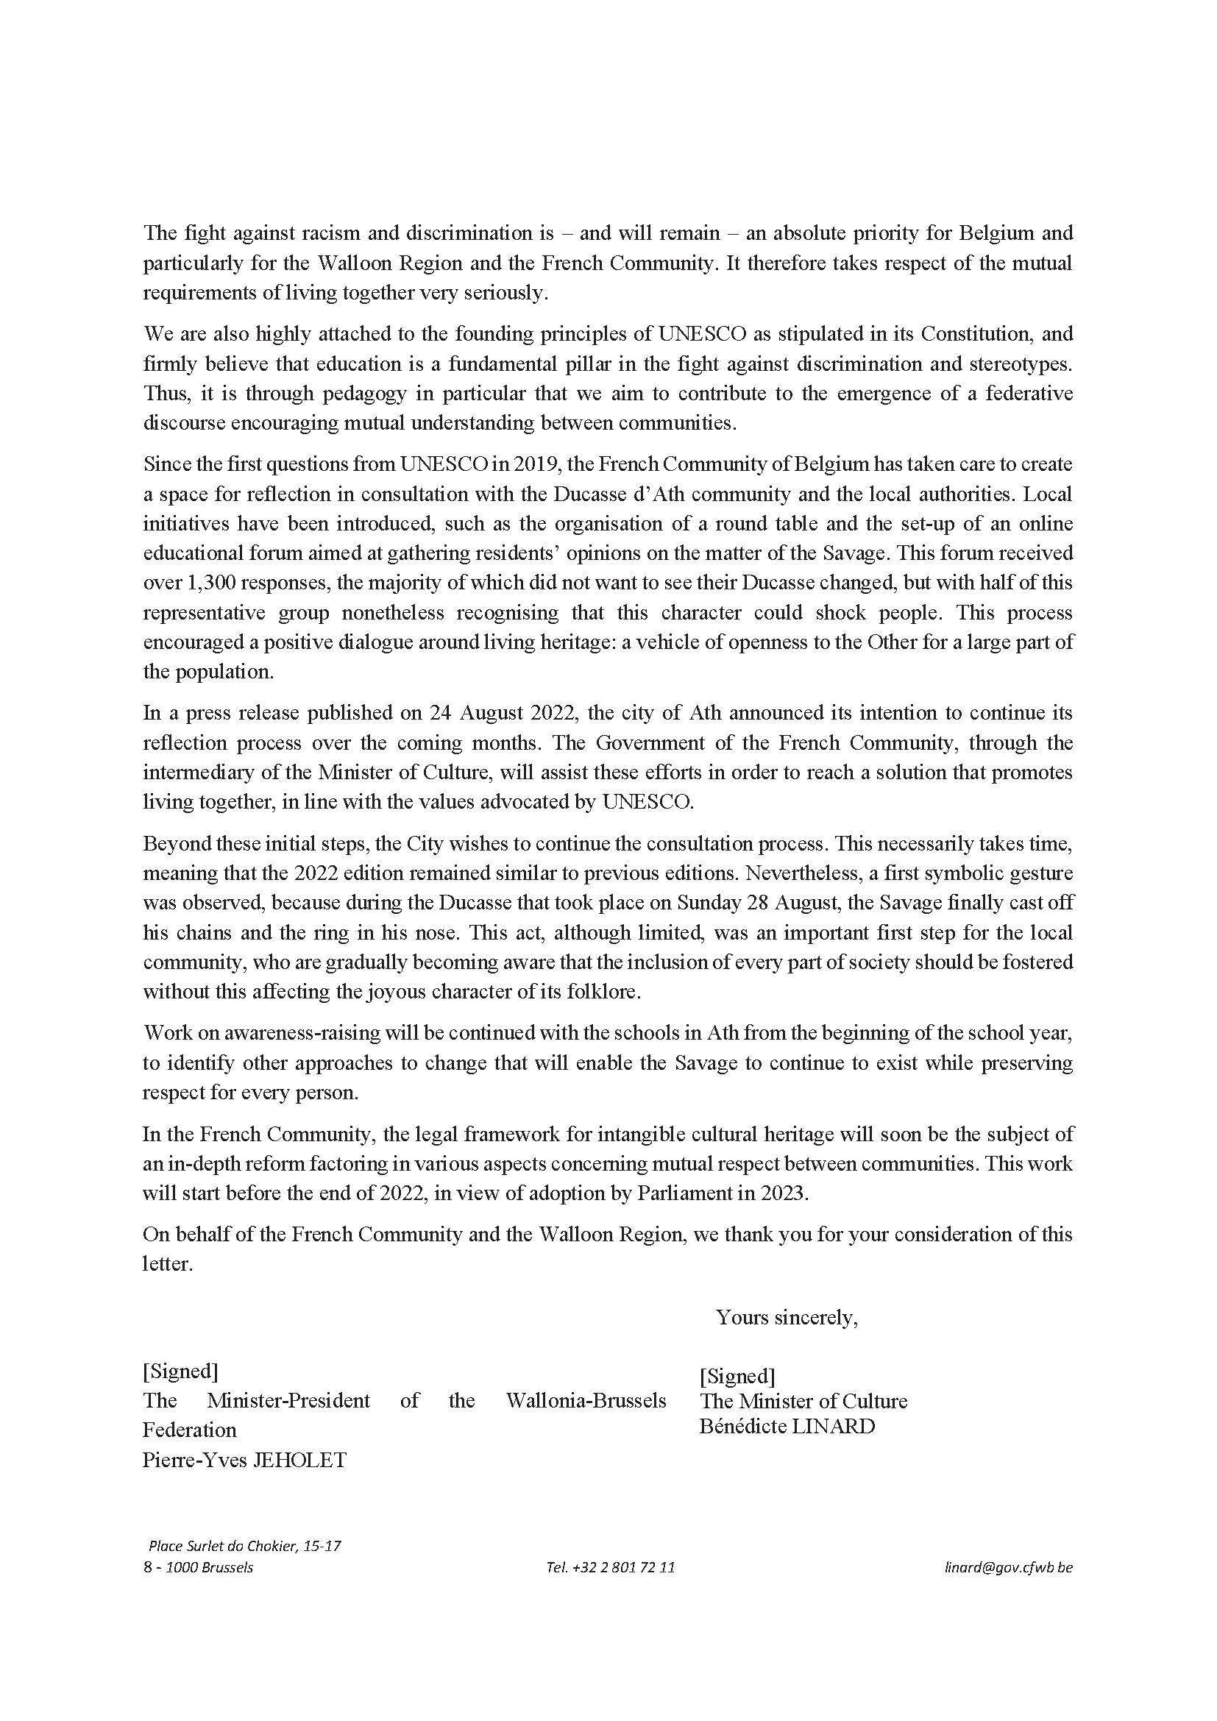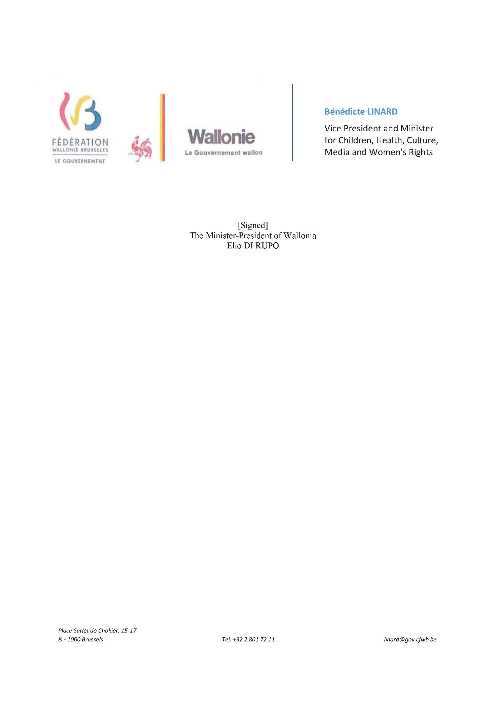

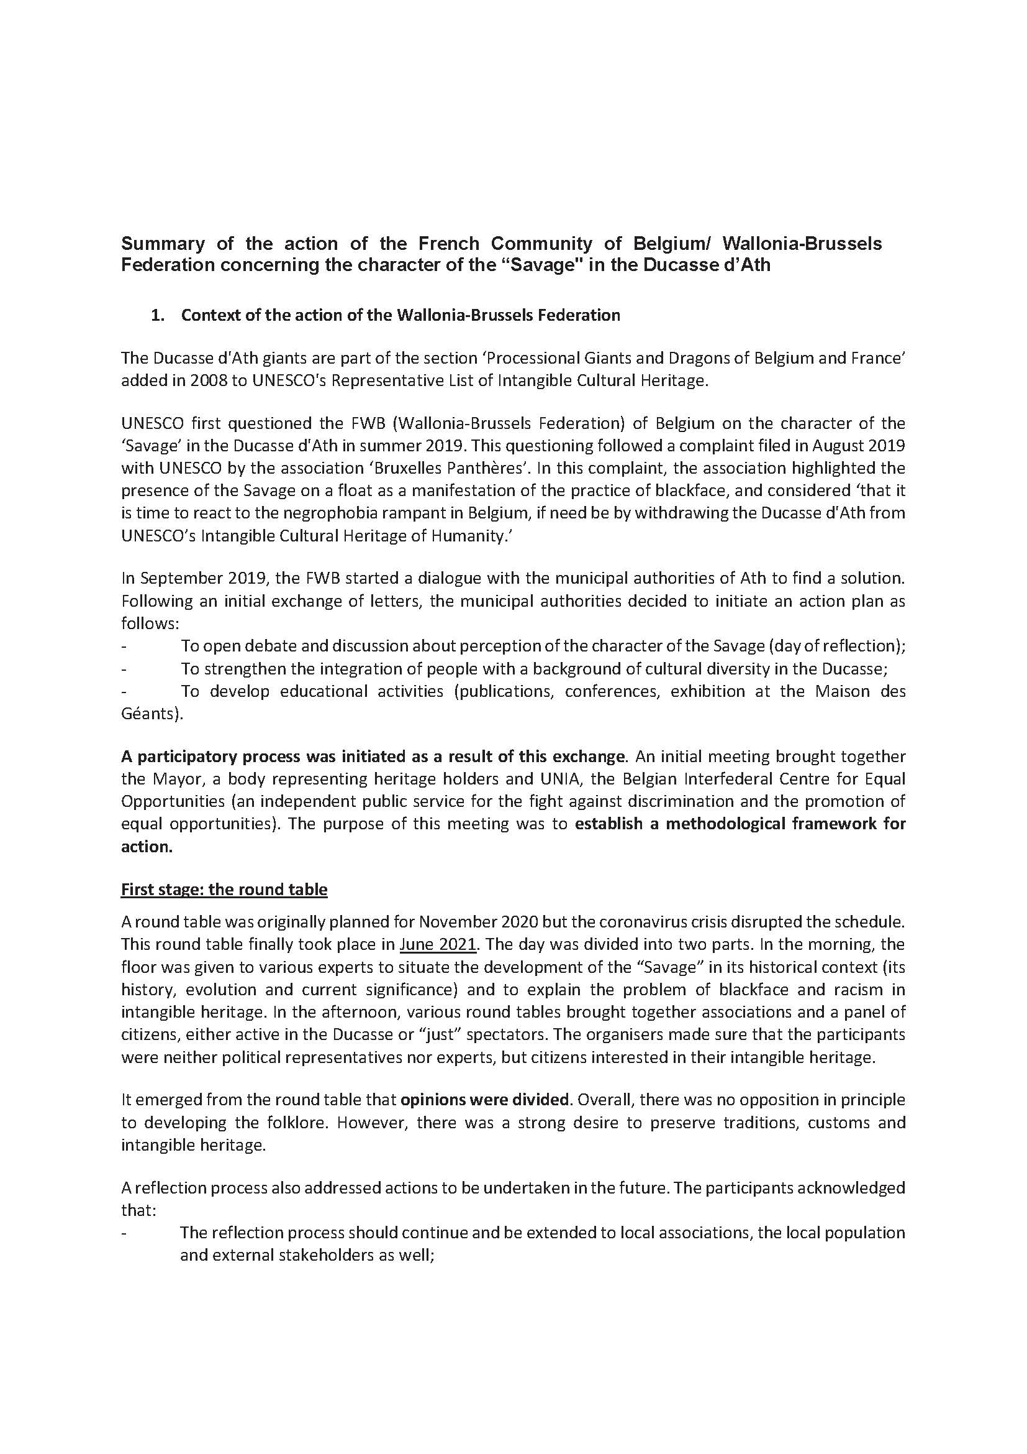

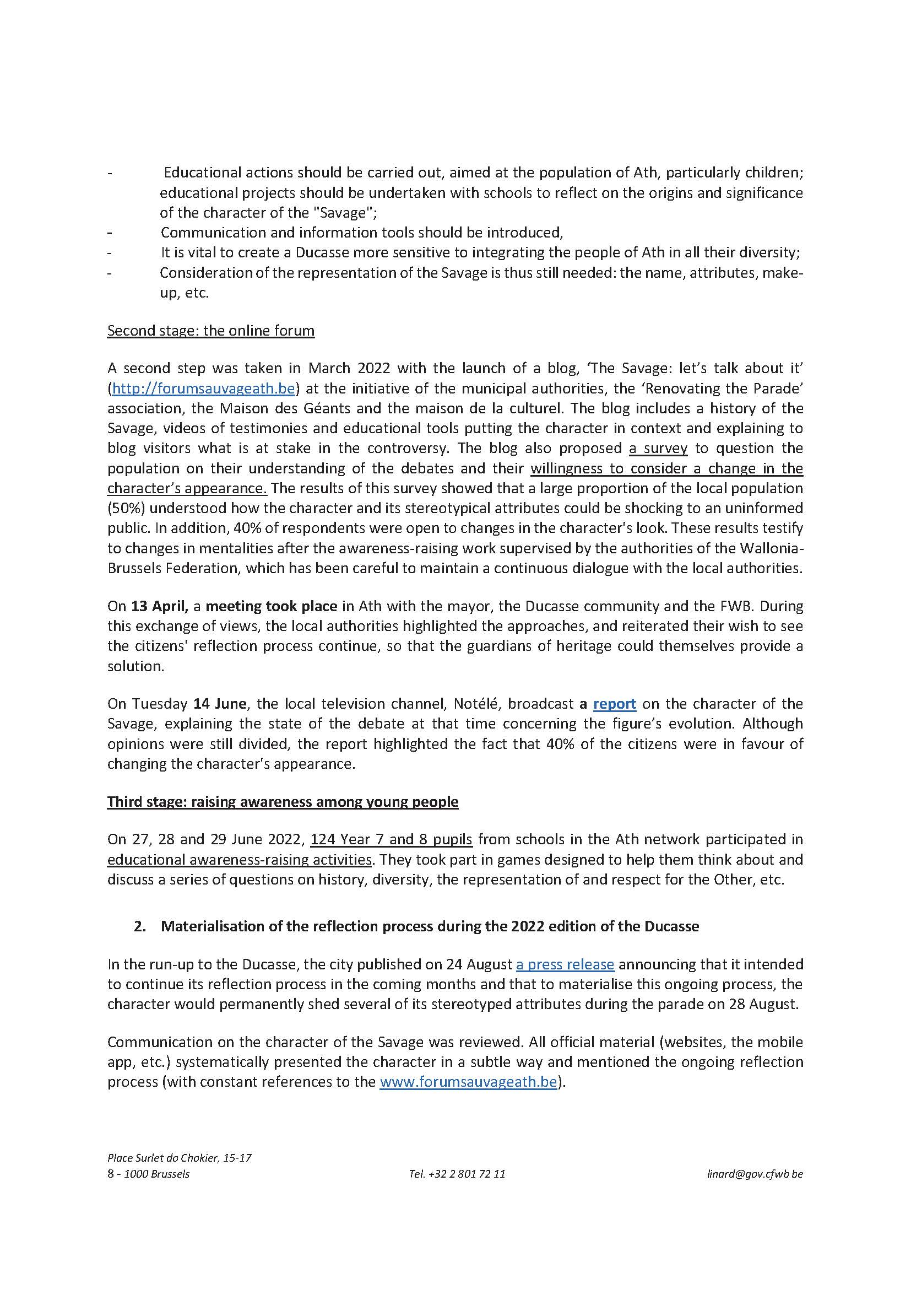

1. At its thirteenth session in 2018, the Committee took note of eight cases of elements which were the subject of correspondence (document ITH/18/13.COM/9; Decision 13.COM 9). At its fourteenth session in 2019, the Committee took note of four cases of elements which were the subject of correspondence (document LHE/19/14.COM/14; Decision 14.COM 14), and also decided on the removal of an element (document LHE/19/14.COM/12+Add.; Decision 14.COM 12). At its sixteenth session in 2021, the Committee took note of eight cases of elements which were the subject of correspondence (document LHE/21/16.COM/11 Rev; Decision 16.COM 11).
. The element was previously proclaimed a Masterpiece of the Oral and Intangible Heritage of Humanity in 2005 and was subsequently and automatically incorporated into the Representative List in 2008, pursuant to Article 31 of the Convention.
. Part of the nomination file for which an authorization was granted by the submitting States is made available through the webpage of the Convention.
Under the reporting period, no correspondence was received in relation to ongoing nominations.
The link provides a compilation of communications received as listed in the table.

