**CONVENTION FOR THE SAFEGUARDING OF THE  
INTANGIBLE CULTURAL HERITAGE**

**Expert meeting in the framework of the global reflection  
on the listing mechanisms under the 2003 Convention for the  
Safeguarding of the Intangible Cultural Heritage**

**Online**

**7, 26 and 27 May 2021 (Paris time/ UTC+2)**

**Summary results of the expert survey**

|  |
| --- |
| **Summary**  As part of the global reflection on the listing mechanisms of the 2003 Convention, 201 experts in living heritage safeguarding were invited to complete an online survey between 26 March and 11 April 2021. The survey aimed to seek experts’ views on the main challenges of the listing mechanisms identified so far, as well as on possible approaches for finding solutions. This document summarizes the results of the survey to feed the discussions during the present expert meeting. |

1. **Background**
2. The Committee considered it important to consult experts when initiating the global reflection on the listing mechanisms of the 2003 Convention established in 2017 ([Decision 12.COM 14](https://ich.unesco.org/en/Decisions/12.COM/14)), in order to seek their views on the main challenges of the listing mechanisms identified so far, as well as on possible approaches for finding solutions. A two-step online consultation process – a survey and a category VI expert meeting – was organized between March and May 2021, as an adjustment in response to the ongoing COVID-19 pandemic and in lieu of the expert meeting originally planned in March 2020. This document aims to feed the discussions during the present expert meeting by providing information pertaining to the results of the online survey.
3. The Secretariat invited 201 experts to participate in the survey between 26 March and 11 April 2021. The participating experts were selected with the aim of ensuring an inclusive process. They included experts nominated by States Parties during a call, present and past members of the Evaluation Body (157 in total, including past Subsidiary Body and Consultative Body members) and experts identified by the Secretariat. Diverse and broad expertise can be found amongst the respondents: some were actively involved in drafting the text of the Convention and/or in various versions of its Operational Directives, while others have direct experience with different aspects of intangible cultural heritage safeguarding under the 2003 Convention, such as drawing up inventories, preparing safeguarding plans or drafting nomination files.
4. Fifty-four experts (28 men and 26 women) responded to the survey, which was available in [English](https://ich.unesco.org/doc/src/LHE-21-EXP-INF.2-EN.pdf) and [French](https://ich.unesco.org/doc/src/LHE-21-EXP-INF.2-FR.pdf) . The geographical distribution concerning the nationality of the survey participants was as follows: 22% from electoral group I, 18% from electoral group II, 15% from electoral group III, 17% from electoral group IV, 19% from electoral group V(a) and 9% from electoral group V(b).
5. The 44 survey questions were grouped into the following four themes established during the recent intergovernmental discussions:

Theme A: overall approach to the listing mechanisms;

Theme B: issues related to the inscription criteria;

Theme C: issues related to the follow-up of inscribed elements; and

Theme D: methodology for the evaluation of nominations

The following section provides a summary of the survey findings along these four themes. In addition, [a compilation of all of the replies](https://ich.unesco.org/doc/src/LHE-21-EXP-INF.1.pdf) received is provided on the webpage (hyperlink) dedicated to the global reflection.

1. **Summary of the online survey findings**

Theme A: Overall approach to the listing mechanism

1. **Priorities** (question 1): The experts highlighted two main intentions with which the listing system should be revised. The first is the intention to ‘make the nomination process better attuned to the realities and broader safeguarding intentions and practices of communities, groups and individuals’ (22%). Several comments highlighted the need to return to the key principle of the Convention to place communities at the centre of safeguarding efforts and to make the listing mechanisms accessible to them. Many experts lamented what they characterise as the top-down approach of the current listing system, claiming that it neither reflects community aspirations and needs nor helps communities recognise and safeguard their own heritage. The second point emphasised is the need to ‘enhance the monitoring of the changing viability of inscribed elements and their safeguarding status’ (19%). This is because, as asserted by an expert, ‘monitoring and follow-up of inscribed elements is almost absent, and the periodic reports clearly do not fulfil that function’. Some experts also considered it important to ensure that the reform redress the imbalance in the use of the listing mechanisms (14%) and improve the current methodology used for evaluating and examining nominations (14%). At the same time, one expert called to be realistic and to find solutions within available resources and time, so as to respect the objectives of the Convention without burdening the system and compromising its credibility.

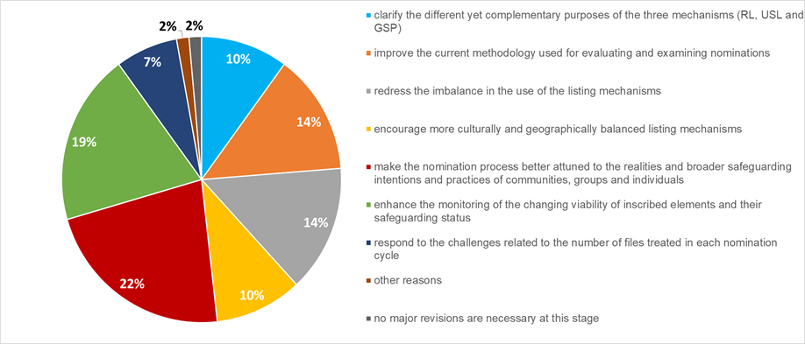

1. **Desired system** (question 2): Nearly half of the experts (48%) favoured keeping the current criteria-based selection process, possibly with enhanced follow-up and monitoring mechanisms, rather than moving to a more open and inclusive system based on a smaller number of inscription criteria (21%). At the same time, 31% of the experts opted for other options or combinations of the two systems proposed. Examples of the alternative approaches proposed include: (a) keeping the same number of criteria but providing ‘criteria that are easier to understand’; (b) ensuring a more open and inclusive Register for Good Safeguarding Practices; and (c) creating ‘a system that allows for the systematic inclusion of elements’ on the Representative List, including a ‘wiki’ modem.
2. **Sunset clause** (question 3): Concerning the introduction of a sunset clause for the Representative List, the experts were divided, with 51% in favour and 49% against. A proponent of the sunset clause expressed that ‘as long as no adequate follow-up system is installed, this [a sunset clause] is unavoidable. It is better to ensure the visibility for new items, and to give them [communities] opportunities to raise awareness and stimulate dialogue’. One argument against the use of a sunset clause is that it would ‘place into limbo how the Convention considers an element, if there is no adjunct instruction on how “formerly” inscribed elements are to be treated’. A possible misunderstanding and disappointment by communities and States Parties was also listed as an argument against the use of a sunset clause.
3. **Priorities and annual ceiling** (questions 4–6): Most experts agreed that in the context of an annual ceiling of files that can be treated, high priority should be given to nominations for the Urgent Safeguarding List (56%) and lower priority to nominations for the Representative List (35%). Concerning the current ceiling of nomination files, nearly half of experts (48%) considered that the number of files treated in a given cycle is appropriate, whereas 26% of experts thought that an increase is necessary and 11% wished for a decrease. At the same time, a clear majority of the experts (70%) considered it appropriate to have a separate annual ceiling for each mechanism.
4. **Underutilization of the Urgent Safeguarding List** (questions 7–8):According to the experts, the Urgent Safeguarding List had been under-utilized mainly because States Parties do not wish to be viewed by the international community as not taking adequate safeguarding actions at the national level, and this is so partly because of confusion with the List of World Heritage in Danger. Some also attributed the underutilization of the Urgent Safeguarding List to the competition with the more ‘prestigious’ Representative List, since the priority and annual ceiling of files do not allow States Parties to nominate elements to both Lists at the same time. In terms of concrete actions to be taken to redress the underutilization of the Urgent Safeguarding List, the experts considered three measures pertinent: (a) ensuring that funding from the International Assistance of the Intangible Cultural Heritage Fund is available for the approved safeguarding plans once elements are inscribed on the Urgent Safeguarding List (26%); (b) systematically offering technical assistance once States Parties have declared their intention to prepare files for the Urgent Safeguarding List (26%); and (c) transferring elements that have regained sufficient viability from the Urgent Safeguarding List to the Representative List (23%). A few experts considered it necessary to shorten the duration of the process for inscription on the Urgent Safeguarding List (12%).

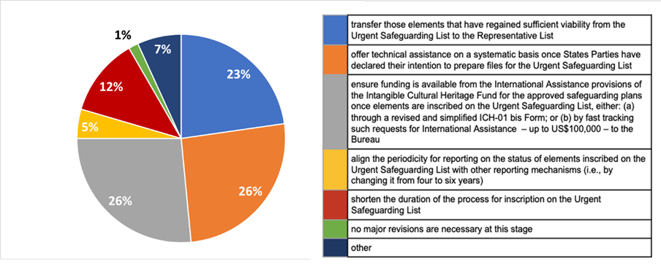

1. **Purposes of the Representative List** (questions 9–11): There is a general agreement that the Representative List has accomplished two of the three purposes outlined in Article 16 of the Convention, namely to ensure better visibility of intangible cultural heritage and to promote awareness of the significance of intangible cultural heritage. However, many expressed doubts about the third point corresponding to the power of the Representative List to encourage dialogue. Some are concerned by the political rivalry, conflict between States and nationalist feelings nurtured by the inscription process. In relation to the intent, half (50%) understand ‘representative’ as encompassing as many examples as possible that highlight the breadth and diversity of communities and their living heritage. For others, it means highlighting the diverse domains or types of intangible cultural heritage (20%) or the diversity of communities around the world (18%). Suggestions for changes include creating a system that enhances community involvement while reducing political considerations and State control, or that strengthens follow-up and monitoring on the status of inscribed elements. Several experts considered it useful to transform the Representative List into an ‘open catalogue’ that lists as many elements of living heritage as possible or into an ‘encyclopaedia’.
2. **Making the Register more useful** (question 12): The vast majority of experts (89%) considered that changes are necessary to make the Register of Good Safeguarding Practices more useful and accorded equal importance to: (a) the establishment of an alternative and simpler validation system for the Register that is separate from the inscription system for the two Lists (38%); and (b) the inclusion in the Register of safeguarding activities that have successfully revitalized elements inscribed on the Urgent Safeguarding List (38%). Such changes may encourage States to pay closer attention to the Urgent Safeguarding List and ‘strengthen the inter-relationship between the two lists’. Other suggestions included allowing actors other than States Parties (such as NGOs and communities) to propose good safeguarding measures, or establishing a process separate from the annual nomination cycle that would allow the Committee to ‘periodically identify themes and safeguarding domains and solicit proposals’ that specifically address them.

Theme B: Issues related to the inscription criteria

1. **Overall trend** (questions 13–19): As shown in the table below, most experts did not consider it necessary to remove or revise the inscription criteria for any of the three mechanisms, with the clear exception (71%) of criterion R.2 for the Representative List. At the same time, about a quarter of experts expressed the need to revise criterion U.3 on safeguarding plans for the Urgent Safeguarding List (22%) and criterion R.3 on safeguarding measures for the Representative List (24%). Concerning the Register of Good Safeguarding Practices, criterion P.9 attracted the most attention (49%) and to a lesser extent criteria P.6 (26%) and P.8 (28%).

|  |  |  |  |  |  |  |  |  |
| --- | --- | --- | --- | --- | --- | --- | --- | --- |
| **Urgent Safeguarding List** | | | **Representative List** | | | **Register of Good Safeguarding Practices** | | |
| Criterion | Yes | No | Criterion | Yes | No | Criterion | Yes | No |
| U.1 | 2% | 98% | R.1 | 7% | 93% | P.1 | 5% | 95% |
| U.2 | 15% | 85% | R.2 | 71% | 29% | P.2 | 26% | 74% |
| U.3 | 22% | 78% | R.3 | 24% | 76% | P.3 | 8% | 92% |
| U.4 | 11% | 89% | R.4 | 10% | 90% | P.4 | 13% | 87% |
| U.5 | 7% | 93% | R.5 | 9% | 91% | P.5 | 13% | 87% |
| U.6 | - | - |  |  |  | P.6 | 26% | 74% |
|  |  |  |  |  |  | P.7 | 18% | 82% |
|  |  |  |  |  |  | P.8 | 28% | 72% |
|  |  |  |  |  |  | P.9 | 49% | 51% |

1. 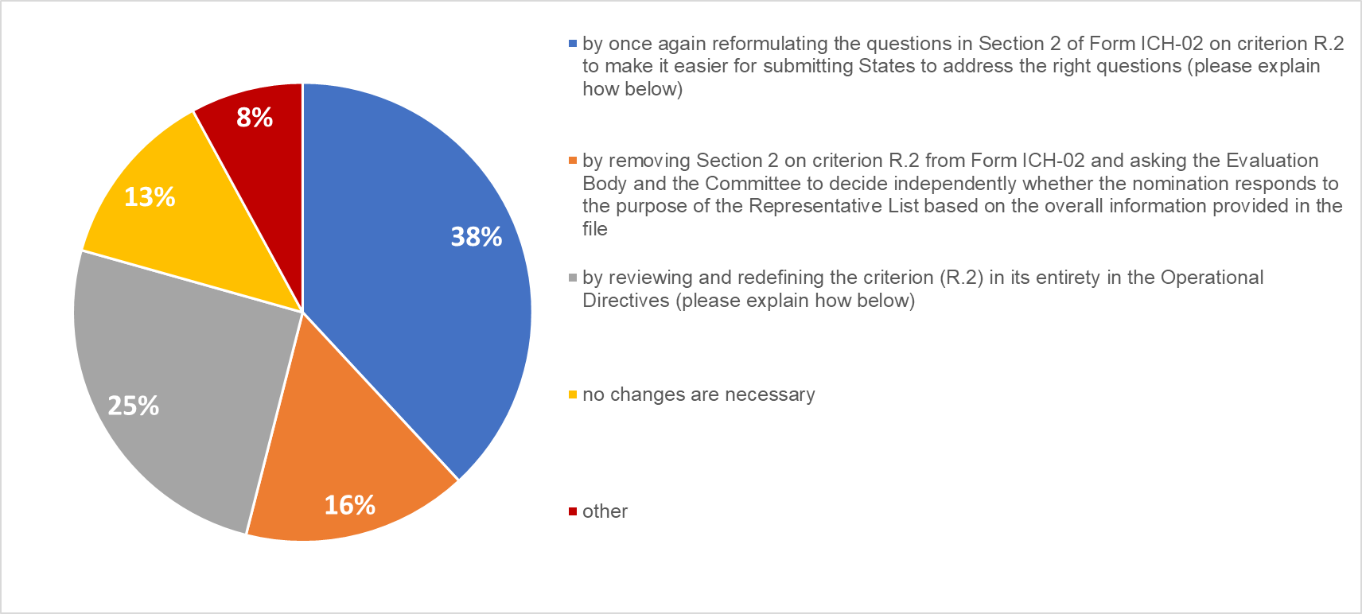**R.2** (questions 16–17): Those experts who considered it necessary to review criterion R.2 referred to the recurrent problems encountered by States Parties and pointed to the ‘subjective’ and ‘aspirational’ character of the criterion and that requires views on the future of the inscribed elements. There is also a general feeling that the way the questions are formulated in section 2 of Form ICH-02 are not helpful. In order to redress the issue, most experts (38%) showed a preference for the option to once again reformulate the questions on criterion R.2 in Form ICH-02.Some of the proposed courses of action in this regard include simplifying the questions while making them evidence-based or linking criterion R.2 to sustainable development (such as through multiple-choice questions). Some experts (25%) preferred to review and redefine criterion R.2 in its entirety in the Operational Directives and suggested merging considerations addressed by criterion R.2 with criterion R.1 or even removing criterion R.2 altogether.
2. **U.3** (question 14) **and R.3** (question 15): The experts who supported the revision of criterion U.3 considered it crucial to link safeguarding efforts directly to communities concerned (by changing ‘may’ to ‘will’, for example). A few comments concerning criterion R.3 made a similar point about the central role of communities in safeguarding. Additionally, an expert suggested revising Form ICH-02 to ask two separate questions (rather than one as currently is the case), one about the risks and threats to the viability of elements that might occur following inscription, and the other about potential corrective measures.
3. **P.9 and other criteria** (questions 18 and 19): Half of the experts advocated for revising or removing P.9 and considered this criterion outdated and confusing. Some experts provided comments to suggest that the revision of criterion P.9 should highlight the usefulness of the practices proposed in regard to sustainable development. A minority questioned the usefulness of criterion P.2 and raised the possibility of merging some of the criteria, for example criteria P.1, P.4 and P.8 and criteria P.5 and P.7. or removing criterion P.6

Theme C: Issues related to the follow-up of inscribed elements

1. **Periodic Reporting and follow-up of inscribed elements** (questions 20 and 21): More than 90% of the experts thought that the Periodic Reporting mechanism alone is insufficient for monitoring the status of inscribed elements. This is mainly because the reports are based on self-assessment and prepared by national authorities with limited participation of communities and other stakeholders. There are also no sanctions or consequences for late or missing submissions, and some experts referred to the long interval between reporting cycles implying that the Committee does not learn about potentially problematic issues until it is too late. In general, experts feel that additional measures are desirable to better monitor the impact of the inscription and to ensure the viability of elements, as well as to monitor the effectiveness of the safeguarding plans and measures by States Parties at the time of inscription.
2. **Possible additional measures** (questions 22 and 23): Suggestions for measures in addition to Periodic Reporting included: (a) the creation of an open communication platform where States Parties, communities and other stakeholders could report on the status of elements; (b) the use of audio-visual materials to facilitate reporting by communities; (c) the creation of an independent intangible cultural heritage observatory; (d) the use of expert evaluations; and (f) aligning the periodicity and reporting of the two Lists at four years. At the same time, an expert felt that there should be no follow-up for elements inscribed on the Representative List since ‘they have been listed as an illustration of cultural diversity’, while others wondered whether a sunset clause for the Representative List would be a solution.
3. **Role of stakeholders and communities** (question 24): An overwhelming majority of experts agreed that communities should play the primary role in the follow-up or monitoring of an element post-inscription. Many advocated for a system allowing communities to directly report to the governing organs of the Convention. This could take place either through a parallel channel in addition to the reporting by States Parties, or as the main reporting channel (although some experts cautioned that communities may require training to this end). A number of experts supported the view that all stakeholders should work together with the aim of placing communities at the centre of the follow-up and monitoring process, while some mentioned the role NGOs could play in this regard, such as by preparing shadow reports on the status of inscribed elements.
4. **Information received by the Secretariat** (question 25): Regarding the mechanisms to be established for treating information received by the Secretariat, several experts suggested systematically sending the information to the States Parties concerned for additional details, clarifications and comments. One other suggestion was to share the information received with the Evaluation Body or some other independent review committee for evaluation, be it for elements already inscribed or for nominations under consideration.
5. **Removal of an element**: In general, experts agreed that an element should be removed from the Urgent Safeguarding List (question 26) once its viability is ensured, since it is no longer in need of urgent safeguarding. As for the Representative List (question 29), experts considered that an element should be removed when it no longer complies with the principles of the Convention and with the inscription criteria. For both Lists, experts suggested (question 32) considering a removal when: (a) an element violates human rights requirements; (b) an element is no longer viable; or (c) the inscription proved damaging for the element and its communities. Some experts also expressed the opinion that a removal should be automatic for the Representative List after a number of years (in the sense of a sunset clause).
6. **Who can initiate the removal process** (questions 27 and 30):For both the Representative List and the Urgent Safeguarding List, many considered that the community itself should be able to initiate the removal process, while others also thought that accredited NGOs, the ICH NGO Forum and the Secretariat could also be mandated to do so. In the opinion of several experts, this is in addition to the Committee who is already empowered to initiate a removal process (in paragraphs 39 and 40 in the Operational Directives of the Convention).
7. **Supporting information** (questions 28 and 31): Many experts advocated for a system whereby several stakeholders could provide information to consider the removal of an element from either of the two Lists. The ICH NGO Forum and members of the global facilitators network were listed as entities that could be entrusted with this task. In terms how to collect the information, experts mentioned on-site missions, needs assessments and community surveys. Some expressed the opinion that information on the status of an element should be accompanied by a consent or by comments from the communities that initiated the inscription or the removal process, as well as by comments from communities that could be negatively affected by decisions to remove the element from the Urgent Safeguarding List. On the other hand, others considered that the information should be communicated to the Committee only through States Parties,since ‘any form of external scrutiny or expertise would violate the principle under which nominations are evaluated and elements inscribed’.
8. **Transfer of an element from one list to another** (questions 33, 34 and 35):There was a broad agreement that the Committee should be able to transfer an element from the Representative List to the Urgent Safeguarding List (87%) and vice-versa (92%). For the Committee to decide to transfer an element from the Urgent Safeguarding List to the Representative List, it was considered necessary to first demonstrate that the element is no longer in need of urgent safeguarding (98%). Nearly half of the experts also expressed that communities, groups and individuals (44%) are best placed to ascertain whether an element is no longer in need of urgent safeguarding, followed by experts and NGOs (34%) and States Parties (21%). Many comments highlighted the complementary roles of the different stakeholders. For example, while communities should have the primary role, experts and NGOs can assist communities in their own assessments and advise States Parties about possible outcomes and consequences.
9. **Automatic transfer** (questions 36 and 37): The majority of experts considered that when an element is deemed to be no longer in need of urgent safeguarding, it should not be automatically transferred to the Representative List (77%), arguing that elements should only be transferred at the request of the State Party and preferably with the consent of the communities concerned. Others were in favour of applying the normal nomination procedure so that the transfer cases be examined by the Committee to ensure that the element fulfil the criteria of the Representative List.

Theme D: Methodology for the evaluation of nominations

1. **Composition of the Evaluation Body** (question 38): Most experts agreed that the current composition of the Evaluation Body is appropriate for evaluating nominations (79%), mainly because of its proven efficiency and credibility over the years as well as the diverse profiles of the Evaluation Body members. Suggestions for improvement include: (a) increasing the capacity of the Evaluation Body to evaluate more files; (b) organizing a capacity-building session before members begin their mandate; and (c) electing experts in their personal capacity rather than as representatives of States Parties.
2. **Overall methodology and process** (questions 39 and 40):More than half of the experts agreed that the Evaluation Body’s current evaluation methodology and process need to be reviewed (55%), rather than keeping it unchanged (45%). Several experts suggested that possible revisions should seek to ensure the independence of the Evaluation Body and the consistency of its recommendations. Others recommended fine-tuning the dialogue process. There was also a suggestion to clarify the principle of evaluation to focus on the values that elements have for communities rather than on vocabulary. In this regard, words such as ‘tourism’ and ‘commercialization’ should be evaluated within the overall context of the enactment, and merit should be given to efforts to achieve sustainable tourism and commercialization, for instance.
3. **Information outside the file** (question 41): According to many experts (67%), the Evaluation Body should be able to consult information outside the file so as to enhance knowledge and understanding about the element by using information from different perspectives. At the same time, experts suggested that the Evaluation Body consult information outside the file primarily when there is strong evidence that the information in the file is inaccurate or contradictory. It was also suggested that States Parties have the possibility to reply and comment on the external information used by the Evaluation Body. Arguments against using external information (35%) include the inequality in the treatment of nominations – as some elements are better-documented and have more information in the public domain than others – and a departure from the fundamental principle of the 2003 Convention that only the communities, groups and individuals can recognize their own intangible cultural heritage.
4. **Multinational files** (questions 42 and 43): Slightly more than half of the experts (54%) are in favour of simplifying the process of extending multinational inscriptions to include additional States Parties. Many argued that the current process is cumbersome and can deter States Parties from pursuing international cooperation through multinational files. Those favouring simplification suggested to request only newly joining States Parties to demonstrate that the element satisfies the inscription criteria, instead of requiring – as is the case under the current system – that all the States Parties participating in the nomination (whether newly joining or part of existing nominations) satisfy the inscription criteria. At the same time, some experts reasoned that the States Parties of the original nomination should at least seek the consent of their own communities to include newly joining communities. Another suggestion was to empower the Bureau of the Committee to examine requests for extensions of multinational files in a fast-track procedure or through the Periodic Reporting exercise. That said, those against such simplifications cautioned against using multinational files as a way to circumvent the annual ceiling of files.

Other ideas to improve the listing mechanisms of the 2003 Convention

1. In addition to the aspects mentioned above, experts provided a few other suggestions (question 44) that are pertinent for the reflection on the listing mechanism of the 2003 Convention, namely to:

a. examine the listing system every two to three years with the aim to improve it;

b. organize regional meetings with a view to discuss how to further improve the listing mechanisms in order to reflect regional characteristics;

c. undertake areview on the effects of the inscription of elements on communities and practitioners by the communities themselves;

d.provide States Parties with expert advice during the preparation of their nominations;

e.set up special awards or prizes to recognise the participation of communities in the safeguarding efforts; and

f. use the Secretariat’s ‘Dive into Intangible Cultural Heritage’ initiative to enhance the visibility of intangible cultural heritage and make the tool accessible to communities.