CONVENTION FOR THE SAFEGUARDING OF THE
INTANGIBLE CULTURAL HERITAGE
Open-ended intergovernmental working group
in the framework of the global reflection on the listing mechanisms
of the 2003 Convention
Online
8 and 9 July 2021 (Part I)
9 and 10 September 2021 (Part II)
General Information
- Open-ended intergovernmental working group in the framework of the global reflection on the listing mechanisms under the 2003 Convention
- The Open-ended intergovernmental working group in the framework of the global reflection on the listing mechanisms under the 2003 Convention (thereafter ‘working group’) will be organized in two parts: Part I will be held on 8 and 9 July 2021 and Part II on 9 and 10 September 2021. Given the ongoing restrictions related to the COVID-19 pandemic, both Part I and Part II will take place online using the Zoom platform.
For Part I there will be four sessions of 90 minutes each day (UTC+2 / Paris time): the morning sessions will be held from 9:30 a.m. to 11:00 a.m. and 11:30 a.m. to 1:00 p.m., and the afternoon sessions will be held from 2:00 p.m. to 3:30 p.m. and 4:00 p.m. to 5:30 p.m. The timetable of Part II of the meeting will be communicated to you nearer the date.
- The working group will begin its work by electing the members of its Bureau on the first day of Part I of the meeting, who will remain in office until the end of the meeting (both Part I and Part II).
Webpage
- All relevant information for the Open-ended intergovernmental working group in the framework of the global reflection on the listing mechanisms under the 2003 Convention, including the registration page, preliminary list of participants, agenda and timetable as well as all other documents for the meeting, can be found on the corresponding webpage at: https://ich.unesco.org/en/open-ended-intergovernmental-working-group-01167. During the four days of the meeting, participants will be able to find the webcast on: https://ich.unesco.org/en/live-webcast-and-recordings-part-i-01181.
Documents
- Documents corresponding to the items inscribed on this agenda were published on the Convention’s website on 28 June 2021 in the two working languages of the 2003 Convention (English and French). If you are unable to download the documents, you may send an e-mail to the Secretariat of the Convention at: ichmeetings@unesco.org.
Registration
- All participants, delegates, observers, and those wishing to attend the working group are strongly advised to register as soon as possible. This is to allow enough time to process all the relevant information and to ensure that all online arrangements are in place before the opening of the meeting.
Please complete the online registration form at: https://ich.unesco.org/en/registration-01177.
- Online modality
- The working group will take place online using the Zoom platform and will be simultaneously webcast, in both English and French, on the webpage for the meeting (https://ich.unesco.org/en/live-webcast-and-recordings-part-i-01181).
Technical set up and troubleshooting
- It is suggested that participants check their technical setup in advance in order to ensure an optimal meeting experience. In this regard, participants should:
  - Join the meeting on a laptop of desktop computer (not a phone or a tablet).
  - Favour a wired connection to the internet.
  - Use a headset with a microphone, if possible.
  - Download Zoom (free) in advance of the meeting through the Zoom Download Centre at: https://zoom.us/download
  - Login at least 30 minutes in advance on the first day of the meeting.
- An automatic email will be sent to your email providing you with the link to access the meeting room (the same link can be used to access the meeting for 8 and 9 July 2021 for Part I and 9 and 10 September for Part 2). Click on the link provided. When you first join the meeting, you should click ‘Test Speaker and Microphone’ and follow the instructions. Once you have joined the meeting, you will be in the ‘Waiting Room/Lobby’ until you are let into the meeting by the host. Please note this may take some time on the first day of the meeting due to the number of participants.
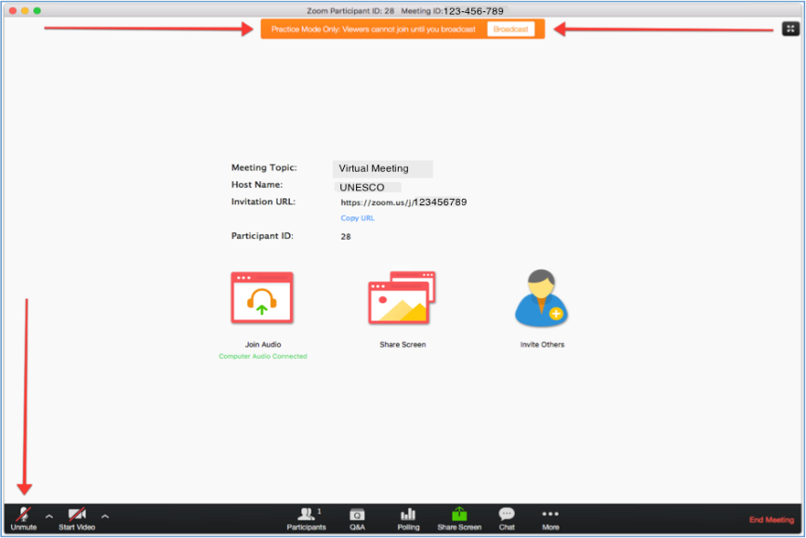
- You need to accept ‘Access the Microphone’ and ‘Access the Camera’. The microphone and video, which can be found in the bottom left corner are ‘on’ when there is no red line over them. Participants’ microphones should be kept on mute at all times except when called on by the Chairperson to give an intervention.
- If you are encountering technical difficulties during the meeting, it is suggested that you first try exiting and re-entering the meeting or try connecting from a different browser. You may also contact the help desk whose contact details will be made available on the website of the 2003 Convention soon.
Active participants
- The Zoom system can accommodate up to 500 active participants. Active participants may take the floor during the debate and intervene using camera/audio. All other participants may follow the online webcast on the event webpage. Each State Party is guaranteed two active connections and each State not party will receive one active connection. Each member of the Steering Committee of the ICH NGO Forum may receive one active connection and each Category 2 Centre will receive one active connection. Additional connections may be provided upon request and depending on availability. When registering, participants should indicate whether they are to be granted an active participation to the meeting.
Naming of speakers
- Participants who requested an active connection will be renamed by the Secretariat prior to the meeting as follows:
If you represent a State Party:
SP-Country (Last name)
If you represent a State not Party to the Convention:
SNP-Country (Last name)
If you represent an NGO:
NGO- NGO Name (Last name)
If you represent a category 2 centre:
C2C-Centre Name (Last name)
Taking the floor
- Participants who have an active connection are able to request to take the floor by pressing the ‘raise hand’ button, which will display a blue hand beside the participant’s name. This button can be found at the bottom of the list of participants.
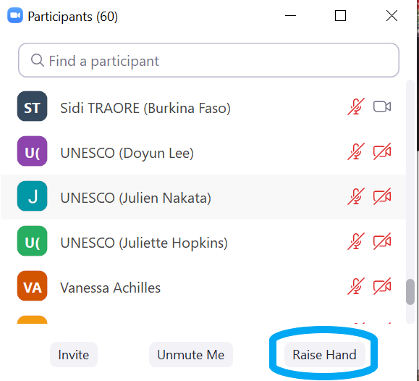
Once the blue hand is raised, it will signal to the Chairperson that the participant would like to take the floor and they will be added to the list of speakers. When the Chairperson calls on a participant to take the floor, they should unmute their microphone using the microphone button in the bottom right corner. Ideally, as long as the internet connection allows, participants should also use their video. After the participant has finished their intervention, they should put their microphone on mute again to avoid background noise.
Chat box
- The chat box is located at the bottom right hand corner of your screen. It can be used to signal a technical problem to the Secretariat. It can also be used by participants wishing to signal a point of order. In this case, the participant should raise their hand to indicate they wish to speak and type ‘Point of order’ in the chat box. The chat box should not be used for submitting amendments. These should be submitted by email to:
ICH-amendments@unesco.org.
- Questions/Answers
BEFORE THE MEETING
Should I register before the meeting? | All participants are encouraged to register as soon as possible and to do so online: https://ich.unesco.org/en/registration-01177  If you encounter any technical problems registering, please contact the Secretariat at ichmeetings@unesco.org
What is an ‘active connection’? | An active connection is for those participants who need to speak during the debate. They may intervene in the meeting using camera/audio.
DURING THE MEETING
How many people can participate in the meeting? | The maximum number of online active participants who may take the floor is 500.  There is no limit on the number of people who may follow the webcast.
If I am registered, will I be able to take the floor during the meeting? | The priority given to States Parties, then observers (States not Party, intergovernmental organizations, non-governmental organizations, etc.)
How can I submit an amendment? | Send your amendment in advance, and as soon as possible to ICH-amendments@unesco.org, with the names of the co-sponsors.  Please do not submit amendments via the chat box during the meeting.
How can I raise a point of order? | States wishing to make a point of order should raise their hand and indicate ‘Point of Order’ in the chat box.
AFTER THE MEETING
Where can I find the recordings of the meeting? | The recordings of the meeting will be made available on the webpage of the Convention related to the global reflection, after the meeting has finished and as soon as they are available.

