CONVENTION FOR THE SAFEGUARDING OF THE
INTANGIBLE CULTURAL HERITAGE
INTERGOVERNMENTAL COMMITTEE FOR THE
SAFEGUARDING OF THE INTANGIBLE CULTURAL HERITAGE
Sixteenth session
Online
13 to 18 December 2021
FINANCIAL REPORT FOR THE PERIOD
1 JANUARY 2020 TO 30 JUNE 2021
Summary
In conformity with Article 10.1 of the Special Account for the Fund for the Safeguarding of the Intangible Cultural Heritage’s Financial Regulations, a biennial financial report showing the income and expenditure ‘shall be prepared and submitted to the Committee and the General Assembly’. The present document includes the Financial Report for the Intangible Cultural Heritage Fund for the period 1 January 2020 to 30 June 2021.
- The present Financial Report of the Special Account for the Fund for the Safeguarding of the Intangible Cultural Heritage (hereafter ‘the Fund’) covers the period 1 January 2020 to 30 June 2021. The Fund is governed by its Financial Regulations, adopted by the Committee at its first extraordinary session and last amended by the General Assembly at its eighth session (Resolution 8.GA 7). According to Article 10.1 of the Financial Regulations of the Fund, a financial report for the entire biennium (1 January 2020 to 31 December 2021) will be submitted to the General Assembly of the States Parties at its ninth session in June 2022.
- The sources of income of the Fund are stipulated in Article 25.3 of the Convention and Article 5 of the above-mentioned Financial Regulations. During the reporting period, the resources of the Fund related to the compulsory and voluntary assessed contributions from States Parties were utilized according to the Plan for the use of the resources of the Fund approved by the eighth session of the General Assembly in September 2020 (Resolution 8.GA 7).
- Income (Statement I)
- During the reporting period, the income of the Fund consisted of:
- Compulsory and voluntary assessed contributions from States Parties
Compulsory contributions from 175 States Parties to the Convention, as described in Article 26.1 of the Convention | US$3,800,602
Voluntary contributions received from three of the five States Parties which, at the time of their ratification, had recourse to Article 26.2 of the Convention | US$430,019
- Voluntary supplementary contributions
Contributions made for specific purposes relating to specific projects approved by the Committee, in accordance with Article 25.5 of the Convention
From Azerbaijan to support the development and implementation of capacity-building activities for safeguarding intangible cultural heritage in conflict-related situations, including situations of forced displacement (Decision 12.COM 6) | US$100,000
From France for the implementation of the programme ‘Strengthening capacities to safeguard intangible cultural heritage and contribute to sustainable development’ (Decision 12.COM 6) | US$271,445
From Kuwait for the implementation of the programme ‘Strengthening capacities at the national and local levels for the safeguarding of intangible cultural heritage in Dominica’ (Decision 12.COM 6) | US$65,000
From Switzerland to support capacity-building in the field of intangible cultural heritage and natural disasters (Decision 12.COM 6) | US$100,000
From ICHCAP (International Information and Networking Centre for Intangible Cultural Heritage in the Asia-Pacific Region) for the implementation of the programme ‘Living Heritage and the Sustainable Development Goals: Safeguarding intangible cultural heritage through formal and non-formal education in the Asia and the Pacific Region and in Africa’ (Decision 12.COM 6) | US$180,000
Sub-fund intended exclusively to strengthen the human capacities of the Secretariat (Resolution 3.GA 9)
Lithuania, Monaco, Palestine, Slovakia and Fondazione Museo del Violino Antonio Stradivari | US$40,823
- Interest credited to the Fund | US$184,853
TOTAL | US$5,172,742
- Compared to the same period in the preceding biennium, the total income during the reporting period increased by 16% due mainly to the increase of voluntary supplementary contributions (from US$77,772 to US$757,268). While interests decreased by 50%, this was offset by the increase in voluntary assessed contributions (from US$363,260 to US$430,019) and compulsory assessed contributions (from US$3,629,786 to US$3,800,602). As of 30 June 2021, the total unpaid balance of assessed contributions represented the equivalent of 74% of compulsory contributions assessed for 2021.
- Schedule of appropriations and expenditure (Statement I and Schedule 1.1, pages 6–7)
- By its Resolution 8.GA 7, the General Assembly approved a budget of US$7,840,379 for the period 1 January 2020 to 31 December 2021, as shown by the schedule of appropriations and expenditure. This corresponds to the balance of the Fund (excluding the sub-fund dedicated to specific activities approved by the Committee and the sub-fund for Enhancing the human capacities of the Secretariat) on 31 December 2019 (US$8,840,379) less the Reserve Fund accumulated up to that date (US$1,000,000).
- The Financial Report (Schedule 1.1) shows a total expenditure of US$2,537,375 as of 30 June 2021, which is 32% of the approved budget. This represents a decrease compared to the situation in the 2018–2019 biennium (47% expenditure rate on 30 June 2019), which is largely due to the impacts of the COVID-19 pandemic on the implementation of operational projects and the organization of statutory meetings. Explanations for each budget line of the schedule of appropriations and expenditure are provided below.
- In line with the priorities set by the Guidelines for the use of the resources of the Fund in Chapter II.1 of the Operational Directives, the General Assembly decided that the majority of the resources (budget line 1, 51.96% of approved budget) would continue to be allocated to the provision of International Assistance to States Parties. The expenditure rate (25%) corresponds to International Assistance granted by the Committee or its Bureau for eleven projects, eight of which were initiated in Africa during the reporting period. The decrease by 56% of the use of this line compared to the same period in the previous biennium is largely due to the lower number of International Assistance requests submitted by States Parties since January 2020 (27 requests registered and treated by the Secretariat during the reporting period against 48 in the 2018–2019 biennium).
- As of 30 June 2021, nine other projects – eight granted by the Bureau that met in October 2019 (Decision 14.COM 4.BUR 4.1), September 2020 (Decisions 15.COM 2.BUR 3.1, 15.COM 2.BUR 3.3 and 15.COM 2.BUR 3.5), October 2020 (Decision 15.COM 3.BUR 3.1), May 2021 (Decisions 16.COM 2.BUR 3.1, 16.COM 2.BUR 3.2 and 16.COM 2.BUR 3.3) as well as one request approved by the last Committee (Decision 15.COM 8.a.4) – for which contracts have not yet been established and are therefore not reflected in Statement I. The expenditure rate should rise up to 57% at the end of the biennium when all of the above-mentioned contracts are established, which would be on par with the expenditure rate achieved at the end of the previous 2018–2019 biennium (61%).
- The budget line 1.1 (10.79%) is used to cover the biennial costs of three extra-budgetary fixed-term posts (one P3, one P2 and one G5) that were created by the General Assembly at in 2018 to fully activate the International Assistance mechanisms and effectively monitor and evaluate their implementation (Resolution 7.GA 8). A ‘Safeguarding Implementation and Monitoring Team’ was established and has been fully operational since February 2020.
- Concerning the budget line 2 (2%), the expenditures reflected include the provision of technical assistance to four States Parties for the development and revision of their International Assistance requests, in accordance with Decision 8.COM 7.c. In one case, technical assistance was postponed due to difficulties organizing a field mission in the context of the COVID-19 pandemic.
- In conformity with the new approval procedure of the spending plan for the ‘others functions of the Committee’ (budget line 3: 20%) established by the Committee in 2019 and its transitional implementation for 2020–2021 (paragraphs 8 and 9 in Decision 14.COM 7), the use of the 2020–2021 budget was endorsed by the eighth session of the General Assembly based on a percentage breakdown in terms of Expected Results as per the approved C/5 (Resolution 7.GA 8). According to the plan approved by the General Assembly (see document LHE/20/8.GA/7 Rev.), these funds were dedicated to: capacity building and guidance on safeguarding measures and good practices (33% of budget line 3); awareness raising and outreach (27%); enhanced monitoring and knowledge-management services (27%); and the integration of intangible cultural heritage into development plans, policies and programmes (13%). Furthermore, 44% of the funds approved for the current biennium were obligated as of 30 June 2021. Based on activities and associated contracts that the Secretariat has established since 1 July 2021 and will establish until the end of the year, the expenditure rate is expected to reach 74% at the end of the biennium. A detailed report on the progress of the implementation of these funds can be found in document LHE/21/16.COM/INF.13.2, ‘Implementation report of the spending plan for the ‘other functions of the Committee’ for the period 1 January 2018 – 30 June 2021’.
- Following the Internal Oversight Service’s recommendation in its audit of the working methods of cultural conventions (IOS/AUD/2013/06), the Committee requested that the Secretariat apply the cost recovery policy consistently when using the resources of the Fund (Decision 8.COM 11). Consequently, budget lines 1 to 3 were charged with direct expenses related to their implementation.
- Due to the impossibility of holding a meeting in presentia during the COVID-19 pandemic, the Bureau of the Committee decided – through electronic consultation held from 9 to 12 November 2020 – that the fifteenth session of the Committee take place exceptionally as a fully online meeting from 14 to 19 December 2020 (Decision 15.COM 4.BUR 1). For similar reasons, the 2020 and 2021 Evaluation Body adjusted their working methods, with the 2020 Body meeting mostly online (with the exception of its first meeting at UNESCO Headquarters on 27 and 28 February 2020) while the 2021 Body carried out its work entirely through virtual means, including its three online meetings in 2021. As budget lines 4, 5 and 6 are almost exclusively destined to cover the travel costs of experts and non-governmental organizations (NGOs) for in presentia Committee sessions and Evaluation Body meetings, the organization of the fifteenth session and of Evaluation Body meetings as online meetings impacted the expenditure rate of all three budget lines and explains the exceptionally low implementation rate of these lines.
- Budget line 4 (2.63%), which is used to finance the participation of experts representing developing States Members of the Committee, its Bureau and subsidiary bodies in its sessions, remained untouched, as the fifteenth session of the Committee took place online in December 2020.
- The expenditure rate of budget line 5 (3.31%), dedicated to facilitating the participation of experts from developing States Parties non-members of the Committee in Committee sessions and those serving in the Evaluation Body to meetings of the Body, reached 2%. Disbursements covered the participation costs of one expert in meetings of the 2020 Evaluation Body. They also include the funds committed for the planned participation costs of one expert in meetings of the 2021 Evaluation Body.
- Budget Line 6 (3.31%) aims to facilitate the participation of NGOs in Committee sessions and in meetings of the Evaluation Body. The expenditure rate of 11% reflects the participation costs of the six accredited NGOs serving on the Evaluation Body in 2020 and 2021.
- Budget line 7 (6%) shows an expenditure rate of 42%, corresponding to the fees of the eligible members of the Evaluation Body (nine in 2020 and eight in 2021) and the fees paid to the Chairperson and the Rapporteur of the Body for the additional tasks they performed. This rate remains relatively low – in line with previous biennia – due to the need to establish the contract of the members of the Evaluation Body at the beginning of the evaluation cycle, when only one-fourth of the total budget is available.
- Additional reports
- Annex II of the present document contains the list of voluntary supplementary contributions paid between January 2020 and June 2021 for specific purposes, as stipulated in Article 25.5 of the Convention, following a decision of the Committee. Document LHE/21/16.COM/12 provides further information on the implementation of ongoing projects supported by voluntary contributions received in support of the 2003 Convention. In addition, in conformity with paragraph 77 of the Operational Directives, an updated list of donors can be found on the website of the Convention.
- Annex III shows the total expenditure incurred for each specific activity/project approved by the Committee, from its beginning until 30 June 2021.
- Annex IV shows the forecasts as of 30 June 2021, based on the Secretariat’s estimation, for the future use of the funds allocated to ongoing specific activities/projects approved by the Committee.

ANNEX I
Statement I
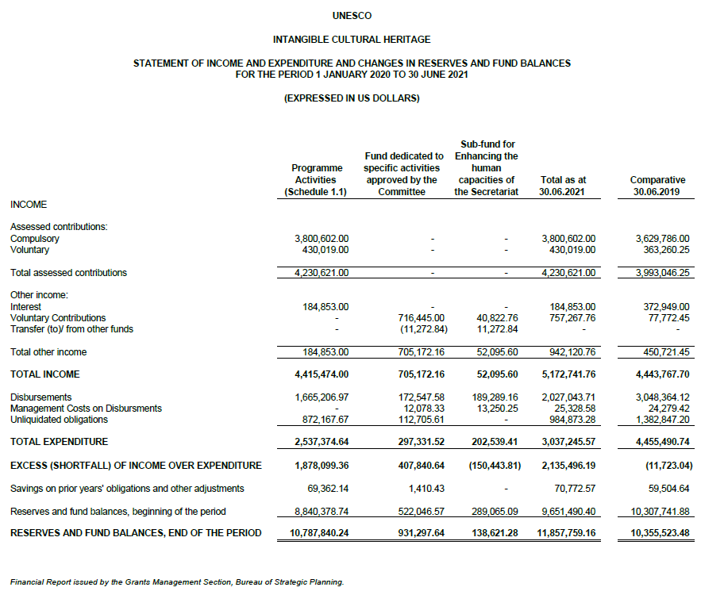

Schedule 1.1

ANNEX II
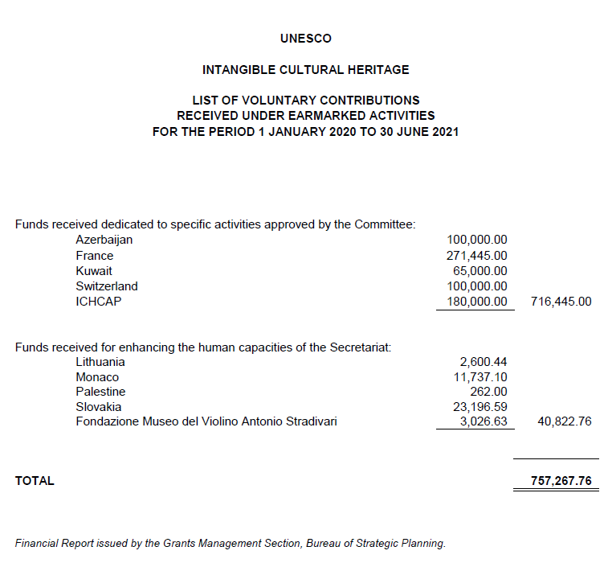

ANNEX III
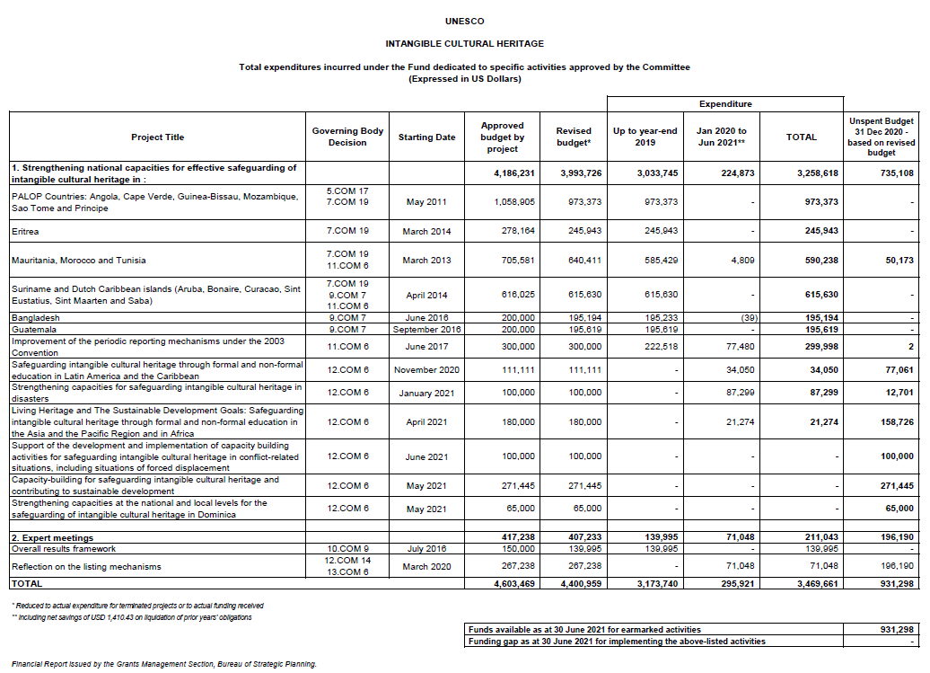
ANNEX IV
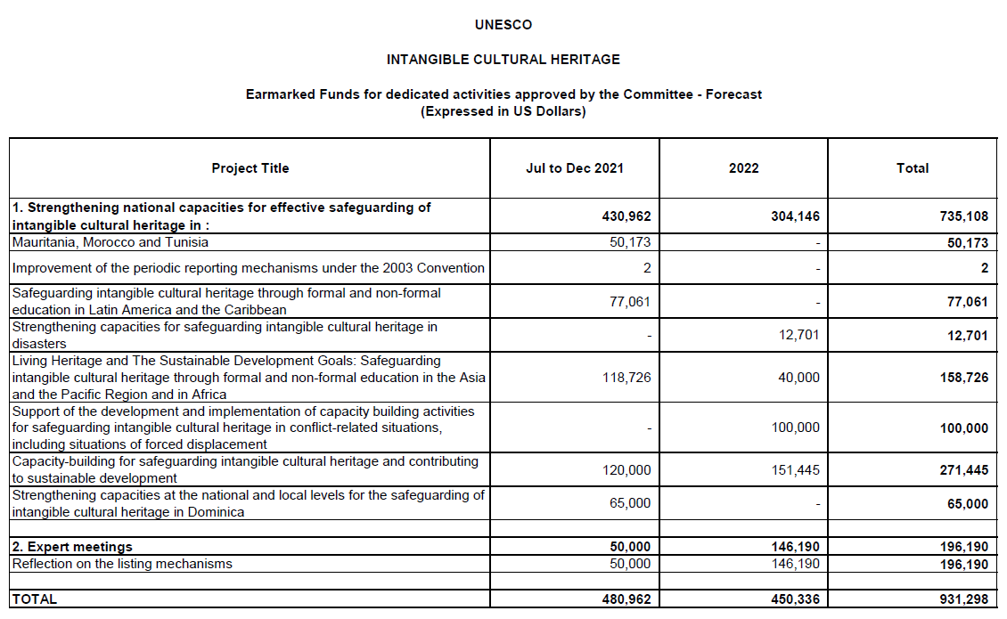

. Figures have been rounded as compared to Statement I and Schedule 1.1, pages 6–7.
. In Statement I, the assessed compulsory contributions for the period 2020 to 2021 are shown as income, whether they have been received or not; in the Statement of Assessed Contributions as of 30 June 2021, the balance of unpaid as of 30 June 2021 was US$1,408,459. The assessed voluntary contributions appear as income only on the date when they are received.
. Article 26.2 of the Convention foresees that ‘each State […] may declare, at the time of the deposit of its instruments of ratification, acceptance, approval or accession, that it shall not be bound by the provisions of paragraph 1 of this Article.’
. As of 30 June 2021, the sub-fund – intended exclusively to strengthen the human capacities of the Secretariat – has received contributions amounting to a total of US$1.6 million.
. Figures have been rounded as compared to Statement I and Schedule 1.1, pages 6–7.

