CONVENTION FOR THE SAFEGUARDING OF THE
INTANGIBLE CULTURAL HERITAGE
INTERGOVERNMENTAL COMMITTEE FOR THE
SAFEGUARDING OF THE INTANGIBLE CULTURAL HERITAGE
Tenth session
Windhoek, Namibia
30 November to 4 December 2015
General Information

TABLE OF CONTENTS
1. TENTH SESSION 4
2. HOST COUNTRY CONTACTS 4
3. REGISTRATION 5
4. ACCOMMODATION 6
5. PASSPORT, VISAS AND OTHER TRAVEL INFORMATION 6
5.1 Immigration/Visa 6
5.2 Health requirements 6
5.3 Medical insurance and service 6
5.4 Travelling to and from Windhoek, Namibia 6
6. LOCAL TRANSPORTATION 7
7. VENUE OF THE SESSION 7
7.1 Meeting venue 7
7.2 Official opening, meetings and related events 7
7.3 Interpretation 7
7.4 Documentation 7
7.5 Meeting registration and information desk 7
7.6 Security badges 8
7.7 Participants’ lounge 8
7.8 Internet connection (Conference venue) 8
7.9 Meals 8
8. MEDIA 8
8.1 Media Centre 8
8.2 Press conference room 8
8.3 Press release 8
9. RECEPTION PROGRAMME AND RELATED EVENTS 8
10. COUNTRY INFORMATION 9
10.1 Namibia at a glance 9
10.2 Government structure 9
10.3 Geography and climate 9
10.4 Namibia and its people 9
10.5 Fauna and flora 9
10.6 The Capital City Windhoek 9
10.7 Currency 9
10.8 Electricity supply 10
10.9 Time zone 10
10.10 Banking services 10
10.11 Important contact numbers 10
ANNEX A REGISTRATION FORM FOR THE TENTH SESSION OF THE COMMITTEE 11
ANNEX B RECOMMENDED HOTELS AND RATES 12

- TENTH SESSION
The tenth session of the Intergovernmental Committee will be held in Windhoek, Namibia, from 30 November to 4 December 2015 at the Windhoek Country Club and Resort:
Address: B1 Western Bypass, Windhoek South, Namibia
Tel: +264 61 205 5911
Fax: +264 61 205 2797
E-mail: windhoek@legacyhotels.com
Website: www.legacyhotels.co.za/en/hotels/windhoek
All the relevant information is also available at: http://www.unesco.org/culture/ich/en/10COM/.
The Intergovernmental Committee for the Safeguarding of the Intangible Cultural Heritage consists of 24 representatives of States Parties to the Convention for the Safeguarding of the Intangible Cultural Heritage, elected by the General Assembly of the States Parties to the Convention.
The current composition of the Committee is: (Group I) Belgium, Greece, Turkey, (Group II) Bulgaria, Hungary, Latvia, (Group III) Brazil, Peru, Saint Lucia, Uruguay, (Group IV) Afghanistan, India, Kyrgyzstan, Mongolia, Republic of Korea, (Group V(a)) Congo, Côte d’Ivoire, Ethiopia, Namibia, Nigeria, Uganda, (Group V(b)) Algeria, Egypt, Tunisia.
The elected members (Decision 9.COM 16) of the Bureau of the tenth session of the Committee are:
Chairperson: H.E. Ms Trudie Amulungu (Namibia)
Vice-Chairs: Belgium, Hungary, Brazil, India and Tunisia
Rapporteur: Mr Ahmed Aly Morsi (Egypt)
The working languages are English and French.
- HOST COUNTRY CONTACTS
Host Ministry
Ministry of Education, Arts and Culture, Republic of Namibia
Address: Government Office Park
c/o Independence Avenue & Luther Street
Tel: +264 61 293 3524
Fax: +264 61 253 671
Contact persons
Ms Ester Moombolah-Goagoses – Deputy Chairperson, Namibian National Organizing Committee for the tenth session of the Intergovernmental Committee
Tel: +264 61 276 813 / + 264 81 128 8241
Fax: +264 61 221 916
Email: goagoses@hotmail.com
Ms M’kariko Amagulu, Overall Manager for the preparation of the tenth session of the Intergovernmental Committee
Tel: +264 61 293 3295 / +264 81 143 6556
Fax: +264 61 293 3209
Email: m’kariko.amagulu@moe.gov.na / mkariko@hotmail.com
Mr Felix Amporo – Namibian Permanent Delegation to UNESCO
Tel: +33 (0) 1 44 17 32 65 / + 33 6 81 09 62 99
Fax: +33 (0) 1 44 17 32 73
Email: dl.namibie@unesco-delegations.org / amporo@embassyofnamibia.fr
Ms Bernadette Shooka - Protocol, Visa, Security and Accreditation
Tel: +264 61 282 2487 / +264 81 1423032 or 0811416153
Fax: +264 61 221145
Email: bshooka@mirco.gov.na

OR
Ms M’kariko Amagulu - Protocol, Visa, Security and Accreditation
Tel: +264 61 293 3295 / +264 81 143 6556
Fax: +264 61 293 3209
Email: m’kariko.amagulu@moe.gov.na / mkariko@hotmail.com

Mr Ervast Mtota – General National Coordination
Tel: +264 61 293 3544 / +264 81 140 3524
Fax: +264 61 293 3209
Email: emtota@gmail.com /Ervast.Mtota@moe.gov.na
Ms Eite Shiponeni – Immigration
Tel: +264 61 292 2041 / +264 81 142 5457
Fax: +264 61 292 2220
Email: eshiponeni@mha.gov.na
Ms Saiya Shivandu – Customs and Excise
Tel: +264 61 209 2324 / +264 81 278 0342
Fax: +264 88 628 253
Email: saiya.shivandu@gov.mof.na
Mrs Gretta Gaspar – Accommodation
Tel: +264 61 293 3363
Fax: +264 61 293 3209
Email: gaspargretta@gmail.com
Ms Regina Nashikaku – Transport and Logistics
Tel: +264 61 293 3036 / +264 812856637
Fax: +264 61 293 3039
Email: Regina.Nashikaku@moe.gov.na
- REGISTRATION
The main participants of the tenth session of the Intergovernmental Committee are the 24 members of the Committee. All participants, delegates, observers and those wishing to attend the tenth session of the Committee are strongly advised to register no later than 15 November 2015. This is to allow the organizers sufficient time to process all the relevant information and to ensure that all the logistical arrangements are in place before the opening of the session. Please register online on the website of the tenth session of the Committee: http://www.unesco.org/culture/ich/en/10COM/.
If you are not able to register online, please use the registration form in Annex A and return it by e-mail to: ichmeetings@unesco.org.
All registered participants, delegates and observers are requested to inform the UNESCO Intangible Cultural Heritage Section of any subsequent changes to their travel arrangements. This will ensure that logistical arrangements are attended to smoothly.
- ACCOMMODATION
Participants are responsible for booking their own accommodation and for covering all costs incurred during their stay in Namibia. It is strongly recommended that participants book their accommodation by 15 October 2015. A list of designated hotels is available at the end of this document (Annex B). Please note that Shuttle services will be provided to participants only to and from these designated hotels. Accommodation bookings will be provided on a first-come-first-serve basis. A credit card number will be required by the hotels to reserve a room. Booking may be done through the below link; www.UNESCO-10COM-Accommodation.com
- PASSPORT, VISAS AND OTHER TRAVEL INFORMATION

5.1 Immigration/Visa
All participants, delegates and observers are required to present a valid passport at the port of entry to legally enter the Republic of Namibia. The passport should be valid for at least six months from the date of arrival and should have at least three clean pages. Participants are kindly advised to check details regarding entry requirements into Namibia with particular reference to nationality and type of passport they hold with the nearest Namibian Embassy, Consulate or High Commission or should contact Ms Eite Shiponeni (Immigration) at tel: +264 61 292 2041 or by email: eshiponeni@mha.gov.na, Ms Bernadette Shooka (Protocol) at +264 61 2822487 or by email: bshooka@mirco.gov.na / Ms M’kariko Amagulu (Protocol) at +264 81 143 6556or by email: m’kariko.amagulu@moe.gov.na / mkariko@hotmail.com or Ms Saiya Shivandu (Customs) at +264 61 209 2324 or by e-mail: saiya.shivandu@gov.mof.na.
Details on visa requirements and application process are also available on the website of the Ministry of International Relations and Cooperation of Namibia at: http://www.mirco.gov.na/.
If you are travelling to Namibia via other countries, please familiarize yourself with the transit requirements of those countries before you travel to Namibia.

5.2 Health requirements
Entry into the Republic of Namibia does not require immunization. Participants travelling from areas where Yellow Fever is endemic should, however, present a yellow fever vaccination certificate. The vaccination must be obtained at least 10 days before entering Namibia.

5.3 Medical insurance and service
First-aid services will be provided at the meeting venue. Direction to the first aid room will be obtained from the reception. Participants are however expected to assume responsibility for medical costs of other treatments that they might receive while in Namibia. It is strongly recommended that participants purchase medical insurance in their home countries to cover medical costs while in Namibia on while in transit.

5.4 Travelling to and from Windhoek, Namibia
Hosea Kutako International Airport is the main international arrival and departure airport to Namibia and is situated 45 km east of the Capital City, Windhoek. A welcome desk will be set up at Hosea Kutako International Airport from 27 November to 4 December 2015 to assist arriving and departing participants.
To facilitate airport transportation arrangements, all participants are kindly requested to submit their expected date and time of arrival in Windhoek and flight details to the Namibian National Organizing Committee by email to: Regina.Nashikaku@moe.gov.na. Any subsequent changes should be similarly communicated to the same email address.
It is requested that the confirmed flight details of all participants, especially participating Heads of State / Government and Heads of Delegations, be provided, at least 30 working days in advance of the meeting.
- LOCAL TRANSPORTATION
The Namibian National Organizing Committee will arrange transport for participants from the airport to the designated hotels as indicated in Annex B and from the designated hotels to the Windhoek Country Club and Resort, the conference venue in the morning
Shuttle bus services will be provided in the afternoon after the sessions for participants who are not booked at the Conference venue. Shuttle bus services will also be provided to venues for planned activities as per the conference programme.
Please note that participants not staying at the officially designated hotels will be responsible for arranging their own transportation to and from the airport as well as between their respective hotels and the conference venue, as well as to venues for planned activities as per the conference programme.
- VENUE OF THE SESSION

7.1 Meeting venue
The meeting venue at the Windhoek Country Club Resort and Casino will be Oryx rooms 1, 2 and 3 located on the ground floor of the hotel.
For general overview of the venue, please visit the website:
www.legacyhotels.co.za/en/hotels/windhoek

7.2 Official opening, meetings and related events
The official opening ceremony of the tenth session of the Committee will take place at 5 p.m. on Sunday, 29 November 2015 at the Windhoek Country Club Resort and Casino.
The session of the Committee meeting will be held daily from 9.30 a.m. to 12.30 p.m. and from 2.30 to 5.30 p.m. from 30 November to 4 December 2015. The NGO Forum will also take place from 9:30 a.m. to 4 p.m. on 29 November 2015.
For more information on the programme of work, please refer to the provisional agenda, which can be retrieved from the UNESCO Secretariat’s website at: http://www.unesco.org/culture/ich/en/10COM/.

7.3 Interpretation
Simultaneous interpretation in the working languages of the Committee namely, English and French will be provided.

7.4 Documentation
For our concern for the environment and in order to reduce costs, printed copies of the documents will only be provided on request. All the documents for the tenth session can be downloaded at http://www.unesco.org/culture/ich/en/10COM/. During the meetings, participants are advised to bring their laptops for consulting the relevant working documents.

7.5 Meeting registration and information desk
Registration and information desk will be set up close to the security check points at the Windhoek Country Club Resort and Casino between 8 a.m. and 8 p.m from 27 November to 2 December 2015 and from 8 a.m to 6 p.m. the 3 and 4 December. Every participant, delegate and observer must register prior to the beginning of the session on the following website: www.unesco.org/culture/ich/en/10COM. An information package on the meeting will be available at that time.

7.6 Security badges
Badges will be presented to the participants, delegates and observers at the registration and information desk. Participants must wear the badges at all times when entering the conference venue.

7.7 Participants’ lounge
A space between the registration desk and the interpreter’s lounge will be available at the Windhoek Country Club Resort and Casino to serve as a lounge for the participants during the session. A number of computers with internet access and printing facilities will be provided. The technical staff will be on site to assist participants.

7.8 Internet connection (Conference venue)
Free Wi-Fi connection is available at the meeting venue. The log-in information would be provided upon arrival.

7.9 Meals
During the meeting, lunch will be provided at a cost in the restaurants located on the ground floor of the conference venue. A continued coffee service will also be available at the conference venue.
- MEDIA

8.1 Media Centre
A media centre will be provided for the media to cover the tenth session of the Committee at the Windhoek Country Club and Resort. The Press will also have access to the internet and fax machine.

8.2 Press conference room
Press conferences will be accommodated in Oryx room 6 located on the ground floor of the conference venue. Access to this room is only allowed to the registered media. The schedule outlining press events will be available upon registration.

8.3 Press release
Press releases and photographs of the meeting will be posted on the meeting website. Press releases will be posted on the media room page and photographs displayed in the photo gallery.
- RECEPTION PROGRAMME AND RELATED EVENTS
Registered participants, delegates and observers will be invited to receptions and other events during the tenth session of the Intergovernmental Committee for the Safeguarding of Intangible Cultural Heritage.
The programme will be available on the webpage of the convention http://www.unesco.org/culture/ich/en/10COM/.

- COUNTRY INFORMATION

10.1 Namibia at a glance
Surface area: 824 268 km²
Population: 2.2 Million
Capital City: Windhoek
Official language: English
Currency: Namibia Dollar (N$)
Dialling code: +264

10.2 Government structure
Namibia is a constitutional democracy consisting of a Legislature (Parliament), Executive (Cabinet) and Judiciary (Courts). Namibia has a two Chamber Legislature, the National Assembly and the National Council.

10.3 Geography and climate
Namibia is situated in the south western part of Africa. The country is bordered along its entire western border by the Atlantic Ocean, while Botswana and Zimbabwe lie to the west. Angola and Zambia are Namibia’s northern neighbours and South Africa is in the South. Namibia has a population of about 2.2 million inhabitants and an area of 824 268 km².
Temperatures in Windhoek in November and December are between 15°C and 29°C. The days are generally hot while the nights are cooler.

10.4 Namibia and its people
Namibia is one of the most fascinating and diverse countries to visit. It is world famous for its highest dunes in the world at Sossusvlei and for the Etosha National Park, one of the world’s greatest conservation areas.
Namibia has a rich cultural and heritage diversity. The population is generally divided into eleven main cultural traditions.

10.5 Fauna and flora
Namibia is blessed with a rich variety of fauna and flora. It was the first country in the world to make protection of the environment part of its Constitution. The Etosha National Park is one of the most popular tourist destinations in Namibia and home to a variety of wildlife, including elephants, rhinos, lions, cheetahs, leopards, giraffes, various species of antelopes and birds.
Detailed information about tourism in Namibia can be found at the following website: www.Namibiatourism.com.na

10.6 The Capital City Windhoek
Windhoek is the capital city of Namibia and is located at the centre of the country surrounded by rolling mountains. Windhoek has an active and lively community of artists and craftspeople. For performing art enthusiasts, a welcome addition to the arts and entertainment scene is Backstage, an intimate lounge theatre where entertainment ranges from solo and ensemble performances of jazz, folk, bluegrass and classical music, to intimate dramas and belly dancing. The 99FM Playhouse Theatre, in the historical Old Breweries Building, presents plays and live music, including jazz, blues and cabaret.

10.7 Currency
The official currency is the Namibian Dollar (N$). The South African Rand is a legal tender in Namibia. N$/US Dollar = 12.17 (latest). Foreign exchange services are available at all banks. Banking hours are from 9 a.m. to 3.30 p.m. from Monday to Friday and 8.30 to 11.30 a.m. on Saturday.

10.8 Electricity supply
The electrical current in Namibia is 220 volts, 50 cycles. Namibian outlets commonly use the three-pronged plug (also known as the South African plug). Adapters can be bought in Windhoek and other major towns.

10.9 Time zone
Namibia is two hours ahead of Greenwich Mean Time (GMT+2) in summer months, from October to March.

10.10 Banking services
Banks are open between 9 a.m. to 3.30 p.m., Monday to Friday. On Saturday banking hours are from 9.30 to 11 a.m. Most banks have a Bureau de Change and all internationally recognized currencies can be exchanged. Most establishments in the country accept international credit cards. Automatic Teller Machines (ATM) are available throughout the city.

10.11 Important contact numbers
Emergency numbers
Namibian Police Emergency +264 (61) 10111
City Police - Crime Prevention Unit (24 hours) +264 (61) 290 2239 / 290 2018
City Police - Fire Brigade +264 (61) 21 1111
(Ambulance, accidents and injuries) +264 (61) 211 111
Aeromed +264 (61) 249 777 / 230 505
Med Rescue +264 (61) 230 505/6/7
Hospitals
Medi-Clinic Windhoek +264 (61) 222 687/4331000
Windhoek Central State Hospital +264 (61) 203 9111
Roman Catholic Hospital +264 (61) 2702167
Rhino Park Private Hospital +264 9610 225 434
Vehicle breakdown services
Breakdown Services + 264 (61) 230 823 / 240 733
Valley Recovery Services + 264 (61) 227 164
Town Tow-in Services + 264 (61) 210 779
Road Guard Emergency + 264 (61) 210 780

ANNEX A REGISTRATION FORM FOR THE TENTH SESSION OF THE COMMITTEE
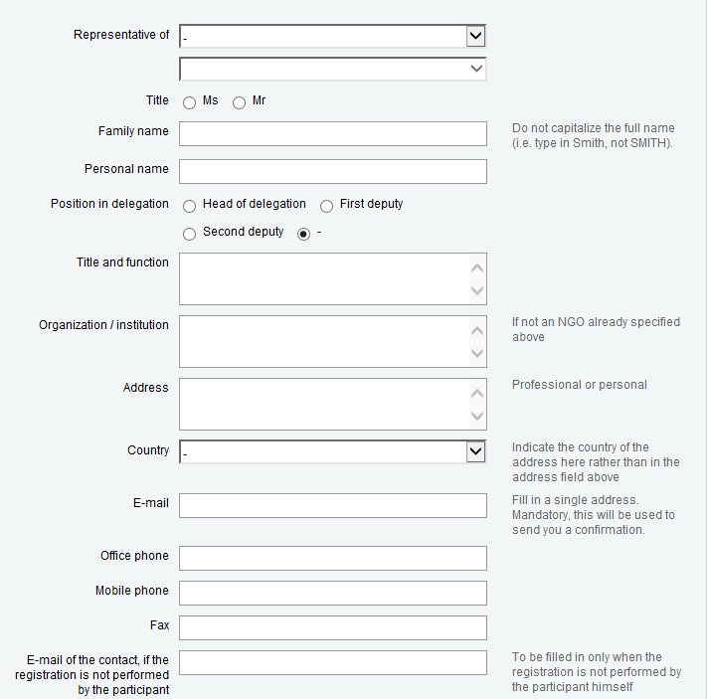

ANNEX B RECOMMENDED HOTELS AND RATES
(Detailed information of some hotels listed below is also enclosed)
HOTEL NAMES | ROOM TYPE | RATES | CONTACT DETAILS
AREBBUSCH  *** | Luxury | Pp N$1095 2p N$ 1380 | Tel: +264 61 252 255  Fax: +264 61 251 670  Email: hr@arebbusch.com  http://www.arebbusch.com/
AREBBUSCH  *** | Self-Catering | N$940 with two beds
AREBBUSCH  *** |  | 3single beds N$ 1100
AREBBUSCH  *** |  | 4 single beds N$1380
AREBBUSCH  *** | Standard | N$ 870
AREBBUSCH  *** |  | N$ 10502pp
PROTEA HOTEL THURINGERHOF  *** | Single | N$ 903 | Tel: +264 61 226 031  Fax: +264 61 232 981  Email: gm.thuringerhof@proteahotels.com.na  http://www.proteahotels.com/
PROTEA HOTEL THURINGERHOF  *** | Double | N$ 1173
PROTEA HOTEL THURINGERHOF  *** | Twin | N$ 1173
PROTEA HOTEL THURINGERHOF  *** | Suet | N$ 1716
PROTEA HOTEL THURINGERHOF  *** | Junior | N$ 1919
PROTEA HOTEL THURINGERHOF  *** | family | N$ 1979
PROTEA HOTEL FURSTENHOFF  **** | Executive | N$1610 | 4 Dr Frans Indongo Street  Windhoek  Tel: +264 61 237380  Fax: +264 61 237855  Email: furstenhof@proteahotels.com.na  http://www.proteahotels.com/
PROTEA HOTEL FURSTENHOFF  **** | superior Single | N$1320
PROTEA HOTEL FURSTENHOFF  **** | Double | N$1610
PROTEA HOTEL FURSTENHOFF  **** | Deluxe | N$1320
PROTEA HOTEL FURSTENHOFF  **** | Single | N$1610
PROTEA HOTEL FURSTENHOFF  **** | Double
ROOF OF AFRICA  **** | Standard | N$ 976.70 | Tel: +264 61 254708  Fax: +264 61 248048  Mobile: +264 811244930  Email: info@roofofafrica.com  http://www.roofofafrica.com
ROOF OF AFRICA  **** | Single
ROOF OF AFRICA  **** | Double | N$ 1373.48
ROOF OF AFRICA  **** | Luxury
ROOF OF AFRICA  **** | Single | N$ 1322.61
ROOF OF AFRICA  **** | Double | N$1617.65
ROOF OF AFRICA  **** | Every extra bed | N$255.00

HOTEL NAMES | ROOM TYPE | RATES | CONTACT DETAILS
AVANI WINDHOEK HOTEL AND CASINO  **** | Avani Room | Single: N$1080.00 Double: N$1260.00 | Avani Windhoek Hotel and Casino ,  129 Independence Avenue,  Gustav Voight Centre,  Windhoek, Namibia  Tel: +264 61 280 0000  E-Mail: windhoek@avanihotels.com  URL:http://www.avanihotels.com/windhoek/
AVANI WINDHOEK HOTEL AND CASINO  **** | Avani Superior | Single: N$1325.00  Double: N$1505.00
AVANI WINDHOEK HOTEL AND CASINO  **** | Avani Suite | Single N$2820.00 Double: N$3000.00
AVANI WINDHOEK HOTEL AND CASINO  **** | Avani Presidential suite | Single N$4120.00 Double: N$4300.00
HILTON HOTEL  ***** | Standard | N$ 1750.00 | Rev. Michael Scott Street  Windhoek  Tel: +264 61 2962929  Fax: +264 61 2962931  Email: Teun.engbers@hilton.com  http://www3.hilton.com/en/hotels/namibia/hilton-windhoek-WDHHIHI/about/index.html
HILTON HOTEL  ***** | Deluxe | N$ 1900.00
HILTON HOTEL  ***** | Executive | N$2300.00
HILTON HOTEL  ***** | Diplomatic | N$5300.00
HILTON HOTEL  ***** | Presidential | N$ 9000.00
ROSAHOFF HOTEL  Free WiFi | Single BB | N$550.00 | Tel: +264 61 227379  Fax: +264 61 227379  Email: rosahoff@iway.na
ROSAHOFF HOTEL  Free WiFi | Double BB | N$800.00
ROSAHOFF HOTEL  Free WiFi | Triple BB | N$1000.00
ROSAHOFF HOTEL  Free WiFi | Family (4) Room BB | N$1300.000
SAFARI HOTEL AND CASINO  *** |  | Provided upon signing a contract | Corner of Auas and Aviation streets  Windhoek  Tel: +264 61 1967180  Fax: +264 61 235652  Email: safai@safarihotelsnamibia.com  reservations@safarihotelsnamibia.com  http://www.safarihotelsnamibia.com/
SAFARI HOTEL AND CASINO  *** | luxury room
SAFARI HOTEL AND CASINO  *** | Deluxe rooms
SAFARI HOTEL AND CASINO  *** | Family suite
SAFARI HOTEL AND CASINO  *** | Executive suites
SAFARI HOTEL AND CASINO  *** | Presidential suite
SAFARI COURT HOTEL  **** |  |  | Tel: +264 61 2968651  Fax: +264 61 249300  marketing@safrihotelsnamibia.com
HOTEL THULE  **** | Single room: | N$932.00 | 1 Gorges Street  Windhoek  Namibia  Tel: +264 61 371950  Fax: +264 61 371967  Email: reservations@hotelthule.com
HOTEL THULE  **** | Double room: | N$1296.00
 | Triple room: | N$1878.50
CASA BLANCA BOUTIQUE HOTEL | Standard Single Room | N$924.00 | Address: c/o Gous & Fritsche St, Pioneerspark, Windhoek, Namibia  Tel: +264 (61) 249 623  - Fax: +264 (61) 249 622  Email: casablanca@afol.com.na  URL: http://www.casablancahotelnamibia.com/
CASA BLANCA BOUTIQUE HOTEL | Standard Double Room | N$1331.00
CASA BLANCA BOUTIQUE HOTEL | Luxury Single Room | N$1200.00
CASA BLANCA BOUTIQUE HOTEL | Luxury Double Room | N$1800.00
CASA BLANCA BOUTIQUE HOTEL | Extra Bed | N$418.00
HOTEL NAMES | ROOM TYPE | RATES | CONTACT DETAILS
PENSION CORI | Single room  Twin room  Double room  Family room | N$ 450.00  N$ 600.00  N$ 700.00  N$ 800.00 | Tel: +264 61 228840  Fax:+264 61 225806  Email: cori@iway.na
PENSION DRN INTERNATIONAL (GUEST HOUSE) | Double Self-Contained  Standard double room  Family room  Suit room  Breakfast N$35.00 pp | N$ 561.00  N$ 357.00  N$ 397.00  N$ 680.00 | Tel: +264 61 254144  Fax: +264 61 235004  Email: bookings@drn-nam.com

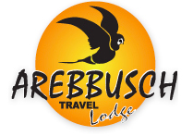
Arebbusch Travel Lodge
Category: 4 Stars
Situated near Eros Airport, this lodge is 0.8 km from Independance Stadium and within 10 km of Hero´s Acre and Zoo Park. All 101 rooms at Arebbusch Travel Lodge provide conveniences like Free Wifi, coffee makers, refrigerators and digital TV. Other amnenities include a conference center, a business center, and conference rooms.
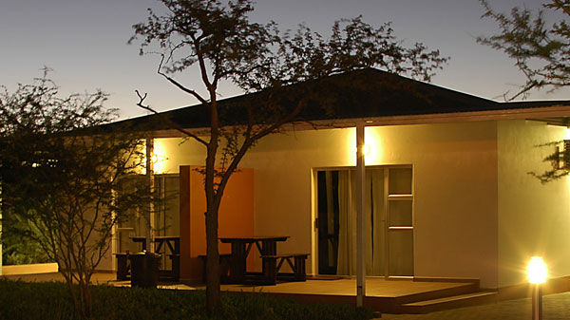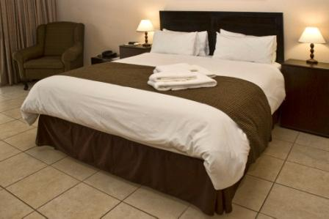
Hotel Rates*
Luxury: N$ 1095/ N$ 1380 (2 Persons)
Self-Catering: N$ 940 (2 beds)/ N$ 1100 (3 Single beds)/ N$ 1380 (4 Single beds)
Standard: N$ 870/ N$ 1050 (double bed)
Number of rooms: 101
Distance from the meeting place: 2,6 km/ 4 min. drive/ 20 min. walking
Address: Arebbush Travel Lodge, Corner Auas and Golf Street, Windhoek 80160, Namibia
Tel.: +264 61 252 255
Fax: +264 61 251670
E-Mail: reservations@arebbusch.com
URL: http://www.arebbusch.com/

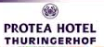
Protea Hotel Thuringerhof
Category: 3 Stars
Situated in the business district of Windhoek is Protea Hotel Thuringerhof – a cosy hotel that offers inter-leading family rooms to make your family feel at home. The hotel also offers business facilities, such as Wi-Fi connectivity and conferencing facilities that can accommodate up to 130 delegates and is only 1km from the closest convention centre, making it ideal for all corporate travellers.
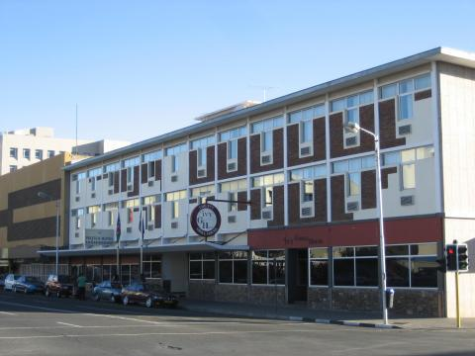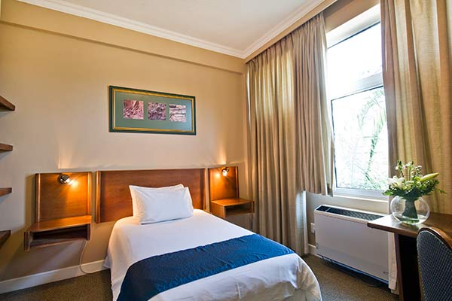
Hotel Rates*
Single: N$ 903
Double: N$ 1173
Twin: N$ 1173
Suet: N$ 1716
Junior: N$ 1919
Family: N$ 1979
Distance from the meeting place: 8,1 km/ 12 min. drive/ 1 hour 30 min. walking
Address: Protea Hotel Thuringerhof, Corner Bahnhof & Independance Avenue, Windhoek, Namibia
Tel.: +264 61 226031
E-Mail: gm.thuringerhof@proteahotels.com.na
URL: http://www.proteahotels.com/

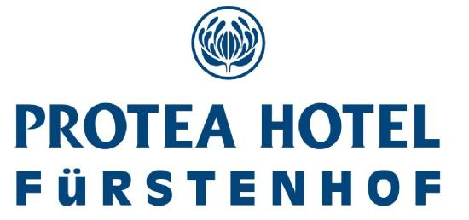
Protea Hotel Furstenhof
Category: 4 Stars
Protea Hotel Fürstenhof is only five minutes’ walk from the city centre and offers easy access to taxis. The hotel has a sparkling swimming pool, same-day laundry services, free Wi-Fi and a shuttle service. The decor is fresh and modern – offering a true escape from anything average.
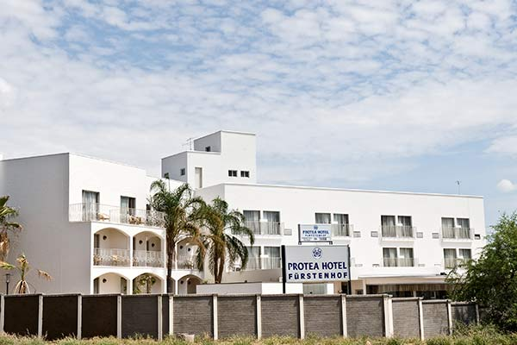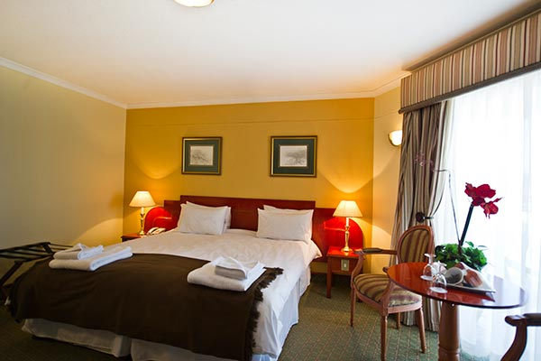
Hotel Rates*
Executive: N$ 1610
Superior Single: N$ 1320
Double: N$ 1610
Deluxe: N$ 1320
Single: N$ 1610
Distance from the meeting place: 8,3 km/ 11 min. drive/ 1 hour walking
Address: Protea Hotel Fürstenhof, 4 Frans Indongo Street, Windhoek, Namibia
Tel.: +264 (0) 61 237 380
Fax: +264 61 251670
E-Mail: furstenhof@proteahotels.com.na
URL: http://www.proteahotels.com/

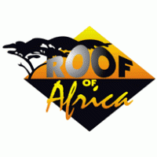
Roof of Africa
Category: 3 Stars
The Roof of Africa Hotel & Conference Centre is conveniently located just 15 minutes walk from the City Centre and Independence Avenue. There is a selection of restaurants within 5 minutes walking distance, shops and banks are also located nearby. The hotel has 27 well appointed rooms all equipped with Air Conditioning/ Heating, Telephone, Satellite TV, Electronic Safe, Tea & Coffee Facilities and free Wi-Fi Internet.
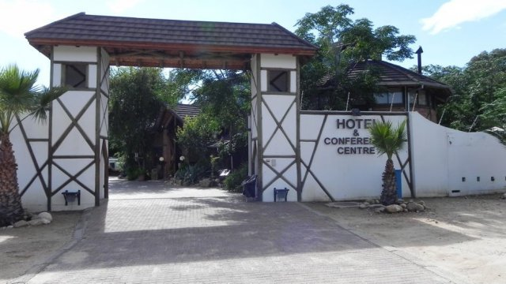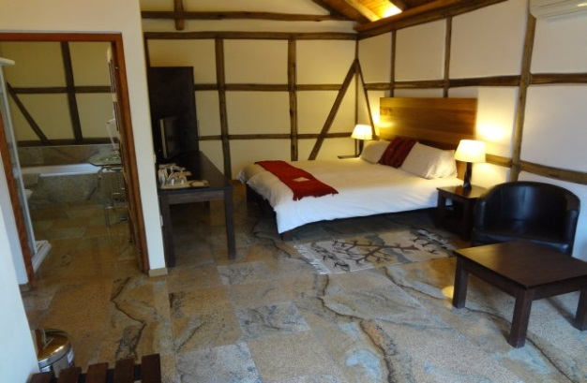
Hotel Rates *
Standard: N$ 967.70
Single: N$ 1322.61
Double: N$ 1378.48
Double: N$ 1617.65
Every extra bed: N$ 2555
Distance from the meeting place: 11,0 km/ 17 min. drive/ 1 hour 54 min. walking
Address: Roof of Africa, 126 Nelson Mandela Ave, Windhoek, Namibia
Tel: +264 61 254708
Fax: +264 61 248048
Mobile: +264 811244930
E-Mail: info@roofofafrica.com
URL: http://www.roofofafrica.com


Avani Windhoek Hotel and Casino
Category: 4 Stars
The Avani Windhoek Hotel and Casino has a total of 173 rooms, incorporating: 151 Twin rooms, 16 Luxury rooms, 5 Deluxe suites, 1 Presidential suite. All rooms are air-conditioned, equipped with satellite TV, radio, telephone, bath/shower, electric shaver plug (220 volts AC, 50 cycles), hairdryer, mini-bar, a butler tray for tea and coffee. Email connection and international adaptor. 24-hour room service.
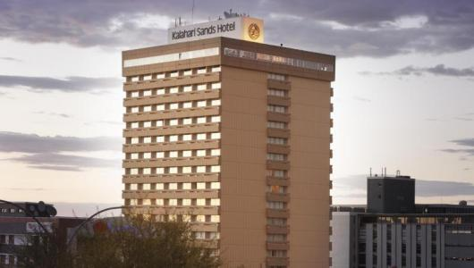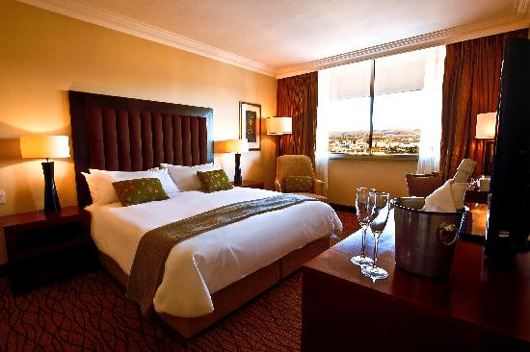
Hotel Rates *
Avani Room: Single N$1080.00 Double: N$1260.00
Avani Superior: Single N$1325.00 Double: N$1505.00
Avani Suite: Single N$2820.00 Double: N$3000.00
Avani Presidential: Single N$4120.00 Double: N$4300.00

Distance from the meeting place: 8,6 km/ 13 min. drive/ 1 hour 28 min. walking
Address: Avani Windhoek Hotel and Casino , 129 Independence Avenue,
Gustav Voight Centre, Windhoek, Namibia
Tel.: +264 61 280 0000
E-Mail: windhoek@avanihotels.com
URL: http://www.avanihotels.com/windhoek/

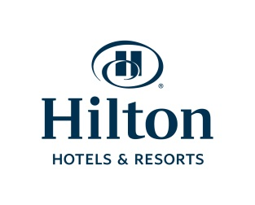
Hilton Hotel
Category: 4 Stars
The hotel boasts an ideal location in the heart of the Windhoek central business district, and is close to shopping venues and popular attractions. The 150 guest rooms and suites offer access to a 24-hour fitness center, an 18m heated lap pool and the rejuvenating Breeze Spa.
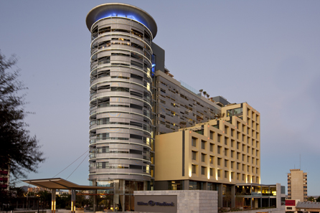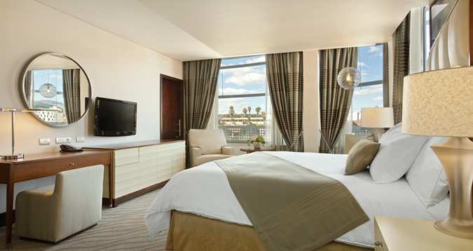
Hotel Rates*
Standard: N$ 1750
Deluxe: N$ 1900
Executive: N$ 2300
Diplomatic: N$ 5300
Presidential: N$ 9000
Number of rooms: 150
Distance from the meeting place: 7,5 km/ 11 min. drive/ 1 hour walking
Address: Hilton Windhoek, Rev. Michael Scott Street, Windhoek, Namibia
Tel.: +264 61 1962929
Fax: +264 61 2962931
E-Mail: wdhhi.reservations@hilton.com
URL:http://www3.hilton.com/en/hotels/namibia/hilton-windhoek-WDHHIHI/about/index.html


Safari Hotel and Casino
Category: 3 Stars (Hotel) and 4 Stars (Court)
Hotel Safari*** is one of the most well-known hotels in Namibia and caters for the holiday maker, the family, the businessman and conference delegate alike. It is located in a Windhoek residential district and next to Eros Airport. All rooms have a sitting area, air-conditioning and heating, en-suite bathroom with a bath-shower combination (Business Class Rooms) or shower (Standard Rooms), toilet, electrical shaving plug (220volts).
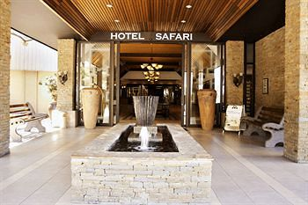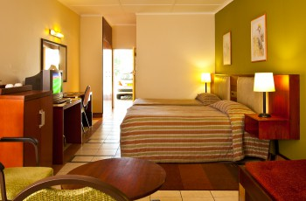
Hotel Rates*
Provided upon signing a contract
Distance from the meeting place: 2,8 km/ 5 min. drive/ 35 min. walking
Address: Safari Hotel and Casino, Corner of Auas and Aviation street, Windhoek, Namibia
Tel.: +264 61 1967180
Fax: +264 61 235652
E-Mail: reservations@safarihotelsnamibia.com
URL: http://www.safarihotelsnamibia.com/

Hotel Thule
Category: 4 Stars
Hotel Thule offers exclusive accommodation in the heart of Windhoek close to Windhoek's CBD. Situated as a pristine hilltop venue. Spectacular views of the city and picturesque Auas Mountains give a sense of tranquillity away from the busy city centre. Hotel Thule has various facilities and is very popular for weddings, corporate events and informal private occasions with a capacity of 60 people per venue. Luxurious accommodation is spoiling our guests in single, twin, double and family rooms.

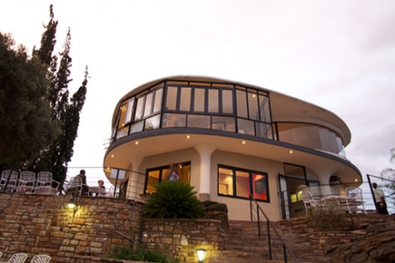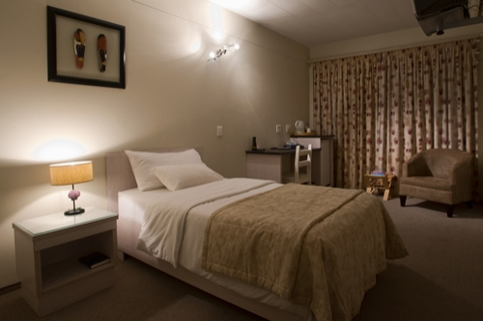
Hotel Rates*
Single room: N$932.00
Double room: N$1296.00
Triple room: N$1878.50

Distance from the meeting place:
Address: 1 Gorges Street, Windhoek
Tel: +264 61 371950
Fax: +264 61 371967
Email: reservations@hotelthule.com
URL: http://www.hotelthule.com/aboutus.php


Casa Blanca Boutique Hotel
Category: stars
Casa Blanca offers Spanish-style architecture and tranquil garden, this boutique hotel pension provides relaxed accommodation for business travellers and tourists alike.
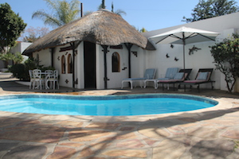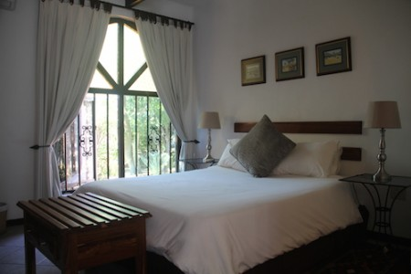
Hotel Rates*
Standard Single Room | N$924.00
Standard Double Room | N$1331.00
Extra Bed | N$418.00

Distance from the meeting place: approximately 4 – 5 km
Address: c/o Gous & Fritsche St, Pioneerspark, Windhoek, Namibia
Tel: +264 (61) 249 623
- Fax: +264 (61) 249 622
Email: casablanca@afol.com.na
URL: http://www.casablancahotelnamibia.com/


Pension Cori
Hotel Pension Cori is centrally situated (about 5 minutes' walk to the city centre) and comprises of 18 luxury en-suite rooms (38 beds). All rooms are equipped with TV, telephone, ceiling fan and/or air-conditioner, heater and tea/coffee facilities.
We have a luxury Stand-up Tan Can if you want to enhance your looks as well as a showroom equipped with massage machines for treatments on appointment after a long drive or to loose some weight. Laundry facilities are available. Transport available on request.
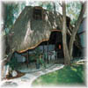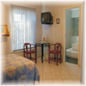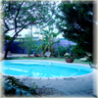
Pension Rates*
Single room N$450.00
Twin room N$600.00
Double room N$700.00
Family room (3) N$800.00
Family room (4) N$900.00

Distance from the meeting place: approximately 7km
Address: 8 Puccini Street Windhoek West
Tel: +264 61 228840
Fax: +264 61 225806
Cell: +264 81 127 7397
E-mail: cori@iway.na
Website: www.pension-cori-namibia.com

