

14th Session of the Committee for the Safeguarding of the Intangible Cultural Heritage
UNESCO

DELEGATES HANDBOOK

Bogota, Colombia
8th to the 14th of December, 2019

CONTENT

About The Commitee 2
Venue 2
Registration 3
Interpretation 3
Informative Desks 3
Passport And Visa Information 3
Accomodation 5
Customs 6
Medical Insurance And Health Information 6
Transportation 6
Opening And Closing Ceremony 7
Side Events 7
Working Documents 7
Climate 8
Currency 8
Time Zone 8
Electricity 9
Security 9
Bogota Bus Network 9
Places To Visit 9
Emergency Numbers 10

ABOUT THE COMMITEE
The Intergovernmental Committee for the Safeguarding of the Intangible Cultural Heritage consists of twenty-four representatives of States Parties to the UNESCO’s Convention for the Safeguarding of the Intangible Cultural Heritage (2003), elected by the General Assembly of the States Parties to the Convention.
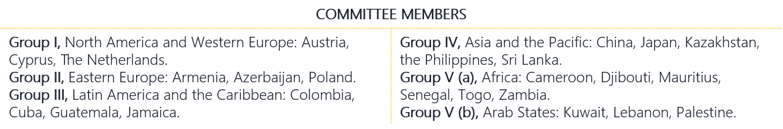

VENUE
This year session will be hosted by the Republic of Colombia and will be held in Bogota, at the Agora Bogotá Convention Center from 9 to 14 December 2019.
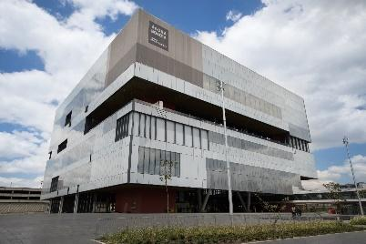
Address: Carrera 24 # 38 - 47 Bogotá, Colombia
Tel: +57 (1) 381 00 00 Ext: 5902
Website: https://agora-bogota.com/
Official 14th Committee Session Website: https://ich.unesco.org/en/14COM/
Event Website:
http://colombia14com.gov.co/ (under construction)

The Committee Sessions will be held daily from 9:30 a.m. to 12:30 p.m. and from 2:30 p.m. to 5:30 p.m. from 9 to 14 December 2019.

Wi-Fi
A free Wi-Fi connection is available at the venue. The log-in information will also be provided in the event. Computers with internet access and printing facilities will be provided at the 5th Floor of the Venue.

Meals and Participants Lounge
A continuous refreshment/coffee service will be available at the conference venue. Agora has two restaurants inside, that will be offering a balanced meal at a reasonable price. There are also a variety of restaurants in the surroundings of the venue.

Host Country Contact Information
For General information please contact: host14com@gmail.com
For Visa issues: contact the Colombian National Commission for UNESCO at: comisionunesco@cancilleria.gov.co Tel: (+571) 3814000, ext. 1309 Bogotá D.C., Colombia
For further information: contact the Colombian Permanent Delegation to UNESCO at:
dl.colombia@unesco-delegations.org
Tels: (+33) (1) 45 68 28 56 / (+33) (1) 45 68 28 74 / (+33) (1) 45 68 28 71

REGISTRATION
All participants are strongly advised to register before the 29th of October 2019 on the website of the 14th Session of the Committee: https://ich.unesco.org/en/14COM/
If you are not able to register online, please use the registration form in Annex A and return it by email to: ichmeetings@unesco.org

INTERPRETATION
Simultaneous interpretation will be provided in the working languages of the Committee, English and French, as in Spanish, the language of the host country.

INFORMATIVE DESKS

Welcome Desk at the El Dorado Airport (Bogota)
A 24 hours welcome desk for 14COM participants will be set up at El Dorado Airport of Bogotá from 6 December to 10 December and from 14 December to 16 December 2019.

Information desk at the Agora Bogotá (Venue Center)
A registration and information desk will be set up at the Agora Bogotá (Venue Center) between 8.00 a.m. and 6.00 p.m. from 8 to 13 December 2019, and between 8.00 a.m. and 2.30 p.m. 14 December 2019.

PASSPORT AND VISA INFORMATION
See Annex B for the list of nationalities that do not require a Visa for short stays to enter the Republic of Colombia. Access the following links to consult the nationalities that do require a visa for short stays to enter the Republic of Colombia:

English  https://www.cancilleria.gov.co/en/procedures_services/visa/requirements | Spanish  https://www.cancilleria.gov.co/tramites_servicios/visa/requisitos

Courtesy Visa (Type V)
Please read all this information before applying for a Courtesy Visa
All participants belonging to the official delegations that represent either a member or an observer State, an NGO accredited to UNESCO or a Category II Center, may request a Courtesy Visa (Type V) to enter the Republic of Colombia.
The application process will be online, by which you will receive an electronic visa, and must be done, at the latest, two weeks before your arrival to Colombia. The Courtesy Visa (Type V) will be free of charge.

Documents Required to Apply for a Courtesy Visa (Type V)
A scanned copy of the main page of your passport, valid for at least six months from the day of your arrival in the Republic of Colombia | An Accreditation Letter issued by your Government or the President of your Organization, certifying you are a member of the official delegation. If this is not possible, you must present an Invitation Letter issued by the Secretariat of the 2003 Convention of UNESCO. | A color photograph, size 3x4cm, white background, .JPG format and with a maximum size of 300 KB

Important Notes:
- The Republic of Colombia will not issue an On-Arrival Visa.
- If you are travelling to the Republic of Colombia via other countries, please familiarize yourself with the transit requirements of those countries before your trip.
- All documents must be in .PDF format. Do not use photographs and avoid converting image files to PDF format.
- You must attach all supporting documents required for your visa, or your application will not be accepted.
- The picture must be frontal and the head should be centered and complete. Both eyes should be open and the ears should be visible. Do not allow hair or accessories to cover your face.

Steps to Apply for a Courtesy Visa
- Enter: https://tramitesmre.cancilleria.gov.co/tramites/enlinea/solicitarVisa.xhtml
- Complete all data required.
- The kind of visa you will be applying to is “Visitor”, the specific activity “Courtesy” and condition “Others”.
- When given the opportunity to choose where to submit your application, please make sure to choose Bogotá. Please do not choose the consulate abroad.
- When entering “institution”, please write “14 COM UNESCO”.
- In the "specify" field, please write the name of your Delegation.
- After completing the information, you must complete the payment option. Your visa will be free of charge, but the system will accept your application only if you complete the payment option. Otherwise, the system will not register the application and therefore, you will not obtain a visa.
- Finally, please make sure to include in your application a valid e-mail address to receive the electronic visa. There is no need to present this visa stamped on your passport when you enter the Republic of Colombia: you need only to present the e-visa received by e-mail, either in print or online format.

Visa for Press Representatives
Press representatives in this event should apply for Visitor Visa -Type V (not a Courtesy Visa). To do so, please consult all the requirements at the following link under the grey title “V-JOURNALISTIC COVERAGE”:
https://www.cancilleria.gov.co/en/procedures_services/visa/v-journalistic-coverage

Finally, to request a Visitor Visa - Type V, please apply through the link:
https://tramitesmre.cancilleria.gov.co/tramites/enlinea/solicitarVisa.xhtml
and when given the opportunity to choose where to submit your application, please make sure to choose Bogotá.

ACCOMODATION
Participants are responsible for booking their own accommodation and for all expenses during their stay in the Republic of Colombia. It is strongly recommended that all participants book their own accommodation by 15 November 2019. A list of designated hotels is available at the end of this document (Annex C).

CUSTOMS
You must declare any amount above US$10,000 and keep all receipts of currency exchanges while you are in Colombia. Please ask for the appropriate in-flight declaration forms or ask an immigration officer after landing.

MEDICAL INSURANCE AND HEALTH INFORMATION
Participants should have an international medical insurance, to cover any medical assistance and emergency hospital care, while in the Republic of Colombia or in transit.

Vaccination
To enter the Republic of Colombia you can be asked to be vaccinated against yellow fever, so please have your Vaccination Card with you to start the trip.

Water
Tap water is safe to drink and use for cooking in Bogota. Other major cities have water supply services that can be used for bath or shower. In small towns and rural areas, it is advisable to buy bottled water or water produced in treatment plants.

Altitude Sickness
It is also important to be aware that altitude sickness might happen due to the lower atmospheric pressures encountered in the places with higher altitudes above sea level, such as Bogotá (2,000 - 3,000 meters above sea level)
To prevent altitude sickness, we recommend you to: 1. Acclimatize; 2. Avoid eating heavy foods; 3. Take pills for altitude sickness; 4. Drink lots of water or other fluids during the trip; 5. Drink coca tea or eat coca candy: the leaves have medical benefits that may help to treat altitude sickness.

TRANSPORTATION
There will be shuttle services for participants from the airport to the designated hotels (see Annex C), only to and from these designated hotels. The host country will post the timetable and shuttle services on https://ich.unesco.org/en/14COM/
The host country offers a special shuttle service to the Head of the Committee Members’ Delegations. For so, Delegations must provide all relevant information of their arrival and departure to: host14com@gmail.com

Taxi Service
Taxis are available 24 hours, we recommend you to call it by phone or app. Easy Tappsi is the most commonly used app; it can be downloaded through AppStore and Google Play. Phone: (+571) 5520022. However, you can always ask the staff at your hotel to call a taxi from a reliable company.
If a taxi service is needed from the airport, it is important to take an “Imperial Taxi", since it is the company officially authorized to assist participants in the event. The fare is about US$6 from the airport to the venue center zone.

OPENING AND CLOSING CEREMONY
Registered participants, delegates and observers will be invited to the opening ceremony that will be held at Agora Bogotá Convention Center (Carrera 24 # 38 - 47) on 9 December 2019, at 7.00 pm.
The closing ceremony will be held on 14th December 2019, at the Plaza de Bolivar with a presentation of the Christmas show arranged by the Mayor de Bogotá.
For both events, Venue center buses will be available from the venue to the ceremony and back. Schedules will be posted on https://ich.unesco.org/en/14COM/

SIDE EVENTS
- The Host Country will provide spaces in Agora, with the basic technical facilities for Side Events.
- To make a Side Event, it is necessary to contact the Secretariat of the 2003 Convention and submit the application form, as well as the technical requirements, no later than November 15th 2019.
- Delegations are responsible for setting up their Side Events and arranging any additional services needed.

WORKING DOCUMENTS
Printed copies of the documents will only be provided under request. All the documents for the 14th Session can be download from https://ich.unesco.org/en/14COM/. Participants are advised to bring their laptops to meetings if they want to consult the relevant working documents. There will be power outlets for computers.

COUNTRY INFORMATION
“There's a place where kindness, joy, diversity, flavor and music come together to make people vibrate: that place is Colombia. Come and feel the rhythm!”

Where to go after the Committee?
Check the best destinations in this link: http://www.colombia.travel/en

CLIMATE
The country is famous for the diversity of its climates, which include high plateaus, low plains, tropical rainforests, deserts, and mountain ranges. Since Colombia is located on the equatorial zone, there are no seasons, but the weather depends on thermal floors, or temperature zones.
Bogota is located in the cold zone, at 2,000 - 3,000 meters above sea level, where the temperature varies from 10°C to 17°C.It´s recommended to wear a coat or jacket, closed shoes and an umbrella. Please have in mind that heating is rarely used in Bogota

CURRENCY
The official currency is the Colombian Peso (COP). The market reference rate for the US dollar at the date of writing was US$1 = COP3,400. The rate varies from day to day, so it is important to keep up with changes to ensure that you are being given the right rate.

You can also pay by credit card in many places. Currency exchange services are available at some hotels, banks (Black Tower Hotel, near the venue), airports and in exchange bureaus. “Cambios Kapital” (Carrera. 40 No. 22A – 95), near the venue of the event, is one option.

BANKING SERVICES
Banking hours are from 9.00 a.m. to 4.00 p.m. from Monday to Friday, and Saturday from 10.00 a.m. to 1.00 p.m. Most banks and hotels accept international credit cards. ATMs are available throughout Bogota.

TIME ZONE
Colombia is five hours behind Greenwich Mean Time (GMT -5).

ELECTRICITY
Household electricity is 110vAC at 60 Hz. Electrical points have two flat vertical pins (type A) or two flat vertical pins with a third round (earthing) pin. You can buy adaptors and voltage regulators at the airport, in the hotel, or in the shopping centers nearby, such as Gran Estación, Plaza Centro, and San Martín.
We suggest that in any case you check the technical characteristics of any devices you are going to use while you are here.

SECURITY
As in every big city, you should not carry around large sums of cash, jewelry or other valuables. Be alert especially in crowded, lonely or dark places.

BOGOTA BUS NETWORK
The mass transit system in Bogota is the Transmilenio bus network and its feeder routes (SITP System). Services run from 5.00 a.m. until 11.00 p.m. It works with a frequent user card ‘Tu llave’, rechargeable at Transmilenio stations interconnecting with other bus services in the SITP system.

PLACES TO VISIT
In the city: National Museum, Gold Museum, Quinta de Bolivar Museum, Botero Museum, Simon Bolivar Park, Usáquen, Monserrate (funicular/ cablecar), la Candelaria Historic Center.

In the area: The Salt Cathedral of Zipaquira (49km), Guatavita - Lake of El Dorado (73km) and Chingaza Nature Park (277km).

Citylife
The following places are well known for its nocturnal activities.
La Candelaria and Monserrate: historical zone of the city, full of architecture, food and culture.
Usaquén: cultural and gastronomical diversity, offered in a traditional environment.
Zona-T and “Zona Rosa”: the liveliest place for nightlife, and a good place to eat out.
Zona G: The place for trying traditional and innovative dishes in cozy spaces.
La Macarena: The “bohemian” neighborhood, home to many of Bogotá´s best artists. Small and charming restaurants, full of seductive aromas and unique ﬂavors.

EMERGENCY NUMBERS

MEDICAL EMERGENCIES
Organization | Address | Phone | E-mail
Emermedica  (ambulance service) | Calle 12b #71D -61 | +57 1 3077098  +57 1 3077089
Colombian Red Cross | Avenida 68 No. 68 b-31. | 132 | salud@cruzrojacolombiana.org www.cruzrojacolombiana.org
Méderi Hospital | Calle 24 No. 29 -45. | +57 1 5600520 | www.mederi.com.co
Colombia University Hospital | Carrera. 66 No. 23 - 46 | +57 1 5948650  +57 1 5948660 | www.colsanitas.com/usuarios/web/guest/directorio-medico
Occidente Clinic | Av. Américas No. 71 C 29 | +57 1 4254620 | http://www.clinicadeloccidente.com/
Clinic for Orthopaedics | Calle. 6a No.70 - 06 | +57 1 7423099 | https://clinica-de-ortopedia-y-accidentes-laborales.negocio.site/

POLICE EMERGENCIES
Organization | Number | E-Mail
Colombian National Police | Number 112  Mobile: +57 3002003351  / +57 3108076835 / +57 3176483469  / +57 3118488172 | dibie.oac@policia.gov.co
Kidnap and Extortion Police | 165 | dibie.oac@policia.gov.co

Annex A. Registration Form for the 14th Session of the Committee, in case you could not do it online

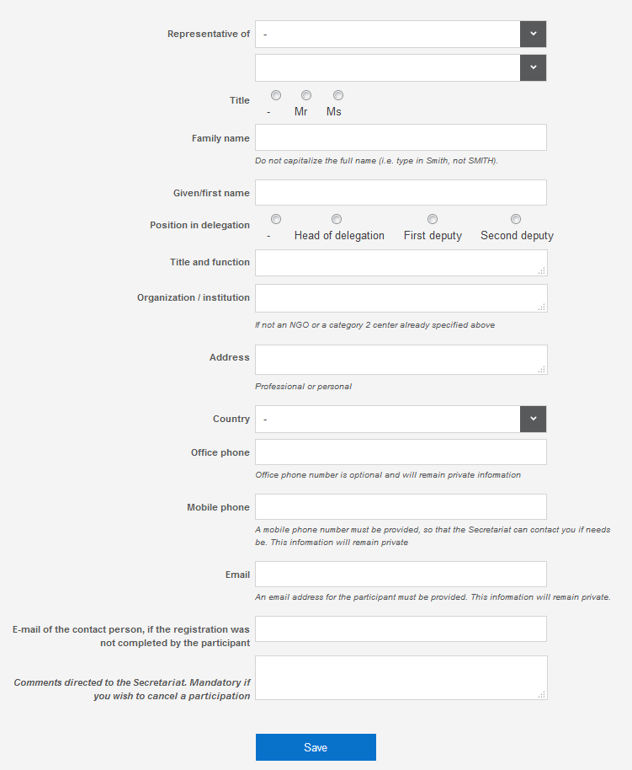

Annex B List of nationalities that don’t require a Visa to enter the Republic of Colombia

Albania

Andorra

Antigua and Barbuda

Argentina

Australia

Austria

Azerbaijan

Bahamas

Barbados

Belgium

Belize

Bhutan

Bolivia

Bosnia and Herzegovina

Brazil

Brunei-Darussalam

Bulgaria

Canada

Chile

Costa Rica

Croatia

Cyprus

Czechia

Denmark

Dominica

Dominican Republic

Ecuador

El Salvador

Estonia

Fiji

Finland

France

Georgia

Germany

Greece

Grenada

Guatemala

Guyana

Holy See

Honduras

Hungary

Iceland

Indonesia

Ireland

Israel

Italy

Jamaica

Japan

Kazakhstan

Latvia

Liechtenstein

Lithuania

Luxembourg

Malaysia

Malta

Marshall Islands

Mexico

Micronesia (Federated States of)

Monaco

Montenegro

Netherlands

New Zealand

North Macedonia

Norway

Palau

Panama

Papua New Guinea

Paraguay

Peru

Philippines

Poland

Portugal

Qatar

Republic of Korea

Republic of Moldova

Romania

Russian Federation

Saint Kitts and Nevis

Saint Lucia

Saint Vincent & Grenadines

Samoa

San Marino

Serbia

Singapore

Slovakia

Slovenia

Solomon Islands

Spain

Suriname

Sweden

Switzerland

Trinidad and Tobago

Turkey

United Arab Emirates

United Kingdom of Great Britain and Northern Ireland

United States of America

Uruguay

Venezuela

Annex C. Designated Hotels

Hotels less than a 15-minute walk from the Venue center
Shuttle buses will not be available from these hotels

Hotel Hilton Corferias
Address | Carrera 37 # 24-29, Bogotá
Tel | +57 (1) 4434400
E-mail | sales.corferias@hilton.com
Website | https://www.hiltonhotels.com
Room rate | Single Deluxe room: 134 USD  Double Deluxe room: 155USD
Reservation | https://secure3.hilton.com/es_XM/hi/reservation/book.htm?inputModule=HOTEL&ctyhocn=BOGCCHH&spec_plan=CPCIA&arrival=20191203&departure=20191217&cid=OM,WW,HILTONLINK,XM,DirectLink&fromId=HILTONLINKDIRECT
Distance to Venue Center | Walking: 5 minutes  Car: 2 minutes
*If you have already booked your room, please cancel it at the site and book it again in the official link, in order to access to the promotion code.

Hotel Estelar de la Feria
Address | Avenida Calle 24 No. 43A-85.
Tel | (+57) (1) 597 8240
Website | https://www.estelardelaferia.com
Room rate | Single room: 61 USD  Double room: 73 USD
Reservation | https://be.synxis.com/?adult=1&arrive=2019-12-07&chain=23120&child=0&currency=COP&depart=2019-12-16&group=1912PROGRA&hotel=1443&level=hotel&locale=es-MX&rooms=1
Distance to Venue Center | Walking: 5 minutes  Car: 2 minutes
*If you have already booked your room, please cancel it at the site and book it again in the official link, in order to access to the promotion code.

Hotel Hyatt Place
Address | Calle 24a #57-60,
Tel | +57 (1) 6541234
Website | https://www.hyatt.com/
Room rate | Single room: 90 USD  Double room: 90 USD *Hotel includes shuttle service Airport-Hotel-Airport
Reservation | https://www.hyatt.com/en-US/hotel/colombia/hyatt-place-bogota-convention-center/bogzb?corp_id=G-UNES  Promotion code: G-UNES.
Distance to Venue Center | Walking: 3 minutes  Car: 1 minute
*If you have already booked your room, please cancel it at the site and book it again in the official link, in order to access to the promotion code.

Hotel Black Tower
Address | Av. Esperanza 43A - 21
Tel | +57 (1) 7424759  +57 320-355-55-55
E-mail | ecommerce@btphotel.com
Website | http://www.blacktowerhotel.com/
Room rate | Single room: 49 USD  Double room: 58 USD  Suite: 89 USD
Reservation | Request your reservation in the following email linadecastro@btphotel.com. Please, specify that you will be participant of the Committee.
Distance to Venue Center | Walking: 4 minutes  Car: 1 minute

Hotels further than a 15-minute walk from the Venue center
Shuttle buses will be available from these hotels
Hotel Wyndham Bogota Art
Address | Av. La Esperanza # 51 – 40
Tel | +57 (1) 608 3000 Reservations: +57 (1) 608 3030
E-mail | info@hotelwyndhambogota.com
Website | https://www.hotelwyndhambogota.com/
Room rate | Single room: 73 USD  Double room: 79 USD  Suite: 101 USD
Reservation | http://bit.ly/UNESCO14COM
Distance to Venue Center | Walking: 21 minutes  The hotel will provide shuttle transport for its hosts between the hotel and the Committee Venue at the start and end of the day´s sessions
*If you have already booked your room, please cancel it at the site and book it again in the official link, in order to access to the promotion code.

Hotel Embassy Park
Address | Avenida de La Esperanza # 44 A – 79
Tel | +57 (1) 2681666
E-mail | reservas@hotelembassypark.com
Website | http://www.hotelembassypark.com/
Room rate | Single room: 51 USD  Double room: 62 USD
Reservation | Request your reservation in the following email reservas@hotelembassypark.com Please, specify that you will be participant of the Committee.
Distance to Venue Center | Walking: 17 minutes  Car: 7 minutes

