**CONVENTION FOR THE SAFEGUARDING OF THE  
INTANGIBLE CULTURAL HERITAGE**

**Training of trainers on living heritage and sustainable urban development**

**Strengthening capacities for resilient communities through sustainable Tourism and Heritage Safeguarding in Latin America and the Caribbean**

**5, 7, 19, 27, 28 March and 1 April 2025  
Online**

**Unit 3 – Practical approach to safeguarding living heritage in urban contexts**

**Case study 4**

© UNESCO 2025

The images of this working document do not fall under the CC-BY-SA licence and may not be used, reproduced, or commercialized without the prior permission of the copyright holders.

The designations employed and the presentation of material throughout this working document do not imply the expression of any opinion whatsoever on the part of UNESCO concerning the legal status of any country, territory, city or area or of its authorities, or concerning the delimitation of its frontiers or boundaries.

The ideas and opinions expressed in this publication are those of the authors; they are not necessarily those of UNESCO and do not commit the Organization.

unit 3

**CASE STUDY 4. As-Salt, jordan – Conservation Management Plan**

1. **INTRODUCTIÓN**

As-Salt is an ancient salt trading city and administrative center in west-central Jordan, in the governorate of Al-Balqa. The city became a regional hub during the Ottoman Empire but was then destroyed by the Egyptians in 1830. In the 19th century it became the capital of Transjordan before Amman was declared the capital of Jordan. Today, As-Salt has a population of 108,000 inhabitants.

Its historic urban core, added to the UNESCO World Heritage list in 2021, has an area of 25 hectares and is surrounded by a buffer zone of 71 hectares. It represents “an exceptional example of a living heritage with a strong link between its intangible attributes (tolerance and cohabitations among Muslim and Christian communities; urban hospitality; and socio-urban welfare system); and tangible attributes (significant architecture and urban morphology)”

The “Conservation Management Plan” of As-Salt’s historic core is intended to: i) sustain and preserve the quality of the urban environment; ii) enhance the continuous use of the public urban spaces; iii) conserve the architecture; and iv) and support and promote social and functional diversity within the historic core. Moreover, it offers “a collective vision and provides a decision-making tool to guide processes and interventions to ensure the continuity of traditions and the protection and conservation of this historic part of the city…” Therefore, the present analysis focuses on understanding how the Conservation Management Plan elaborates a framework for safeguarding living heritage by incorporating urban planning processes.

**Brief history of As-Salt’s living heritage:** According to the plan, “Bythe end of 19th century the As-Salt urban community was a mix of local tribes and merchants from Nablus, Jerusalem, Hebron, Damascus, Nazareth, Lebanon, and Turkey. A distinctive social life emerged from a combination of tribal customs and new urban social norms with influences from Ottoman and missionary public works and reform, and from constant newcomers to town, including merchants, and migrants. This created a tradition of urban hospitality where travelers and visitors were welcomed in the merchants’ houses and offered food, drink, and accommodation. The religious diversity of the community of As-Salt and its hinterland (e.g., Muslims, Greek Orthodox, Roman Catholics, and Protestants), and the different ethnicities (e.g., Arabs, Turkmans, Kurds, Chechens) encouraged tolerance and support between diverse groups who coexisted in a dense urban environment. These traits shaped the urban fabric in a way that strengthened social relations (e.g., houses share semi-public spaces and alleyways) and where no divisions (ethnic or religious) between residential areas exist”. Moreover, As-Salt “enjoys an active and inclusive public life through public buildings and spaces (e.g., mosques, churches, clinics, schools) where religious holidays for diverse religions are celebrated”. However, today factors such as intensive urbanization, demolition of or insensitive additions to historic buildings are threats to the heritage of the historic core.

1. **ANALYSIS OF THE CONSERVATION MANAGEMENT PLAN**

The methodology of the plan comprised three components: i) identification and description, ii) assessment and analysis, and iii) response. The scope of each component is described below.

1. **Identification and description:** Understanding and documentation of the historic core, and stakeholder analysis of individuals or groups associated with the area. This phase allowed to identify the objectives and purposes of the plan.
2. **Assessment and analysis:** Understanding the management context (i.e., ongoing constrains and opportunities), the physical conditions of the area (i.e., environmental and physical threats and challenges), and the cultural significance values (i.e., why the site is important and for whom).
3. **Response:** Elaborate a vision for the historic core, set the objectives of the plan, establish policies and purposes, and develop strategies to translate the policies into actions for the conservation and management of the area.

# Objectives and policies of the plan

The Conservation Management Plan defines 6 high-level objectives, 10 policies and 29 strategies for conservation and management, along with several tools or mechanisms and projects that are being or will be implemented in the historic core for safeguarding cultural heritage. With respect to the objectives (see below), these are intended to provide a comprehensive understanding of the different heritage layers of the historic core, including the tangible elements and social and cultural practices which contribute to the identity of the place, and to make recommendations for their protection, conservation, and management.

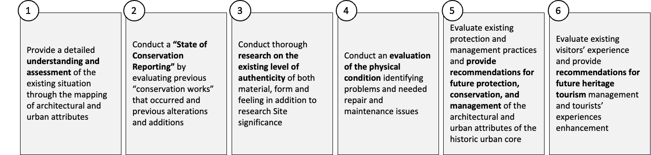

As mentioned, the plan also establishes 10 policies to ensure proper conservation and management. As shown in the below diagram, many of these are directly or indirectly related to the safeguarding of living heritage, and, for the purposes of this analysis, it is worth noting that several are related to the four urban structures defined in the proposed methodology to incorporate ICH in urban planning, namely, the ecological, functional, socioeconomic, and historic and built heritage structures.

Moreover, several of these policies address heritage from a physical or spatial dimension, for instance, those related to the conservation of historic buildings or providing services in the historic area, whereas others touch upon Intangible Cultural Heritage (ICH) such as oral historic traditions. These policies are multidisciplinary in nature, meaning that they intend to help safeguard the cultural heritage of the historic core in various ways, including physical interventions, awareness raising, financing, and others.

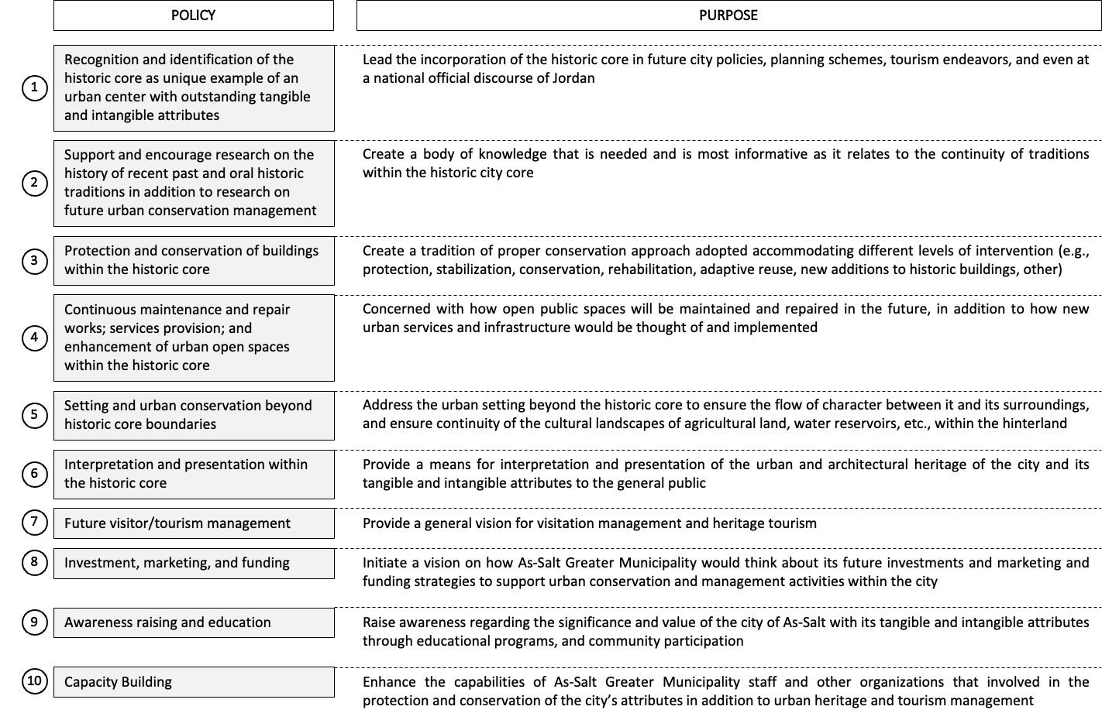

# Methods for the elaboration of the plan and key stakeholders involved

The process of elaboration of the plan included the use of several research methods to analyze “the specificity and nature of living heritage in the historic urban core of As-Salt, and to contextualize its tangible and intangible attributes”. These methods included:

* **Surveys and mapping:** of architectural and urban characteristics of the city, including natural, cultural, architectural, urban, and sociocultural attributes.
* **Literature review:** on the city’s urban social history and its architectural, urban, and cultural heritage.
* **Ethnographic encounters and interviews:** conducted with elderly men and women of the city.
* **Meetings and Interviews with key historians:** to collect information from subject matter experts.
* **Archival research:** including historic photos of the city from personal collections; the archives of Greater As-Salt Municipality; the Library of Congress; the Palestinian Exploration Fund; and others.

# Key stakeholders involved in the elaboration and implementation of the plan

The As-Salt Conservation Management Plan was prepared by a Working Group created for the sole purpose of developing the plan. This group was made up of stakeholders from diverse sectors and backgrounds which helped ensure a multidisciplinary approach. The organizations represented in the Working Group are the following:

|  |  |
| --- | --- |
| **Stakeholder** | **Description** |
| **As-Salt Greater Municipality** | It is the governing authority of the As-Salt Greater Municipality. It led the elaboration of the Conservation Management Plan and has also advanced safeguarding efforts such as conducting inventories; establishing heritage regulations; introducing processes for permits (e.g., demolition, alterations, etc.); eliminating visual pollution from the historic urban core; and others. |
| **As-Salt Greater Municipality Development Projects Unit** | It was established in 2005 within the As-Salt Greater Municipality to coordinate efforts for the safeguarding, conservation, and management of the historic core. A heritage section within the Unit has been incorporated to plan, design and implement policies, plans and projects on cultural heritage. |
| **Former Director of the Department of Antiquities** | The Department of Antiquities was established in 1923 to “protect the antiquities of the country and to collect antiquities that were scattered all over the country and those in the hand of civilians”. |
| **TURATH: Architecture and Urban Design Consultants** | Private architectural, urban design and research foundation specializing in architecture and urban regeneration. It provided technical support and expertise to the elaboration of the plan. |

In addition, and as mentioned in the plan, this instrument is not only meant to help guide policymakers and planners involved with the historic core but also to engage with a wide variety of stakeholders to ensure a sustainable future in the long-term. In that regard, the plan identified the following stakeholders as additional key players for its implementation.

|  |  |
| --- | --- |
| **Stakeholder** | **Description** |
| **As-Salt Development Corporation** | It is a non-profit, non-government organization that focuses on tourism infrastructure in the city of As-Salt. |
| **Religious organizations** | These organizations in the historic core are very significant due to the presence of historic and contemporary mosques and churches. The main religious endowments in the area are Muslim and Christian which are categorized into: Muslim Waqf, Christian Waqf, and Communal Family Waqf. |
| **Landowners in the historic core** | These stakeholders own land in the historic core and therefore their involvement is needed to meet the objectives of the plan. These include national ministries; non-profits or NGOs, including charitable organizations; professional syndicates (e.g., Jordan Engineering Association); and private individual landowners. |
| **Private sector** | The private sector is active in building rehabilitations and adaptive reuse projects, such as the adaptation of a historic house in the Al Jad’a area into a restaurant and bed and breakfast, and the adaptive reuse of Al Bashir House into a coffee shop. |

# Public engagement and consultation

According to the plan, the policies and strategies of the plan emerged from a “collective vision that involved consultation and debates between various stakeholders including the As-Salt Greater Municipality and its city Development Projects Unit; the As-Salt Development Corporation; representative and members of both Muslim and Christian communities of the city; and a group of experts who had been working on the identification, protection, and conservation of the city’s cultural heritage for decades”.

# Strategies and proposals for the incorporation of ICH in planning

As mentioned earlier, the Conservation Management Plan comprises 6 high-level objectives, and 10 policies and 29 strategies for conservation and management, expected to be implemented within a 5-year timeframe. The strategies are meant to translate the policies into actions for the safeguarding of cultural heritage in the historic urban core, and many are related to the urban structures (i.e., ecological, functional, socioeconomic, and historic and built heritage) defined in the proposed methodology for the incorporation of ICH in urban planning. The strategies that more closely relate to the latter are summarized below, organized by each of the said urban structures.

**Ecological structure:** The plan proposes to “develop general guidelines and principles for the conservation and management of agricultural land, cultural landscapes (e.g., water mills, orchards, scenery, other) and water sheds and resources” to ensure a more sustainable link between the city and its hinterland. Moreover, considering that As-Salt lies in the Great Rift Valley, a geophysical formation that presents high seismic risk, according to the plan, selected heritage buildings now need to incorporate anti-seismic design principles and guidelines.

**Functional structure:** The plan includes several strategies around areas such as transportation, public spaces, public services and urban facilities that relate to the safeguarding of cultural heritage:

* Transportation and mobility: Projects include the rehabilitation of historic steps, streets and sidewalks and others related to street lighting in the historic core, as well rehabilitating areas to serve as surface or underground parking to release congestion and traffic jams in the area. Other projects, albeit a city-wide scale, include the Bus Terminal Project which intends to improve the existing bus connectivity across the city, including the historic core.
* Public spaces: The municipality has led public space projects within the historic core focusing on the enhancement of public stairs, plazas, streets, and facades (e.g., at Hammam Street). These contribute to the viability of living heritage in spaces such as the main square where elderly men continue to play traditional board games. Accordingly, the plan also proposes to develop “guidelines and principles for the design of urban open spaces within the designated property area”, and to implement capacity building programs “in areas of public space and infrastructure design” to prepare municipal staff “to deal with various conditions and scenarios of development and change within the historic core”.
* Public services: The plan recommends to “put forward a Memorandum of Agreement that facilitates a coordination mechanism between As-Salt Greater Municipality and other infrastructure providers in the city regarding the priorities, nature and character of the historic core”. These agreements will help ensure that the provision of water, sanitation, and electricity infrastructure is aligned with conservation goals.
* Urban facilities: In As-Salt, many families have a “Diwan”, a gathering place where guests are received during public and family events (e.g., weddings). These spaces ensure the continuation of the “urban hospitality” tradition of the city, and thus the plan establishes measures to preserve them. Likewise, the project “Eco Museum”, which understands the whole city as an open-air museum, will enable visitors to explore the historic core through heritage tails “to enjoy the city life in As-Salt, interact with locals and with living traditions and the peaceful coexistence of the two faiths while sharing a unique experience focusing on tangible and intangible cultural heritage”. Lastly, according to the plan, the As-Salt Development Corporation and the Greater As-Salt Municipality, will work with international donors to promote heritage tourism by incentivizing local investment “to protect and develop heritage houses and traditional markets along heritage trails”.

**Socioeconomic structure:** The plan proposes to “Develop and put in place a visitation and tourism strategy in coordination with As-Salt Greater Municipality and other affiliated agencies such as the Ministry of Tourism of Jordan”, and to “Develop diverse itineraries within the city that are based on experiencing the city’s historic urban setting, architecture, and its associated intangible attributes”. In that regard, heritage tourism in As-Salt is seen as a sustainable form of employment and income generating activity. A campaign is also proposed to raise awareness on the benefits of heritage tourism and will encourage students to pursue careers in such area of expertise.

**Historical and built heritage structure:** The architecture and urban environment of the historic core “reflect the collective memory of As-Salt and show how cultural traits are continued in present time”. Thus, the plan states that the As-Salt Greater Municipality has promoted the adaptive reuse of historic buildings to turn them into cultural facilities, tourism facilities, and others, which can help safeguard the cultural practices in them. These projects include the adaptation of “Abu Jaber House” into the Historic Old Salt Museum; of the Anglican Church Complex into a physical rehabilitation center; and of “Touqan House” into the As-Salt Archaeological Museum.

The plan also proposes to prepare “registers and designated lists…for the historic significant buildings within the property area and beyond, and also registers and lists for the significant noticeable urban areas and spaces”, where protection and management guidelines would be enforced “to safeguard the physical and nonphysical attributes”. It also promotes the “Preparation of guidelines related to the future conservation of buildings and to the implementation of various levels of intervention including protection, stabilization, restoration, rehabilitation, adaptive reuse, new additions…within the designated property area”. Lastly, the plan recommends establishing within the Municipality a Technical Heritage Design Review Committee to “review and approve applications regarding buildings conservation, demolition, or additions and alterations”.

# Other tools or mechanisms for implementation

The As-Salt Conservation Management Plan is accompanied by other sectoral (e.g., legal) and cross-cutting (e.g., institutional) tools or mechanisms for implementation, some of which are directly related to the incorporation of ICH in planning, as described below.

**Property Boundary and Buffer Zone** *(sectoral)*: A geographical boundary of the historic core and a buffer zone have been demarcated to establish the area where special regulations are to be enforced to safeguard cultural heritage. The Property Boundary, applicable to the historic core, was drawn to incorporate most of “the attributes [tangible and intangible] that convey the Outstanding Universal Value and that are concentrated within a particular part of the historic core”. The limits of the boundary were also influenced by the topography and other features, such natural landforms, street layout, public spaces, commercial areas, and others. Accordingly, the buffer zone is “a protection layer” around the Property Boundary of the historic core. These areas are subject to special regulations in terms, for example, of “protection and conservation, views and view corridors, land use, zoning and future development”.

**City Core Special Regulations (CCSR)** *(sectoral):* The Ministry of Tourism and Antiquities developed the CCSR for 4 historic towns in Jordan, including As-Salt, which were endorsed, in 2014, by the Ministry of Municipalities and Rural Affairs, the Higher City Planning Council of Jordan, and the As-Salt Greater Municipality. The CCSR include the following practical guidelines: i) heritage grading for buildings, and designation of special conservation areas and special development corridors; ii) construction guidelines addressing conservation guidance, mechanisms for diagnosis, remedial works, and others; iii) design guidelines and considerations for new additions and alterations; and public realm guidelines addressing public spaces, streetscape, and street furniture. Moreover, the CCSR are composed of 16 Articles, many of which are intended to safeguard both historic built heritage and associated intangible cultural practices, as those described below:

|  |  |
| --- | --- |
| **Article** | **Description** |
| **Article 4** | Regulates that any structure that blocks the view within the designated area may be subject to partial demolition to restore the original view. |
| **Article 5** | Clarifies what are the “special conservation areas” and their boundaries. |
| **Article 8** | Deals with areas not developed yet, restricting new development, encouraging agricultural use, and emphasizing the protection of olive trees, in particular trees higher than 10 meters. |
| **Article 9** | Determines compatibility of uses within the historic core (e.g., slaughterhouses, carpentry, blacksmiths, car repairing, are not compatible), and considers environmental issues, such as acoustic pollution, vibrations, odors, and urban waste. |
| **Article 10** | Defines the “volumetric and dimensional conditions of development” including control of heights, setbacks, lot coverage, projections from façades, balconies, and parking. |
| **Article 11** | Grades (from 1 to 5) heritage buildings in terms of conservation needs and development permits. Grade 1 buildings, for instance, cannot be demolished due to authenticity; must adhere to high conservation standards; and cannot be used for industry or commerce. |
| **Article 14** | Speaks about “special urban spaces” such as Sahat Al-Ain and Al Maydan Square and specific regulations applying to public open spaces. |
| **Article 15** | Deals with expropriation and compensation to property owners to ensure compensation according to the market value to properties that are subject to high conservation standards. |

**Geographic Information System (GIS)** *(sectoral):* A GIS for the historic core was developed “to include plot parcel, building and roof plan survey, number of floors, ownership, material used, date of construction and current use. Around 4,400 buildings were surveyed, including all buildings in the historic core”. The GIS has helped inform a “Manual for the Conservation of the Historic Center of As-Salt”, as well as other conservation efforts.

**As-Salt City Development Projects Unit** *(cross-cutting):* The As-Salt Greater Municipality recently created the Development Projects Unit to coordinate efforts for the safeguarding, conservation, and management of the historic core. The Unit has developed regulations for permits of demolition, alterations and conservation and rehabilitation works within the historic core. It provides recommendations to the Local Planning Commission on cultural heritage management and performs supervision and monitoring of projects in the historic core. It has received funding from intersectoral entities such as the Ministry of Tourism, the Ministry of Planning and International Cooperation, the Ministry of Local Governance, the Ministry of Finance, international and local donor agencies, and the As-Salt Greater Municipality.

**Memorandum of Agreements** *(cross-cutting)*: The As-Salt Greater Municipality and multiple infrastructure and service providers such as the Jordanian Electric Power Company have signed memorandums “to coordinate efforts and work together on enhancement of public spaces paying attention to issues of visual integrity and to adopt measures to minimize the impact of telecommunication networks infrastructure projects on the historic urban core”

1. **KEY LESSONS FROM THE CONSERVATION MANAGEMENT PLAN**

Key lessons from the As-Salt Conservation Management Plan are presented in the following table:

|  |  |
| --- | --- |
| **Component** | **Key Lesson** |
| **Urban structures** | The plan sets several policies and strategies that relate to the urban structures of the methodology for the incorporation of ICH in urban planning. Particularly, it addresses public spaces as a key means for the safeguarding of living heritage in the historic core; it looks at several socioeconomic aspects such as promoting heritage tourism which can serve as a form of employment and income generation activity; and at integrating service providers into conservation strategies in the historic area, all of which reflect how urban planning structures can contribute effectively to safeguarding ICH. |
| **Multisector coordination** | The plan was elaborated by a Working Group composed of stakeholders from various organizations and backgrounds, which helps bring together sectors that often operate isolated from each other. It also identifies stakeholders of diverse nature (e.g., religious organizations, landowners) that need to be involved for its implementation, which reflects the multidisciplinary process of safeguarding living heritage in urban contexts. |
| **Social participation** | The plan involved consultation of various stakeholders, including public and private sector, religious groups, experts in the field, and others involved in the cultural sector. Participatory processes are central to incorporate ICH in urban planning and to ensure that different views and voices are reflected in urban plans. |
| **Tools or mechanism for implementation** | The plan is accompanied by several sectoral and cross-cutting tools and mechanisms that help operationalize the plan and facilitate its implementation. Tools such as defining a Property Zone and Buffer and developing the City Core Special Regulations give legal support to the plan and set special land use and building regulations; while mechanisms such as the creation As-Salt City Development Projects Unit and the signing of Memorandum of Agreements with services providers reflect the type of institutional arrangement that are key to advance safeguarding efforts. |

1. **CONCLUSION**

The Conservation Management Plan demonstrates how city governments can elaborate plans for specific urban zones with high cultural significance value, such as As-Salt’s historic core, in such a way that urban planning processes contribute to the safeguarding of heritage. Moreover, the plan illustrates that type of legal, institutional, and other tools or mechanisms that can help ensure that these plans are implemented and enforced and exemplifies that stakeholders of a very diverse natures can and need to be involved in safeguarding processes in urban contexts to ensure that a plan’s objectives are met. In that regard, the As-Salt Conservation Management Plan is a case that shows how the urban planning and cultural can be integrated in a practical, viable manner.

**REFERENCES**

As-Salt – Conservation Management Plan: <https://whc.unesco.org/en/list/689/documents/>