**CONVENTION FOR THE SAFEGUARDING OF THE  
INTANGIBLE CULTURAL HERITAGE**

**Training of trainers on living heritage and sustainable urban development**

**Strengthening capacities for resilient communities through sustainable Tourism and Heritage Safeguarding in Latin America and the Caribbean**

**5, 7, 19, 27, 28 March and 1 April 2025  
Online**

**Unit 3 – Practical approach to safeguarding living heritage in urban contexts**

**Case study 2**

© UNESCO 2025

The images of this working document do not fall under the CC-BY-SA licence and may not be used, reproduced, or commercialized without the prior permission of the copyright holders.

The designations employed and the presentation of material throughout this working document do not imply the expression of any opinion whatsoever on the part of UNESCO concerning the legal status of any country, territory, city or area or of its authorities, or concerning the delimitation of its frontiers or boundaries.

The ideas and opinions expressed in this publication are those of the authors; they are not necessarily those of UNESCO and do not commit the Organization.

unit 3

**CASE STUDY 2. BOGOTÁ, COLOMBIA. TERRITORIAL PLAN 2022 – 2035 ‘BOGOTÁ REVERDECE’**

1. **INTRODUCTION**

Bogotá is the capital of Colombia and is located in the Department of Cundinamarca in the geographical center of the country. The city has a population of approximately 7.7 million and is one of the main hubs for commerce, financial and business services in Latin America.

The city recently concluded the process of elaborating a new Territorial Management Plan (POT, by its acronym in Spanish) for the period 2022-2035. The POT, also known as “Bogotá Reverdece”, will serve as a roadmap for territorial development and to inform decision-making and investments around areas such as land use, transportation, public spaces, public services, and facilities. Accordingly, the POT establishes the permissible land uses and density for physical developments through building controls and regulations. It is anchored in the Decree 555 approved in 2021 and is therefore a binding instrument that the city government must comply with.

The POT 2022-2035 showcases how city governments can incorporate culture and heritage in urban plans and can thus serve to inform the application of the proposed methodology for the incorporation of Intangible Cultural Heritage (ICH) in urban planning. This analysis focuses on understanding how the POT addresses cultural heritage and the measures intended to safeguard Bogotá’s living heritage.

1. **ANALYSIS OF THE PLAN**

The POT identifies policies, principles, objectives, strategies and interventions across multiple sectors (e.g., land use, mobility, heritage) to guide the territorial development of Bogotá. As shown in the below diagram, it first defines 11 long-term policies intended to respond to territorial challenges. It then identifies 15 guiding principles which seek to achieve 7 long-term objectives. To contextualize the principles and objectives to the geographical realities of Bogotá, a model of territorial occupation has been developed. This model comprises 4 territorial structures: ecological, functional and care, heritage, and socioeconomic and innovation. As described later, the heritage structure is intended to safeguard the tangible, intangible, and natural heritage and is directly related to the methodology for the incorporation of ICH in planning. Each territorial structure comprises a number of strategies and interventions to be implemented during the timeframe of the plan 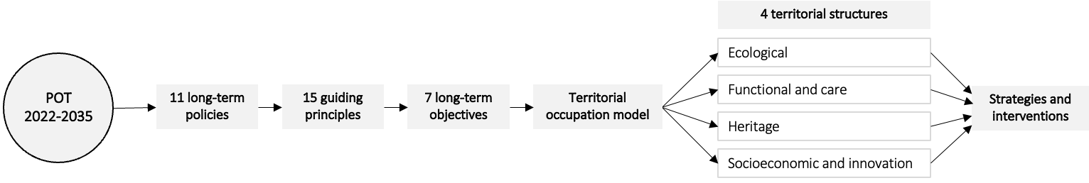to achieve its objectives.

# Long-term policies on territorial development

As mentioned, the POT identifies 11 long-term policies intended to address the territorial challenges of Bogotá. These policies are summarized below:

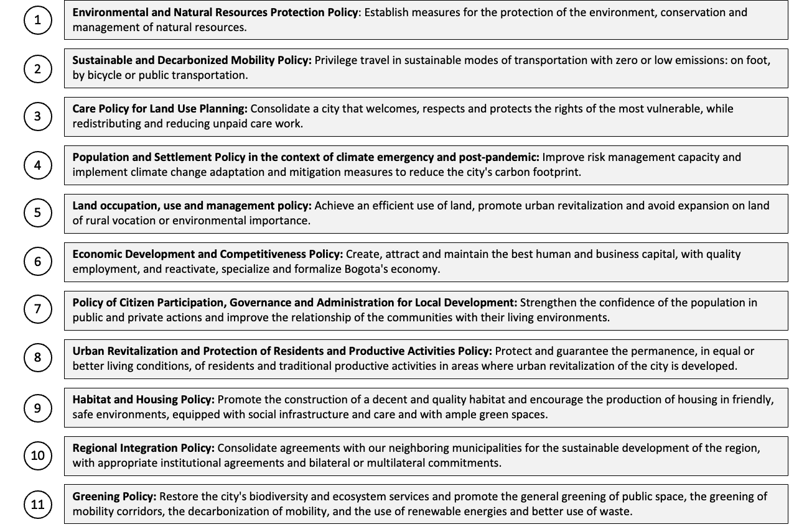

# Long-term objectives

The plan has also defined 7 long-term objectives to make Bogotá a more “sustainable, resilient, green, equitable and caring city”, some of which are directly or indirectly related to preserving heritage in urban and rural contexts. Some objectives touch upon cultural aspects: for instance, in the POT heritage is considered a key element of the ecological structure and productive cultural practices are seen to enhance economic reactivation. Cultural links between rural and urban environments are given high importance to achieve some of the objectives.

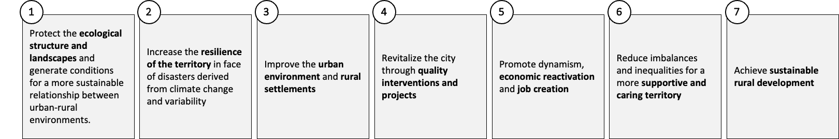

# Model of territorial occupation: territorial structures

The model of territorial occupation defines the implementation of the strategies and interventions of the POT. This model comprises the 4 territorial structures as shown in the below diagram. The heritage structure illustrates how the POT incorporates cultural heritage into the planning process and how this type of plans, which in most cases around the world address planning merely from a spatial lens, can effectively incorporate intangible cultural elements.

The POT states that the heritage structure is intended to “strengthen the social ties and productive activities of social and community groups that remain, relate and give meaning to the urban and rural landscapes of the Capital District”. It recognizes the “symbolic value of women and communities associated with natural and tangible and intangible cultural elements” and the “existing and new identity manifestations, as well as Muisca ancestry, which influence the characterization of the territory and the identification of ancestral and traditional trades, infrastructure and cultural practices, ensuring their viability”. Lastly, it considers as key territorial elements the “manifestations, practices, uses, representations, expressions, knowledge, techniques, ways of life, and ways of managing the territory and cultural spaces…” as these “generate feelings of identity and establish links with the collective memory and the territory”.

# Process of elaboration and key stakeholders involved

The process of elaboration of the POT comprised five phases: i) preliminary, ii) diagnostic, iii) formulation, iv) implementation, and v) monitoring and evaluation. The scope of each of the five phases is described below.

1. **Preliminary:** The economic, social, financial, environmental, and regional background information is validated. The technical and economic feasibility of the process is analyzed.
2. **Diagnostic:** Identification of the current state of the territory, identifying potentialities, limitations, and existing conflicts. Analysis of urban-regional vision of the city.
3. **Formulation:** Formulation of strategies and interventions intended to achieve the desired vision of the territory. Decision-making with respect to the proposals.
4. **Monitoring and evaluation (M&E):** M&E activities developed on a permanent basis to provide inputs for future reviews and adjustments of the POT. The M&E framework to monitor and evaluate the POT is defined.
5. **Implementation:** Execution of financial, technical, and institutional actions across multiple sectors for the implementation of the plan. Implementation roadmaps are defined according to technical and financial resources and complexity of the proposals.

In addition, it must be noted that the POT was elaborated through extensive public engagement and multisector coordination which helped ensure that views and interests of diverse stakeholders were reflected in the plan. These two process, public engagement and multisector coordination, are key elements of the proposed methodology to incorporate ICH in urban planning and are therefore summarized next.

# Multisectoral coordination

The District’s Secretary of Planning is the main responsible for leading and coordinating the process of elaboration of the POT, in coordination with 5 other entities: District’s Secretary of Environment; Cundinamarca’s Regional Autonomous Corporation (CAR); Bogotá’s Territorial Council of District Planning (CTPD); the District Institute of Cultural Heritage; and the Council of Bogotá. The nature and role of these entities are described in the following table.

|  |  |
| --- | --- |
| **Stakeholder** | **Description** |
| **Secretary of Planning – District of Bogotá** | Leads the planning processes of the Capital District, including the formulation, monitoring and evaluation of territorial, economic, social, environmental, and cultural policies, the instruments derived from them, as well as a comprehensive information system. It coordinates a planning model that contributes to an equitable, sustainable, equitable and competitive development in urban and rural areas. |
| **Secretary of Environment – District of Bogotá** | Promotes, guides and regulates the environmental sustainability of Bogotá, and leads efforts to mitigate environmental degradation and foster positive environmental practices. It formulates policies for the recovery, conservation, and sustainable use of ecosystemic goods and services, and for climate change mitigation and adaptation. |
| **Cundinamarca’s Regional Autonomous Corporation (CAR)** | It is the Department of Cundinamarca’s lead authority in charge of implementing environmental policies, plans, programs and projects and those related to renewable natural resources. It is responsible for ensuring compliance with legal provisions regarding the disposal, administration, management, and use of natural resources. |
| **Bogotá’s Territorial Council of District Planning (CTPD)** | It is the highest participatory planning entity and is in charge of ensuring representation of all sectors of civil society in the planning process. It is composed of 99 councilors from 22 sectors of civil society. Its main functions include accompanying the formulation, monitoring and evaluation of the POT. |
| **District Institute of Cultural Heritage** | It is responsible for implementing policies, plans and projects for the effective exercise of the cultural and heritage rights of the inhabitants of the Capital District, and for the protection, intervention, research, promotion and dissemination of tangible and intangible cultural heritage. |
| **Council of Bogotá** | It is the highest authority of the Capital District. Its attributions are normative in nature and is responsible for overseeing and controlling the performance of the District Authorities. It has a plenary of 45 councilors, a board of directors and three permanent commissions, each made up of 15 councilors: Development Plan and Land Management, Government and Finance and Public Credit. |

The above entities are involved throughout the process and contribute, in multiple capacities, to ensure representation of various stakeholders in all phases of the plan. The CAR and the District Secretary of Environment, for instance, are involved in early stages to agree upon the environmental components of the POT, and the CTPD participates in the conceptualization of the plan and provides opinions and recommendations throughout the process. One of the five commissions of the CTPD, the “Commission for Regional Development, Decentralization and Deconcentration”, has the objective of promoting “the collective construction of the region as a planned and integrated cultural, social, physical, economic, fiscal and environmental territory…” Therefore, the involvement of the CTPD contributes to a broader perspective that touches upon multiple areas, including culture, into the planning process. Lastly, the Council of Bogotá is responsible for the approval of the plan within a 90-day timeframe after a review and deliberation process.

The involvement of entities such as the District Secretary of Environment and the CTPD serves as an example of multisector coordination processes that are key to enable cross-sectoral dialogue and ensure that different views are taken into account. This type of practices help transition from a mere spatial understanding of an urban plan to a comprehensive vision that brings together many sectors.

# Public engagement and consultation

The public engagement and consultation process of the POT is regulated by Law 388 of 1997, which establishes that a participatory process must be conducted in all phases of the process to collect feedback from various stakeholders and the general population. This process involved stakeholders from the following groups: social and community (e.g., CTPD, local planning councils, neighborhood associations, ethnic groups organizations, NGOs, others); public (e.g., local and district entities, district council, CAR, others); private (companies, unions, professional associations, cult organizations, others); opinion leaders (e.g., massive and alternative media, opinion columnists and academia); and individual non-organized citizens.

The POT 2022-2035 received nearly 38,000 contributions from more than 30,000 citizens. According to the District Secretary of Planning, 74% of all contributions were incorporated or coincided with the proposed plan. A total of 26 participation channels were set up, some of which are listed below to exemplify the nature of the public engagement process:

|  |  |  |
| --- | --- | --- |
| **Activities** | **Participants** | **Contributions** |
| Telephone calls | 8,059 | 7,890 |
| Online meetings | 395 | 1,649 |
| Emails | 395 | 1,649 |
| Online maps: *“Your contribution, your territory”* | 464 | 464 |
| Online course: “Our contribution, our territory” | 1,040 | 1,388 |
| Facebook Live | 346 | 135 |
| In-person meetings with the Local Planning Units (UPL) | 878 | 3,597 |
| Online meetings with the Local Planning Units (UPL) | 1,485 | 1,135 |

This participatory process illustrates the type of cross-cutting processes that are central to the methodology to incorporate ICH in urban planning, considering that the involvement of diverse members from the community –including social, private, and public sectors– can contribute with different views and opinions to urban plans.

# Other tools or mechanisms for implementation

The POT is accompanied by other sectoral (e.g., legal) and cross-cutting (e.g., institutional) tools or mechanisms for implementation, some of which are related to the incorporation of ICH in planning and are described below.

**Urban Development Treatments** *(sectoral):* these define the form, intensity, and other regulations applicable to the development of public spaces and buildings, according to the uses defined by the POT. It establishes 5 urban development treatments to achieve its objectives: i) development, ii) urban renovation, iii) consolidation, iv) integral improvement, and v) conservation. In this case, conservation treatment is most relevant as it seeks “to preserve the memory and heritage of the built city that have differential values from an environmental, historical, aesthetic, symbolic, urban or architectural point of view”.

**Plan for Vital Heritages** *(sectoral):* the POTmandates the preparation of Plans for Vital Heritage through which the management, design, promotion, development, and execution of actions in sectors of urban interest will be materialized through programs and projects related to the revitalization of the cultural heritage of the Capital District. These plans will contain the definition of specific intersectoral projects for the recovery or protection of Assets of Cultural Interest, and actions for the recognition, promotion, and safeguard of ICH elements.

**Program to Re-signify Identity, Culture, and Heritage** *(sectoral):* the POT foresees the creation of this program to “revitalize the city through quality interventions and projects that ensure the viability, visibility and appropriation of natural, tangible and intangible heritage, reinforcing their condition of memory and testimony of the historically built city”. The program will identify ways to “allow for their physical and functional integration with each other and with the rest of the urban landscape”, and “contribute to beautify the city and dignify public space”. It will include a subprogram for the “promotion, attraction and permanence of traditional and artisanal activities”.

**Observatory of the POT’s Heritage Structure** *(cross-cutting):* the District Institute of Cultural Heritage, within 12 months after the approval of the POT, shall establish an observatory of the tangible, intangible and natural cultural heritages to inform the population about the territorial dynamics of heritage; to define the baselines and indicators required for monitoring and evaluating progress in this area; and to track the programs and projects related to cultural heritage.

# Strategies and interventions for the incorporation of ICH in urban planning

As mentioned earlier, the POT is composed of 11 long-term policies, 15 guiding principles, 7 long-term objectives and a model of territorial occupation that comprises 4 territorial structures (i.e., ecological, function and care, heritage, and socioeconomic and innovation). The heritage structure is directly related to the safeguarding of natural, tangible, and intangible heritage and can best inform the methodology for the incorporation of ICH in planning. The strategies that relate to or derive from the heritage structure are summarized below. For this analysis, these strategies are organized by each of the four urban structures of the proposed methodology.

**Ecological structure:** The POT gives this structure the highest priority in terms of territorial development and proposes to increase the ecological surface by 30%, from 95,000 to 124,000 hectares. It intends to preserve or restore 1,200 hectares of the Bogotá River Park Network where cultural, recreational, educational and conservation activities will be conducted. It includes measures to protect and restore heritage trees and traditional gardens and reactivate historic trails in the *Cerros Orientales*. Other strategies include protecting the Thomas Van der Hammen Reserve, Sumapaz National Natural Park, and Media Luna del Sur, and creating three border parks: Cerro Seco, Río Bogotá and Cerros Orientales.

The Decree 555 which grants legal support to the POT, includes supplementary provisions with respect to cultural heritage related to the ecological structure. Article 81 encourages the “protection of the natural heritage and renaturalization of heritage environments” through “traditional gardens and historic heritage trees”. Article 84 states that “any intervention on areas with presence of pre-Hispanic hydraulic systems of the *Sabana de Bogotá* must formulate and implement management measures for archeological heritage”. Article 86 promotes the creation of “cooperative systems of sustainable production such as productive orchards, native seed banks and plants for medicinal use, among others”. Lastly, Article 86 mandates the elaboration of inventories of natural assets through a participative process along with the identification of safeguarding projects.

**Functional structure:** The POT includes strategies and interventions around areas such as transportation, public spaces, and urban facilities that may contribute directly or indirectly to safeguard cultural heritage.

* Transportation and mobility: the plan intends to consolidate a sustainable transportation system to decarbonize the city through the *RegioTram* and Metro and a network of cable transportation. It plans to build 500 kilometers of bicycle and micro-mobility infrastructure, and to consolidate a network of green non-motorized corridors, including the “Seventh Green Corridor” where 87% of the trips would be zero emissions, and the “Ciclo-Alameda Medio Milenio” which will be a 26-kilometer bicycle highway.
* Public spaces: the plan promotes the “Social Tactical Urbanism Network” which would be composed of new public spaces in priority neighborhoods. It proposes to increase the share of public spaces per person from 4.5 to 6 sqm and to create 1,770 hectares of new large-scale parks, among other actions.
* Urban facilities: the plan seeks to consolidate six marketplace environments as sites for culture, tourism, and promotion of the gastronomic heritage of Bogotá. It establishes 24 Sectors of Cultural Interest where investments will be focalized to recover tangible heritage and promote intangible or living heritage and intends to create a network of Sustainable Tourism Corridors to link the Sectors of Cultural Interest.

**Socioeconomic structure:** the POT has several provisions related to employment and income-generating activities, as well as demographic factors such as ethnicity and rural-urban linkages. It recognizes rural areas as active parts of the city, as these represent more than 70% of its territory, and intends to ensure proper conditions for the rural population to develop social, cultural, and productive activities. It seeks to alleviate the pressure of urbanization in the urban-rural border, and to promote sustainable agricultural production based on traditional and non-traditional practices. Moreover, the POT institutionalizes a gendered approach to territorial development as reflected in the proposed “Care System” composed of a network of public spaces, services and facilities. Lastly, it recommends the creation of cultural innovation areas (or “Creative Districts”) which will house traditional production clusters.

Furthermore, Article 81 of the Decree 555 calls for the “safeguarding and strengthening of collective initiatives related to traditional and ancestral productive activities, peasant ways of life or cultural projects that contribute to affirming the link between memory and territory and contribute to economic reactivation…” and encourages “activation and consolidation of heritage environments where traditional and ancestral productive activities are practiced” to support cultural innovation and recognizes “urban-rural borders” as places of relevant cultural value.

**Historical and built heritage structure:** the POT recognizes the city’s “cultural, natural, and architectural wealth as part of land use planning”. It encourages the recognition, integration, and enhancement of Assets of Cultural Interest into the development process, such as, for example, the historic roads of the *Cerros Orientales*. Similarly, Article 81 of the Decree 555 mandates the “protection and integration of the heritage of the Historic Center of Bogotá, through the execution of a Special Management and Protection Plan”, while Article 85 outlines several provisions to ensure the protection of the urban or rural landscape that surrounds Assets of Cultural Interest, such as regulating the location and dimensions of telecommunication antennas, street lighting, advertising and solid waste containers. Likewise, Article 86 encourages “archaeological research on the history of human occupation in the region in pre-Hispanic and present times”, and states that the planning and management of the Usmeka Archaeological site shall reflect “a perspective of historical interest and tangible and intangible cultural heritage, linked to the living memory of the city and the region”.

1. **KEY LESSONS FROM THE POT 2022-2035**

Key lessons from the POT 2022-2035 are presented in the following table:

|  |  |
| --- | --- |
| **Component** | **Key lesson** |
| **Urban structures** | The POT 2022-2035 includes a Heritage Structure in its model of territorial occupation and defines policies and strategies for the safeguarding of natural, tangible and intangible heritage. The POT considers heritage as a cross-cutting component that touches upon other urban structures, such as the ecological and the socioeconomic structures. It is thus a good practice on how a plan can incorporate cultural factors into urban planning processes. |
| **Multisector coordination** | The process of elaboration was based on a collaborative approach led by the District Secretary of Planning in coordination with other public and civil society entities, such as the Secretary of Environment and the Territorial Council of District Planning. This approach reflects the importance of incorporating multiple views and ensure proper representation in the planning process. |
| **Social participation** | The POT 2022-2035 received nearly 38,000 contributions from more than 30,000 citizens through 26 participation channels. This participatory process reflects how the general population can contribute effectively to the elaboration of an urban plan and make contributions on multiple topics, including culture and heritage. |
| **Tools or mechanism for implementation** | The POT is accompanied by sectoral and cross-cutting tools or mechanisms to facilitate its implementation. Regulations such as the Urban Development Treatments can ensure the preservation of heritage sites, while other instruments mandated by the POT, such as the Plan for Vital Heritages and the Program to Re-signify Identity, Culture, and Heritage, can support the implementation. Lastly, the creation of an Observatory of the Heritage Structure exemplifies the type of institutional entities that can help oversee the incorporation of heritage in urban planning. |

1. **CONCLUSION**

The POT 2022-2035 illustrates how cultural heritage, and most importantly in this case, intangible cultural heritage, can be incorporated into an urban plan which will guide the development of Bogotá in the following years. It has not only made heritage a central structure of the territorial model of Bogotá but has also incorporated strategies to achieve the objective of safeguarding and enhancing natural, tangible, and intangible heritage. The POT comprises other complementary tools or mechanisms to facilitate its implementation and demonstrates that the involvement of stakeholders from social, private and public sectors can help inform the plan. Accordingly, the POT 2022-2035 of Bogotá is a good practice that helps inform the implementation of the proposed methodology regarding the incorporation of ICH in urban planning.

**REFERENCES**

Alcaldía Mayor de Bogotá (2021). Plan de Ordenamiento Territorial Bogotá Reverdece 2022-2035. Retrieved from: <https://bogota.gov.co/bog/pot-2022-2035/#que-es>