CONVENTION FOR THE SAFEGUARDING OF THE
INTANGIBLE CULTURAL HERITAGE
Training programme for the Global facilitators’ network
Living heritage IN URBAN CONTEXTS
23 April 2026
Online
Report

- Background
- As part of the 2026 Training Programme for the Global Facilitators’ Network of the 2003 Convention for the Safeguarding of the Intangible Cultural Heritage, the Secretariat organized an online training session on Living Heritage in Urban Contexts (see documents LHE/26/TRA-URB/1 and LHE/26/TRA-URB/2 Rev.), which was held online on Thursday, 23 April 2026.
- The purpose of the training was to strengthen facilitators’ conceptual and practical knowledge of safeguarding intangible cultural heritage in urban contexts. This included familiarizing participants with key concepts and guidance, notably the UNESCO Guidance Note on safeguarding intangible cultural heritage in urban contexts (2025, endorsed by the twentieth session of the Intergovernmental Committee of the 2003 Convention), as well as presenting practical tools. The session also provided a forum for facilitators to exchange experiences and ideas about the topic more broadly.
- The session was facilitated by the lead facilitator María Claudia López, who presented the Guidance Note, training materials and tools, and co-moderated with the Secretariat. An online survey was conducted before the session to gauge the depth of knowledge and practical experience of facilitators in this thematic area. In total, 85 facilitators attended the session. All documents and recordings from the session are available on the dedicated webpage of the Secretariat.
- Summary of survey results
- An online survey titled ‘2026 Training Programme: Living Heritage in Urban Contexts’ was shared with facilitators before the session. In total, 37 responses were received, which provided detailed and insightful information regarding the key topics on living heritage in urban contexts, specifically from an urban planning perspective. These responses will also enable the Secretariat to better understand the breadth and depth of experience in the facilitators’ network, while helping facilitators integrate the latest developments in the thematic areas under the 2003 Convention into their work. A summary of the survey results is presented in Annex.
- Training session discussion
- At the start of the session, two opening questions were launched through a Zoom poll to get a feel of the participants’ experience in urban contexts:
- Are you familiar with the concepts and structures of urban planning?
- Are you aware of the impacts and opportunities urban planning presents for the safeguarding of living heritage? If yes, please elaborate.
- Regarding the first question, the results showed that of the 29 respondents, 16 were familiar with urban planning concepts and structures, while 13 were not. This indicates that there is a significant number of facilitators (45%) who need to strengthen their knowledge on this topic.
- As for the second question, out of the 22 respondents, only 4 were unaware of the impacts and opportunities urban planning presents for the safeguarding of living heritage. Many of those who responded positively mentioned the impact that urban planning can have in cultural spaces where living heritage is practiced. It was also noted that changes in land-uses and new construction can have a negative impact on intangible cultural heritage.
- During the session, time was allocated for six facilitators with prior experience in the topic to share their experiences. These interventions were valuable for the participants and fostered further discussion.
- Mr David Brown shared some insights from the pilot programme in Kingston carried out in 2018-2022 (“Intangible Heritage and Creativity for Sustainable Cities”, 2018-2022). He focused his intervention on three groups – the Rastafari in Trench Town, the fisherfolk of Port Royal, and Revivalist communities. In each case, he highlighted how urban environments can provide a framework for communities to harness their living heritage for income generation, thereby improving livelihoods while ensuring the continued practice and viability of their heritage.
- Ms Linina Phuttitarn spoke about the threats and challenges facing living heritage in urban contexts in Thailand, focusing on the experiences of the Nangleong community. In particular, she highlighted how the community has adapted its living heritage practices within a changing urban landscape. She also demonstrated how younger community members were utilizing technology and partnerships with universities and cultural institutions to communicate the value of their living heritage and ensure the transmission of their arts, narratives and dances to future generations.
- Ms Deidre Prins-Solani presented insights from her Master’s research, “Memoryscapes of Belonging: Black Women Navigating the City”, which explores how Black women experience, shape and find belonging in urban spaces. Drawing on her research in South Africa, she noted that urban planning is neither value-free nor neutral, and that built environments can sometimes reflect ideologies linked to racism and sexism. She demonstrated how communities in South Africa created ‘systems of care’ connected to their living heritage under challenging circumstances and emphasized the importance of recognizing the fluidity of living heritage as it evolves alongside communities moving across different places.
- Mr Hani Hayajneh spoke about the safeguarding of living heritage in relation to a project conducted in Irbid in 2022 (“Intangible Heritage and Creativity for Sustainable Cities”, 2018-2022). He described how migration into Irbid and interactions between local communities and newcomers have generated new cultural practices, demonstrating the adaptive nature of living heritage. He also highlighted the project’s participatory design, describing how participants gradually became community facilitators and emphasized the importance of institutionalizing such participation in efforts to integrate living heritage into urban planning and governance.
- Ms Hanna Schreiber spoke about the work of the Warsaw Intangible Cultural Heritage Team, which has been operating within the city’s municipal government since February 2020. She emphasized how the Ethical Principles for Safeguarding Intangible Cultural Heritage provided a framework for engaging with city officials and helping communities prevent the over-commercialization of their living heritage. She described awareness-raising activities titled ‘Intangible Warsaw’ in the form of training for different groups (teachers and city officials), movies, reports and cooperation with communities; one of these activities eventually led to the inscription of the Collection at Powązki Cemetery on the National ICH List in 2024. She also announced the planned opening of the Home of the ICH of Warsaw in January 2027, as a branch of the Museum of Warsaw. She also described the establishment of a new municipal ICH Team in Krakow in 2023, which provides a platform for experts and city officials to better understand how living heritage can be integrated with the city’s structure and urban planning.
- Ms Jorijn Neyrinck first outlined the history of living heritage safeguarding in Bruges, demonstrating how recognition of living heritage has evolved alongside the city’s development. She noted that living heritage safeguarding has increasingly focused on urban elements, with greater attention being paid to the spatial aspects of living heritage and the practitioners involved, such as funfairs and craftspeople. She also discussed how migration has contributed to a more diverse urban context and emphasized the need for more facilitation and coaching, as well as a more integrated approach towards built and living heritage, particularly in the context of urban redevelopment.
- At the beginning of the plenary discussion, some results from the preliminary survey were presented. The discussion then focused on two guiding questions:
- Are you aware of any concrete urban planning measures to safeguard living heritage (e.g. physical interventions, works, infrastructure, legal provisions, impact studies, incentives or subsidies)?
- What are the main challenges for facilitators working on safeguarding intangible cultural heritage in urban contexts?
- Most of the facilitators who intervened addressed the challenges they face in safeguarding intangible cultural heritage in urban contexts. Some of the key points raised during the discussion on these two questions are summarized below:
- Challenges for facilitators working on safeguarding intangible cultural heritage in urban contexts
- Much remains to be done in terms of raising awareness about the importance of living heritage, especially among local communities and municipal governments. Other stakeholders, such as NGOs, academics, and civil society, should also be aware of the importance of intangible cultural heritage and its potential to contribute to urban planning. This is crucial because intangible cultural heritage is often forced to fit into rigid urban planning categories, leading to oversimplifications or reductive interpretations that significantly undermine its social function.
- There is an urgent need to engage in a genuine dialogue with urban planners, as living heritage is often viewed with condescension or simply as something “picturesque,” rather than as a fundamental element of the city. On the other hand, it is important for living heritage experts and facilitators to understand the concept of urban planning.
- Emphasis was placed on the need to adopt an integrated approach to safeguarding intangible cultural heritage in urban contexts. This is important not only for raising awareness of the connection between tangible and intangible cultural heritage, but also for bridging the gap between urban planning experts - who often focus on physical infrastructure - and heritage professionals, who deal with intangible and social dimensions.
- Considering the rich cultural diversity of many large cities, as well as the phenomenon of migration and displacement, there is an important challenge in terms of how to design inclusive urban planning policies that recognize and do not marginalize the different groups and communities.
- Legislation that recognizes community-based management systems for intangible cultural heritage can pose a challenge. In this regard, it is necessary to eliminate or simplify the licenses and permits that bearers must obtain to perform or practice in public spaces.
- A particular emphasis was placed on the importance of transmitting intangible cultural heritage and on the vital role played by communities. The discussion addressed how to engage bearers in preserving their living heritage in urban contexts in the face of threats such as commercialization and overtourism.
- Urban planning measures to safeguard living heritage
- Few facilitators mentioned specific urban planning measures to safeguard living heritage. This is consistent with the results of the survey conducted among facilitators prior to the seminar, which show that only 10 facilitators had participated in urban planning exercises.
- Among the measures that were mentioned was a new policy that brings the urban development and heritage development entities together. Examples were also presented of regulations designed to promote tourism and prevent overtourism in cities such as Marrakech, Barcelona, and Amsterdam, where regulatory policies are in place to limit the use of certain urban spaces in order to safeguard living heritage.
- The integration of cultural values and living heritage into the management plans of sites of interest and historic centres is also a measure that was mentioned. For some World Heritage Sites, planning and visitor management plans can address intangible cultural heritage if site managers and urban planners are sensitized.
- Conclusion
- Overall, the session achieved its objectives, and the format encouraged participation. The pre-session survey, the two questions posed before the presentation of the Guidance Note, the training materials, and the time devoted to the facilitators’ experience proved very productive, as did the plenary discussion.
- Looking ahead, it is important to continue presenting the Guidance Note to new audiences. It is also important to continue these discussions and to create opportunities for sharing experiences regarding the safeguarding of living heritage in urban contexts. It is also key to further explore the methodological tools to integrate living heritage into urban planning, as they are of great practical use.

Annex: Summary of survey results
Question 1: What is your existing experience working on living heritage safeguarding in urban contexts?
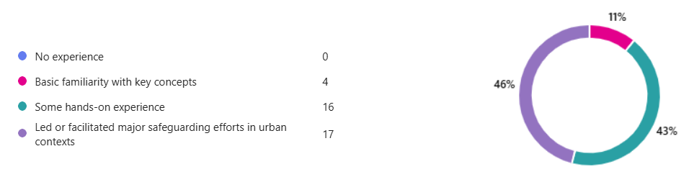
The majority of facilitators (89%) have experience in this area: 43% have some hands-on experience while 46% have led or facilitated major safeguarding efforts in urban contexts.
Question 2: If you have experience, in which region have you worked?
Europe is the region with the most reported experience (33%), followed by Africa (28%), Asia and the Pacific (19%), Arab States (14%) and Latin America and the Caribbean (12%).
Question 3: What type of support did you provide as a facilitator in such contexts?
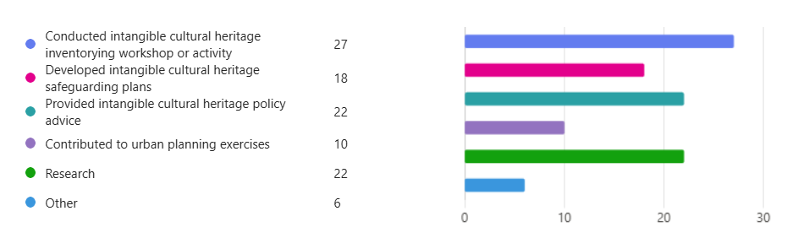
Most of the responses concerned the organization of workshops and activities to inventory intangible cultural heritage. In second place were policy advice on intangible cultural heritage and the conduct of research. Some respondents also have experience in developing safeguarding plans. Significantly fewer people have contributed to urban planning exercises, which shows the importance of strengthening dialogue between the culture and urban planning sectors.
Question 4: Elaborate briefly on your experiences.
In relation to conducting intangible cultural heritage inventories, the respondents mentioned various activities such as workshops, seminars, community-based inventorying, publications, field inventorying programs, processing of documentation data, training and capacity-building programs, and ensuring youth participation. For the development of safeguarding plans and the advice for cultural heritage policy, the importance of community participation was highlighted, especially that of children and the elderly, to establish intergenerational dialogue, as well as to support local communities and institutions in defining measures to protect both the physical cultural spaces and the intangible cultural heritage. Some specific research cases were mentioned, while those who have contributed to urban planning exercises did not provide detailed information.
Question 5: Are you currently collaborating in your work with any agencies, organizations, or actors in this area?
Most respondents indicated that they collaborate with academic, educational, or research institutions (26), as well as with civil society, associations, and specialized agencies working in urban contexts (23). Others (12) collaborate with regional or local government planning authorities, UN agencies (7), and, to a lesser extent (4) with national urban planning authorities.
Question 6: Please provide more details on your collaboration with these actors.
Among the actors with whom the facilitators collaborate are UN agencies such as UNESCO, UNITAR and UNICEF, as well as civil society organizations, UNESCO field offices, ministries of culture, category 2 centres, universities, bearers, libraries, museums and local authorities.
Question 7: What areas would you like to learn more about as a facilitator to support your work in this area?
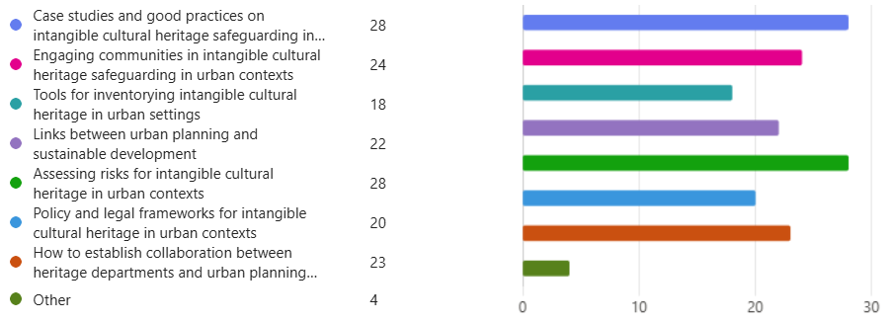
Respondents indicated that they wanted to learn most about case studies and good practices on intangible cultural heritage safeguarding in urban contexts (28), as well as about assessing risks for intangible cultural heritage in urban contexts (28). Engaging communities in intangible cultural heritage safeguarding in urban contexts (24), as well as establishing collaboration between heritage departments and urban planning departments (23), were also areas of major interest. The links between urban planning and sustainable development (22), policy and legal frameworks for intangible cultural heritage in urban contexts (20) and tools for inventorying intangible cultural heritage in urban settings (18) also received a large number of responses. This demonstrates that all areas are of interest to the facilitators.
Question 8: What do you see as some of the key challenges for facilitators working on intangible cultural heritage safeguarding initiatives in urban contexts?
The responses provided by facilitators were quite varied. However, for three of them, establishing collaboration between living heritage departments and urban planning departments is the main challenge. Other responses highlighted challenges in relation to the following topics:
Policies and governance
- Lack of visibility of the relevance of living heritage in urban policies: There is often too much focus on architecture, monuments, and the built environment, while intangible cultural heritage is underestimated in development policies, planning and decision-making.
- Bureaucratic limitations: Rigid regulatory frameworks and strict administrative procedures.
- Fragmented governance: living heritage and built heritage are managed by separate government departments
- City authorities rarely include experts (such as facilitators) in their meetings for future planning.
- Lack of consistent communication with national authorities.
- There is a need to clearly explain how to incorporate the relationship between tangible cultural heritage (cultural spaces) and intangible cultural heritage into public policy.
- Risk of appropriation: Presentations and expressions of living heritage can easily be altered under creative or economic mandates, exposing tensions between the implementation of the 2003 Convention and 2005 Convention.
Urban development impacts
- Disrespect for local traditions: Urban dwellers relocating to new districts often disregard or undermine established living heritage practices.
- The strong influence of the market and pop culture on living heritage: People adopt new ways of life and leave aside traditions that their parents and ancestors practiced.
- The intermingling of cultures within urban communities, particularly among people who migrate from rural or coastal areas.
- Sustaining the meaning and continuity of living heritage while enabling its transformation within rapidly changing urban environments.
- Ensuring effective citizen participation in diverse and rapidly changing urban environments.
- The depopulation of historic town centres due to overtourism, dilapidated and inefficient housing, and the closure of small shops and local services.
Communities
- The concept of what is considered a ‘community’ can be harder to define or delineate in urban contexts.
- Weak transmission of traditions to younger generations.
- Ensuring bearers’ rights.
Others
- Artificial intelligence.
- Lack of understanding of the Convention's objectives.
- Instrumentalization of intangible cultural heritage.
- Difficulty in identifying and documenting intangible cultural heritage in large cities, due to the cultural diversity of the population and their cosmopolitan nature.
Question 9: Is there a specific experience you would like to share during the session?
The following experiences were mentioned in the survey:
- Creation of an association to benefit from the skills of elders who moved to the city as adults;
- Two grassroots initiatives that have proven effective in asserting the right of residents to express their diverse cultures in urban contexts in Italy;
- Experiences on how intangible cultural heritage and the UNESCO Creative Cities Network can be utilised in urban transformation processes in Ecuador;
- Experience on integrating living heritage and built heritage in the historic center of Multan;
- Experience in Irbid, Jordan, where everyday practices, social interactions, and public spaces contribute to identity, belonging, and social cohesion in a rapidly changing city.

