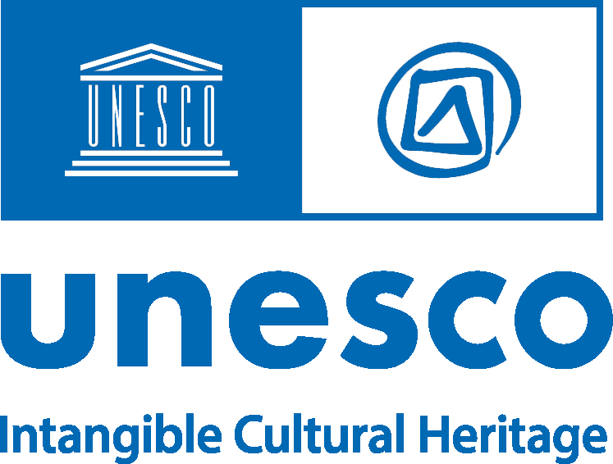

Safeguarding Intangible Cultural Heritage in Urban Contexts

This survey is an thematic initiative of the Secretariat of the 2003 Convention of UNESCO. It aims to assemble inputs from stakeholders working in or involved with the fields of urban planning and intangible cultural heritage (ICH) so as to identify key subjects when it comes to
safeguarding this heritage in urban contexts. More specifically, the responses to the survey will contribute to the preparation of a guidance note on living heritage and urban planning, with a view to generating guidelines and methodologies for safeguarding living heritage in urban contexts. This initiative responds to the UN Sustainable Development Goal 11.4 which seeks ‘to make cities and human settlements inclusive, safe, resilient, and sustainable.

The survey is confidential, and its results will only be presented in an aggregate form. The survey has been tested and takes approximately 90 minutes to complete.
You are kindly requested to complete the survey by 30 October 2022.

Please refer to Annex (https://ich.unesco.org/doc/src/56687-EN.pdf) for descriptions of key terms and concepts used in this survey.

If you have any technical issues while completing the survey, please contact the Secretariat: ich@unesco.org

Since entering into force, the 2003 UNESCO Convention for the Safeguarding of the Intangible Cultural Heritage has raised awareness around the globe of the need to support the ongoing transmission of living heritage with community-based approaches. Currently, urbanization processes worldwide have brought into sharp focus the need to better identify how living heritage adapts and evolves in urban contexts. Multiple factors such as rural to urban migration, climate change, land scarcity and increasing living costs are impacting the practice of living heritage in cities, as elsewhere.

Intangible cultural heritage experts and urban planning professionals, with their understanding of demographics, public infrastructures and both land and place management, can play a significant role in supporting better environments for communities. Your contribution to this survey will greatly assist in UNESCO’s preliminary efforts to identify key resources, challenges, practical approaches and recommendations when it comes to ICH and urban planning.

The survey is designed to solicit replies from those working in the technical domains of urban planning, architecture and policy, as well as living heritage specialists and community representatives concerned with urban planning. Throughout the survey, links to key definitions and concepts, along with background information, are provided.

ACRONYMS AND ABBREVIATIONS

ICH: Intangible Cultural Heritage, also referred to as 'living heritage' in this document.
2003 Convention: 2003 Convention for the Safeguarding of the Intangible Cultural Heritage

Part 1: Contact Information

Institutions or organizations (if applicable):

Name of institution or organization:

- Area of expertise:

City:

- Country:

Contact person:

- Email:

Telephone (optional):

Individuals

Full name

- Please select your gender:

Woman Man
Non-binary Prefer not to say

Position:

- Field of expertise:

Policy maker Researcher Urban planner
Urban manager Architect
ICH expert Other

Email:

- Telephone(optional):

Part 2: Identification of ICH in urban contexts
The global urban population is exponentially increasing, making urbanization one of the most transformative trends. With the phenomenal rate of urbanization, shaping the way humans live and interact, planners are presented with many human, environmental and spatial challenges, as well as opportunities. This is the case not only in cities, but in the surrounding areas such semi-rural or peri- urban, smaller, and evolving urban clusters, etc. In many cases, multiple communities converge, with different cultures and backgrounds. In contexts of fast-evolving urban environments, there is a need to identify ICH in its many forms, along with how it is transmitted, by whom and where, and challenges it may be facing.

Among the elements of living heritage that exist in the urban context/s with which you work, please list one or more elements that you are familiar with, and which are of particular importance to the communities concerned. They may be expressions of ICH that are long-established and flourishing or elements that have more recently appeared in urban contexts belonging to newer migrant communities.
Please include the following information in your answer:

Name/s of the element(s) of ICH:
City:

A brief description of the element(s):
Location/geographic distribution: describe the part of the city or other urban environment where they take place. The location may be centralized or spread over a wide part of a city:

Communities concerned: name and scale of the community/ies (population, age group, ethnic etc.). Describe how the ICH is
practiced (e.g. on daily basis/regular event/ other): Inventorying or another form of identification of ICH: the identification of living heritage is one of the key measures

encouraged by the 2003 Convention for safeguarding the skills, knowledge and cultural meanings ICH embodies. To date, the identification of ICH, which may also involve inventorying[1], is a relatively new endeavor in many cities and other urban
environments):

Under the 2003 Convention for the Safeguarding of the Intangible
Cultural Heritage, inventorying is an obligation of States Parties and can be described, in terms of the Convention, as systematically documenting ICH in accessible ways, with community participation. Further information is available at: https://ich.unesco.org/en/inventorying-intangible-
heritage-00080

- Do you know whether the element/s has/have been inventoried? And if so, do you know if the community/ies have participated in this

process? If yes, please provide the name of the document and the source/how it can be accessed.

Threats to ICH in urban contexts

The threats to living heritage in urban contexts are multiple, and can include population mobility, fragmented social structures, rapidly changing lifestyles and a waning interest in ICH among youth, communities pushed out of areas due to gentrification and rising costs, the need to increase working hours at the cost of time dedicated to social and cultural relations, among other factors. The survey aims at identifying the threats that are impacting the transmission of ICH which are exacerbated by urban planning omitting the ICH of communities.

- Below are some of threats that impact the transmission of ICH which is exacerbated by urban planning that does not consider living

heritage. Please mark those that are particularly relevant to urban contexts in your experience.

Destruction or changes to spaces associated with living heritage practices Rapid urbanization altering ways of living
Migration (inward or outward)

Infrastructural strain due to population growth
Inadequate housing or housing inconsistent with community-oriented social interaction and organization
Unemployment or low incomes
Industrialization (usually more relevant to areas in the process of urbanizing, rather than already industrialized cities)
Lack of public spaces Consumerism
New technologies

Globalization (homogenization)
State appropriation of land and land clearing (rezoning for urban or agricultural extensions)
Climate change and associated natural disasters (mudslides, heatwaves, fires, flooding…)
Food shortages

Armed conflict and displacement

- Please share any experiences of threats to the practice and
transmission of lCH you have observed in urban contexts, describing

they may be linked to the spatial organization of the urban environment, along with any of its ecological, economic, and/or social functions. For
example, rituals usually require dedicated spaces (whether temples or shrines, etc.) while elements relating to festivals may require access to public spaces at specific times, and businesses involving gastronomic traditions usually require restaurant locations with exposure to public areas or dense public passage.

- Please share any experiences of communities adapting to the urban
contexts in order to continue the practicing and transmitting of lCH?

Part 3: Integration of ICH in urban planning
Urban planning, as the design and regulation of the uses of spaces and their physical forms (built and natural), encompassing proposed economic functions, resource and environmental conservation strategies and zoning areas (residential, industrial, commercial, cultural, leisure), affects all dimensions and characteristics of cities, shaping, to various degrees, how people live and use the space around them. As such, it can have a direct impact on sustainable development, if uses of space and resources are proposed in ways that lead to more equitable socio-economic impacts, and the durable use of resources. Urban planning can also facilitate the safeguarding of living heritage by considering communities’ and practitioner needs in terms of spatial organization. This could happen, for example, through zoning which allocates public spaces or protective regulations in areas where social practices or production and distribution points for ICH are particularly important, including traditional markets or workshops. Given how ICH can contribute to greater social cohesion and
well-being as well as to livelihoods – two key contributors to sustainable development – it is also important that communities’ views and participation is sought in urban planning processes.

Urban planning is multiple and inter-connected layers, for example:
Ecological structure: relating to the connectivity of natural areas and corridors, risk management, rural development, and environmental sustainability.
Functional structure: composed of public spaces, public services/infrastructure, mobility (circulation in cities), and urban facilities systems (roads, railway and other transport hubs, waterways, pedestrian lanes and spatial connectors).
Socioeconomic structure: takes into account the integration of urban-rural areas, among others, and relate principally to planning for greater economic efficiency in terms of productivity, employment, housing, attractivity of the city as a destination for investment (such as industrial

19. Please share any examples of effective safeguarding measures you may know of, or more general efforts to support the practice and transmission of ICH in urban contexts.
relocation) and various other economic activities.
Historical and built heritage structure: treated as an imperative element in the structuring of an urban plan, notably with regard to significant gazetted historical monuments or districts, etc, which

Do you know of efforts to safeguard ICH that place importance on or protect areas/spaces where the ICH is practiced?

- Can you give examples of specific relations between built
environments and ICH or living heritage that could be taken into consideration in urban planning?

- While public spaces are usually present in urban plans, they are not
necessarily identified clearly with a need to safeguard living heritage.

Can you suggest ways that this situation could be addressed in the places with which you work?

- Can you give any examples whereby the protection and/or
encouragement of living heritage has been integrated into an urban

plan? If yes, please provide name of the city(ies), name of the key agency and focal point.

- Based on the example you have given, were there any methodologies, tools, or mechanisms established or applied for the inclusion of ICH in urban plans (policies, legislation, financial, administrative)? If yes, please provide more specific information.

Community participation in efforts to integrate ICH in urban planning are essential if this integration is to be sustainable. Community members are best placed to know, and to articulate, what conditions are most important to the continuity of their living heritage. Yet it can be a challenging process to implement. Can you give any examples of
community participation in the process of integrating ICH in urban planning?

- Benefits of integrating the safeguarding of ICH into urban plans can be significant, and many are listed below. Please mark those you consider to be of relevance:

Social cohesion and well-being Informal social support structures Inter-generational communication Sense of identity
Intra and inter-community tolerance Protection of local economies
Sustainable livelihoods Urban rehabilitation
Environmental protection Urban – rural integration Risk preparedness
Other

Regarding question 26, please explain the reason for your choice(s) (maximum 150 words).

- Challenges to integrating ICH into urban plans are numerous. Please name and describe any challenges you have observed (maximum 250 words):

Part 4: Potential actions/recommendations

In the sound preparation of an urban plan, there is often an obligation to hold public meetings to collect feedback from communities living in the area concerned (residential groups, commercial interest groups, etc.).
How do you consider community participation can be ensured in the integration of ICH in urban planning process?

- Living heritage can contribute to different aspects of urban planning, such as ecological, economic, and social structures of cities. Can you

give any concrete examples of ways in which it does, or could do so from your experience?

- What are the key planning areas/domains for ICH integration? For example, historic and built heritage zones, residential areas, public

spaces, public services and facilities, economy and livelihoods, infrastructure, etc.

- Please describe key or overarching and practical actions that could play pivotal roles in integrating ICH in urban planning.

With a view to define a methodology to integrate ICH in urban planning, what do you consider the key components?

- What are the key short term, medium-term and long-term measures

for ICH integration into urban planning processes, either in general
terms, or, in relation to the cities and communities with which you work.

Part 5: Key stakeholders, experts and institutions
The nature of urban planning incorporates multiple disciplines and components (heritage protection, land use connectivity, zoning, infrastructure, natural risk and resource management, trade and transport, etc.). Therefore, many stakeholders and professions are involved. Among them, can you highlight key stakeholders to consider when incorporating ICH in urban planning processes?

Are you aware of individuals who work on ICH in urban contexts in your city/ country/region from the urban planning perspective?
If yes: please provide information (name, position, email)

Can you suggest individuals who may not be directly involved at present with urban planning, but who could contribute through their knowledge of living heritage in urban contexts by proposing informed viewpoints on key safeguarding issues?
If yes, please provide information (name, position, email):

- Do you know any institutions/networks working in areas relating to ICH and urban planning?
If yes, please provide information(name, web page, brief description):

Would you be willing to accept a follow-up interview with the Secretariat of the 2003 Convention based on the answers you provided above?

Yes No
Maybe

Thank you for your time in completing this survey. All responses will be analyzed, with the results contributing to the preparation of a guidance note on ICH and urban planning.

This content is neither created nor endorsed by Microsoft. The data you submit will be sent to the form owner.
Microsoft Forms

