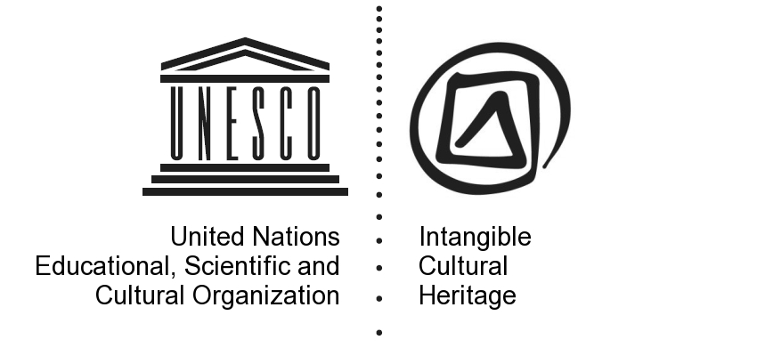 | Original: English and French
CONVENTION FOR THE SAFEGUARDING OF
THE INTANGIBLE CULTURAL HERITAGE
INTERGOVERNMENTAL COMMITTEE FOR THE
SAFEGUARDING OF THE INTANGIBLE CULTURAL HERITAGE
Fourth session
Abu Dhabi, United Arab Emirates
28 September to 2 October 2009

Nomination for inscription on the Representative List in 2009 (Reference No. 00175)
A. | State Party: Mexico
B. | Name of element: Ritual ceremony of the Voladores
C. | Community(ies), group(s) or, if applicable, individual(s) concerned:  The Ritual Ceremony of the Voladores, of Mexican origin, has been practiced by various Mesoamerican ethnic groups:  • Totonac  • Teenek  • Nahua  • Ñañhu  • Maya  It is in the Totonacapan region where its representative and emblematic value is most evident, linked to community life itself and strengthened by the proximity of El Tajín, an important cosmopolitan, pre-Hispanic Ceremonial Center (8th through 12th Century: Late Classic) where various groups converged.  The Totonacapan region accounts for, approximately:  • 33 Groups of Registered Voladores  • Voladores not registered  • 3 Voladores Schools for Children  • 3 Associations  • Approximately 500 identified Voladores
D. | Brief textual description of the nominated element:  A group of people, hanging from a mast 18 to 38 meters high, twirl around the pole mimicking flight, while one of them dances at the top of the pole to the sound of flute and drum.  With many spatial and temporal variations to the Ceremony, it becomes, in essence, a ritual to establish communion and communication with the gods through offerings and entreaties for the fertility of the earth.  According to tradition that dates to 600 B.C., in times of drought and hunger the elders sent messenger-priests (Voladores) to proffer their offerings to the gods and implore rainfall to fertilize the land.  The Ceremony comprises several stages:  • the physical and spiritual preparation of the participants,  • the sewing of the garments,  • the selection and cutting of the tree,  • the dragging and raising of the pole,  • the dance performance on the ground and flight on the pole  During some of the stages, offerings are given to the deities and forgiveness is implored; practicing ethnic groups maintain that human beings do not own nature but are a part of it, hence, this relationship should be one of respect and harmony.  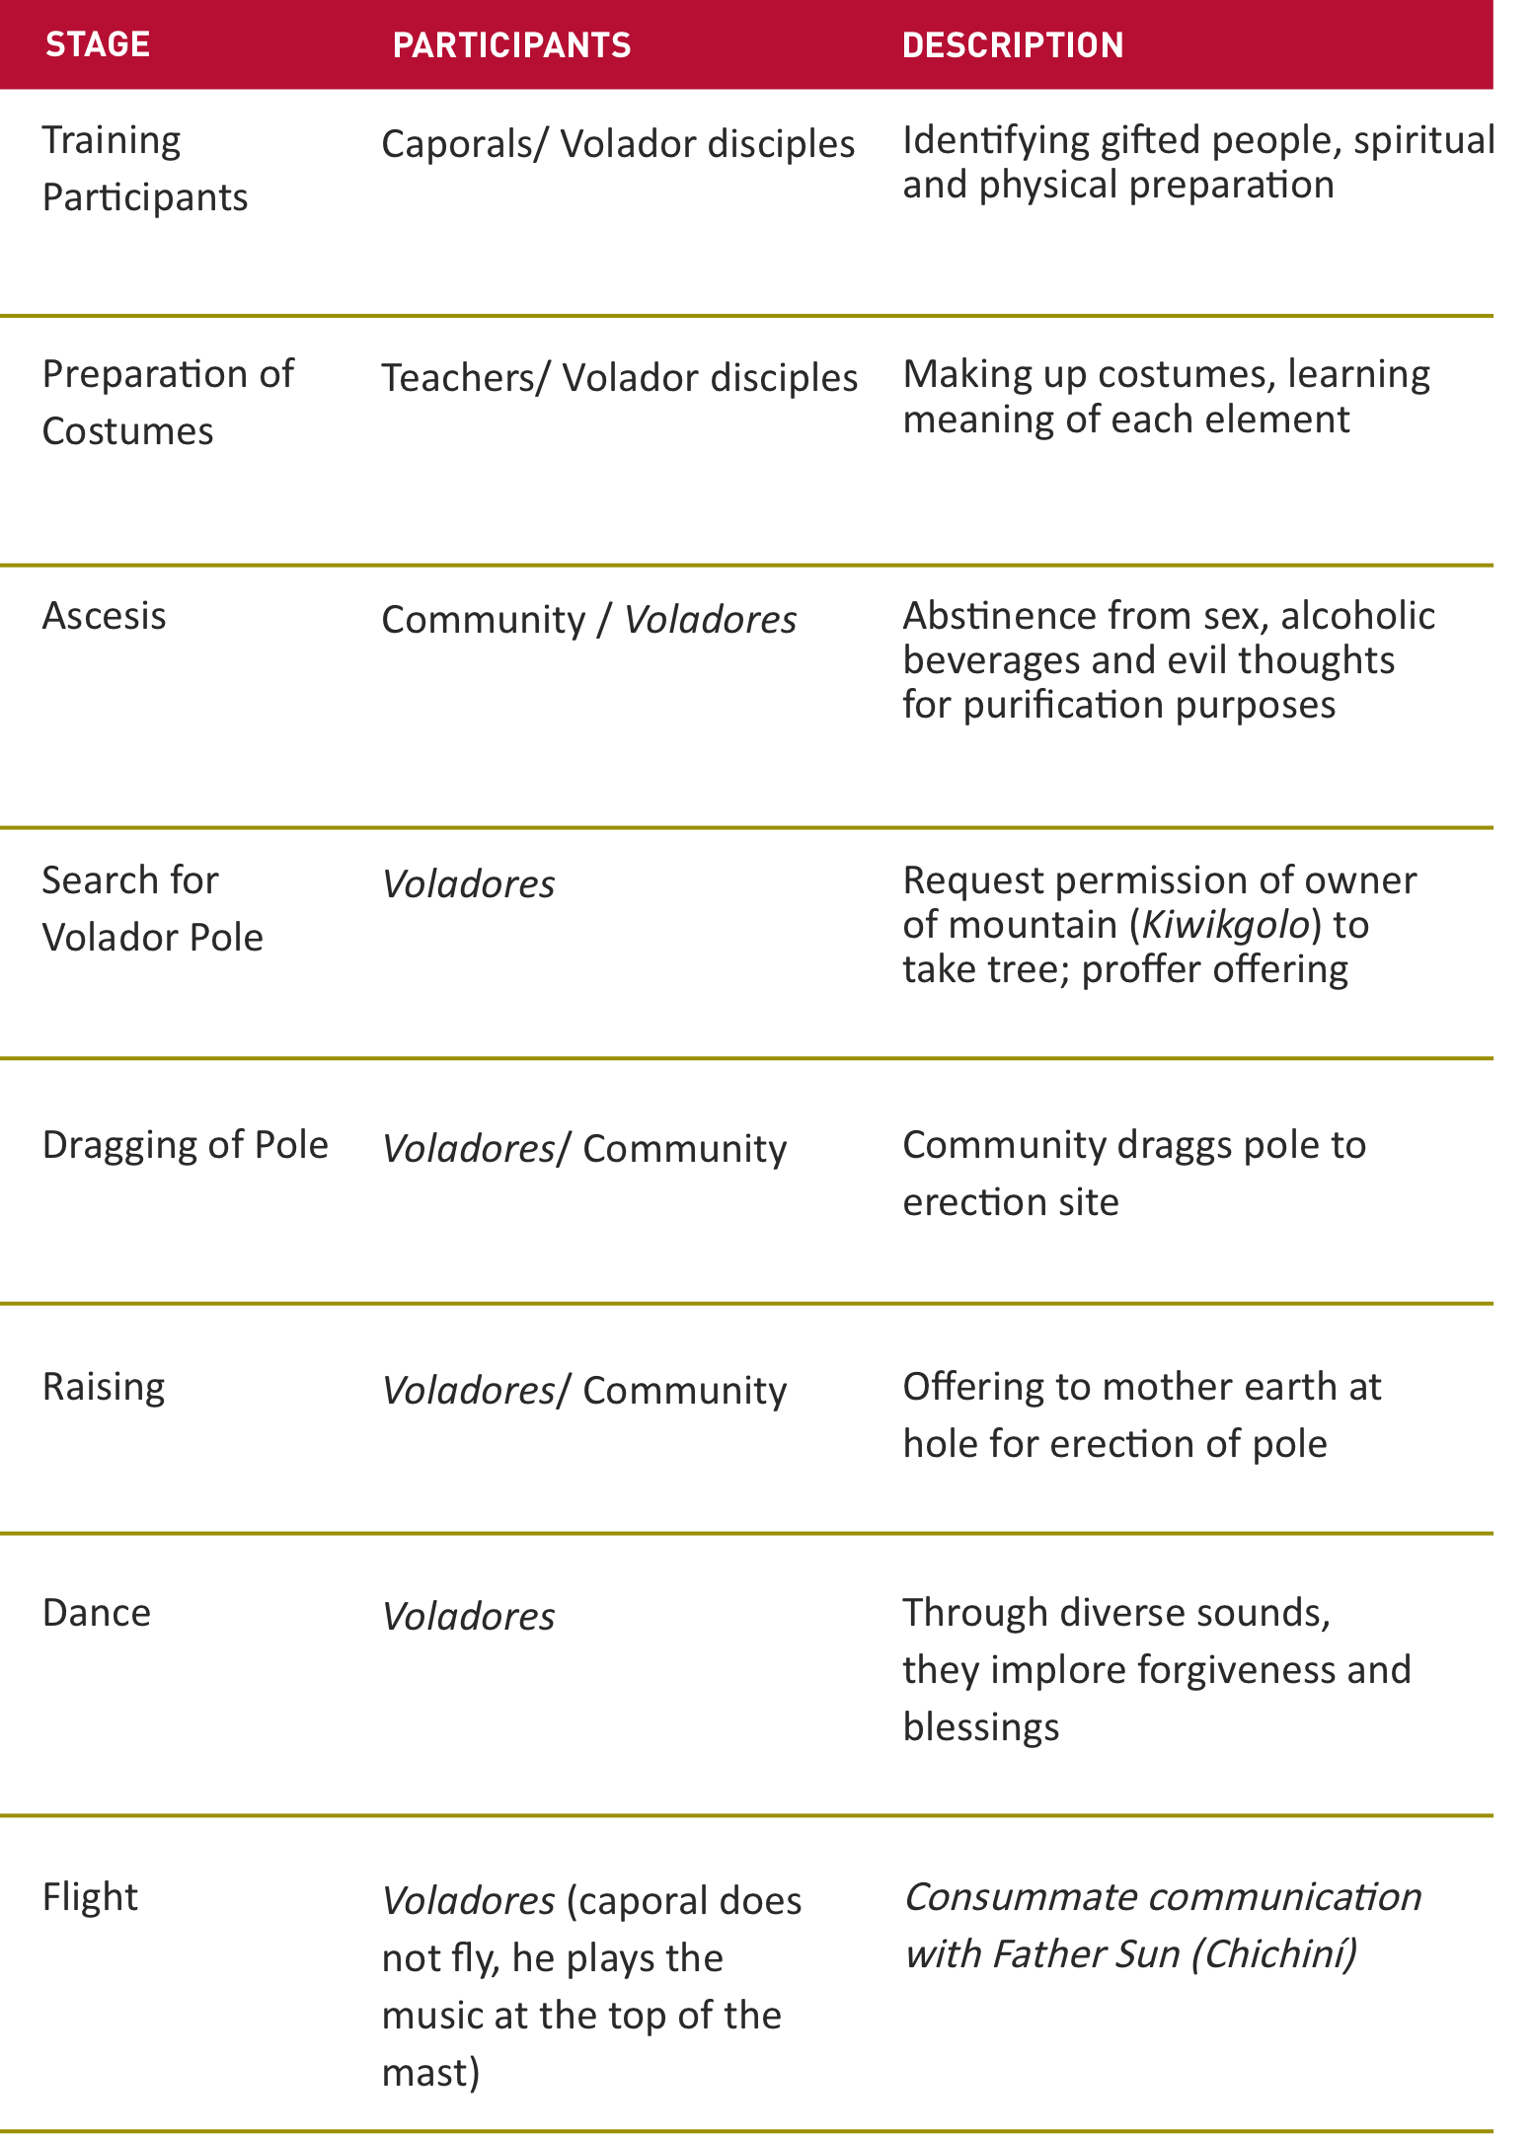

1. | Identification of the element
1.a. | Name of element: Ritual ceremony of the Voladores*  * Generally speaking, in Spanish these Ceremonies are called “Dances” and not “Ceremonies”. This occurs because sometimes it is difficult to find a precise meaning when translating from one language to another and the Ceremony then takes on the name of one of its stages. Nevertheless, in recent meetings the members of the communities agreed that the correct name is “Ritual ceremony of the Voladores” (Flying Men or Flyers), and as thus they want it to be known

1.b. | Other name(s) of the element, if any:  • Papantla´s Voladores  • Dance of the Voladores  • Dance of the Flying Pole  • Dance of Eagles or Sparrowhawks  • Dance of the Sun  • Dance of Fertility  • Dance of the Monkey  • Dance to the God of Cacao  • Ritual Ceremony of the Voladores  Names in the languages of the different communities  • Totonac: Kogsni (Flyer)  • Teenek: Bixom T´iiw (Dance of the Sparrowhawks)  • Nahua: Cuauhpatlanque (Those who Fly with the Help of a Mast)  • Ñañhú: Ratakxöni (Those who Fly)  • Mayas Kichés: Ajxijoj Kiktzoykib´ Pwi´che (Dance of the Monkey)  • Pipiles: Comelagatoazte.(Dance to the God of Cacao)
1.c. | Identification of the community(ies), group(s) or, if applicable, individual(s) concerned and their location:  - Totonacs of the sierra region and the northern coast of Veracruz (primarily communities in the townships of Papantla, Zozocolco de Hidalgo, Filomeno Mata,  - Coyutla, Coatzintla, Espinal and Mecatlán; in the state of Puebla: Cuetzalan, Caxhuacan or Huehuetla; in the state of Hidalgo: Huehuetla). Also worth noting is the importance of the Kgosni school for Totonac Volador children at the Center for Indigenous Arts of Papantla.  - Teeneks of the state of San Luis Potosí  - Nahuas of the state of Hidalgo and Puebla (of importance here is the community school for Nahua Volador children of Xolotla, Pahuatlán).  - Tepehuas of northern Veracruz, although in this region the Ceremony has fallen into disuse.  - Ñanhús of Puebla (of importance here is the community school for Volador Children of the community of Chila, Municipio de Honey).  - Maya (speakers of k’iche’, kaqchiquel, achi and tz’utujil of Guatemala)  - Piples of Nicaragua

1.d. | Geographic location and range of the element:  The Ritual Ceremony of the Voladores, originating – according to some investigators – in the west of Mexico (Jalisco), has been practiced by diverse Mesoamerican ethnic groups; given its antiquity and migratory phenomena, there are variations.  It is, however, in the Totonacapan¹ zone, and more specifically in the region of Papantla² and other areas neighboring El Tajín³, where the center of confluence lies. There, the Ritual Ceremony of the Voladores has become a solid, identifiable icon; the Totonac have assumed the paternity⁴ of the element, protecting it –as the essence of their identity– from multiple risk factors in the past (the conquest, colonization, the Inquisition, etc.) and in the present (migration, excessive commercialization, economic impoverishment of the campesino dancers, homogenizing educational models, the aculturation of new generations, deforestation, etc.)  Notwithstanding their willingness to live abroad or outside their region⁵, the Totonac are very careful to preserve their cultural values. In the specific case of the Ritual Ceremony of the Voladores, though they are willing to share it with tourists, the Council of the of Totonacapan, keen on preserving their identity, have supported the creation of various Associations of Voladores and Schools for Volador Children, with the purpose of preserving the original Ritual.  ¹ The Totonac are thus named because they worshiped Totonac. Other versions stress an etymological interpretation of “tutu” (three) and “nacu” (heart): three hearts. This interpretation refers to the three major Ceremonial Centers -Tajín, in Papantla, Zempoala, close to the original site of the founding of the Port of Veracruz, and Yohualichan, in the Northern Sierra of Puebla, close to Cuetzalan.  ² The Voladores, in Papantla, are known for their capacity to organize in various Associations, thanks to which they are world renowned as the “Los Voladores de Papantla”, The Papantla Flyers or The Flying Men of Papantla –icon of Mexican culture.  ³ El Tajín was declared a World Heritage site in 1992.  ⁴ The Totonac believe that the true meaning of paternity, beyond that of begetting, is to bestow life; this is accomplished through protecting, teaching and molding.  ⁵ The Totonac dancers have often traveled abroad, and they have welcomed visitors from all over the world, since the year 2000, at the Tajín Summit Festival, whose main purpose is to bring together cultural expressions from all over the world.
1.e. | Domain(s) represented by the element:  First and foremost, and in the fullest sense, the element stands out because of its profound belonging to the domain, in which it encompasses social customs, rituals and festivities; albeit in the past the spectacular nature of the flight phase was a factor that facilitated its survival in adverse conditions and in the present contributes to its visibility.  In like manner, we reiterate that their original and essential purposes express the very principles and values of indigenous cosmogony, such as communication with deities and their harmonious relationship with the universe and nature, as well as such values as tradition, purification, pardon, community participation, and more. Lastly, an interesting body of traditions and oral expressions are embraced.  If in recent times some groups have agreed to present an abbreviated version (the flight) of the Ceremony to the delight of tourists, this is partly owing to the capacity for adaptation of these ethnic groups; for example, during the Colony¹, its practitioners were able to merge the ritual with the newly imposed religion, as evidenced in the Azcatitlán Codex, where we see the Voladores (Flyers) clad in wings of angels; on the other hand, some narrations incorporated the figure of Christ into their own beliefs. Regardless, it is most important to underscore that the flight is only one stage of the Ceremony, and there is some concern regarding ensuring that the rite is practiced in its entirety within the communities.  ¹ The period of the Colony in Mexico covers from 1521 (when Tenochtitlan was taken by the Spanish conquerors) through 1821, the year in which the War of Independence began.  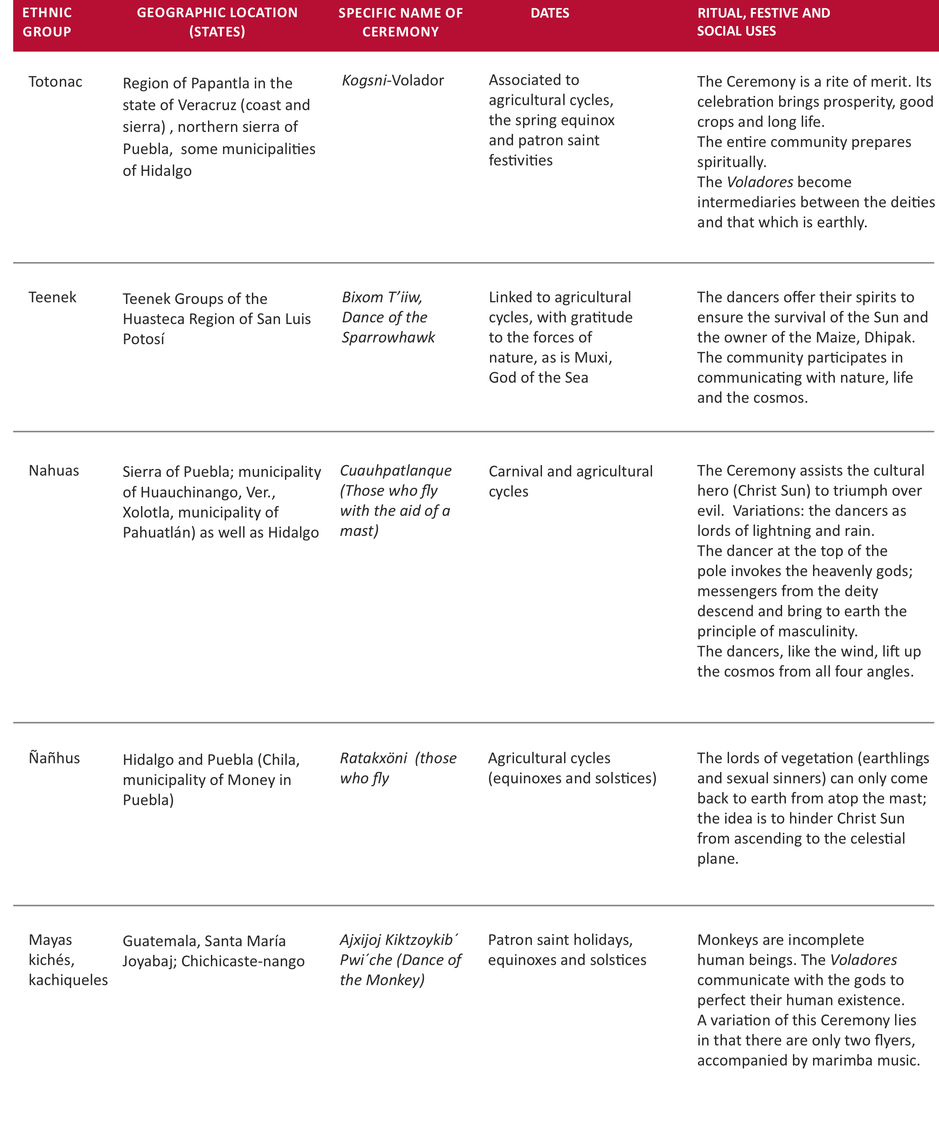Principal domain  a. Social customs, rituals and festivities  The Ritual Ceremony of the Voladores is a true work of art, one that summarizes the meaning of li tutu nakú: “being Totonac”. It reaffirms group identity and the awareness of continuity of practicing ethnic groups, given that it is linked to the cycle of life, expresses a vision of the past and present world, and manifests the need to maintain a harmonious and respectful relationship with Nature.  It is of the utmost importance that the Voladores and the community as a whole comply with the period of personal spiritual preparation (ascesis and purification) prior to the Ceremony, for if during the Ceremony an accident should occur, it would be interpreted as a bad sign.  The Ritual Ceremony of the Voladores is held during patron saint festivities and/or carnivals, solstices and equinoxes, festivities surrounding the Day of the Dead, and in ceremonies associated with the sowing and harvesting of crops. The flight stage of the Ceremony can take place at any time, for exhibition purposes, for which reason the Voladores must be physically, mentally and spiritually prepared at all times.  Secondary Domains  b. Knowledge and customs related to Nature and the Universe  The Ritual Ceremony of the Voladores expresses important myths and concepts regarding the Universe and Nature. All variations recreate a cosmogonic myth:  … if the dance takes place during cyclical moments in the cosmos, such as during carnivals, the winter solstice or at the start/end of an agricultural cycle, that is, when renewal and strengthening is needed, not only of the world but also of humanity and victuals, the great phallus will again penetrate the earth and cause great fertility, recreating a cosmogonic myth. The moment the tree is “planted” in the middle of the town square, the center of the cosmos, the world is shored up and once again, as in the myths of origin, the heavens and the earth separate. The captain of the dance, upon raising his arms, renews the axis mundi that is fixed in the navel of the earth and reaches to the sky; this gesture takes on cosmogonic meaning. Upright, at the apex of the mast, he plays his flute and imitates the primordial sound; bowing in reverence to the four directions of the world, he gains sovereignty over cosmic space, temporal space and the movement of the solar star. Once cosmogony is recreated, as in the case of birds, his flight can be interpreted as the movement of solar rays, of heated forces. With his movements, the circular course of the Sun around the earth recommences. The descent of the beings associated with the infraworld –cold beings, the creatures who inhabited the earth before the appearance of real men– once again opens up that plethoric space of fertility and the renewal of the entire universe is complete. Sovereignty over the four directions of space is acquired through these rites, and one commands the view of the entire temporal space (Nájera Coronado, 68-69)  c. Traditions and oral expressions, including language as a vehicle for intangible cultural heritage.  The Ritual Ceremony of the Voladores is based on an important oral tradition that includes legends, prayers and dialogues from the pre-Hispanic era that have been transmitted for generations as elements essential to identity.  Each time it is told, myths and conceptions about the Universe and nature surface, either in original form (pre-Hispanic) or by virtue of expressions grown from the adaptation of indigenous communities to new religions and circumstances. One way or another, we find in these myths and conceptions the manner in which they perceive the world and relate to it and to their deepest values, including: the recreation of cosmogonic myths, communication with that which is divine, offerings, asking nature for her bounty, the struggle of good against evil, the fertility of the earth that depends on human merit, etc.
2. | Description of the element (cf. Criterion R.1):
The Voladores (The Flying Men or Flyers)
Krickeberg, anthropologist, in Los totonacas, states that the Voladores in ancient times wore costumes depicting eagles that represented the souls of warriors sacrificed in battle; he also mentions the indigenous belief that sacrificed warriors returned to earth in the guise of birds and butterflies at noontime to suck nectar from flowers; he adds that the Voladores are morning stars and candescent looks from the day star: the Sun (Chichiní).
Cecilia Bretón Fontecilla, in her article “Fiesta de Corpus Christi”, notes that a group of single young men take a seven-year vow; during this time they may not have a sweetheart so as not to tarnish their offering with sullied thoughts. They will spend these years practicing the dance.
Samuel Martí, in Canto, danza y música precortesiana, (Song, Dance and Pre-Cortes Music) states this fertility ceremony perhaps was disguised as a game to preserve it and mock the Christian inquisitors; he adds that this is one of the oldest dances known.
Lorenzo Boturini, Royal Chronicler of the Indies, tells us in his treatise, “Idea of a New General History of North America”, that the four flyers represent the four symbols of the year and the thirteen turns of each one form a tlalpilli for every 52-year cycle. That is why each flyer was given a name: the first flyer, Tochtli (rabbit); the second, Acatl (cane); the third, Tecpatl (flint) and the fourth flyer, Calli (house).
Tezozomoc tells us that the dance of the volador was introduced among the Mexica by Huehue Moctezuma during the fifth year of his reign in Tenochtitlan (1465). This ceremony was known as Tlacacalistli, and held during the festivities of Tlacaxipehualistli, dedicated to Xipe Totec.
Studies of various interpretations of this Ceremony have only been able to agree that it is related to fertility.
In the opinion of Torquemada, Clavijero and Boturini, we find that the dance of the volador is of Toltec origin, its paternity ascribed to the Totonacs and linked to the indigenous time cycle: the cords tied to each flyer measure a determined length so that with thirteen turns around the pole the flyers will touch the ground. In the Papantla region and in part of Puebla, there is a ritual whose beauty and meaning has mesmerized the world. The ritual, beginning with the preparation of the costumes, is shrouded in mystery and highlights the dancers’ courage; their skillful hands make music from the rustic reed flute, an artistic expression of the culture of ancient Totonacapan.
Legend has it that long ago, during a time of famine and drought, the elders convened and decided to send messengers to heaven to honor the gods with their offerings, beg for forgiveness and ask for rain and the fertility of Earth, for we humans are not owners of the earth, we are merely part of it.
Description
One group, led by its Caporal, goes to the forest in search of the tallest, strongest tree, begging forgiveness to the god of the mountain, Kiwíkgolo, “Old one of the hill”, for they will sacrifice a member of the plant community.
The ground is cleared around the chosen tree where the ceremony is to be held, all done to the tune of the flutes. After four days, the dancers return and the ceremony and music begin again; the axe falls 12 times first, to the tune of a “forgiveness” song. Once this step concludes, the dancers withdraw, purified, and later proceed to chop down the tree.
Once the tree has fallen, more than 200 men – the tree is over 20 meters long – transport it to the place where it will be sunk. Before sinking the pole, the rungs for the ascent of the flyers are added; the necessary adaptations for flight are made.
A black hen is placed into the previously dug hole and a bottle of aguardiente (hard liquor) is poured over it to consecrate it to the gods and protect all from harm. In ancient times the labor was performed by human strength alone. Before beginning the flight around the pole, a dance is performed to invoke the god of wind and beseech forgiveness and protection.
On the day of the ceremony, all participants must be abiding in the grace of God –indigenous people have not forgotten their native deities and protectors, a fusion of Catholicism and paganism. Before beginning the ritual, the caporal marks the beginning of the ceremony with his flute and small drum.
The Voladores climb up the pole one by one; once at the top, they tie themselves securely to each side of the small platform installed, each corner representing the four cardinal points. Once the four men are in place, the Caporal climbs up, flute and small drum attached to his waist; at the knob on top he sits, looks to the east, calls to the Sun through his instruments, leans over backwards while looking straight up at the sky, and addresses all the gods to ask for protection for those embarking on the flight. The first song is dedicated to the east, the second to the west, the third to the north and the fourth to the south.
The invocation over, the dancer stands upright on the small platform, erect, majestically tall at 25 to 30 meters above ground, looks to the east and begins to dance, turning on the platform until he faces east once again. At all times he plays music, repeating the “song of the four cardinal points”. Once the rite has concluded, the Caporal sits and the four flyers – now certain of divine protection – fling themselves into the void.
This important ceremony has undergone some modifications. Of old, it was a truly splendorous sight to behold; in essence, it remains the same. When the Spaniards arrived, they celebrated the Corpus Christi festivities; the Catholic religion appears to have adapted to the dates on which the majestic celebration of the sun takes place.
3. | Contribution to ensuring visibility and awareness and to encouraging dialogue  (cf. Criterion R.2):
By virtue of being live heritage, the Ceremony has not remained unchanged over time; rather, due to constant recreation and the incorporation of new contexts and generations, it has been modified by means of unique processes of adaptation and regeneration in such a way that today it expresses the cosmogony, values, and identity of present-day communities.
The beauty and visual spectacle of the flight stage of the Ritual Ceremony of the Voladores has contributed to its permanence and to being considered, both nationally and internationally, as one of the icons of indigenous traditions of Mexico. Nevertheless, the fact that its folklore and spectacular aspects are acclaimed does not mean that they are understood; on the other hand, these very factors may expose the Ceremony to being perceived of as merely commercial or recreational, thus affecting its survival, or contributing to it not being valued, or perhaps even its authentic and essential meaning becoming distorted.
The expansion of global values and institutions does not necessarily imply that the cultural traditions of Africa, Latin America and other regions are being abandoned or destroyed in light of the spread of global influence. Very often we witness transculturation processes in which local “realities” – whether ancestral or modern – seep in and are reinterpreted in global realities. Mesoamerican cultures, together with other ethnic groups, at present share the risk of being absorbed by the cultural homogenization of global institutions, though they seek to maintain the beliefs, rites and practices which to a greater or lesser degree set them aside as ethnic groups and often mark the differences that separate them from the rest.
Hence the importance of proposing the Ritual Ceremony of the Voladores (Flyers) as Intangible Cultural Heritage of Humanity.
If the element is considered Intangible Cultural Heritage of Humanity, this will, primarily,
Stimulate practicing communities to offer their values and expressions to the globalized world with pride and the assurance of acceptance and respect.
Open a window to the rest of the world, with the possibility of accessing different structures of present-day thought.
Those of us who participate in this project rest assured in the knowledge that understanding and respect of cultural differences is one of the main factors that will help in creating inclusive paradigms and synergy, moving beyond ethnocentric or universalist stances, in juxtaposition to paradigms that exclude others and are imposed by stakeholders who – one way or another – are more influential than others.
Concretely, acceptance of the element will contribute to:
• Recovering and strengthening the perception of the Ceremony and its array of meanings within practicing communities.
• Reinforcing the visibility it already enjoys (in terms of creating greater awareness as a tourism product linked to El Tajín), while providing information that will underscore the authentic meaning and values, whose reinterpretation gains credence in a world undergoing globalization; doubtless, this will preserve and enrich it.
For example:
• Values that promote convivial harmony with nature, to whom (in the course of the ritual) offerings are respectfully presented: material (food) and spiritual (reflection and community ascesis) to be deserving of her bounty;
• Values that promote working for the common good (both, for the participation of the entire community in a ritual proffering benefits for all, as for the Ceremony itself, in which the observation of physical and spiritual security standards by each member will affect that of the entire group of dancers)
• Recovering and strengthening the perception of culture, in the broadest sense, of each practicing ethnic group; the element cannot survive in isolation, it will survive in its association with physical, communicative, economic, and artistic spaces, etc.
• Promote the protection and care of other elements that are part of these cultures, in an integral manner (for example, oral traditions and their languages; artisan work and its techniques and materials, etc.)
• Encourage pride, dignity and respect for one’s culture and its diversity, upon showing how, through rituals, culture contributes to fostering a global understanding of diversity.
• Facilitate access to the conceptual world in which practicing ethnic groups live so as to establish an intercultural dialogue.
• Support the legitimation of cultural policy as a strategic element for the eradication of poverty and taking care of natural resources.
For example: Sustainable ethno and eco tourism projects intended to open spaces for dialogue among the stakeholders of cultural diversity, both nationals and foreigners.
• Make commitments in terms of the physical and social safety of the dancers who risk their lives in this Ceremony and their families.
• Promote a reflection on the importance of community work and commitments.
• Encourage the investigation and systemic dissemination of information on this and other elements to recognize the situation and design strategies to answer to the present-day needs of indigenous groups.
4. | Safeguarding measures (cf. Criterion R.3)
4.a. | Current and recent efforts to safeguard the element:  Viability endangered  In the Totonacapan region these ceremonies survive the homogenizing process of modernity and adapt to the demands of the tourism and trade markets without losing the essential elements that lend meaning to the communities; nonetheless, there are factors that endanger their profound meaning.  Some of the factors that endanger the viability of the element are:  - Loss of meaning of the ritual  While the spectacular aspect of the flight stage of the Ritual Ceremony of the Voladores has permitted its practitioners to take part in the tourism market with relative success –doubtless a factor which has contributed to its permanence– one of the aspects that most concerns the elders of the communities and the traditional teachers is that there are only “pieces” remaining of the Ceremony (entrepreneurs are only taking into account 4 or 5 sounds and the flight). Contracts are signed, and only bits and pieces reach the new generations.  For the new generations of “professional” dancers, the “complete” ritual is no longer necessary; hence they see no need to train “complete” dancers. The ascetic principles and traditional standards of ethic and conduct of the dancers-leaders are fast deteriorating, thereby leading to a loss of life concepts that were wont to materialize through the Ceremony.  Young people, in like manner, learn the abbreviated versions, and regardless of the keen interest of the elders and teachers to preserve the full meaning, this becomes diluted gradually in the face of new stereotypes and life models (new ways of spending free time, becoming informed, communicating, interpreting and becoming part of the world, etc.)  - Increasing danger  The loss of principles mentioned earlier also leads to the neglect of meticulous technical knowhow that the dancers need to execute their work, leading to the possibility of accidents which imperil their safety.  - Competition  There are insufficient positions to guarantee work for the different groups of Voladores in each region, envy and competition to secure contracts lead to frequent divisions and conflicts.  - Poverty, disenfranchisement and discrimination  • Performing the Ritual Ceremony of the Voladores implies a cost (materials, garments) which, given the socioeconomic situation of the practitioners, is high.  • Concerned with supporting their families, adults and youths migrate to seek opportunities elsewhere.  • Members of the indigenous communities gradually stray from their traditions, language and garb in an attempt to feel like they belong to modern urban life; in time, this dilutes their sense of belonging and ethnic identity.  • The lack of understanding regarding cultural diversity causes people not familiar with indigenous traditions to show a lack of respect for them, or believe them to be merely exotic.  - Lack of information  The lack of available information on the significance and meaning of the complex ritual of the Ceremony affects the young population that resides in the region as well as visitors, making it difficult to appreciate it in all fairness and undertake comprehensive actions to safeguard it.  - Deforestation  Deforestation in the region, caused by extensive cattle grazing practiced by the non-indigenous population, has led to the disappearance of the tsakáe kiwi or flying pole; though it has been substituted by metal tubes, this eliminates the stages where the spiritual communion established with the natural and supernatural world are crystallized through the steps involving the selection, cutting down, dragging and raising of the flying pole. The absence of the latter may even hinder the culmination of the Ceremony: the flight.  To comply with this part of the ritual procedure requires several days and the participation not only of musicians and dancers, but of the entire community: men and women. The relationship of the ritual to the elements of the cosmos (sun, water, air, earth) is not a simple matter; at stake is the balance of the world and the survival of humankind. The dancers become officiating priests –going between the deities and human beings.  Prior to entering into the sacred space of the Ceremony, the practitioners must comply with strict ascetic norms: fasting, retreat, abstinence from sex and alcoholic beverages, prayer, meditation; not even evil thoughts are allowed. Lack of compliance with these norms may cause not only the death of the dancer, but drastic consequences for the community: natural disasters, conflicts, disease, famine, discord, etc.  Mexican legislature enshrines cultural diversity as part of its heritage; there are governmental and academic institutions charged with implementing the spirit of these laws and agreements.  Worth underscoring is the notable effort of the Center for Indigenous Arts, born as a school of and for the community of Totonacapan, a school that has sought to maintain relations and dialogue with other ethnic groups.  This center emerged from the state government’s sponsorship, beginning with the first Tajín Summit, whose purpose, among others, is to promote the economy and culture of the zone neighboring the archaeological site of El Tajín; the first Tajín Summit was held in the year 2000, with the endorsement of the National Institute for Anthropology and History (INAH).  This multifaceted festival, where artists from various countries around the world come to perform and share their local customs, practices and rites with national and foreign visitors, has not only significantly increased revenue, thanks to the flow of tourists visiting the area, but has also triggered the activities of the Center for Indigenous Arts, which has become a sound space where work to regenerate the Totonac culture is carried out.  Through the Center, several institutions take part in supporting the community in regenerating the Totonac culture in an integral manner.  The work model consists, in essence, of channeling the interest, wisdom and experience of the elders so they might become teachers of the younger people (adults, young people and children, men and women).  The groups work in different spheres, including the “House of Cotton”, “The House of Pottery”, “The House of the Word” and “The House of Music and Dance”, among others. Teachers and students receive support in methodology –when needed– and financial aid too (materials, transportation expenses, stipends, meals).  Within this context, the teachers of the community expressed the need to include the “School for Volador Children” project in the program, with the purpose in mind of safeguarding the full traditional ritual and its meaning, given that the Ceremony embodies the essential elements of being Totonac (identity).  In regards to communities of other regions, regrettably there is no specific data available, but it is expected that the work carried out in Papantla will become an example, support and encouragement to carry out similar measures for safeguarding the Ceremony elsewhere.  In like manner,  • Five Encounters with Voladores have been held; groups of Voladores from 17 national communities and 1 Quiché group from Guatemala have convened.  • Support has been given to produce relevant audiovisual material and its dissemination has been promoted.  • Support has been provided at multiple presentations of Voladores events, both abroad and in Mexico.

4.b. | Safeguarding measures proposed:  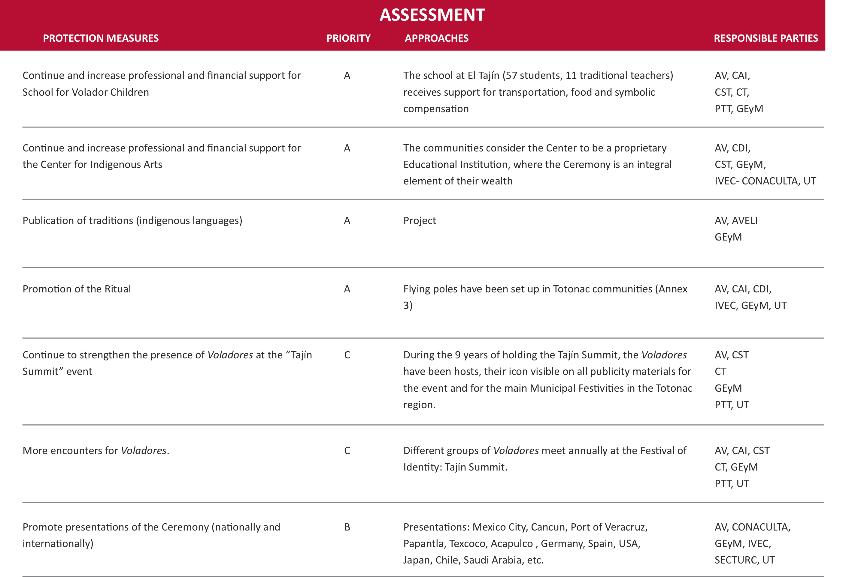  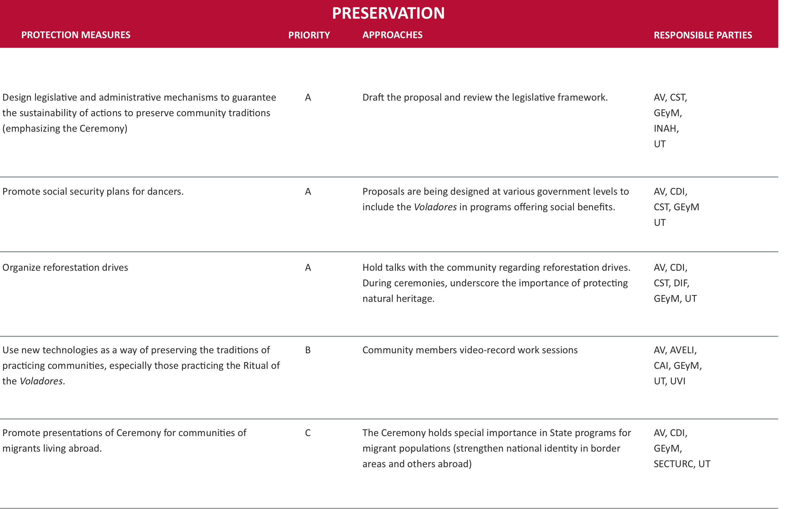  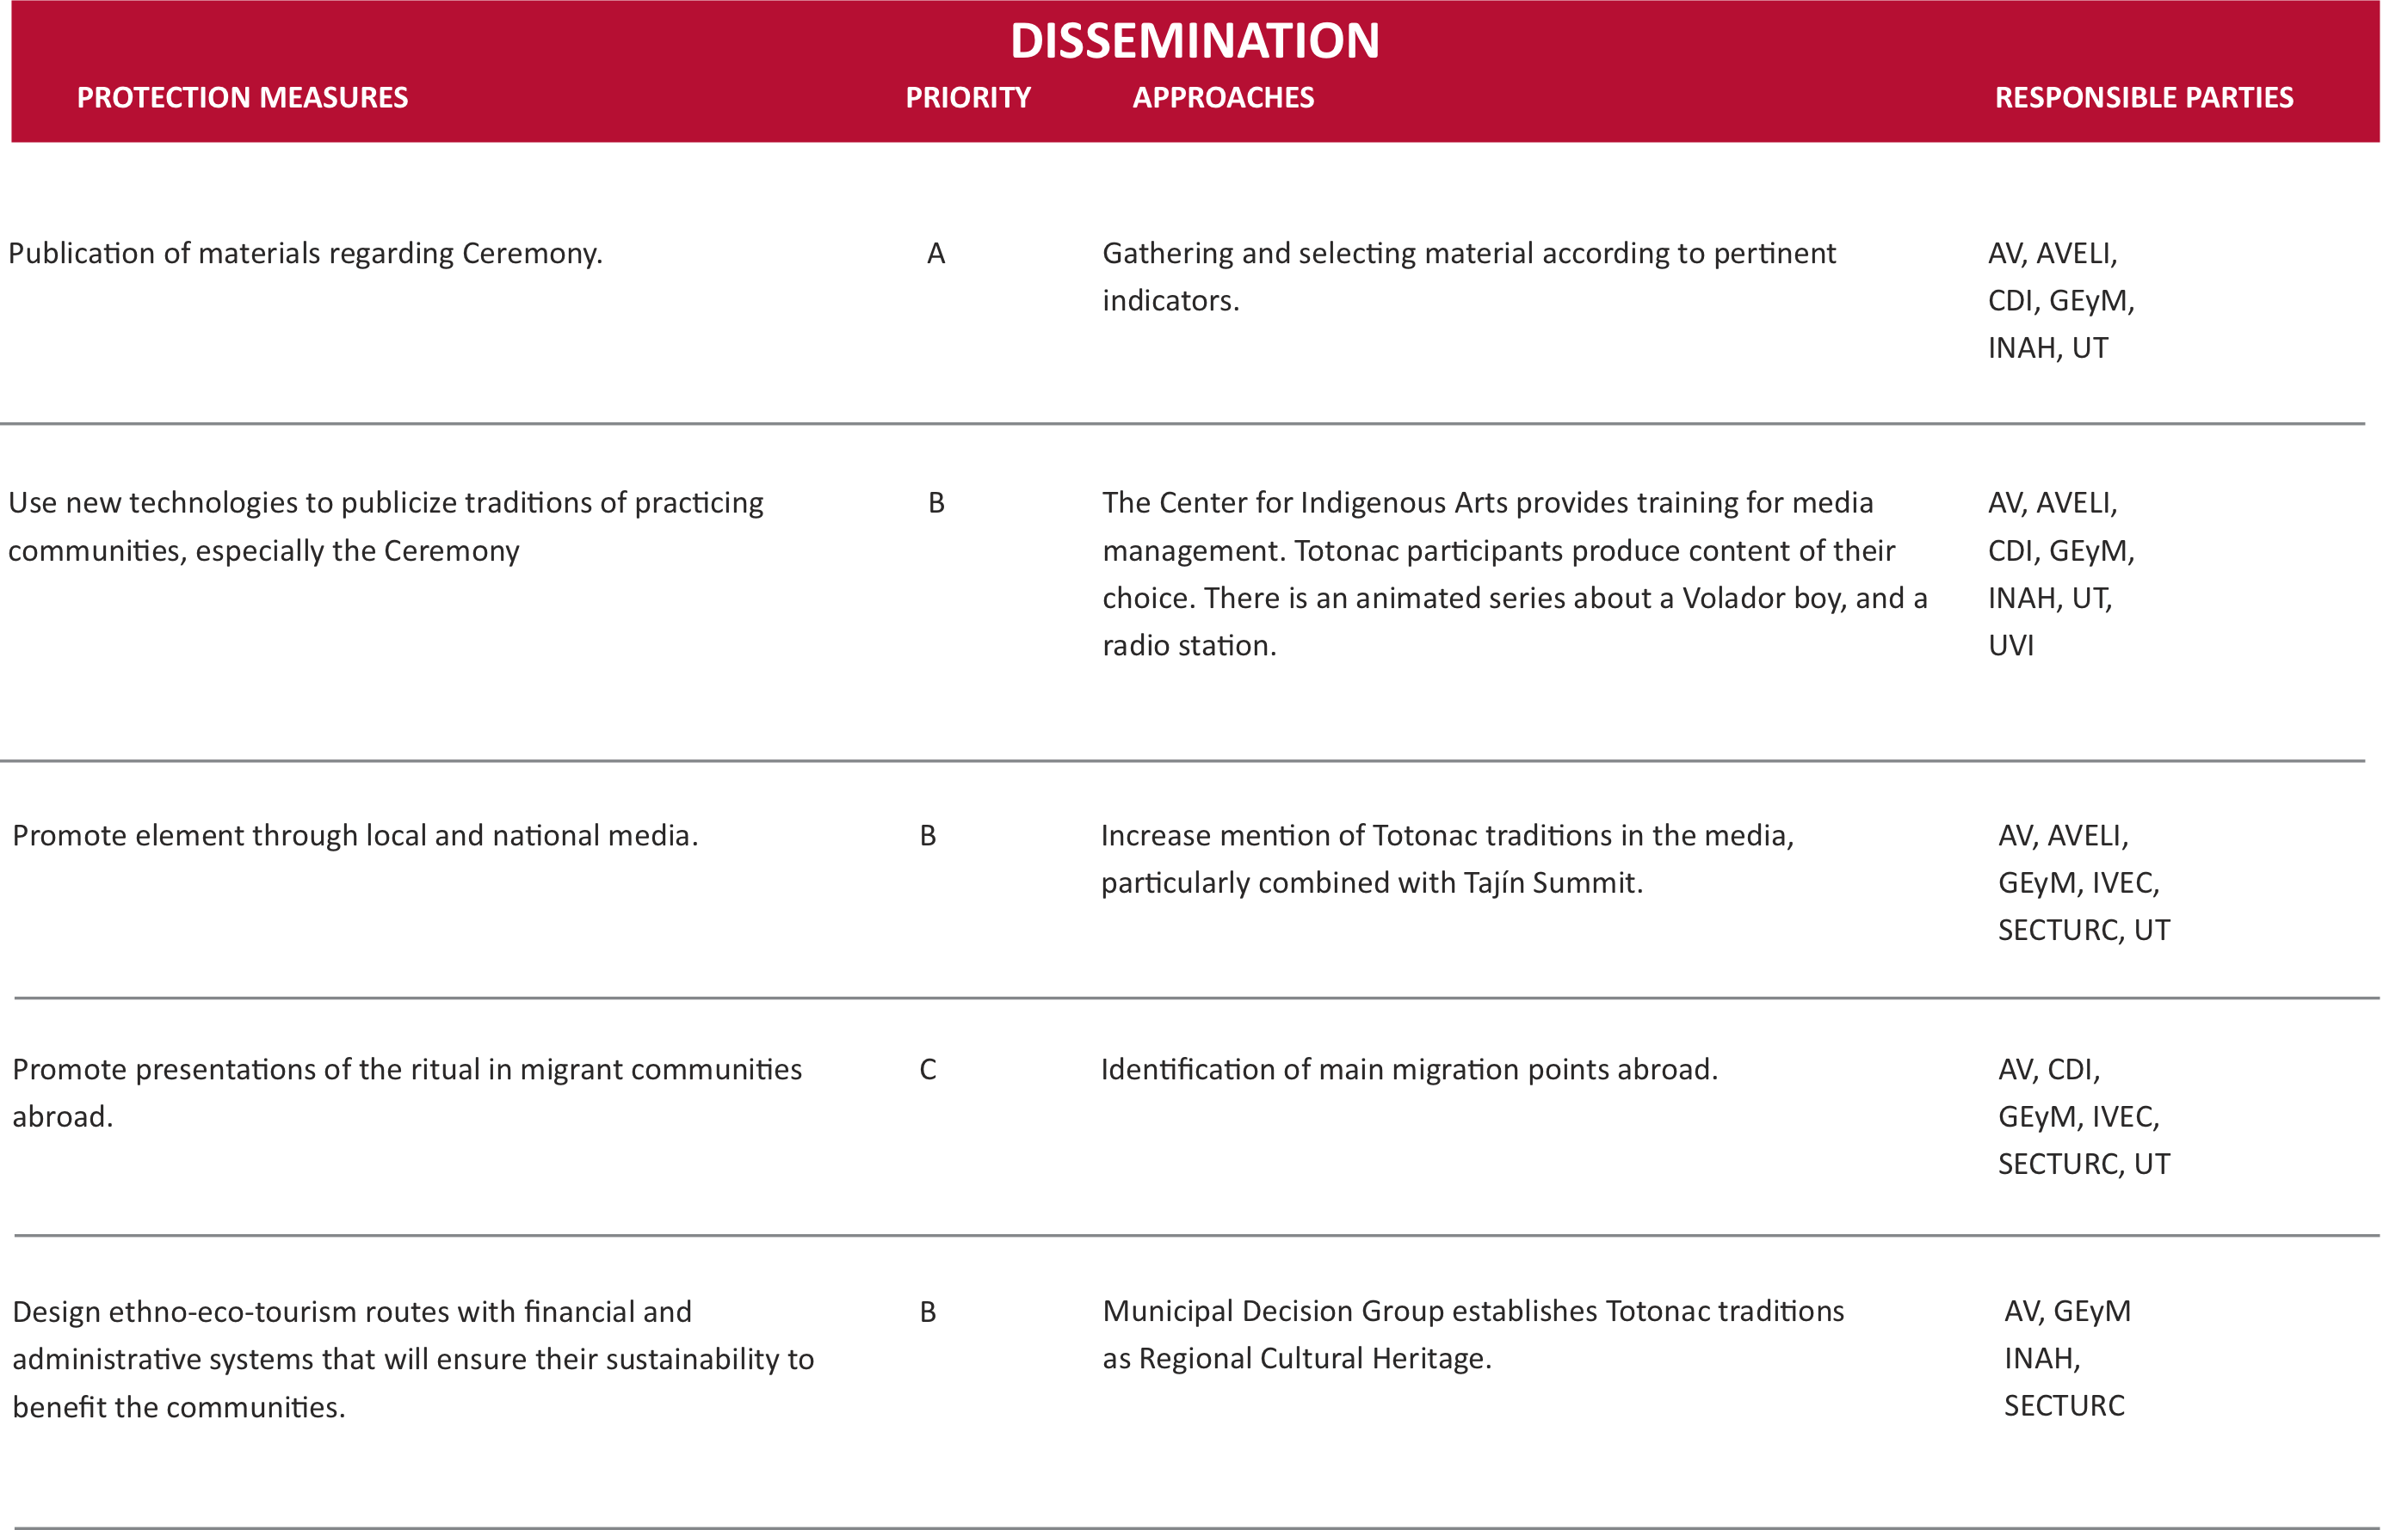  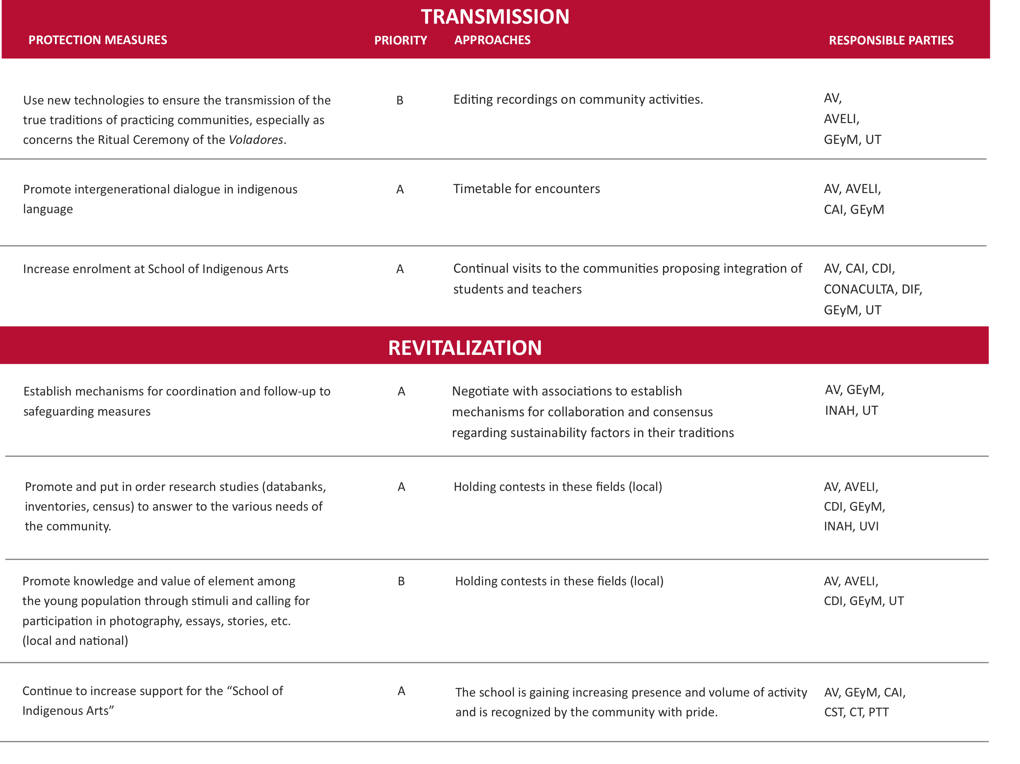  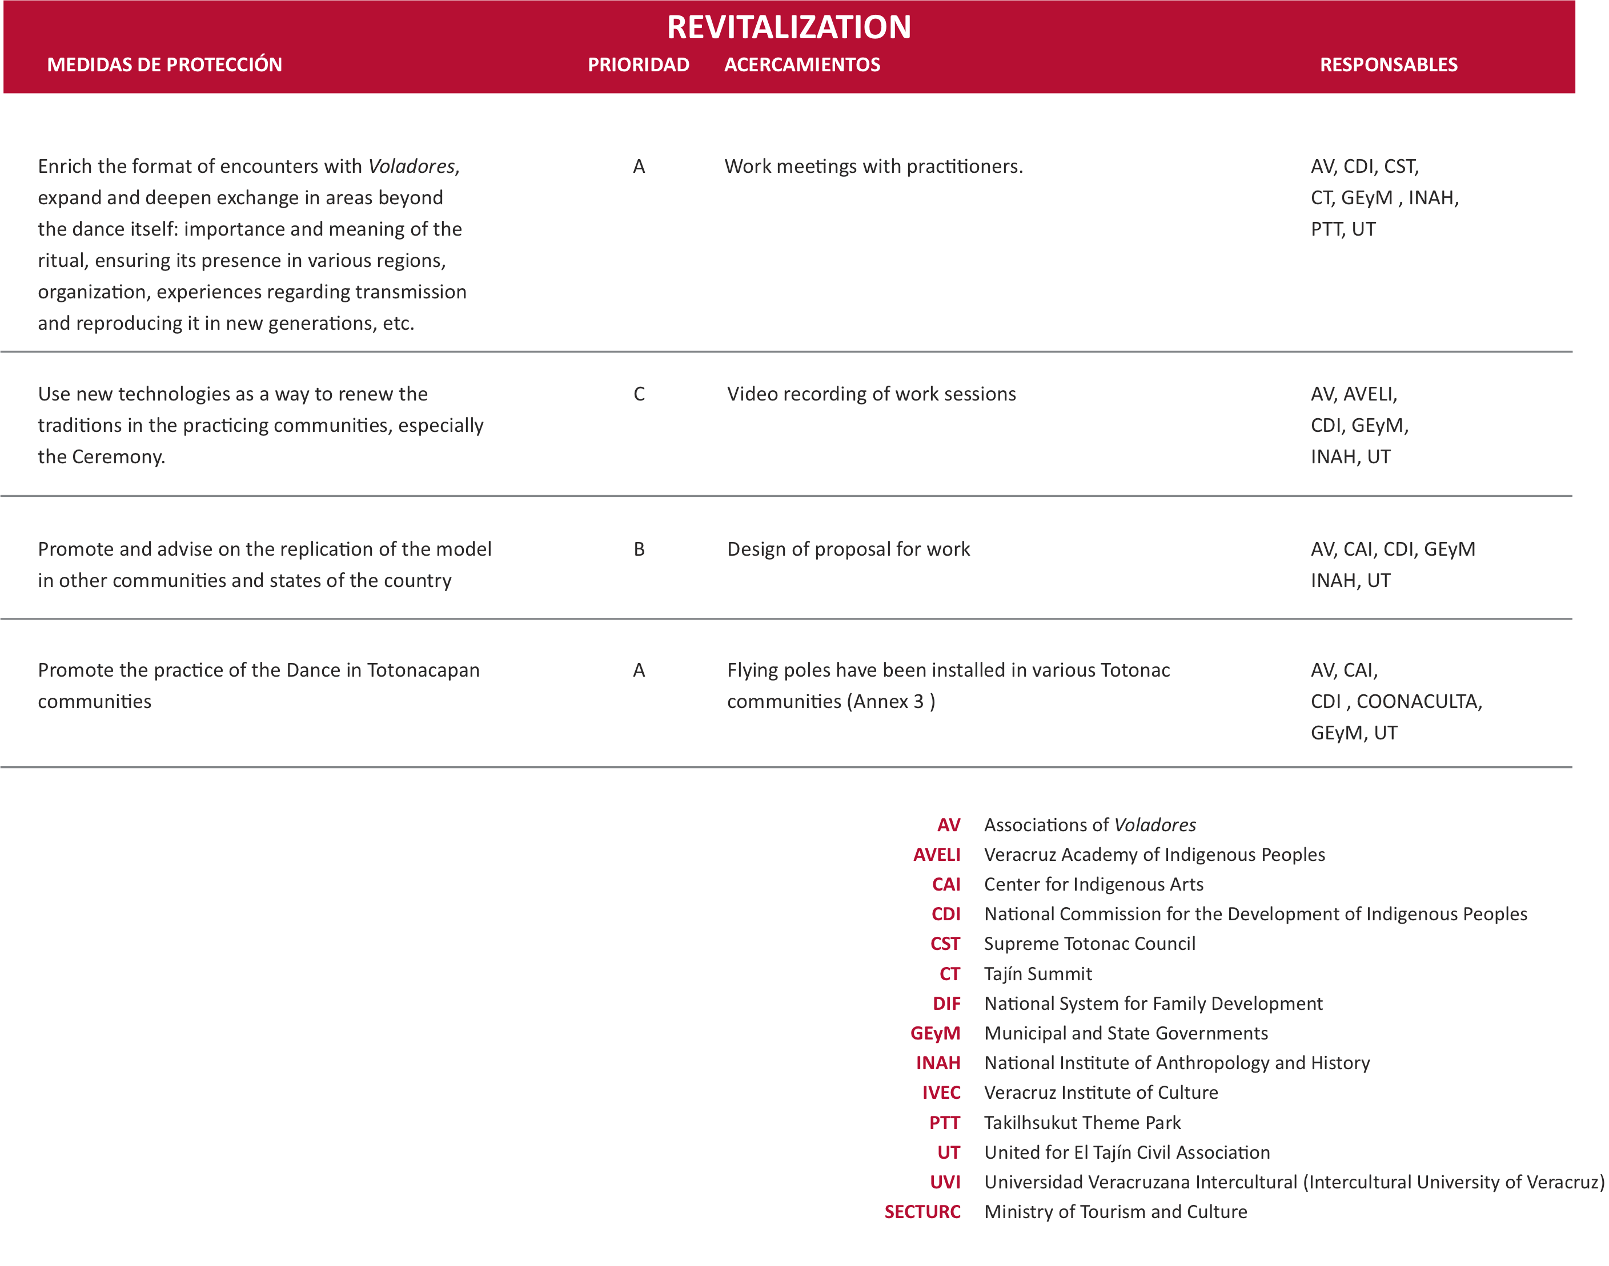

4.c. | Commitments of States and of communities, groups or individuals concerned:  The Government of the state of Veracruz and representatives of the communities, through the establishment of the School for Volador Children, is committed to working together to ensure the continuity and organization of the comprehensive training process for new generations of Voladores, strengthening the teaching of the “complete” ritual and including other aspects of Totonac culture that –given the historic cultural influence experienced– have been weakened, including the teaching of: language (tutu-nakú), history (mythical and official) the proprietary system of norms and philosophical principles, and the conduct that the practitioners of the Voladores rite should evidence.  At the same time, work is progressing in other projects that have a direct repercussion on the appreciation of and continuity of the rite:  - The creation of an Information and Documentation Center, specializing in Totonac culture, with special emphasis on compiling diverse reference and audiovisual collections of work featuring the Voladores.  - The promotion of research projects on aspects of the ritual which thus far have been little documented, including: geographic coverage, historic and present-day, of the Voladores; variations of the dance; recording of the music and sacred words (prayers) that are offered during the rite; production of a directory of groups and communities where the ritual is performed; relationship to other practices of pre-Hispanic origin that execute flight, such as: dances performed by the Guaguas or Quetzals, acrobats, indigenous carnival celebrations, and more.  - Holding Encounters of Voladores, where the practitioners themselves can directly share their experience and perspectives regarding the future of the ritual.  - At the School for Volador Children, setting up museum spaces to provide historic and recent information to visitors to the Center for Indigenous Arts, headquartered at the Takilhsukut Park, adjoining the El Tajín archaeological zone.  - Support for the Volador teachers who have trained at the school so that they might strengthen and multiply the execution of the ritual in the communities of the region in its original context, placing priority on those communities where it is no longer practiced.  - Implementation of a reforestation program to plant the tsakáe kiwi tree (Flyer’s Pole) to preserve the integral nature of the rite.  - The design of diverse information materials to distribute regarding the ritual, both for the use of performing communities themselves as for the public at large: brochures, books, videos, short films, Web page, etc.
5. | Community involvement and consent (cf. Criterion R.4)
5.a. | Participation of communities, groups and individuals:  Throughout the preparation of this nomination there has been significant participation from society at all levels. The document was developed by the Voladores themselves, either individually or through their associations (there are more than 250 active Voladores), and the Supreme Totonac Council has also taken part, as well as various Civil Associations, renowned intellectuals, public and private universities, town hall organizations of the Veracruz region of Totonacapan, and several federal institutions devoted to culture, in addition to the State Government of Veracruz (Letters of Support).  It was agreed that the safeguarding plan be developed with the assistance of all stakeholders and institutions involved, and periodic meetings are held to analyze the progress attained.  This work sets an important precedent in ensuring community participation in the nomination process; this includes creating awareness and knowledge of the subject, and the selection of individuals and organizations that will comprise the work teams.  The team that has worked and participated in the nomination process is an interinstitutional, multidisciplinary one comprising:  Francisco Acosta Báez, Center for Indigenous Arts  Salomón Bazbaz Lapidus, Tajín Summit and Takilhsukut Park  Manuel Gameros Esponda, Pórtico, Información y Análisis, S. C  Domingo García García, Commission for the Development of Indigenous Peoples  Wenceslao García Santes, Union of Dancers and Voladores of Papantla  José Luis Perea González, National Institute of Anthropology and History  Cruz Ramírez Vega, Civil Association of Voladores Kgosni, S. C.  Adolfo San Martín García, Organization of Voladores Tutunakú  Juan Simbrón Méndez, Supreme Council of Traditional Totonaca  At the facilities of the Takilhsukut Theme Park, several meetings have taken place with the participation of Caporals, Voladores, and representatives of federal, state and municipal indigenous organizations and cultural institutions interested in preserving and registering before UNESCO the Ritual Ceremony of the Voladores as Intangible Cultural Heritage of Humanity.  The purpose of the meetings has been to report on the progress attained regarding the technical file, as well as reaching consensus on and promoting actions to protect this Ceremony and its values.  For the development of the meetings, a methodology was chosen that would allow for constructive dialogue, learning of the appreciations of participants on the meaning and values of the Ceremony, identifying problems regarding its preservation and proposing coordinated actions to find solutions to said problems.  The meetings were held at three crucial moments:  - By way of introduction, the Council of Elders of Totonacapan expressed their assessment regarding the objectives of the meeting and the importance of reflecting on the preservation of the Ritual Ceremony of the Voladores, as well as the need to find ways to strengthen its preservation.  - Several work tables were organized to discuss five wide-ranging questions with the following objectives:  • To identify the meaning of the values of the Ritual Ceremony of the Voladores  • To become aware of the problems involved in its preservation  • To listen to the participants’ proposals for action to set up a work program  - The results were presented at a plenary session.  Below is a summary of the results obtained at the work tables.  - What does the Ceremonial Rite of the Voladores mean in our communities and culture?  • The Ceremonial Rite of the Voladores has been perceived as a rite of fertility to ask the gods for abundant crops.  • The Ceremonial Rite of the Voladores is an element of identity that transmits the thinking of the ancestors; it binds, brings joy, strengthens and fosters harmony and mutual respect.  - What are the problems its preservation faces?  • There are few Volador teachers.  • New generations appear to consider that tradition and modernity are in opposition one to another.  • New generations, influenced by the media, prefer external models of conduct and appear not to value their own, and indeed may feel ashamed of them.  • The Ceremony is expensive, based on the difficult economic situation that the communities face.  • Migration, family disintegration, not enough respect for the elders and the presence of new religions in the zone.  • Deforestation and lack of plots or land.  • Absence of laws to protect the ritual.  - What are the objectives of preserving the Ceremonial Rite of the Voladores?  • That it be shared with the world.  • That the Totonac identity may survive.  • That it be transmitted fully and authentically.  • That it may continue to prompt unity, pride and joy.  • That new generations may learn about it and love it, cherishing the principles and values of their culture.  • That nature be valued and cared for.  - What actions can contribute to the preservation of the Dance in general and in our communities specifically?  • Fostering traditional ways to organize in a group.  • Supporting family values.  • Strengthening the vocation to become a dancer within the family.  • Set up troupes of professional and traditional dancers and teachers.  • Teach its meaning and practice in an exciting but standardized manner to young generations through workshops.  • Rescue the traditional principles, songs and dress.  • Disseminate and promote the dance.  • Improve the framework for protection and promotion of the ritual.  - What organizations, programs or institutions can support us in achieving this purpose?  The following organizations were mentioned (all those mentioned and others that were not mentioned at this meeting are being considered as participants in protection measures under heading 4b):  Municipal, state and federal governments, Ministry of Tourism and Culture, the Veracruz Institute of Culture, the National Council for Culture and the Arts, the National Commission for the Development of Indigenous People, the National Institute of Anthropology and History, the National Institute of Fine Arts.  At the end of the first meeting, the suggestion that the element be proposed to UNESCO as Intangible Cultural Heritage of Humanity was met with great enthusiasm, and the following actions were agreed on for immediate implementation:  • Promote municipal ordinance or legal instruments at the regional and state levels to favor the recognition, inventory and integral preservation of the Ceremonial Ritual of the Voladores.  • Recover the Ritual Ceremony of the Voladores through participation in cutting down the Flying Pole on September 21, 2008.  • Convene a grand meeting of Caporals and Voladores from different states of the country to build a plan for the short and long term conservation and preservation of the Ritual.  • Complement and enrich the technical file on the Ritual Ceremony of the Voladores so that it may be submitted to UNESCO, based on the principles of the Convention to Safeguard Intangible Heritage.  At subsequent meetings, it was agreed that a Coordinating Council for  Follow-up to the Technical File of the Ritual Ceremony of the Voladores  be established to provide follow-up to the element submitted to UNESCO for consideration for inclusion on the Representative List of Intangible Cultural Heritage of Humanity.  A work plan was also designed, including:  • Visiting the coastal and sierra regions of Veracruz, as well as other states of the country, to report on the technical file on the Voladores submitted to UNESCO and the creation of a Coordinating Council, and to convene all to participate in the Management Plan.  • Produce a directory of Voladores encompassing all zones.  • Produce and inventory of the Flying Poles (both wood and metal), and a diagnosis of their condition.  • Seek and formalize sources of work (contracts, fees, insurance, per diem, work conditions, etc.) and carry out productive projects that may generate income for the groups of Voladores and their families.  • Create a fund to handle health and education needs, and other needs.  • Create workshops to rescue the Voladores costumes and instruments.  • Propose to the Ministry of Public Education that it should incorporate the teachers of the Ritual Ceremony in the artistic education syllabus in the schools of the region.  • Propose a media campaign at state and national level to promote the element.  • Petition the state government for a Declaration of State Heritage for the element.  • Design a reforestation plan for the Flying Pole tree.  • Draw up tourist routes related to the Ceremony.  Notes on progress attained:  • The Totonacapan census has identified 264 Voladores, divided into three signatory organizations and 50 additional independent Voladores (not belonging to an association). There is ongoing investigation to determine the presence of Voladores in other areas and to establish contact with them.  • To date, 56 volador poles have been located in Mexico, 38 of these in the Totonacapan region and 27 in various places around the country; a diagnosis is underway on the status of these poles.  • Various proposals for internal regulations were suggested for the development of the objectives proposed in the administrative plan.  • A campaign has been launched in Totonacapan to endow the Ceremony with dignity and report on progress attained in the plan to safeguard it.  • There is a plan underway for reforestation of the Flying Pole tree with the objective of maintaining protected areas in several Totonacapan municipalities.  • The number of students enrolled at the school for Volador Children has increased.  • The Voladores have taken part in several festivals in various municipalities of the state of Veracruz, as well as in other states of Mexico and other countries.
5.b. | Free, prior and informed consent:  Attached is the Declaration on the Ritual Ceremony of the Voladores, the content of which was agreed on by members of the community, and through letters of support received.
5.c. | Respect for customary practices governing access:  Despite the fact that this Ceremony has always been open to observation by the public at large, there are regulations regarding the physical and spiritual safety of both participants and observers:  - The Ritual Ceremony of the Voladores is carried out by dancers who are spiritually and physically prepared; it is important to underscore that this ritual is not open for performance by just any person as a recreational or sport activity. On occasion, people from outside the community have been invited to fly, insofar as they have prepared appropriately to do so, and under the express consent of the member of the group of Voladores.  - The Pole should measure 28 meters, of which 2.5 meters are buried in the ground; the ropes that the dancers are tied to should measure approximately 32 meters and should be very resistant (the length will vary proportionally to the length of the mast); observers should not step into the safety diameter, equal to the freestanding height of the Flying Pole (in this case, 25 meters).  - During the cutting, dragging and raising of the pole, women should not touch the pole; it is thought that female energy will create an imbalance with the masculine energy and the safety of the flight will be jeopardized. In the communities of the Totonacapan sierra region, it has been accepted that women can participate in the flight, though this does not hold true along the coastal region of Papantla.  - On occasion, people from outside the community have been invited to fly, insofar as they comply with the appropriate preparatory steps and be expressly invited to do so by the members of the group of Voladores.  - The Ceremony to cut down the tree can only be attended per explicit invitation to do so; the Voladores must fully trust that those taking part in the Ceremony have met the prerequisite of ascesis.  - Although there is the option of offering only one stage of the Ceremony to the public –the dance and the flight –, when the pole is raised (or the metal tube when a wood Flying Pole is not available) the entire Ceremony to raise the pole must be carried out, complete with offerings for Mother Earth.

6. | Inclusion on an inventory (cf. Criterion R.5):
 | The Ritual Ceremony of the Voladores is registered on the “Intangible Cultural Heritage Inventory of Mexico”, produced by CONACULTA (National Council for Culture and the Arts) and its representative departments, including INAH (National Institute of Anthropology and History) and the Department of Popular Cultures.
7. | Documentation
7.a. | Required and supplementary documentation:  Primary:  Technical file in digital format  Photos :10 photograhis on CD format: “Digital photographic archive, 10 principal Photos”  Video : DVD “Ritual Ceremony of the Valadores”  Complémentary:  • Photos : 20 photographs on CD format: Digital photographic archive, 20 comntary Photos, complementary Photos”  Video : “Ritual Ceremony on the Valadores” (Annex) ; The tree of Life  Maps : 3 maps included on CD, Digital photographic archive, 20 complementary”
7.b. | Cession of rights:  Appended.
7.c. | List of additional resources:  Aguilera Madero, Rocío y Cano González Onésimo.«La danza ritual del Volador”. Papantla: Cahier polycopie», en: Enquetes sur l’ Amérique Moyenne. México: cemca-inah-conaculta, 1989, 329-339.  García García, Domingo «Los Voladores”. Fragment de «Significado de las danzas de la región totonaca de Papantla, Veracruz”. Papantla: Edition polycopiée de l´Union de Danseurs et Voladores, 1980.  Masferrer Kan, Elio. Cambio y continuidad, los totonacos de la Sierra Norte de Puebla. México: Editions du Gouvernement de l´État de Veracruz, 2006.  Nájera Coronado, Martha Ilia. «El rito del <palo volador>: encuentro de significados”, dans Revista Española de Antropología Americana. Madrid, 2008, Vol. 38, Num. 1, 51-73.  Olivier, Guilhem (coordinador). Viaje a la huasteca con Guy Stresser-Péan. Mexique: FCE, 2008.  Stresser-Péan, Guy. «El Volador: Datos históricos y simbolismo de la danza”, dans: Arqueología Mexicana. Mexique, 2005, Vol. 13, Num. 75, 20-27.  Urcid Serrano, Javier. «Antigüedad y distribución de la danza de los Voladores: águilas que descienden, corazones que ascienden”, dans Arqueología Mexicana. Mexique, 2006, Vol. 14, Num. 81, 70-74.  Comisión Nacional para el Desarrollo de los Pueblos indígenas. Monographies des peuples indigènes, dans: http://faculty.smu.edu/rkemper/anth_3311/ANTH_3311_cdi_  mografias_pueblos_indigenas.htm  Danses de Voladores, dans: http://www.porticoproyectos.com/Voladores/
8. | Contact information
8.a. | Submitting State Party: Mexico
8.b. | Contact person for correspondence:  Initial contact  Salomón Bazbaz Lapidus  Direction Unis pour le Tajin A. C  Boulevard Cristóbal Colón #5  Edif. Torre Ánimas desp. 608-609  Col. Vista Hermosa, Ánimas C.P. 91190 Xalapa, Veracruz.  52 (228) 8135 408-09  salobazbaz@gmail.com  Other contacts  Francisco Javier López Morales  Direction de Patrimoine Mondial  Av. Revolución Nos. 4 y 6  Col. San Angel. C. P. 01000  México, D. F.  52 (55) 55 50 42 11  direccion.pmundial@inah.gob.mx  José Luis Perea González  Direction de la Zone Archéologique de El Tajín  Carretera Federal 130 Poza Rica – San Andrés  Domicilio Conocido C. P. 93400  Papantla, Ver., México  52 (784) 8 81 27 27  52 (784) 8 42 83 54  jluisperea@gmail.com
8.c. | Competent body involved:  Francisco Acosta Báez  Directeur Centre des Arts Indigènes  Parc Thématique Takilhsukut  Carretera Poza Rica-San Andrés Km. 17.5  Municipio de Papantla, Veracruz, México  52 (782) 821 70 89  francisco.acosta@cumbretajín.com  Salomón Bazbaz Lapidus  Direction Unis pour le Tajin A. C  Carretera Poza Rica-San Andrés Km. 17.5  Municipio de Papantla, Veracruz, México  52 (782) 821 70 89 y 821 70 90  salobazbaz@gmail.com  Francisco Javier López Morales  Direction de Patrimoine Mondial  Av. Revolución Nos. 4 y 6  Col. San Angel. C. P. 01000  México, D. F.  52 (55) 55 50 42 11  direccion.pmundial@inah.gob.mx  José Luis Perea González  Direction de la Zone Archéogique de El Tajín  Carretera Federal 130 Poza Rica–San Andrés  Domicilio Conocido C. P. 93400  Papantla, Ver., México  52 (784) 8 81 27 27  52 (784) 8 42 83 54  jluisperea@gmail.com
8.d. | Concerned community organization(s) or representative(s):  Wenceslao García Santes  Président de l´Union de Danseurs et Voladores de  Domicilio Conocido.  Comunidad El Tajín, Papantla, Veracruz, México.  52 (782) 841 05 06  Cruz Ramírez Vega  Président de l´Association Civile de Voladores Kgosni, S.C  Domicilio Conocido  Comunidad Ojital Viejo, Papantla, Ver.  52 (782) 101 92 23  kosni_69@hotmail.com y/o puxcu@hotmail.com  Adolfo San Martín García  Président de groupe de Voladores Tutunakú  Domicilio Conocido.  Comunidad Ojital Viejo, Papantla, Veracruz, México.  52 (782) 104 84 59  Juan Simbrón  Guide Moral et Spirituel du Conseil Suprême Traditionnel Totonaque  Président de la Fédération Nationale des Peuples Éthniques  Domicilio Conocido en la Comunidad de Zapotal Santa Cruz,  Municipio de Papantla, Veracruz, México.  52 (784) 842 73 03
9. | Signature on behalf of the State Party:
 | <signed>

